DEMO

materials taken from Business Partner B1, p.70, 150

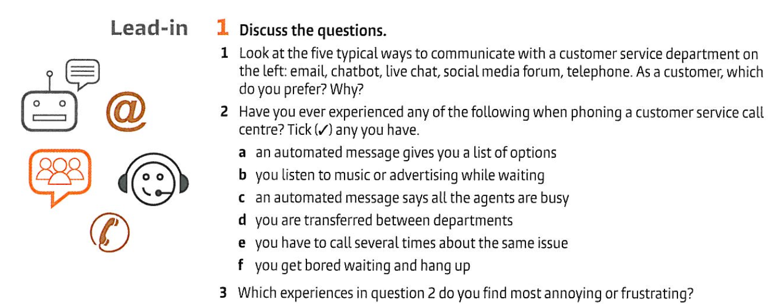

|  |  |  |  |  |  |
| --- | --- | --- | --- | --- | --- |

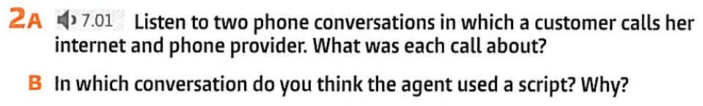

|  |
| --- |
|  |

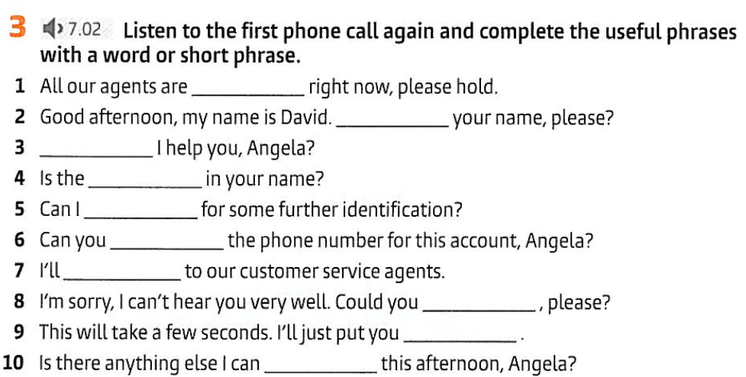

|  |
| --- |
|  |
|  |
|  |
|  |
|  |
|  |
|  |
|  |
|  |

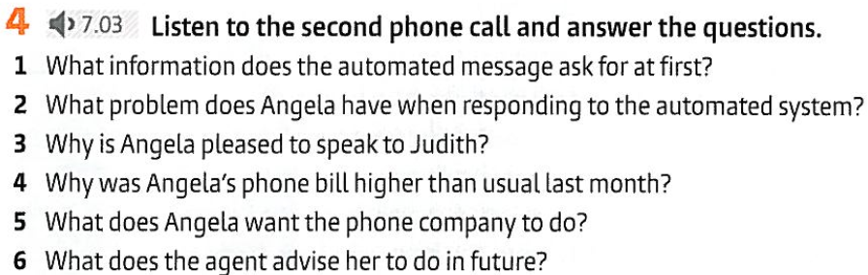

<https://on.soundcloud.com/mMkLYmNu8zzFqGPW8>

|  |
| --- |
|  |
|  |
|  |
|  |
|  |



**Script CALL _*1* _ ( 7.02)** [**https://on.soundcloud.com/Sj6K4T4AMQAH6UaB7**](https://on.soundcloud.com/Sj6K4T4AMQAH6UaB7)



  
  
  
  