DEMO

Materials taken from Business Partner B1 SB, p.54-55

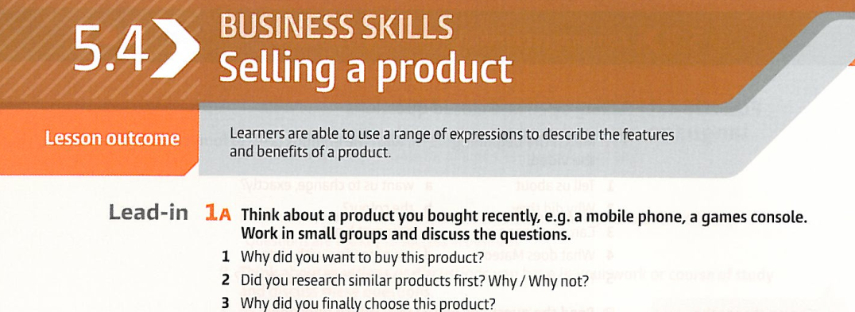

|  |
| --- |
|  |
|  |

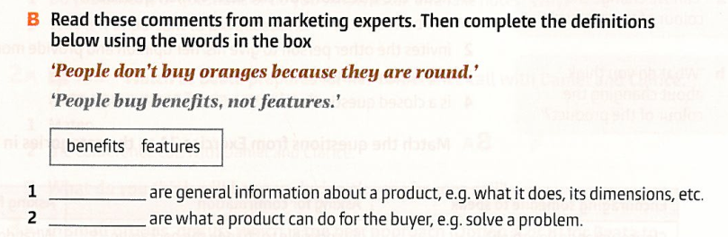

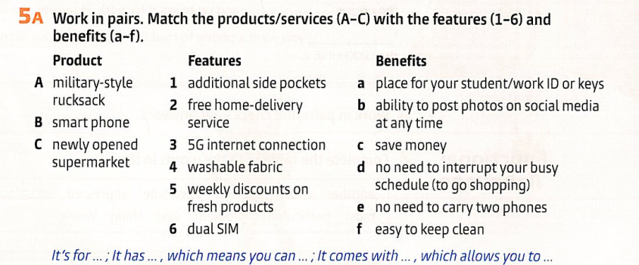

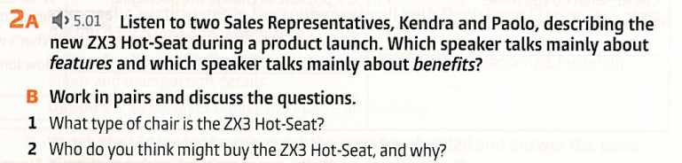

|  |
| --- |
|  |

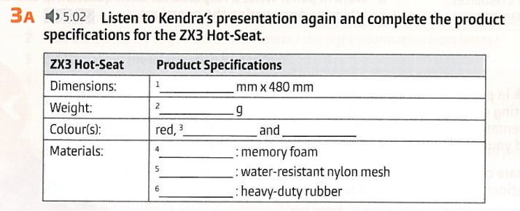

|  |  |
| --- | --- |
|  |  |
|  |  |
|  |  |

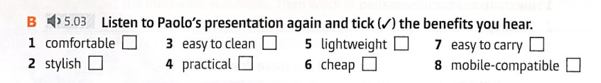

|  |  |  |  |  |  |  |  |
| --- | --- | --- | --- | --- | --- | --- | --- |

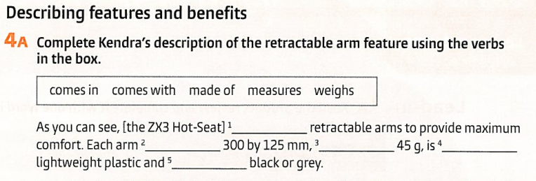

|  |  |  |  |  |
| --- | --- | --- | --- | --- |

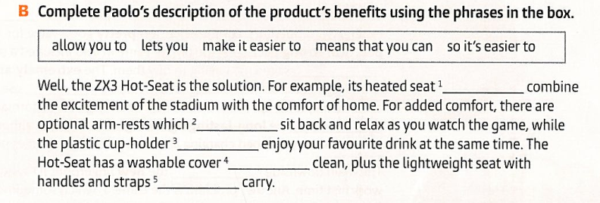

|  |
| --- |
|  |
|  |
|  |
|  |

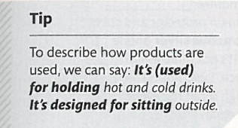

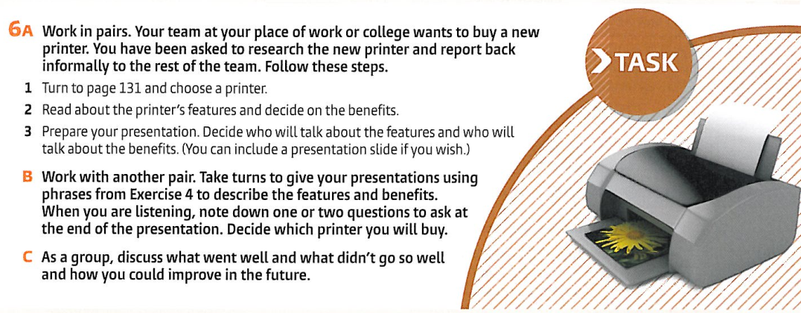

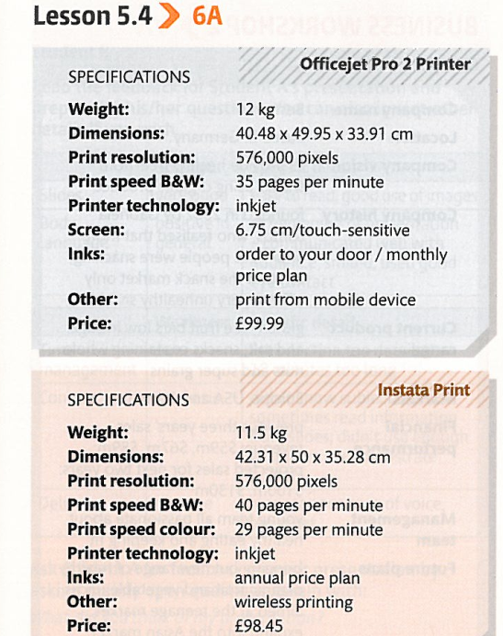

Tapescript:

