John Milton
(1608–1674)
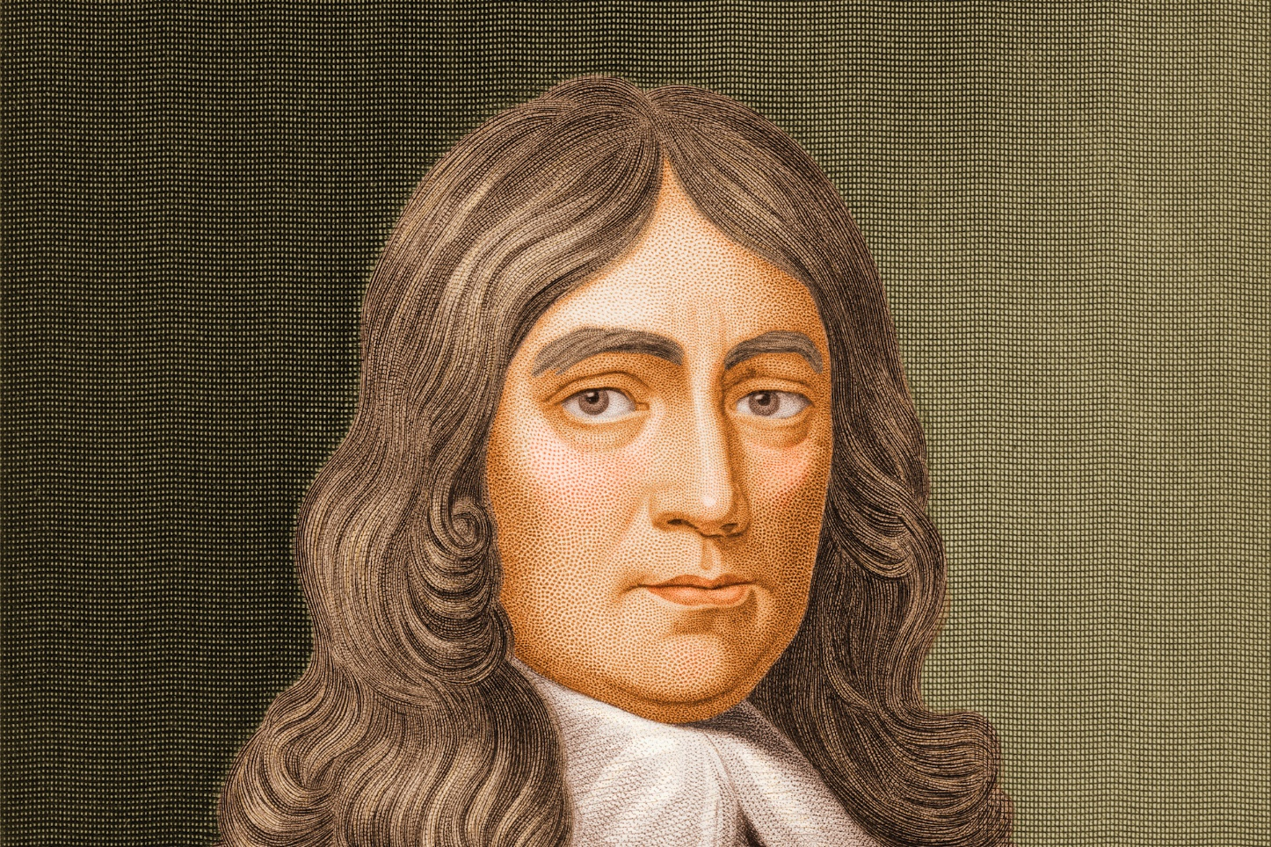

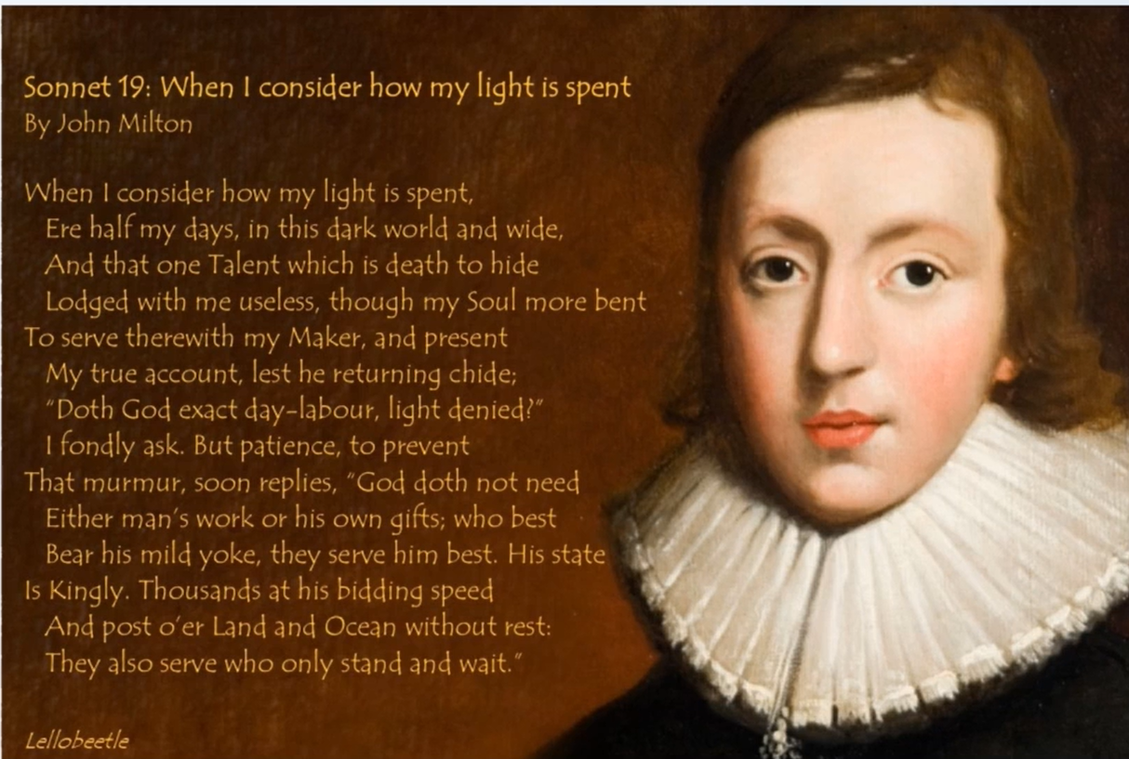John Milton (1608–1674)
- One of the major figures of English, and indeed world, literature
- Most famous for the epic poem Paradise Lost
- A poet and a polymath, he knew science, theology, philosophy and history, and spoke many languages
- Lived through the English Civil War
- Fell from favour during his own lifetime

Poet, Republican, Civil Servant
- A high-ranking civil servant under Oliver Cromwell, leader of the government after the execution of King Charles I
- Cromwell is often seen as an unsympathetic figure, but Milton was a great admirer
- An ardent Republican who refused to recant his political opinions after the Civil War
- Died completely broke after falling from favour following the Restoration of 1660, when Charles II reclaimed the throne

Reputation and Influence
- Paradise Lost: one of the major works of world literature and one of the most important works in the English language
- An epic poem written in blank verse
- Samuel Johnson both praised and loathed him, remarking that Paradise Lost is a book that, once put down, is hard to pick up again
- An influence on William Blake, William Wordsworth and Thomas Hardy

Family and Early Life
- Born and bred in London, in a middle-class home
- Son of John Milton, composer and scrivener, and his wife Sarah Jeffrey
- His father came from a wealthy Catholic family and was disinherited for his attachment to Protestantism
- His tutor Thomas Young, a Scottish Presbyterian, introduced him to religious radicalism, which runs through his work

School Years
- Attended St Paul’s School, where he learned Latin and Greek
- The classics were a huge influence on his work: Paradise Lost is the English equivalent of the classical epic
- At 15 he wrote his first poems: two psalms
- His brother Christopher recalled that he studied very hard and commonly sat up till twelve or one o’clock at night

Cambridge (1625–1632)
- BA at Christ’s College, Cambridge (1625–1629); MA in 1632
- Intended to become an Anglican minister
- Did not get on with some of his teachers; rumoured to have been suspended after a dispute with a tutor
- Did not fare well socially, but wrote poetry, including:
  - On the Morning of Christ’s Nativity
  - An Epitaph on the Admirable Dramatic Poet W. Shakespeare
- His first published work appeared anonymously in an edition of Shakespeare’s works

Years of Private Study (1635–1638)
- After his degrees he moved to Horton and undertook years of private study
- He had to obtain all the books he needed himself
- Studied ancient and modern theology, philosophy, history, politics, literature and science, to prepare himself to be a poet
- His commonplace book, a record of his intellectual development, is in the British Library
- Could read and write Latin, Greek, Hebrew, French, Spanish, Italian, Old English and Dutch
- Wrote Arcades, Comus and Lycidas, an elegy for a Cambridge friend

Travels in France and Italy
- From May 1638 to July or August 1639 he toured France and Italy
- Became known as one of the foremost European intellectuals
- Met historians, theologians, poets and writers
- Returned home because of what he called “sad tidings of civil war” in England

The English Civil War
- Charles I was in opposition to Parliament; many felt the king’s powers were too extreme and Parliament should have more
- This (in simplified terms) led to the English Civil War
- Milton was firmly on the side of the Parliamentarians
- He wrote tracts in support of the Puritan and Parliamentary cause

Marriage, Divorce and Free Speech
- In 1642 he married 16-year-old Mary Powell; she returned to her family after only a month and came back only in 1645 (partly due to the war)
- Three daughters and a son, who lived only a year; the daughters had a strained relationship with their father
- He wrote a defence of divorce, which was controversial and brought him to the attention of the authorities
- In response he wrote his famous defence of free speech: Areopagitica: A Speech of Mr. John Milton for the Liberty of Unlicensed Printing, to the Parliament of England

Regicide and the Republic
- After Parliament’s victory he wrote The Tenure of Kings and Magistrates (1649), which seemed to sanction regicide
- The execution of Charles I, the only English king to be executed, sent shockwaves across Europe; the divine right of kings was widely accepted
- On the orders of the Council of State he wrote A Defence of the English People
- Then a Second Defence, praising Oliver Cromwell
- Appointed Secretary for Foreign Tongues by the Council of State; held the post until the Restoration in 1660

Blindness
- Completely blind by 1652
- His work was carried out by secretaries, with Milton dictating
- The cause is unknown; some scholars suggest retinal detachment
- Sonnet 19, “When I consider how my light is spent”, reflects on his blindness
- Its final line became famous: “They also serve who only stand and wait.”

- 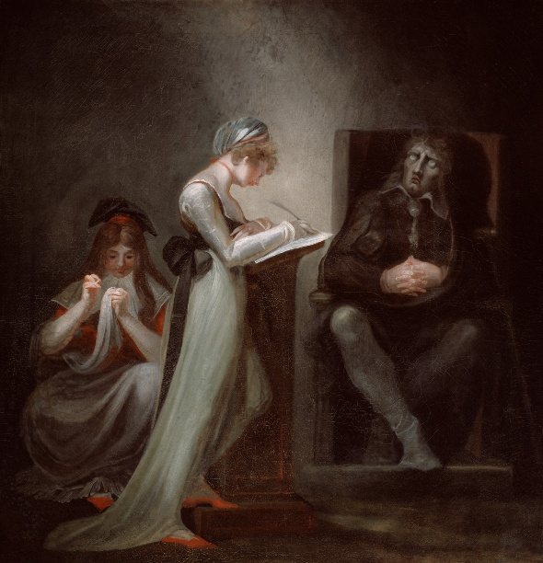

Sonnet 19
When I consider how my light is spent,
Ere half my days, in this dark world and wide,
And that one Talent which is death to hide
Lodged with me useless, though my Soul more bent
To serve therewith my Maker, and present
My true account, lest he returning chide;
“Doth God exact day-labour, light denied?”
I fondly ask. But Patience, to prevent
That murmur, soon replies, “God doth not need
Either man’s work or his own gifts; who best
Bear his mild yoke, they serve him best. His state
Is Kingly. Thousands at his bidding speed
And post o’er Land and Ocean without rest:
They also serve who only stand and wait.”
— John Milton, Sonnet 19

The Restoration
- In 1656 he married Katherine Woodcock, who died in 1658
- When Oliver Cromwell died in 1658, the administration began to crumble; Milton feared a restoration of the monarchy and proposed alternatives
- The Restoration took place in 1660 and Charles II took the throne
- Milton’s books were burned, an order was issued for his arrest, and he went into hiding

Later Life
- In 1663 he married 24-year-old Elizabeth Minshull; they lived quietly in London for the rest of his life
- During the Great Plague of London he retired to his cottage in Chalfont St Giles, which can still be visited
- He contributed to the debate on excluding James, Duke of York (later James II), from the succession because of his Catholicism
- Wrote several tracts on religious tolerance, from which he excluded Catholics

Death
- Died of kidney failure on 8 November 1674
- Commemorated as the writer of Paradise Lost
- His funeral was attended by the intelligentsia and by the public
- By then his Republicanism no longer prevented public acknowledgement of him

Paradise Lost
- His magnum opus among many writings: polemics, tracts and poetry
- An epic poem in blank verse
- First edition 1667: ten books, around ten thousand lines; second edition 1674: twelve books
- Written in the manner of Virgil’s Aeneid; follows the biblical story of the Fall of Man
- Its stated purpose: to “justify the ways of God to men”
- He was 58 when it was first published, but some passages were written in his youth

Paradise Lost: Satan
- Classical motifs: Satan’s journey through Chaos recalls the journeying heroes of classical epic, such as Virgil’s Aeneid and Homer’s Odyssey
- Some claim Milton was sympathetic to Satan
- Readers tend to see their own views reflected in the poem:
  - C. S. Lewis strongly felt Milton was not sympathetic to Satan
  - The critic William Empson felt that he was
- Read it and make up your own mind

Paradise Lost: Epic and Biblical Devices
- Acrostics, a Hebrew form found in the Book of Psalms: in Book IX, lines describing the serpent tempting Eve spell out SATAN
- The angelic war: a large-scale battle between angels and fallen angels, an epic convention like the Trojan War
- Adam and Eve ask God for grace but are expelled from Eden
- The Archangel Michael tells Adam he may find “a paradise within thee, happier far”, a reflection of Milton’s own thinking

Famous Lines
The mind is its own place, and in itself
Can make a Heav’n of Hell, a Hell of Heav’n.

What though the field be lost?
All is not lost; the unconquerable will,
And study of revenge, immortal hate,
And courage never to submit or yield:
And what is else not to be overcome?
— Paradise Lost, Book I

Lofty Themes, Grand Style
- Grandiose statements on lofty themes are typical of epic poetry
- “The mind is its own place…” was slightly controversial in its day
- “All is not lost” has entered common parlance
- Apart from Beowulf, English had no great epic of its own until Paradise Lost

At once as far as Angels ken he views
The dismal situation waste and wild:
A dungeon horrible, on all sides round,
As one great furnace flamed; yet from those flames
No light, but rather darkness visible
Served only to discover sights of woe
— Paradise Lost, Book I

Blank Verse
- Paradise Lost is written in blank verse: it does not rhyme, but follows iambic pentameter
- Iambic pentameter: an unstressed syllable followed by a stressed one, in lines of ten syllables
- Milton was a great admirer of Shakespeare, master of the same metre

Milton’s Legacy
- Over the centuries the response to Milton has fluctuated, partly because of his Republicanism and his Protestantism
- Readers interpret Paradise Lost from their own philosophical viewpoints
- An absolute classic, not just of English but of world literature
- Highly recommended reading

