DEMO
Lead-in


Look at the picture. Agree or disagree with the statements.

Friends came to visit.
The woman didn’t expect them.


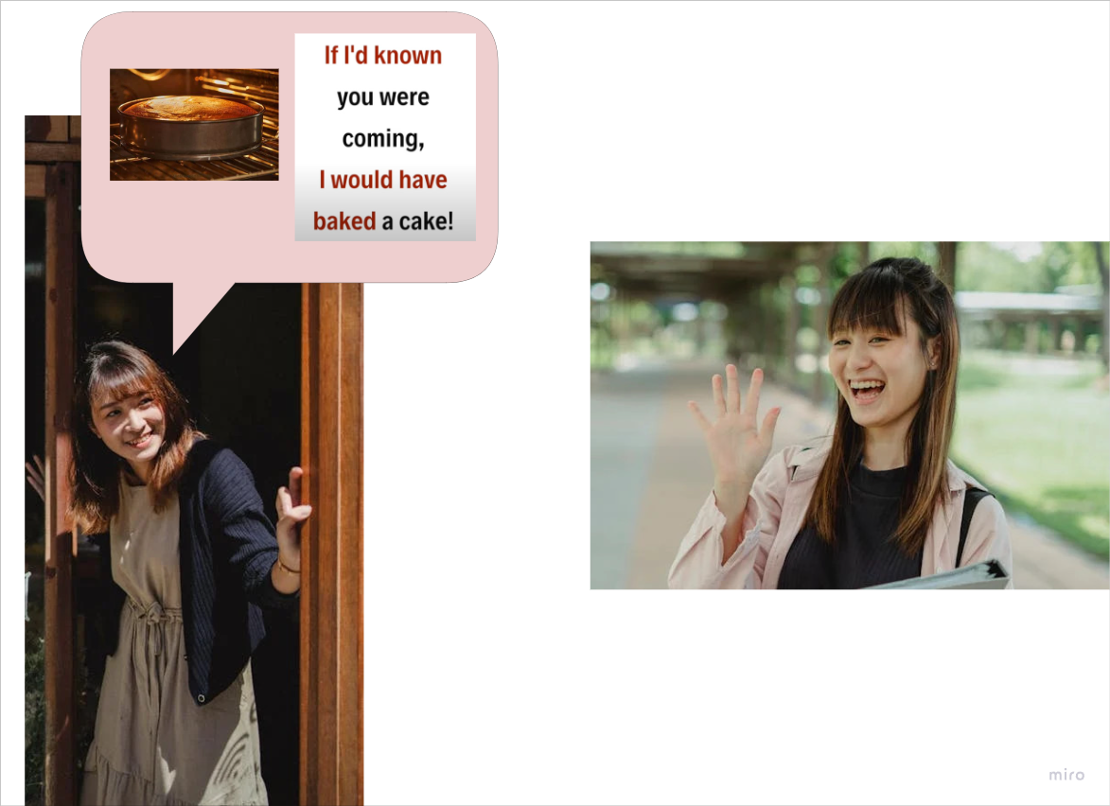

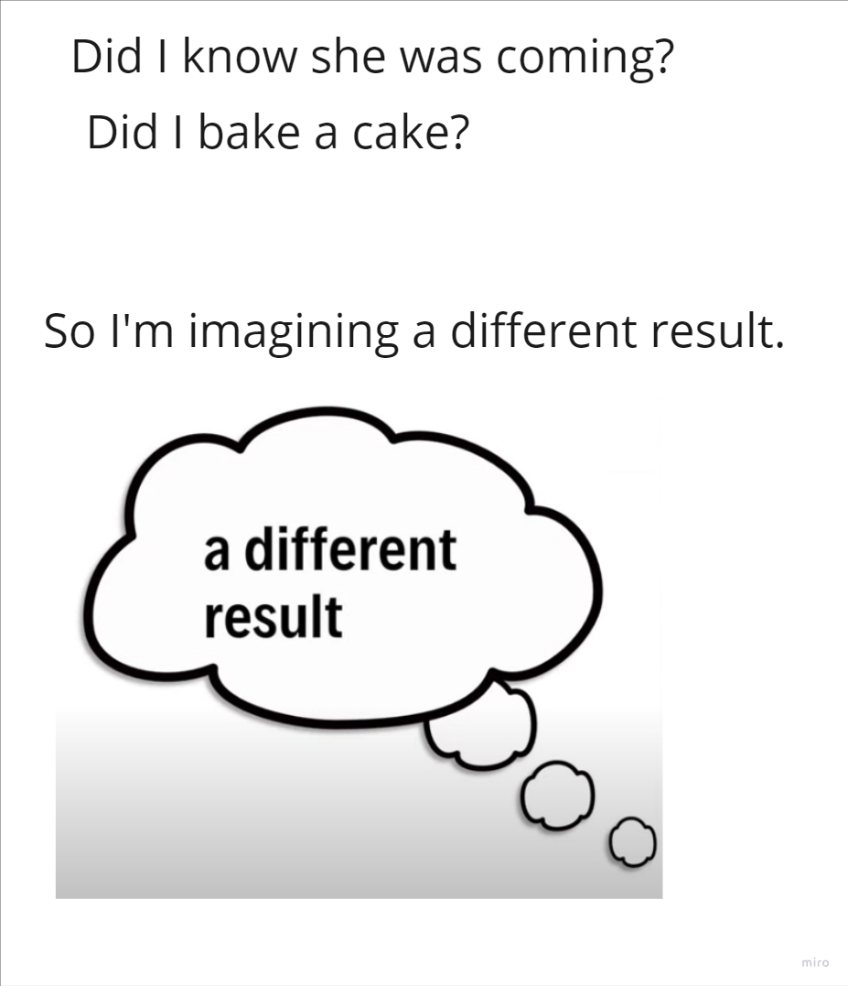

If I + ______________, I would + past participle.

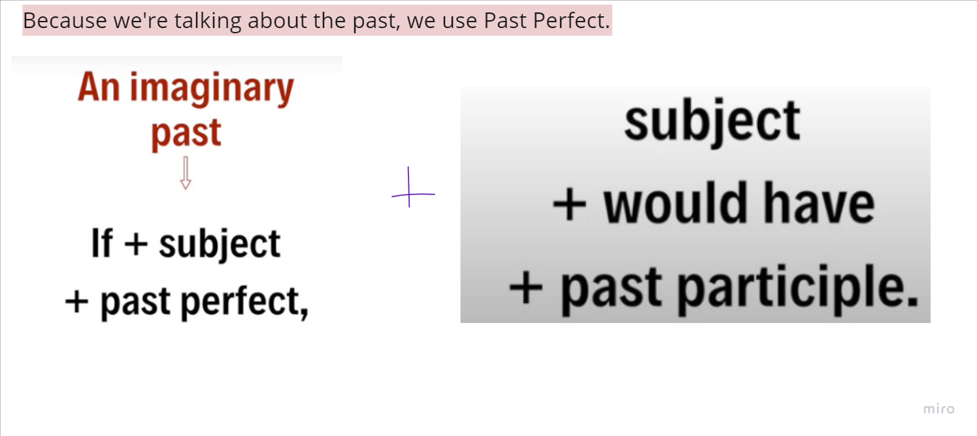
the third conditional structure is:

If + past perfect + would/could/might + have + past participle

(or reversed)

Meaning: This structure expresses hypothetical past situations and their imagined consequences.

- These events didn't actually happen
- We're imagining alternative scenarios
- The consequences are imagined results
