DEMO
Task 1. Match the dish with the country:
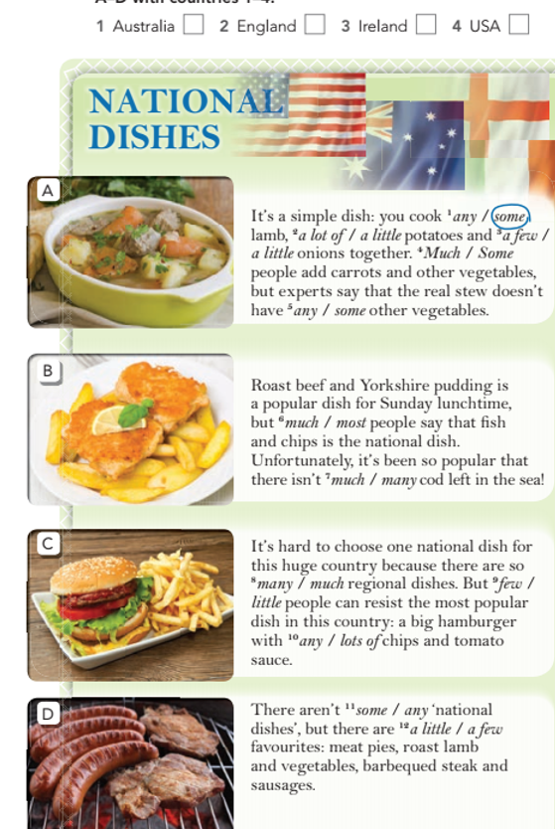

Task 2
Read the texts again. Choose the correct quantifier:

some

Task 3
