Practical Seminar 2: Military Terminology

4. Translate the following sentences into English.
Верховна Рада ухвалила законопроект, який запроваджує в Україні нові військові звання вищого офіцерського складу відповідно до військових звань НАТО. Його у другому читанні та в цілому підтримав 291 народний депутат.
3 переліку звань Збройних сил зникнуть генерал-полковник і генерал армії України: першого називатимуть просто генерал, а друге звання зникне з переліку зовсім. Водночас звання генерал-майор і генерал-лейтенант будуть збережені. У вищого офіцерського складу зʼявиться звання бригадний генерал та коммодор. У Військово-морських силах звання бригадного генерала відповідатиме чину командор-адмірала.
Військові звання генерал армії України, генерал-майор, контр-адмірал, генерал-лейтенант, віцеадмірал, генерал-полковник та адмірал, присвоєні до набуття чинності цього закону, зберігаються за військовослужбовцями та звільненими з військової служби в запас або у відставку.
На початку листопада у ЗСУ вже вносили зміни до військових звань і поділу сержантського та старшинського складу. Тоді замість прапорщика і старшого прапорщика зʼявилися штаб-сержант та майстер-сержант. Замість старшини - головний сержант.
Рядового замінили на солдата. Також зʼявилося нове звання - рекрут. Воно стосується людей, які проходять випробувальний термін на військовій службі за контрактом, до прийняття присяги. У корабельних званнях мічмана замінили на штаб-старшину, а старшого мічмана на старшого майстер-старшину. Крім того, передбачається поділ сержантського та старшинського складу на молодший і старший склади. А назву полк змінили на бригаду, відтак командир полку став командиром бригади.

- Content Study
1. Read the following sentences and expand the idea.
- "In the United States, the army represents not just a force of defense, but a complex symbol of freedom, sacrifice, and sometimes controversial global intervention."
- "The American military's immense budget and advanced technology provoke questions about the balance between national security and domestic needs."
- "The legacy of the U.S. army is a tapestry of heroic triumphs and morally ambiguous conflicts, each shaping the nation's identity and foreign policy."
- "Despite technological advancements, the heart of the U.S. army remains the individual soldier, whose sacrifices are often hidden behind the veil of geopolitics."
- "The British Army, steeped in centuries of tradition, reflects a paradox of maintaining imperial legacies while adapting to modern ethical standards."
- "From colonial conquests to peacekeeping missions, the British Army's role has evolved, prompting reflection on its changing identity and global impact."
- "As the UK navigates a post-Brexit world, the future role of the British Army in Europe and beyond is a subject of intense debate and uncertainty."
- "The British Army's storied past is a reminder of the enduring influence of military power on national pride and international relations."
- "In Ukraine, the army symbolizes a nation’s resilience and determination to uphold sovereignty in the face of external aggression."
- "The ongoing conflict in Eastern Ukraine casts the military not just as a defender of borders, but as a bulwark of national identity against foreign influence."
- "The transformation of Ukraine’s military from a Soviet legacy force to a modern, Western-aligned entity reflects the country’s broader aspirations and challenges."

2. Explain the difference between:
1. Explain the difference between a Private and a Corporal.
- Discuss the roles, responsibilities, and rank insignia of a Private compared to a Corporal.
2. Explain the difference between a Sergeant and a Staff Sergeant.
- Highlight the distinctions in duties, leadership expectations, and progression to these ranks.
3. Explain the difference between a Lieutenant and a Captain.
- Compare the command responsibilities, scope of authority, and insignia for a Lieutenant and a Captain.
4. Explain the difference between a Major and a Lieutenant Colonel.
- Detail the differences in command level, administrative duties, and rank insignia.
5. Explain the difference between a Colonel and a Brigadier General.
- Discuss the transition from senior officer to general officer, including changes in responsibility and authority.
6. Explain the difference between a Warrant Officer and a Commissioned Officer.
- Compare their roles, training, and the differences in their paths within the army hierarchy.
7. Explain the difference between an Enlisted Soldier and a Non-Commissioned Officer (NCO).
- Describe the distinctions in roles, leadership expectations, and career progression.
8. Explain the difference between a General and a Field Marshal.
- Highlight the distinctions in strategic roles, command levels, and the historical context of these ranks.
9. Explain the difference between a Specialist and a Sergeant.
- Discuss the differences in job specialization, leadership roles, and rank insignia.
10. Explain the difference between a First Lieutenant and a Second Lieutenant.
- Compare their responsibilities, command roles, and the significance of their rank in the officer hierarchy.

Read the following text.
CORPORALS
WHERE NCO LEADERSHIP BEGINS
By Staff Sgt. David Abrams
Senior Journalist, NCO Journal
Originally published in the Summer 1995 edition

Talk to most corporals today about pulling rank and they might tell you they’re like half-powered Supermen: faster than a speeding specialist, but not able to leap tall sergeants in a single bound. The modern corporal inhabits a kind of “no man’s land” in the noncommissioned officer chain: no longer a private, but not quite a sergeant. While the hard stripes are still hardening, so are these new NCOs.
Time was, however, when the “Big C” was the Man to all those privates in his squad and under his supervision. With more recognized authority, the corporal was the one-man buffer zone between the legendary Private Snuffys and Sergeant Rocks. He was the spout at the bottom of the funnel in line units, nearly all junior enlisted soldiers channeled their grievances through the guy with two stripes on his collar. Just as the rest of the Army has transitioned from Old to New, the “taproots” of the NCO tree have also grown.
To find some of the first corporals, we have to turn back several pages in the military history books. The English adopted the rank of corporal from the French who, in turn, got it from either the Italians or the Spanish. The term caporale is of Italian original cabo de esquadra, or “chief of the squad,” comes from the Spanish. Corporals had been a permanent part of the military structure in the French Army since the mid-1500s where, along with sergeants, they taught daily drill in marches and countermarches. Later in that century, corporals began to appear in the ranks of the English county militia where they commanded 25-man squads.
According to Johann von Wallhausen, a professional soldier of the early 17th century, the corporal was like a hausvater (“father of the family”) to his men, maintaining peace and friendship with his soldiers and ensuring all soldiers in the squad had ammunition and rations. In his book Guardians of the Republic, Ernest E. Fisher Jr. says the 17th-century corporal “became a sort of middle class in the command structure of all Western armies, both professional and militia.”
In America’s early years, corporals occupied similar roles in the military middle class, working as the first-line NCOs in the Continental Army. In 1813, William Duane’s A Hand Book for Infantry noted that corporals were to keep duty and detail rosters, help train recruits in the manual of arms and show them how to care for arms and ammunition. At tattoo, both sergeants and corporals called the roll and posted guard.
In the era surrounding the War of 1812, the lines of authority between junior NCOs started to blur, with sergeants frequently assuming the role of squad leader, making corporals assistant squad leaders. At the time, sergeants were given the monthly salary of $11, while corporals pocketed $10.
Fifty years later, Gen. Silas Casey’s Infantry Tactics changed the tactical formation of Army units and gave control of the squad back to the corporal. During the Civil War, corporals served as color guards — one of the most dangerous positions on the battlefield.
In World War I, corporals often found themselves in command of their platoons after the commanders and platoon sergeants had been killed or gravely injured. For their demonstrated bravery and leadership, several corporals received Medals of Honor, including Alvin York who was with the 82nd Division when he charged an enemy gun position and took more than 120 enemy soldiers prisoner. Another contemporary corporal of York’s, Frank Dillman of the 7th Division, found himself the senior NCO in his unit and later boasted, “I felt pretty important with a whole platoon on my hands.”
Several decades later, during World War II, the eight-man squad increased to a 12-man squad and the squad leader was elevated to the rank of sergeant, with corporals once again serving as second fiddle in the squad structure.
These years also saw a steady inflation in the NCO ranks. In December 1941, only 20% of the enlisted ranks were NCOs; but by June 1945, that proportion had swelled to nearly 50%. In time, the power of corporals in line units lessened, even though the corporal was, in theory and by tradition, a combat leader. With so many privates receiving promotions in the European and Pacific theaters, it was a case of “corporal overload.”
During both the Korean and Vietnam conflicts, the corporal found himself thrust to the front of the battle. Terrain and tactics dictated that most battles be fought through small unit operations. As squad leaders, corporals guided their men through the treacherous battlefields.
Today, corporals may not always leap over tall sergeants in a single bound, but throughout history, the Army has needed corporals who have taken the first step up the NCO staircase of rank. Both war and peace have proved the importance of junior NCOs–the ones who tend their squads as fathers (and mothers) tend their children.

4. Answer the following questions:
- What role did corporals historically play in the early military structures, according to the text?
- How did the authority and responsibilities of corporals change over time in the American military?
- Describe the origins of the rank of corporal as discussed in the text.
- What specific duties did corporals have during the Civil War, according to the text?
- How did World War I impact the role and responsibilities of corporals?
- What challenges did corporals face during World War II, and how did their roles evolve?
- How did the proportion of NCOs change in the military from 1941 to 1945, and what impact did this have on corporals?
- What were the primary duties of corporals during the Korean and Vietnam conflicts?
- How has the role of corporals evolved in modern times compared to their historical roles?
- What is the significance of corporals in both wartime and peacetime, according to the text?

- Use the following vocabulary items from the text above to talk about military ranks, units, and structure.
- a buffer zone
- to pull rank
- to turn back
- a military structure
- a daily drill in marches and countermarches
- to appear in the ranks
- to keep duty
- to train recruits
- to care for arms and ammunition
- to serve as
- a battlefield
- gravely injured
- a steady inflation in smth
- in theory
- by tradition
- a promotion
- war and peace

- Give the English equivalents.
- буферна зона
- війна та мир
- військова структура
- навчати новобранців
- доглядати за зброєю та боєприпасами
- служити як
- за традицією
- тяжко поранений
- стабільна інфляція
- в теорії
- повернути назад
- підвищення
- поле бою
- виконувати обов'язки
- служити
- використовувати службове становище
- щоденне навчанн в маршах і контрмаршах

- Fill in the blanks using the vocabulary items mentioned above.

The Forgotten Buffer Zone
(1) In a land where war and peace were constant bedfellows, a ___________________ lay between two warring factions, a strip of desolate land meant to keep the fighting at bay. By tradition, this buffer zone served as a neutral territory where neither side dared to tread, except for the occasional foray by scouts or emissaries.
(2) The buffer zone was overseen by a military structure, an old fort that had seen better days. Major Henry Thatcher was the commanding officer, a man who knew how to _________________ but preferred to lead by example. (3) He often ________________________, a reassuring presence among his men. (4) He was a stickler for discipline and ensured that __________________________ were carried out without fail.
Each morning, the soldiers would march up and down the dusty parade ground, their boots kicking up clouds of red earth. The men grumbled but complied, for they knew that Major Thatcher would brook no dissent. (5) His motto was simple: _____________________ was to keep honor. (6)(7) Every soldier was expected to ________________________, _____________________, and be prepared for the day when they might be called upon to turn back an enemy advance.
One evening, as the sun dipped below the horizon, casting long shadows across the buffer zone, Major Thatcher received word of a promotion. He was to be elevated to the rank of Colonel, a reward for his steadfast service. The news was bittersweet, for it meant he would leave behind the men he had trained and the fort he had come to regard as home.
(8) But fate had other plans. That very night, the enemy launched a surprise attack, breaching the buffer zone and turning the ________________________ into a scene of chaos. (9) Major Thatcher, ___________________________ in the initial onslaught, refused to be evacuated. He insisted on staying with his men, pulling rank only to ensure that the wounded were cared for first.

In the heat of battle, it was hard to tell friend from foe. The air was thick with the acrid smell of gunpowder and the cries of the wounded. Yet, amid the confusion, a strange calm settled over Major Thatcher. (10) _____________________, the buffer zone was meant to prevent such bloodshed, but the reality was far more brutal. He realized that the buffer zone was merely a thin line drawn on a map, easily crossed by those with a mind for conquest.
As the enemy forces began to retreat, Major Thatcher's men rallied, pushing them back across the buffer zone. The battle was won, but the cost was high. A steady inflation in casualties left many questioning the value of such conflicts. (11) Major Thatcher, now confined to a hospital bed, wondered if his ______________________ was worth the lives lost. He had served his duty, but at what price?
(12) _____________________, a hero's actions on the battlefield were celebrated, but Major Thatcher found little solace in his newfound rank. (13) _________________________, he mused, were two sides of the same coin, forever in flux. He had played his part, but the buffer zone remained, a stark reminder of the fragile line between conflict and harmony.

- You are going to read an article about the U.S. Military Units. Try to guess an answer to the following questions:
- What are the primary functions of military units?
- What are the different types of military units?
- How are military units typically organized?
- What roles do specific ranks play within a military unit?
- How has the organization of military units evolved over time?
- What is the significance of unit cohesion and morale?
- What training do military units undergo to prepare for their roles?
- How do military units operate in different environments (e.g., urban, desert, jungle)?
- What historical battles or conflicts have prominently featured specific military units?
- What technology or equipment is typically used by various military units?
- How do different countries organize their military units?
- What are the roles and responsibilities of a unit commander?
- How do military units coordinate with each other during operations?
- What are some famous military units and their accomplishments?
- How do military units adapt to modern warfare and emerging threats?
- What are the logistical challenges faced by military units?
- What is the role of specialized units (e.g., special forces, medical units)?
- How do military units maintain discipline and order?
- What are the ethical and legal considerations for military units during combat?
- What impact do military units have on civilian populations during deployments?

- Read the article and learn about the U.S. Military Units.

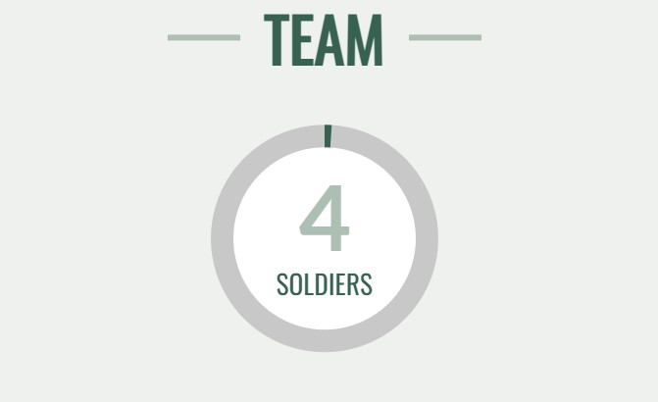

Four soldiers make up a team — a noncommissioned officer and three junior enlisted soldiers. Teams with special functions may also include officers or warrant officers. An infantry fire team might include two riflemen, one of whom is the team leader; a grenadier and an automatic rifleman, who is used when small reconnaissance or special missions are required. Teams can serve as a base-of-fire or as a maneuver element.

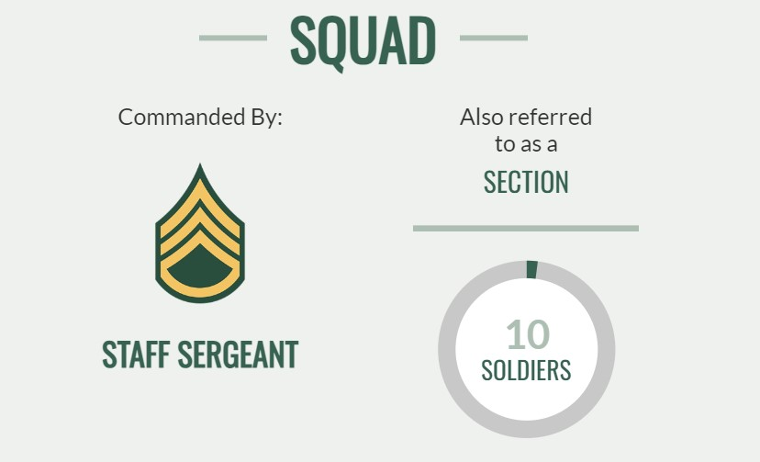

Two teams make up a squad, which has four to 10 soldiers. In an infantry squad, the teams divide duties: one serves as a base-of-fire element, while the other serves as the maneuver element. A staff sergeant is often in charge.

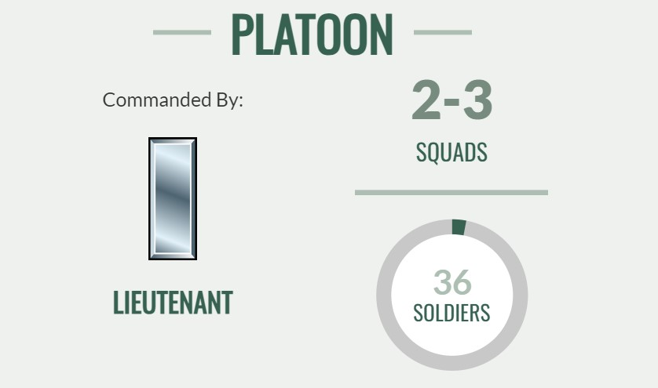

A platoon consists of a few squads and up to a few dozen soldiers. They’re generally run by a lieutenant, often with a noncommissioned officer as second in command. An infantry platoon might include a weapons squad, which is divided into two M240 machine gun teams, and two close-combat missile teams armed with Javelin missiles.

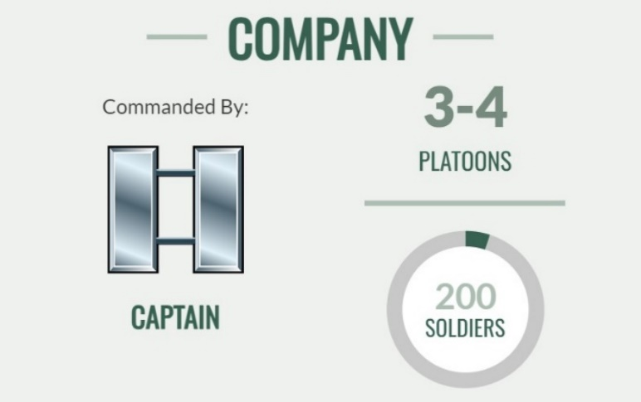

A company has anywhere from a few dozen to 200 soldiers. It’s a tactical-sized unit that can perform a battlefield function on its own. A company consists of three or four platoons and is generally commanded by a captain. It can also go by different names, depending on the function: Company-sized artillery units are called batteries, while in armor and air cavalry units, they are called troops.

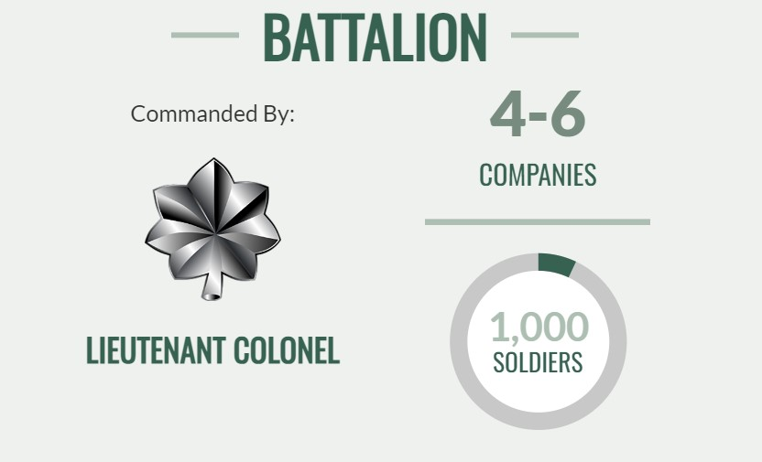

Battalions consist of four to six companies and can include up to about 1,000 soldiers. They can conduct independent operations of limited scope and duration and are usually commanded by a lieutenant colonel. There are combat arms battalions, as well as combat support and combat service support battalions. An armor or air cavalry unit of equivalent size is known as a squadron.

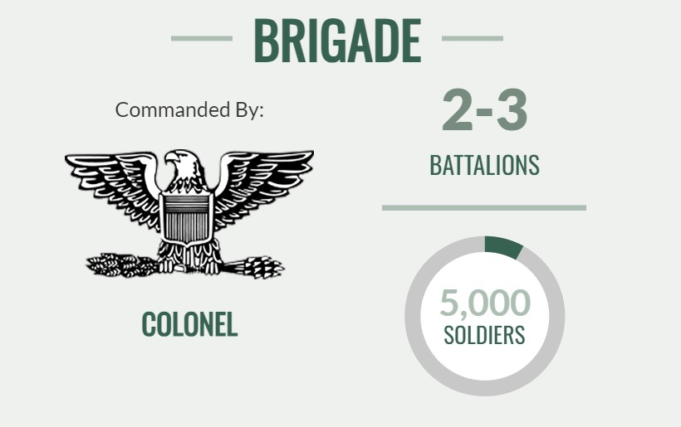

A brigade consists of a few battalions and anywhere from 3,000 to 5,000 soldiers. A colonel is generally in command. For historical reasons, armor and Ranger units of brigade size are called regiments, and the equivalent Special Forces units are called groups. In 2016, the Army reorganized its brigades into brigade combat teams, which are autonomous modular brigades that most commonly include one combat arms brigade and its assigned support and fire units.

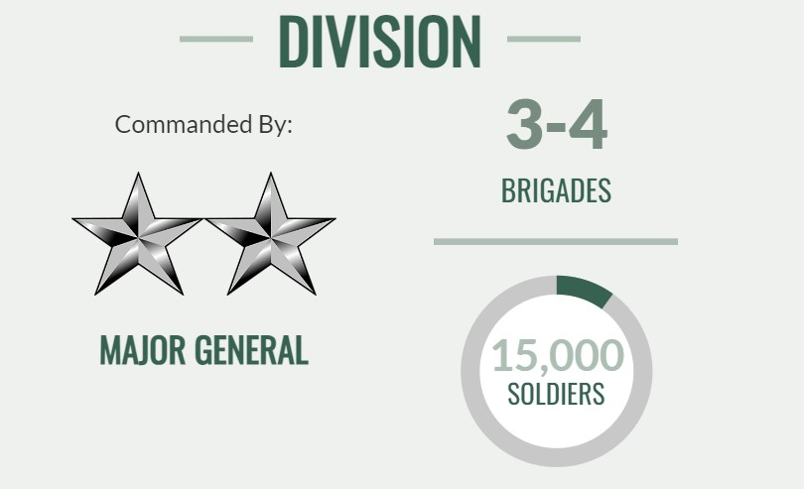

Usually commanded by a major general, divisions are made up of three or four brigades and include 10,000 to 15,000 soldiers. Current divisions include airborne, armored, infantry and mountain divisions. Each can conduct major tactical operations and sustained battlefield operations. They are numbered and assigned missions based on their structures.

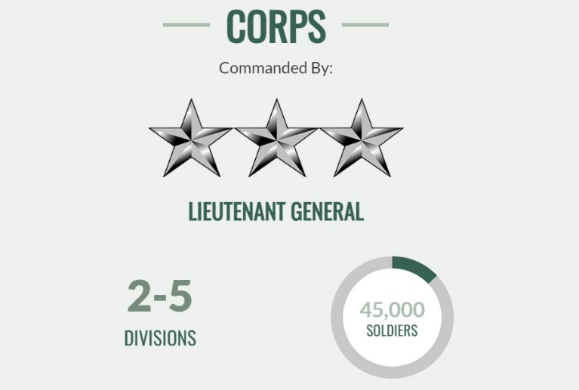

A corps includes two to five divisions with anywhere between 20,000 and 45,000 soldiers. A lieutenant general is in command. The corps is the highest level of command that can provide operational direction for actual combat. Higher levels are concerned with administration rather than operations. The current active corps are I Corps at Fort Lewis, Washington; III Corps at Fort Hood, Texas; and XVIII Airborne Corps at Fort Bragg, North Carolina.
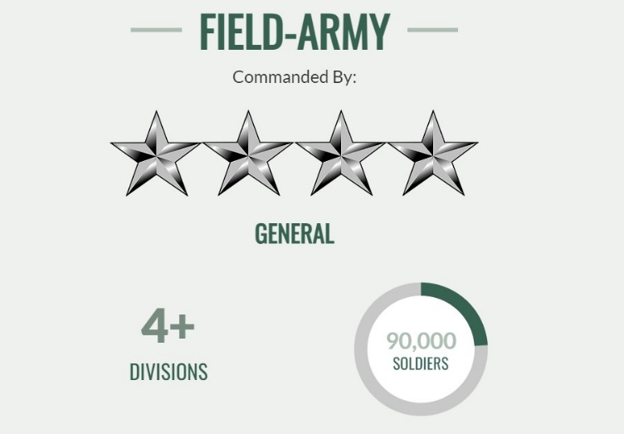

A field army consists of two or more corps and is run by a general or lieutenant general. First Army serves as a mobilization, readiness and training command; Third Army, or U.S. Army Central, commands all Army forces for U.S. Central Command; Fifth Army, or U.S. Army North, commands all Army forces for U.S. Northern Command; Sixth Army, or U.S. Army South, commands all Army forces for U.S. Southern Command; Seventh Army, or U.S. Army Europe, commands all Army forces for U.S. European Command; Eighth Army commands all U.S. Army forces in South Korea; and Ninth Army, or U.S. Army Africa, commands all Army forces for U.S. Africa Command.

- Fill in the gaps with the appropriate military unit:
- __________ is typically commanded by a brigadier general and consists of several battalions.
- __________ consists of multiple platoons led by a captain.
- __________ is commanded by a lieutenant colonel and composed of several companies.
- __________ is the smallest unit, usually consisting of 8-12 soldiers.
- __________ comprises multiple divisions and is commanded by a lieutenant general.
- __________ consists of multiple corps and is commanded by a general.
- __________ comprises multiple brigades and is commanded by a major general.
- __________ comprises multiple squads, usually commanded by a lieutenant.

- Division
- Battalion
- Corps
- Brigade
- Platoon
- Company
- Squad
- Army

B. Writing Practice
Write a descriptive essay on the topics suggested. Mind the scheme given below.
Descriptive essay is designed for describing details of the subject. It can be written about any object and its features. You are to describe the way it looks, smells or works. It can be compared with a detailed overview of the things you write about. In this type of essay, every detail counts.
1. Introduction
- Hook: Start with a compelling opening sentence that grabs the reader’s attention. This could be a startling fact, an intriguing quote, or a vivid description.
- Context: Provide some background information or context to set the scene for what you will be describing.
- Thesis Statement: Clearly state the subject of your essay and the main impression or feeling you want to convey about it.
2. Body Paragraphs
- Topic Sentence: Begin each paragraph with a sentence that introduces the main idea or focus of that paragraph.
- Sensory Details: Use vivid and specific sensory details to describe the subject. Incorporate descriptions related to sight, sound, smell, taste, and touch to create a full picture.
- Organization: Organize your details in a logical order. This could be spatial (describing from one location to another), chronological (describing events in the order they occurred), or by importance.
- Examples and Analogies: Use examples, comparisons, and analogies to make the description clearer and more relatable to the reader.
- Show, Don’t Tell: Instead of merely stating facts, show the reader what you mean through detailed and evocative descriptions.
3. Conclusion
- Summarize the Main Points: Briefly recap the key details and ideas you’ve described in the body paragraphs.
- Reflect on the Significance: Reflect on the overall significance of the subject and what it means to you or its impact.
- Closing Thought: End with a final thought, image, or insight that leaves a lasting impression on the reader.

TOPICS:
1. Evolution of Military Ranks and Units Over Time
Explore how military ranks and units have evolved from ancient times to the present, focusing on key changes and their impact on military organization and effectiveness.
2. Comparative Analysis of Military Rank Structures Across Nations
Compare and contrast the military rank structures of different countries, such as the U.S., Ukraine, Germany, and the UK, highlighting similarities and differences in hierarchy and roles.
3. The Role of Non-Commissioned Officers (NCOs) in Modern Militaries
Discuss the importance of NCOs in maintaining discipline, training soldiers, and leading units, and how their roles have evolved over time.
4. The Impact of Technology on Military Units and Ranks
Examine how advancements in technology, such as drones, cyber warfare, and precision weaponry, have influenced the structure and roles within military units.
5. Military Units and Their Strategic Functions
Analyze different types of military units (e.g., infantry, cavalry, artillery, special forces) and their specific roles in various military operations and strategies.
6. Women in Military Ranks and Units
Explore the historical and current roles of women in the military, discussing progress, challenges, and the impact of their inclusion in combat and leadership positions.
7. Rank Insignia and Symbols: Their Meaning and Significance
Investigate the symbolism and history behind different military rank insignia, exploring how they represent hierarchy, tradition, and identity within the armed forces.
8. Leadership and Decision-Making in Military Units
Discuss how leadership within military units is structured, the role of various ranks in decision-making processes, and the impact of leadership on unit effectiveness and morale.
9. The Role of Reserve and National Guard Units
Examine the functions, importance, and challenges of reserve and national guard units in modern military organizations, including their roles in both peacetime and wartime.
10. The Influence of Military Culture on Rank and Unit Cohesion
Analyze how military culture shapes the dynamics of rank and unit cohesion, including traditions, discipline, and the concept of camaraderie among soldiers.
11. The Impact of Rank on Military Career Progression
Explore how military rank affects career advancement, opportunities, and responsibilities within the armed forces, and how this impacts individuals’ career trajectories.
12. Historical Case Studies of Military Units in Key Battles
Present case studies of specific military units that played crucial roles in significant historical battles, examining their composition, strategies, and outcomes.
13. The Evolution of Special Forces Units
Discuss the development and role of special forces units in modern militaries, including their specialized training, missions, and impact on contemporary warfare.
14. Integration of Multinational Military Units in Peacekeeping Missions
Explore the challenges and benefits of integrating multinational military units in peacekeeping missions, focusing on issues of coordination, command, and cultural differences.
15. The Impact of Military Rank and Unit Structure on Civilian-Military Relations
Analyze how military rank and unit structures influence civilian-military relations, including public perception, accountability, and the integration of military personnel into civilian society.

Read the article and learn about the Military Structure.
The U.S. military is a complex organization with various branches, specialized units, and support elements working together to ensure national defense and security. This structure ensures that the U.S. military can respond effectively to a wide range of challenges, from conventional warfare to humanitarian missions.

Military Structure:
  - Branches of the Military: Army, Navy, Air Force, Marines (in some countries).
  - Special Forces: Elite units trained for unconventional warfare and special operations.
  - Support Units: Provide logistics, medical, engineering, and administrative support to combat units.
  - Joint Commands: Coordinate operations across different branches of the military.
  - Military Districts/Regions: Administrative divisions responsible for specific geographical areas.
  - Headquarters: The command center is responsible for strategic planning, policy-making, and coordination.

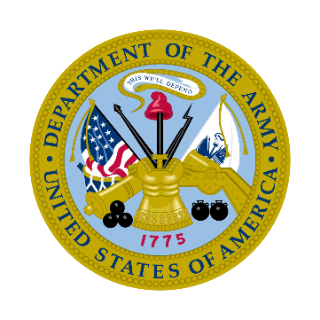
1. Branches of the Military
- Army:
The largest and oldest service in the U.S. military, the Army provides
the ground forces that protect the United States.
  - Mission: Ground-based military operations.
  - Components: Active Army, Army Reserve, and Army National Guard.
  - Key Units: Infantry, armor, artillery, aviation, and support units.
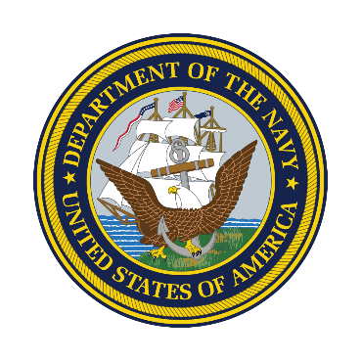
- Navy:
On, above and below the water, the Navy is America's forward-deployed
force and is a major deterrent to aggression around the world.
  - Mission: Maritime operations, power projection, and maintaining
freedom of the seas.
  - Components: Active Navy, Navy Reserve.
  - Key Units: Surface ships, submarines, aviation, and the Marine Corps.

- Air Force:
The Air Force provides a rapid, flexible, and lethal air and space capability
that can deliver forces anywhere in the world within hours.
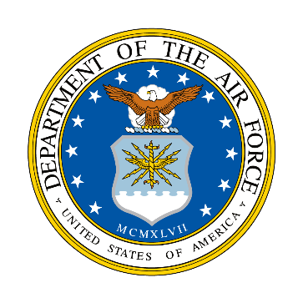
  - Mission: Air and space superiority, rapid global mobility, and strategic
  - deterrence.
  - Components: Active Air Force, Air Force Reserve, and Air National
  - Guard.
  - Key Units: Fighter, bomber, reconnaissance, and airlift squadrons.
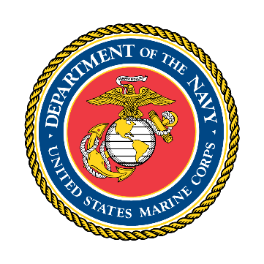
- Marine Corps:
A component of the Department of the Navy, the Marine Corps
maintains amphibious and ground units for contingency and combat
operations.
  - Mission: Rapid response force, specializing in amphibious operations.
  - Components: Active Marine Corps, Marine Corps Reserve.
  - Key Units: Infantry, aviation, and logistics units.
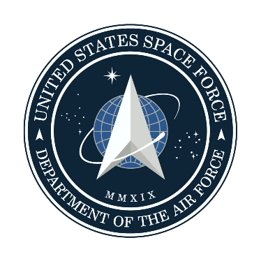
- Space Force:
The Space Force organizes, trains, and equips space forces in order to
protect U.S. and allied interests in space and to provide space capabilities
to the joint force.
  - Mission: Protecting U.S. interests in space.
  - Components: Active Space Force.
  - Key Units: Space operations squadrons, satellite control, and

space-based missile defense.

- Coast Guard:
The Coast Guard provides law and maritime safety enforcement, marine
and environmental protection and military naval support. Part of the
Department of Homeland Security during peacetime, the Coast Guard
operates under the Navy during times of war.
  - Mission: Maritime security, search and rescue, and law enforcement.
  - Components: Active Coast Guard, Coast Guard Reserve.
  - Key Units: Cutters, small boats, and aircraft.

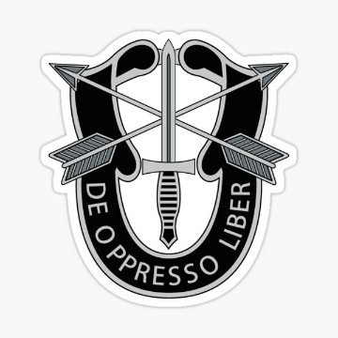
2. Army Special Forces (Green Berets):
The U.S. Army Special Forces, commonly known as the Green
Berets, are elite, highly trained units specializing in unconventional
warfare, foreign internal defense, direct action, counter-insurgency,
special reconnaissance, and counter-terrorism. They are part of the
United States Army Special Operations Command (USASOC).
  - Focus: Unconventional warfare, foreign internal defense, direct
action, and counterterrorism.
  - Notable Units: 1st Special Forces Group, 5th Special Forces Group.

3. Support Units

Army support units play a crucial role in ensuring that combat forces can effectively perform their missions by providing essential services and logistical support. These units are varied and specialized, covering a wide range of functions necessary for the operation and sustainability of an army.
- Logistics:
Mission: Supply chain management, transportation, and distribution of equipment and supplies.
- Medical:
Mission: Providing medical care and support to troops.
- Engineering:
Mission: Combat engineering, construction, and infrastructure support.
- Administrative:
Mission: Personnel management, finance, legal, and administrative support.

4. Joint Commands

Army Joint Commands are specialized units or organizational structures designed to integrate different branches of the military—such as the Army, Navy, Air Force, and sometimes the Marine Corps or Coast Guard—to conduct operations more effectively. These commands are pivotal for ensuring interoperability and unified action across diverse military forces.
Importance of Army Joint Commands
- Operational Effectiveness: Joint commands enhance the military’s ability to conduct complex, multi-faceted operations by integrating capabilities from different branches.
- Resource Efficiency: By pooling resources and expertise, joint commands ensure more efficient use of military assets.
- Strategic Flexibility: They provide the flexibility needed to respond to a wide range of scenarios, from combat to humanitarian missions.
- Interoperability: Joint commands foster better interoperability and communication among the different service branches, crucial for effective modern military operations.

5. Military Districts/Regions
Military districts or regions are significant organizational structures within armed forces, designed to streamline command and control over large geographic areas. They serve several purposes, including territorial defense, administration, training, and logistical support. These districts or regions can vary significantly between different countries in terms of their structure, size, and responsibilities.
Historically, military districts have been used to maintain order and ensure the effective governance of vast territories. For instance, during the Roman Empire, provinces were managed by military governors who had both civil and military authority. In more modern times, military districts have been crucial during major conflicts, such as World War II, where they helped organize and deploy large numbers of troops across various fronts.
Military districts or regions are essential for the efficient management of military forces across large geographic areas. They provide a framework for command and control, logistical support, and readiness, ensuring that a country’s armed forces can respond effectively to both national and international threats. Each country adapts its military district structure to fit its specific needs and strategic goals, reflecting its unique geopolitical situation and military doctrine.
The U.S. is divided into several regions for administrative and operational purposes, often aligning with major commands and joint task forces.
- Army Service Component Commands (ASCCs):
Oversee Army operations in different regions.
- Naval Regions:
Handle naval activities and support in specific geographic areas.
- Air Force Major Commands (MAJCOMs):
Responsible for organizing, training, and equipping forces for various regions.
- Marine Corps Installations:
Oversee bases and support functions in specific areas.

6. Headquarters

A military headquarters is a command center where senior military leaders and their staff coordinate operations, manage logistics, and communicate orders to units in the field. These headquarters are critical for strategic planning and control across various military operations.

Military headquarters have evolved significantly over time, from rudimentary command centers in ancient armies to sophisticated, technology-driven hubs in modern military forces. Key historical examples include:
- Napoleon’s Grande Armée Headquarters: Pioneered centralized command and control.
- Allied Headquarters in World War II: Integrated joint and combined operations across multiple nations and services.

Modern military headquarters leverage advanced technology for real-time communication, data analysis, and decision support, enabling rapid and effective response to dynamic operational environments.

Key Functions of Military Headquarters:
- Command and Control: Direct military operations and maintain control over forces.
- Planning and Strategy: Develop and implement strategic plans and operational directives.
- Intelligence: Gather and analyze intelligence to inform decision-making.
- Logistics: Manage supply chains, equipment, and personnel movements.
- Communications: Ensure secure and reliable communication channels for command and control.
- Coordination: Coordinate efforts between different units and branches of the military.

Examples of Army Military Headquarters:
- The Pentagon (USA)

Location: Arlington, Virginia

Function: The Pentagon serves as the headquarters of the United States Department of Defense. It is one of the largest office buildings in the world and coordinates the activities of all branches of the U.S. military, including the Army.
- Heeresführungskommando (Germany)

Location: Strausberg, Brandenburg

Function: This is the main command center for the German Army (Heer), responsible for operational command and control of land forces.

5. Choose the correct answer.

- Which branch of the U.S. military is the largest and oldest?
A) Navy
B) Air Force
C) Army
D) Marine Corps

- What is the primary mission of the U.S. Navy?
A) Ground-based military operations
B) Maritime operations and maintaining freedom of the seas
C) Rapid global mobility
D) Amphibious operations

- Which component is NOT part of the Air Force?
A) Active Air Force
B) Air Force Reserve
C) Air National Guard
D) Navy Reserve

- What is the mission of the Marine Corps?
A) Space operations
B) Amphibious and ground combat operations
C) Maritime security
D) Air superiority

- Which branch of the military is responsible for space-based missile defense?
A) Coast Guard
B) Navy
C) Space Force
D) Air Force

- During peacetime, which department oversees the Coast Guard?
A) Department of Defense
B) Department of the Navy
C) Department of Homeland Security
D) Department of State

- What are the U.S. Army Special Forces commonly known as?
A) Navy SEALs
B) Green Berets
C) Delta Force
D) Rangers

- Which of the following is NOT a focus area for the Green Berets?
A) Unconventional warfare
B) Maritime security
C) Counter-terrorism
D) Foreign internal defense

- Which is a notable unit of the Army Special Forces?
A) 101st Airborne Division
B) 1st Special Forces Group
C) 82nd Airborne Division
D) 75th Ranger Regiment

- What is the primary mission of logistics units in the Army?
A) Combat operations
B) Medical support
C) Supply chain management
D) Intelligence gathering

- Which unit provides medical care and support to troops?
A) Infantry
B) Logistics
C) Engineering
D) Medical

- What is the role of Army engineering units?
A) Personnel management
B) Supply distribution
C) Combat engineering and construction
D) Maritime operations

- Which of the following is a benefit of Army Joint Commands?
A) Exclusive operations by one branch
B) Limited resource use
C) Enhanced operational effectiveness and interoperability
D) Increased independence of service branches

- What does the term "interoperability" refer to in the context of joint commands?
A) Separation of military branches
B) Independent operations
C) Better communication and coordination among different branches
D) Limited flexibility in operations

- What is NOT a key benefit of joint commands?
A) Strategic flexibility
B) Resource efficiency
C) Inflexibility in military operations
D) Enhanced interoperability

- What is the main purpose of military districts or regions?
A) Individual branch operations
B) Streamlined command and control over large geographic areas
C) Limited regional activities
D) Single-unit command

- Which of the following is an example of an Army Service Component Command (ASCC)?
A) Naval Regions
B) Air Force Major Commands (MAJCOMs)
C) Marine Corps Installations
D) Army operations in different regions

- What is the role of the Air Force Major Commands (MAJCOMs)?
A) Overseeing naval activities
B) Organizing, training, and equipping forces for various regions
C) Managing Marine Corps bases
D) Coordinating with the Department of Homeland Security

- What is a primary function of military headquarters?
A) Combat operations
B) Command and control
C) Individual unit training
D) Basic training

- Which of the following was a historical example of a military headquarters?
A) Pentagon during World War II
B) Napoleon’s Grande Armée Headquarters
C) Air Force Major Commands
D) Naval Regions

- What does modern military headquarters leverage for effective operations?
A) Traditional command methods
B) Advanced technology for real-time communication and data analysis
C) Limited strategic planning
D) Independent unit operations

- Where is the Pentagon located?
A) New York, New York
B) Washington, D.C.
C) Arlington, Virginia
D) Los Angeles, California

- Which country’s main command center for its army is the Heeresführungskommando?
A) United States
B) United Kingdom
C) France
D) Germany

- Which is NOT a key function of a military headquarters?
A) Command and control
B) Intelligence gathering
C) Individual combat operations
D) Strategic planning

- Which historical example integrated joint and combined operations across multiple nations?
A) Pentagon during World War I
B) Allied Headquarters in World War II
C) Napoleon’s Grande Armée Headquarters
D) Heeresführungskommando in modern Germany

