Lecture 5. Introduction to Agile Project Management

1. Introduction to Agile. Agile Manifesto
2. Differences between Waterfall and Agile Methods
3. Adopting and Creating an Agile Environment
4. The Elements of an Agile Environment [Oguz]

1. Introduction to Agile
1980s and 1990s were the years software development teams started to have serious problems with developing and finishing their software projects which were getting more complex with more computer power and digitalization of businesses and organizations. Project managers and developers faced more and more problems when they were using the traditional waterfall approach. The development of software necessitated more collaboration among the project manager, developers, testers and users, and constant feedback from the users. Besides, new requirements were emerging while the software was being developed, and the client and end users were not always happy with the final product when they had the chance to see it after some time passed. Therefore, new methods started to emerge among software developers who lead that type of projects. Lean methodology created by Toyota for their production system, and utilized by many manufacturers was an inspiration for many of these software developers. In addition to the lean manufacturing process, Just-In-Time process (JIT) and Total Quality Management (TQM) movement were other influencers of Agile Project Management. Furthermore, Kanban which is a process improvement method in manufacturing was adapted to the software development life cycle.
As indicated above, new methods began to emerge in the 1980s and mostly in the 1990s as a response to some of the challenges that developers faced when using a waterfall approach.
One of the first to become popular was Rapid Application Development (RAD). James Martin, an IT consultant, developed an approach through which he divided the process into four distinct phases (Figure 1), namely, (1) requirements planning phase, (2) user design phase, (3) construction phase, and (4) cutover phase.
It involved creating prototypes and using them to elicit requirements, validate designs and evolve toward usable solutions. RAD, itself, led to the development of alternative approaches as well.
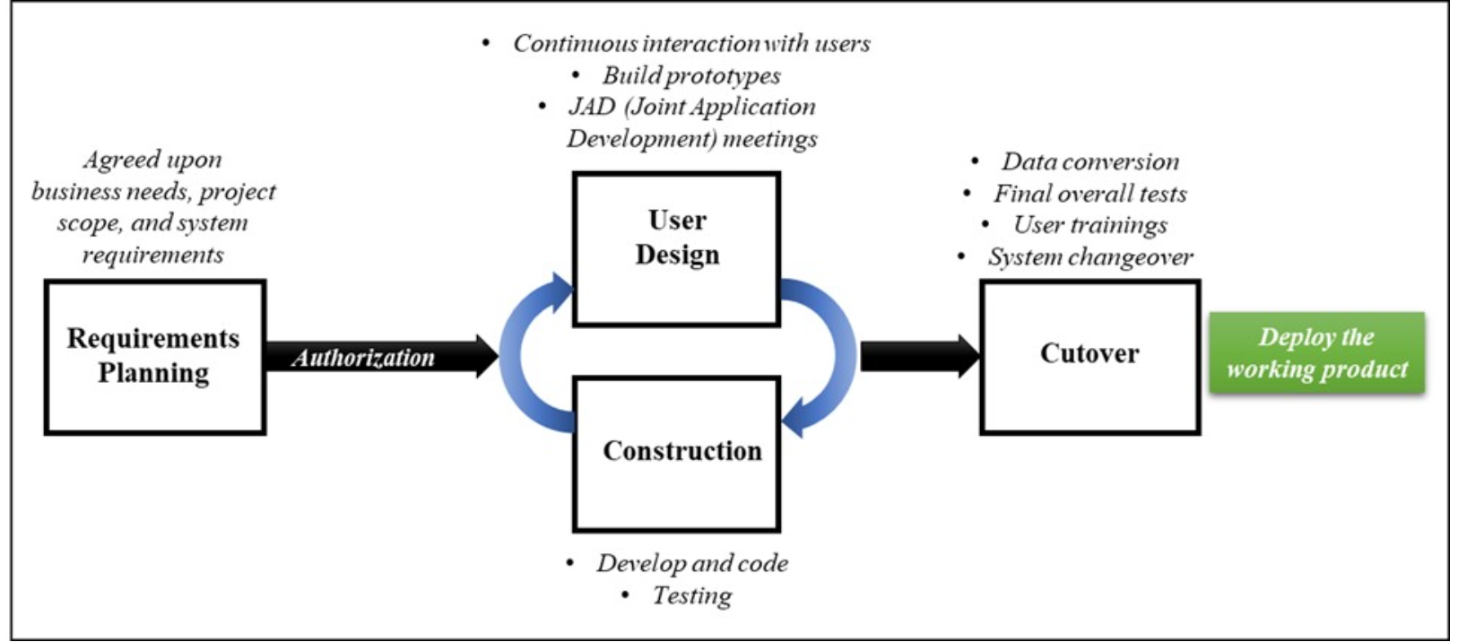
Figure 1. Rapid Application Development (RAD) Phases
Before Agile Alliance had their first meeting in 1999, there had been a diversification of agile methods which were called as lightweight methods as compared to the heavyweight waterfall models. The most popular methods were Crystal methods (1992), Dynamic Systems Development Model (DSDM) (1995), Scrum (1995), Feature Driven Development (FDD) (1997), Extreme Programming (XP) (1999), and Adaptive Software Development (ASD) (2000). Through the 1990s, a number of alternative ways to organize and structure the development of software products emerged as mentioned above, and they eventually evolved into the “agile” in 2001 with “Agile Manifesto”.
Agile Manifesto
At their initial meeting in 1999, the pioneers of agile methods discussed the similarity of XP with other methods and decided to meet again, with a broader range of people, to explore common ground. In 2001, a group of 17 people met at Snowbird Ski Resort in Utah (the USA) to talk, ski, relax and try to find common ground between their thoughts on software development. They represented the leading thinkers from XP, Scrum, DSDM, ASD, Crystal, FDD and Pragmatic Programming, along with others who wanted a viable alternative to traditional heavyweight and documentation-driven development processes. They published the “Agile Manifesto” that embodied the values they all believed in and a set of guiding principles. Thus, the Agile Alliance was born.
Task 1. Learn about Manifesto for Agile Software Development following the link https://agilemanifesto.org. Also discover Twelve Agile Principles behind the Agile Manifesto. Be prepared to present your findings in class.
2. Differences between Waterfall and Agile Methods
As can be seen in Figure 2, in the waterfall (predictive, traditional) project management approach, the process is linear and sequential. Project teams should finish one stage to proceed with the following stage. As seen in Figure 3, the agile (adaptive) project management approach compresses the sequential phases in small timeboxes. Therefore, agile teams work on a limited number of requirements (i.e., user stories) at a time, and they can receive frequent stakeholder feedback at the end of each timebox when they create a partial working product.
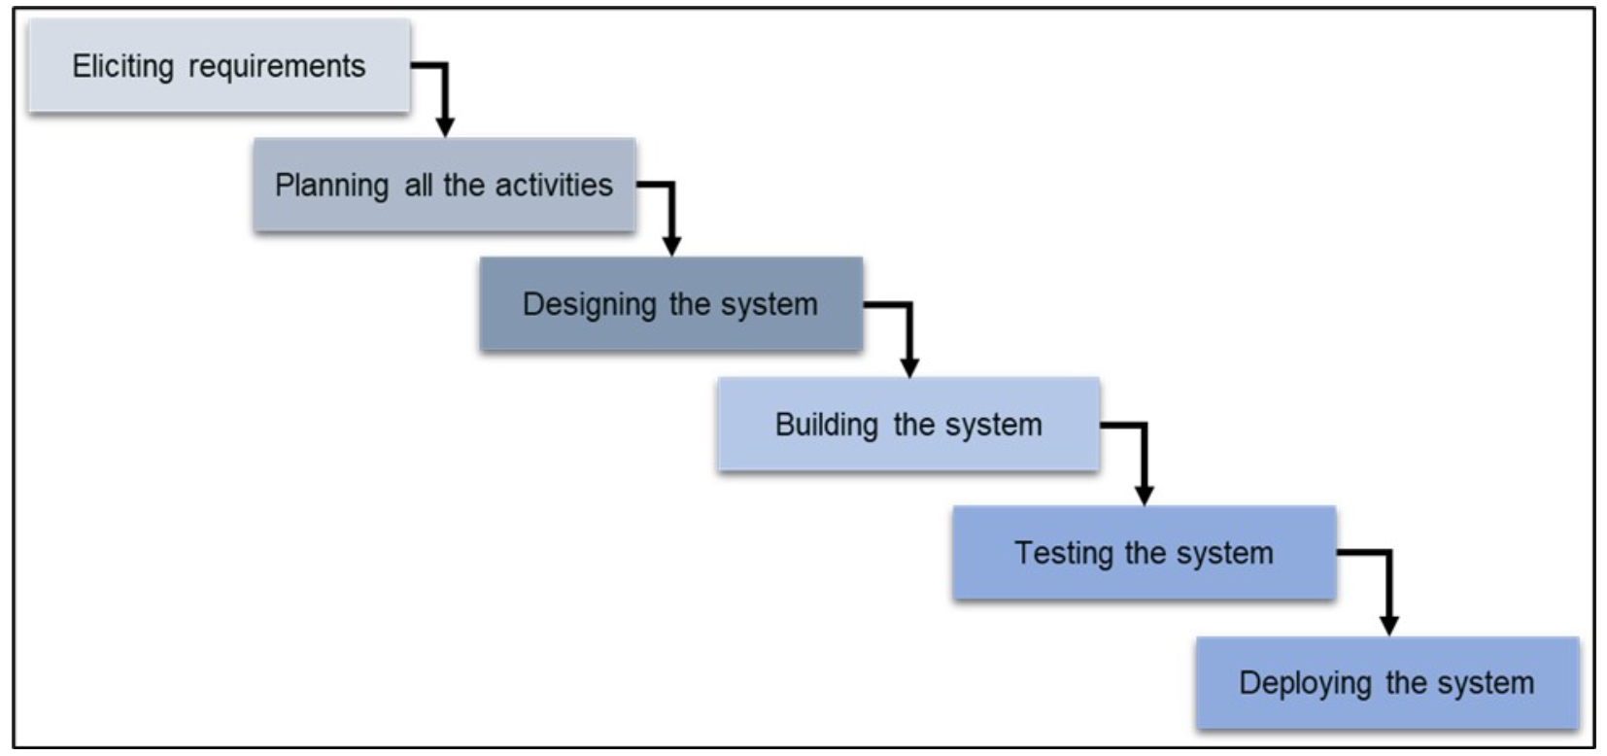
Figure 2. Waterfall Project Management

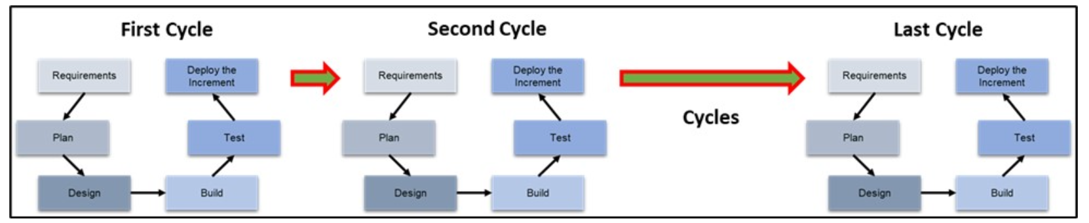
Figure 3. Agile Project Management

Increment – one of a series of increases [Cambridge Dictionary]
The term “increment” comes from Latin and means “to enlarge” or “increase”. Applied to incremental software development, this means that a system is planned as a whole but realised in parts. The scope and/or number of functions grows per increment [https://t2informatik.de/en/smartpedia/increment/]

The frequent interaction with the client and stakeholders offers an environment where the frustration level of stakeholders is minimized. Nevertheless, agile methods may not be appropriate for all projects. Waterfall project approach may work better when:
- Requirements are very well understood and can be fixed before the implementation begins.
- Client’s and customers’ expectations from the product is stable and substantial changes can be avoided.
- Technology and the tools utilized are understood very well by the stakeholders, and changes that may affect the project’s progress are not expected.
- The duration of the project is relatively short.
- The uncertainty is at a low level.
- Resources are available, and easy to acquire.
Therefore, we can implement a waterfall project when we expect low uncertainty and define the project and product scope, and project constraints easily with clear and unambiguous procedures. The production domain and processes involved are usually well understood and there are typically low levels of execution uncertainty and risk. However, if we cannot define the product scope, and uncertainty level is high, an agile approach would be better to move gradually by clarifying the requirements and uncertainties with the active involvement of clients and stakeholders.
In agile projects, client and stakeholder involvement can be provided constantly since product owners are a part of the team, and the increments are reviewed by the product owner and the client frequently. In waterfall projects, the interaction with the client is deferred to the end of a phase, for instance, when the software coding and testing are complete. However, in real life projects, teams often implement a hybrid approach which is a blend of waterfall approach and some principles of agile such as client involvement and feedback.

Task 2. Agile vs. Waterfall: A Balancing Act.
Both cases demonstrate the use of different project management methodologies. Discuss the factors that influenced the choice of either Agile or Waterfall in each case.
1. How can organizations effectively balance the structured approach of Waterfall with the flexibility of Agile to achieve optimal project outcomes?
2. What are the potential risks and benefits of adopting a hybrid approach that combines elements of both methodologies?

Example 1. Grocery LLC Decides on the Project Approach for the “Self-Checkout Stations Project”
The grocery chain, Grocery LLC, considers establishing self-checkout station areas in all fifty branches to find a solution to long lines in front of the current checkout stations where the cashiers work. The project selection committee discussed the solution and decided to implement this project. As part of requirements elicitation, business analysis team surveyed managers and employees, and interviewed customers. Besides, the team visited the competitors’ markets and made market research to have a better understanding of possible solutions in the market. The team concluded that self-checkout has been increasingly deployed in many grocery store and pharmacy chains (e.g., Walmart, Target, CVS) across the United States, and the manufacturers and service providers are experience. Therefore, the sponsor, project manager, and relevant departments had a meeting to discuss the project management approach. They decided to implement a waterfall approach supported by continuous stakeholder interaction as is done in agile methods.
- Managers, employees, and customers conveyed their requirements. The analysis revealed that requirements are consistent with the current implementations and the research consultancy company’s report. Therefore, it was concluded that requirements are very well understood and can be fixed to a large extent before the implementation begins. However, in order to keep up with the technological advancements and to be prepared for the risks such as new waves of pandemic, it was decided to establish a continuous interaction and feedback system with the stakeholders.
- There are experienced companies which provide competitive prices to acquire the systems. They implemented numerous projects across the United States. They have comprehensive knowledge of the current and upcoming technologies.
- The duration of the project is 8 months.

Example 2. Grocery LLC Decides on the Project Approach for the “M-Commerce Project”.
The grocery chain, Grocery LLC, considers having a better online presence by creating a mobile app and optimizing the website for mobile devices in particular due to the negative effects of pandemic on the number of in-store customers, hence significantly decreased revenue and profit. In the initiation stage, project manager prepared a report justifying the need for conducting an agile methodology, i.e., Scrum, during this project in order to accelerate the pace and achieve the outcome in a relatively shorter time, receive constant and timely feedback from the employees and customers, keep a healthy interaction with the stakeholders, and adjust the specifications to the fast and unprecedented changing technologies and socioeconomic conditions. Since it was not easy for the project manager and the team to oversee the near future in a turbulent environment (e.g., Covid cases and hospitalizations rocketing to the peak in a very short time), the sponsor and the project steering committee supported the project manager’s decision to implement an agile method. The Scrum cycles (sprints) were set as two weeks so that a working app and mobile website can be developed gradually with some of the requirements and functions at the end of each sprint, which can allow frequent end-user feedback and interaction.

3. Adopting and Creating an Agile Environment
A Case Study of the Penta Transformations
A Six-Month Cultural Transformation: The Penta Story
Penta Technologies, a family-owned construction software company in Wisconsin, developed and provided customized accounting and finance ERP systems (Enterprise resource planning), labor productivity suites, and payroll tools for construction back-office services. However, the convenience of customization led to more complicated workload for the project teams and employees while it was a relief for the clients. Rather than focusing on the effectiveness of projects and their outcomes, the company dealt mostly with the contract negotiation and customer emergencies. The main issues were the implementation of a traditional project management approach that made the frequency of delivery slow and inconsistent. However, the solution was not that easy just by switching to an agile structure. The president and the COO (Chief Operating Officer) figured out that there are organizational and cultural barriers that need to be overcome first.
First of all, they reduced the number of executives to three, which simplified the decision making and allowed space for the team to identify the most urgent issue, optimizing the product development teams. But this was only the initial step to transition to a more agile structure. The COO announced that they were going to partner with everyone in the organization to figure out the best structure for the business. As a result, employees’ feedback was aggregated in five areas that need attention:
(1) Remove functional silos,
(2) more ownership in the work,
(3) remove unnecessary and complex processes,
(4) stop micromanagement and improve trust, and
(5) more focus on value.
Based on this valuable employee feedback, a team conducted research on different organizational structures. The team suggested a transition to the Scrum framework which a team-based and servant-leadership organizational structure. This was just the beginning for Penta. However, this case showed that organizations need to evaluate the current organizational structure and culture, and develop a novel background and mindset over which they can build the new agile structure. A new house cannot be constructed over an old and torn foundation. We need to ensure that the foundation is so strong that it can bear.

Creating a Novel Mindset: Agile
As can be seen in the case study of Penta Technologies above, organizations don’t start creating, adopting and implementing an agile project approach in one day as is the case for all the actions organizations should take. A long and well-thought-out process is inevitable to generate ideas effectively, which can benefit the organization in the long term. As for the agile environment, the challenging process requires adoption of an agile mindset that spans throughout the organization including the executive team, managers, supervisors, and all other employees. At the very beginning, organizations and their project teams and leaders should answer many questions, some of which are provided below, to develop an implementation strategy :
- How can organizations, their employees, and project teams and in particular, their members, act in an agile manner?
- Are there organizational impediments that we need take care of (e.g., issues in formal structure such governance and policies, and informal structure such as organizational culture)?
- What are the levels of acceptance and resistance that we may expect from the executives, managers, employees, project managers, and team members?
- How can we measure these levels (e.g. survey, interviews, focus group meetings) so that we can create an action plan?
- What kind of activities (e.g., seminars, webinars, training, social events) do we need to organize?
- What can our teams deliver quickly and obtain early feedback to benefit the next delivery cycle?
- Are our products appropriate for quick incremental deliverables?
- How can the teams act in a transparent manner?
- What works can be avoided in order to focus on high-priority items?
- How can a servant-leadership approach benefit the achievement of the team’s goals and project objectives?

Benefits and Challenges of Agile Project Management
When organizations start utilizing agile project management approach and principles, they can expect to see the benefits below:
- They can find opportunities to deliver business benefits at an early stage through addressing straightforward problems.
- They can shorten the time to introduce new products and services to the markets and customers.
- They can increase and maintain the adaptability to changing needs of customers.
- They can achieve an improved quality of products and services through short cycles and constant client and stakeholder interaction and feedback.
- Ultimately, they can maximize the return on investment.

The common benefits of implementing agile project management in a non-software development context (Gustavsson, 2016):
- Better collaboration in the team
- Increased customer interaction
- Increased productivity and speed
- Increased flexibility in coping with the change
- Better understanding of goals/tasks/requirements
- Increased transparency and visibility
- Increased quality
- Customer-centered value adding priority process
- Increased knowledge sharing
- Increased cross-organizational collaboration

The problems and challenges while adopting and implementing agile approach (Gustavsson, 2016):
- Changing mindset to allow flexibility
- Lack of process visibility
- Buy-in from managers
- Difficult to see benefits early in the project
- Inadequate knowledge sharing
- Individual work, lack of communication
- Long-term planning
- Lack of stakeholder engagement
- Scope creep (uncontrolled expansion of the scope with product requirements and project activities)
- Insufficient resource allocation
- Redundant work
These results demonstrate that no one system, approach, or methodology is alone perfect. Project managers and team members always need to take into account the coexistence of pros and cons of anything used in a project by incorporating the cost-benefit analysis. While increased knowledge sharing was indicated as a benefit, challenges presented a challenge of inadequate knowledge sharing. Thus, decision-makers and project managers should consider the factors that may cause inadequate knowledge sharing in an agile environment. This is also valid for other elements such as flexibility, communication, early delivery, and resources as well as triple constraints (i.e., scope, schedule, and budget).

4. The Elements of an Agile Environment
Although the roles and the practices of each agile method and framework vary from one to another, there are common roles and practices across them.

Common Agile Roles and How Agile Team Works
There are three main roles in agile teams.
1. Cross-functional and self-organizing teams and their members
2. Product owner
3. Team facilitator

Considering the self-organizing structure of agile teams and the role of project manager as a team facilitator and servant leader, we can first focus on the team members who form the agile teams. Cross-functional teams consist of members with various skills from different areas. If it is a software development team, it can be composed of designers, systems analysts, developers, testers, and business unit representatives. Team members discuss the tasks and pick the ones they think would fit the best. Team facilitator (or the project manager) doesn’t tell who should do what, but acts as an obstacle remover and a coordinator. Agile teams generally work during short cycles (i.e., iterations) to release a working product, an incomplete but a testable partial product, which is named as increments. Rather than creating the whole website with its all backend features in three months, these teams create a number of web pages with some of the properties and functions in a short time (e.g., a two-week iteration). In the end of each iteration, the team presents the increment in the form of a partial product (e.g., three-web pages). The product owner representing the client and the end-users provide the feedback about what they think of these three-web pages. They may say “We want the navigation bar at the top with that size and those colors” or “The pictures should not cover more than one third of the row while not zoomed in”. These increments help the team receive feedback constantly. Therefore, they can work on each increment based on the feedback, and they can improve the product. This provides the team with the opportunity to make timely and effective interventions which otherwise would cause serious problems at the end of the project. So, when the team receives the feedback as regards the navigation bar’s position and color, they apply the request to the current and future web page layouts. However, another feedback may still want the team to change the position and color. This is an ongoing process with constant interaction with the client, end users, and stakeholders. In a waterfall project management approach, the team finishes the development of the whole website, and submit it to the client for the inspection of the client and its end users. However, in the meantime, a three-month duration passes, and the possibility of receiving feedback from the client that can lead to a serious rework could be high.
As is discussed above, these teams are self-organizing teams, which means that team members decide on the tasks that each will work during an iteration, rather than a team facilitator tell them what they need to do. Agile teams are generally small teams smaller than 10 members. These teams use techniques to collaborate more effectively such as pairing, swarming, and mobbing. Pairing is generally utilized by XP (Extreme Programming) teams when software developers write codes. While one member works on coding, the second member checks the quality of the coding made by the first member. Another collaboration technique is swarming through which multiple team members focus collectively on resolving a specific impediment.

A second agile role is the product owner who is responsible for guiding the direction of the product. Product owners can be a representative of the internal or external client, or a person who represents the client and the stakeholders. Product owners keep a constant daily communication with the agile team. They provide the product backlog which includes the user stories (requirements), and prioritize the user stories. Product owners are the bridge between the clients (and their end-users, customer and stakeholders) and the agile team. The feedback conveyed by the product owner is used to develop the increments at each cycle. Product owners communicate with subject matter experts to produce good-quality user stories (requirements) and offer effective feedback. Recently, IIBA (International Institute of Business Analysis) have offered a new certificate, “Certificate in Product Ownership Analysis”, which integrates product ownership and business analysis.

The third and the final role is a team facilitator which can be also named as project manager, scrum master, project team lead, or team coach based on the method or framework utilized, and/or the organization’s guidelines. In agile teams, project managers’ role is different from the traditional role they play in waterfall (predictive) project management. Generally, in traditional approach, project managers are the ultimate authority in a team who decides which tasks are carried by which member. Their authority with respect to the control is high. However, in agile teams, project managers should be the facilitators and coaches, and they need to adopt a servant leadership approach. Team members organize the tasks that needs to be carried out during a cycle. Project managers help them in removing the impediments, overcoming the conflicts inside the team or with stakeholders, and coaching the members to allow them to improve their skills. For example, if team members find themselves in a conflict with a stakeholder and cannot solve the issue themselves, the project manager gets involved to resolve the conflict. Or developers in the team may ask the project manager to buy a license for a software which can help them produce a better quality IT solution or complete the activities earlier. Servant leaders empower their teams and facilitate their teams’ success by promoting self-awareness, listening, helping people grow, coaching, promoting safety, respect and trust, and promoting the energy and intelligence of others. They practice their leading through service to the team focusing on understanding and addressing the needs and development of team members. Hence, interpersonal skills such as team building, motivating, communicating, influencing, decision making, political and cultural awareness, negotiating, facilitating, managing conflict, and coaching are more important than the technical skills.

Task 3. Learn about two-pizza rule by Amazon.

Common Agile Practices
Agile teams utilize various artifacts and events to conduct their tasks and achieve project objectives. Although they are used in different agile methods with same or different names, the Scrum framework which is the most common agile method make use of all of these artifacts and events. They are:
1. Team charter
2. User stories and backlog
3. Planning of each iteration or cycle (Not a comprehensive upfront planning)
4. Daily standups
5. Demonstration or reviews
6. Retrospectives
7. Backlog refinement

A team charter is necessary for all types of projects. It consists of team values, working agreements, ground rules, and group norms. It is a social contract which indicates how the team members interact with each other. The primary objective of a team charter is to create an agile environment where project managers, team members, and product owner can work to the best of their ability. In agile projects, the team charter has to define what “ready” and “done” mean. In particular, when teams use a Kanban board, tasks are organized on a timebox (i.e., cycle, iteration, Scrum sprint) to display and monitor their status such as to-do, doing (in progress), and done. Teams can assess the completeness of user stories and tasks according to the definition of “done”. Therefore, they can evaluate the completed tasks consistently.

User stories are requirements presented in a story form for the team to understand the needs of the client and stakeholders. They, together, establish the product backlog, the basis of the plan and each iteration. The structure of a user story is given below. These stories don’t only convey what a stakeholder expects from a product or service, but also includes the reason why that stakeholder needs. The project team can better understand why the stakeholder asks for a requirement. It can give a clue to the team if the requirement is a must or not, or if it is possible to incorporate into the product.

- As a “user/stakeholder”, I want to “perform a function / an action / an app feature” so that I can “acquire a benefit / an expected outcome”.

Let’s consider that our grocery chain’s m-commerce project is conducted as an agile project. Therefore, we have created some of the user stories. It is of high importance to keep in mind that product owner doesn’t need to list all the user stories since one of the advantages of agile projects is that a product evolves throughout the project based on the feedback of the end-users. Three user stories are provided below as examples that can be used in this m-commerce project:

- As a customer, I want to browse all the items under relevant categories (e.g., bakery, beverages, laundry and cleaning, electronics) so that I can find the items I am looking for and view all the related items on a single window or page, or more than one page with the page numbers displayed at the bottom of each page.

- As an administrator, I want to disable accounts which are not valid anymore so that we can manage the active accounts and archive the disabled accounts.

- As a shopper (or a store employee who is picking up the ordered items from the shelves), I want to view all the online orders assigned to me on my mobile device so that I can start shopping two hours before the delivery begins.

Table 1 exhibits four user stories selected from our m-commerce project. In order to keep the user story column shorter, we removed the “so that” part which provides the reasoning of why the stakeholder needs this requirement.

Table 1. A Backlog composed of Four User Stories
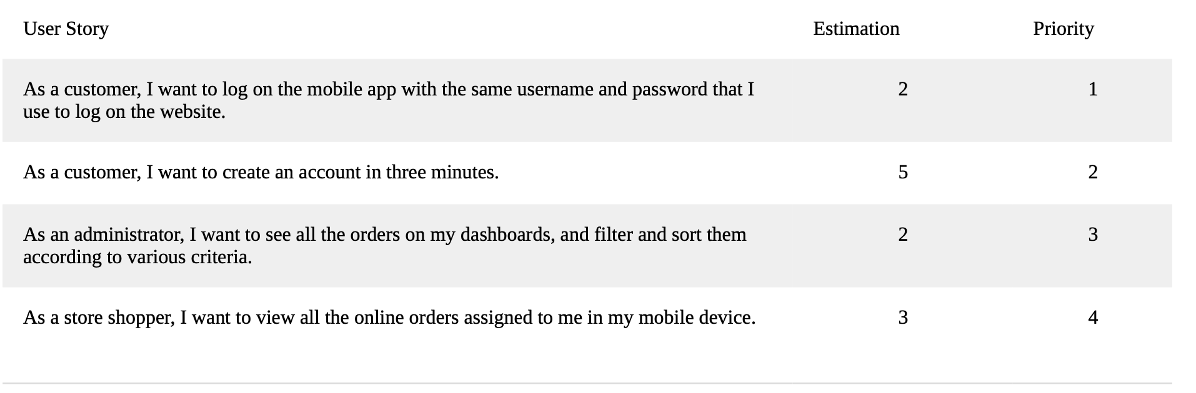
Product owners prioritize the user stories. Before each cycle starts, sufficient numbers of user stories with the highest priority are pulled from the backlog so that the team can work on these user stories. Let’s assume that the user stories in Table 1 were selected for the first cycle / timebox since the team decided to pull the highest priority user stories for the first cycle. Priority is the only factor to consider while selecting the user stories. Teams also estimate the story size taking into account the estimated time to finish and other criteria such as the effort and resources required to complete these tasks. Analogous estimating technique that takes into account the information from other projects, experience of project managers and team members from previous projects, and lessons learned helps the teams to create these estimates. Estimations are very important to make a better planning if the team can complete them in one cycle or iteration. While scrum teams set a specific time to finish each iteration (e.g., 1 week, 2 weeks, 30 days), Kanban teams focus on the user stories by means WIP (Work in Progress) limits. Therefore, Kanban teams don’t necessarily set a timebox, but they commit to completing an increment of work by focusing on a limited number of manageable tasks.

Instead of carrying out an overall project planning and trying to predict all the aspects of a project (e.g., scope, requirements, schedule, cost) as is done in waterfall project before the implementation phase starts, agile projects work on a limited number of requirements. Thus, planning can be done at the beginning of each cycle, which allows the team to adjust itself according to the feedback from end-users, and changing requirements and conditions. As the project progresses, agile teams generally spend less time in the initial phases (e.g., requirements, planning, design). Hence, they can focus more on implementation.

Another practice in agile projects is the daily standup meetings which occur mostly in the very morning before starting the daily tasks. They are called standup meetings since members generally stand up instead of sitting so that they can accelerate the meetings by avoiding the comfort of sitting. Although team members don’t meet in person at the collocated offices as it used to be due to the wider utilization of virtual teams recently and because of the Covid-19 pandemic measures that mandated to stay at home, agile teams continue holding these standup meetings, being the mostly utilized agile practice, in online platforms such as Microsoft Teams. The project leader or a team member can take the lead in standup meetings. In general, team members discuss the three questions below:
1. What have I completed since the last standup meeting?
2. What am I planning to complete until the next standup meeting?
3. What are the impediments, risks and problems that I may encounter?

When teams create an increment (e.g., a website with three web pages, an EPR module for accounting with limited functions, a prototype of a machine that is intended to manufacture spare auto parts) at the end of a cycle, they can demonstrate how this increment works. The product owner assesses the demonstration and collects the feedback from end-users. Therefore, the team can continue building upon the increment according to the feedback. Although negative feedback from the product owner may lead to a frustration for the team, frequent feedback in earlier stages prevents the team from heading in a wrong direction. The team leader’s servant leadership role as a coach can help the team enable frequent delivery.

At the end of each cycle, agile teams discuss what worked and what could have been better in that cycle. These retrospectives help the teams learn from their previous work. The lesson learned process becomes more frequent in line with the review and feedback from the product owner and end-users. As one of the agile principles indicate, “at regular intervals, the team reflects on how to become more effective, then tunes and adjusts its behavior accordingly.” Teams may also decide to retrospect at different times, not only limited to the end of the cycles. For example, the project manager may call for a retrospective meeting when the team is stuck and cannot complete the work. Therefore, this meeting can help the team determine the underlying reason of the bottleneck and find a solution with a facilitated brainstorming session.

The last common agile practice to mention is the backlog refinement process which occurs generally in the middle of iterations. In this refinement meetings, product owners present story ideas to the team and the team learns about the potential challenges or problems in the stories.

Common Agile Framework and Methods
Although there are many agile approaches, only several of them are utilized commonly by organizations. The Agile Practice Guide by PMI (Project Management Institute) lists the single-team agile methods as below:
1. Scrum
2. Extreme Programming (XP)
3. Kanban
4. Crystal methods
5. Scrumban
6. Feature-Driven Development (FDD)
7. Dynamic Systems Development Method (DSDM)
8. Agile Unified Process (AgileUP)

Besides single-team agile approaches, higher-than-single-team level (e.g., enterprise-level) scaling frameworks are provided below:
1. Scrum of Scrums
2. Scaled Agile Framework (SAFe®)
3. Large Scale Scrum (LeSS)
4. Enterprise Scrum
5. Disciplined Agile (DA)

Scrum
Scrum is the most utilized single-team agile method. It consists of roles, events, artifacts, and rules. Scrum events are sprints, sprint planning, daily scrum, sprint review, and spring retrospective.
Scrum artifacts are product backlog, sprint backlog, and increments. It uses an iterative approach to deliver a working product (i.e., an increment) at the end of each timebox. These timeboxes are called sprints which last generally for one month, or four weeks, or shorter with consistent durations. When a two-week sprint duration is determined, all the sprints are set at two weeks. At the end each sprint, a potentially releasable increment of product is produced. A scrum team is composed of product owner, development team, and scrum master. The scrum master is responsible for ensuring the Scrum process is upheld and works to ensure the Scrum team adheres to the practices and rules as well as coaches the team on removing impediments .

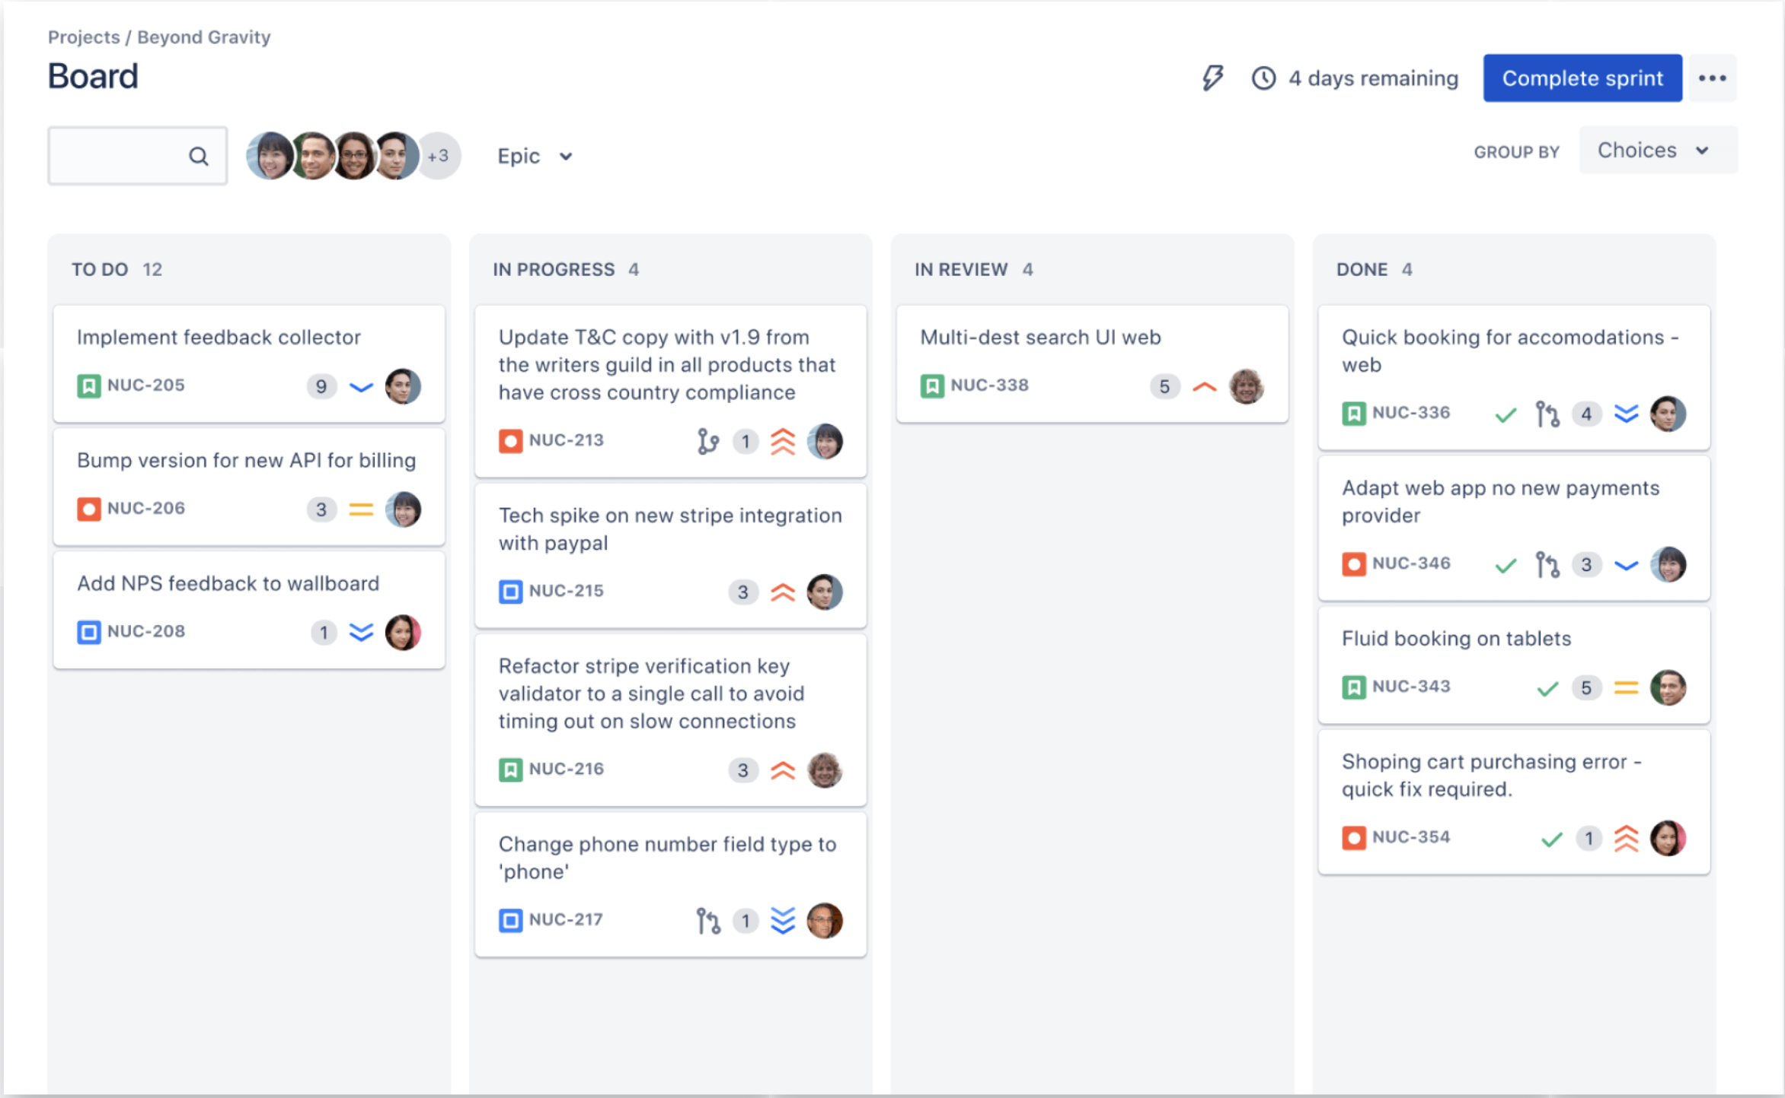
Figure 4. Scrum board [atlassian]

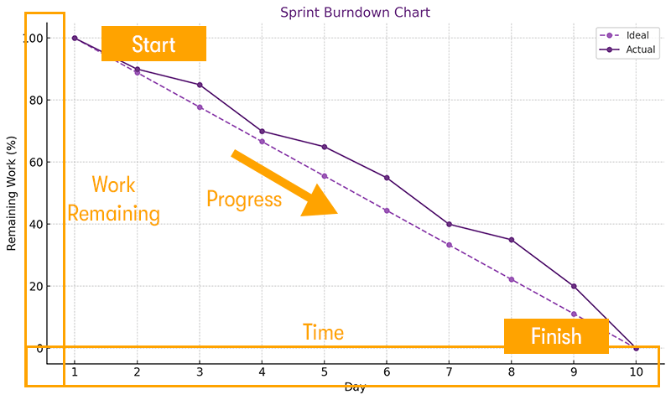
Figure 5. Burndown chart

Kanban
The Japanese word “kanban” means “visual board” or a “sign”. It was first developed and applied by Toyota as a scheduling system for just-in-time manufacturing. The workflow is visualized on a Kanban (Figure 6). The Kanban board is also used by Scrum teams.
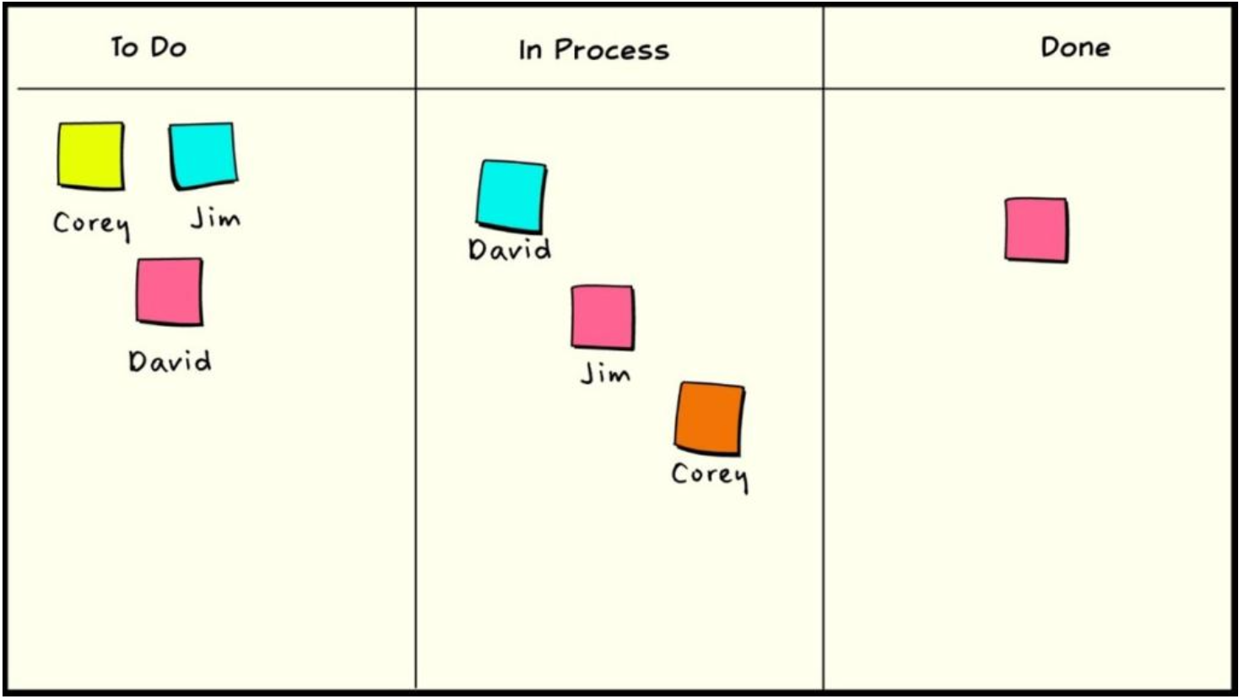
Figure 6. A task board in Kanban

The work is split into pieces, and each item is written on a card. Then, they are put on the wall, or it can be visualized in a software program or a website such as Jira. Explicit limits are assigned in Kanban projects so that each workflow state can have limited number of in-progress items (Work in Progress – WIP). The team tries to finish these tasks in the shortest possible time. This lead time is measured so that the team can optimize the process to make the lead time as small and predictable as possible.

Scrumban
Scrumban is an agile approach originally designed as a way to transition from Scrum to Kanban. Scrumban teams use Scrum as a framework and Kanban for process improvement. It uses the prescriptive nature of Scrum to be agile, and uses the process improvement of Kanban to allow the team to continually improve its process. In Scrumban, the work is organized into small “sprints” and leverages the use of Kanban boards to visualize and monitor the work. There are no predefined roles in Scrumban as is the case in Kanban. However, the Scrumban teams generally retain the Scrum roles.

eXtreme Programming (XP)
It is an agile software development framework that aims to produce higher quality software, and higher quality of life for the development team. XP is the most specific of the agile frameworks regarding appropriate engineering practices for software development. This method does not only focus on project management like other methods and frameworks do, but also focuses on how teams actually build code. Like Scrum, it has practices and values that help teams get into an effective mindset. One of the primary practices of XP is pair programming through which coding process is conducted by two developers working together at a single computer. While one member works on coding, the second member checks the quality of the coding made by the first member. Another unique XP practice is the coding the unit test first. Before writing the code, a unit test is created so that new codes are automatically tested.
XP is a development approach where everything is done in small steps, tested frequently, continuously improved, and closely aligned with the client's needs.

SAFe® (Scaled Agile Framework)
Imagine a company where not one small team is building a product, but dozens of teams, each with their own tasks, people, priorities, and challenges. Everyone is talented and hardworking – but without coordination, their efforts can easily clash. One team may build something that another team hasn’t prepared for. Someone may work on a feature that is no longer needed. Deadlines slip not because people are slow, but because no one sees the whole picture.
SAFe® exists to prevent this chaos.
It is a structured way for a large organization to work the Agile way, but at a scale where hundreds of people need to move in one direction. Think of SAFe® as the “conductor” of a huge orchestra: each team plays its part, but only when they follow the same rhythm and the same plan does the music sound right.
In SAFe®, teams don’t just run independently. They are connected into a larger system called an Agile Release Train, essentially a big group of teams that plan together, set shared goals, and deliver results in a coordinated flow. Instead of everyone working in isolation, they gather to align their priorities, identify dependencies, and decide what truly matters for the next 8–12 weeks. This shared planning session is called PI Planning (Program Increment), and it keeps the entire organization synchronized.
SAFe® doesn’t take away creativity or flexibility. Instead, it gives large groups of people clarity, transparency, and a common direction. It helps them avoid duplicated work, manage complex projects more predictably, and deliver value faster – even when the products are big and the stakes are high.
SAFe® is a way for a big company to stay coordinated and Agile, helping many teams work together smoothly instead of getting lost in chaos.

The SAFe is the most common scaling framework according to the 15th State of Agile Report published in 2021. Thirty-seven percent of respondents indicated that their organization applies SAFe while 9% uses scrum of scrums and 6% uses enterprise scrum. The SAFe focuses on providing a knowledge base of patterns for scaling development work across all levels of the enterprise (Figure 7). It also focuses on detailing practices, roles, and activities at the portfolio, program, and team levels. SAFe organizes the enterprise around value streams that focus on providing continuous value to the customer. https://scaledagileframework.com

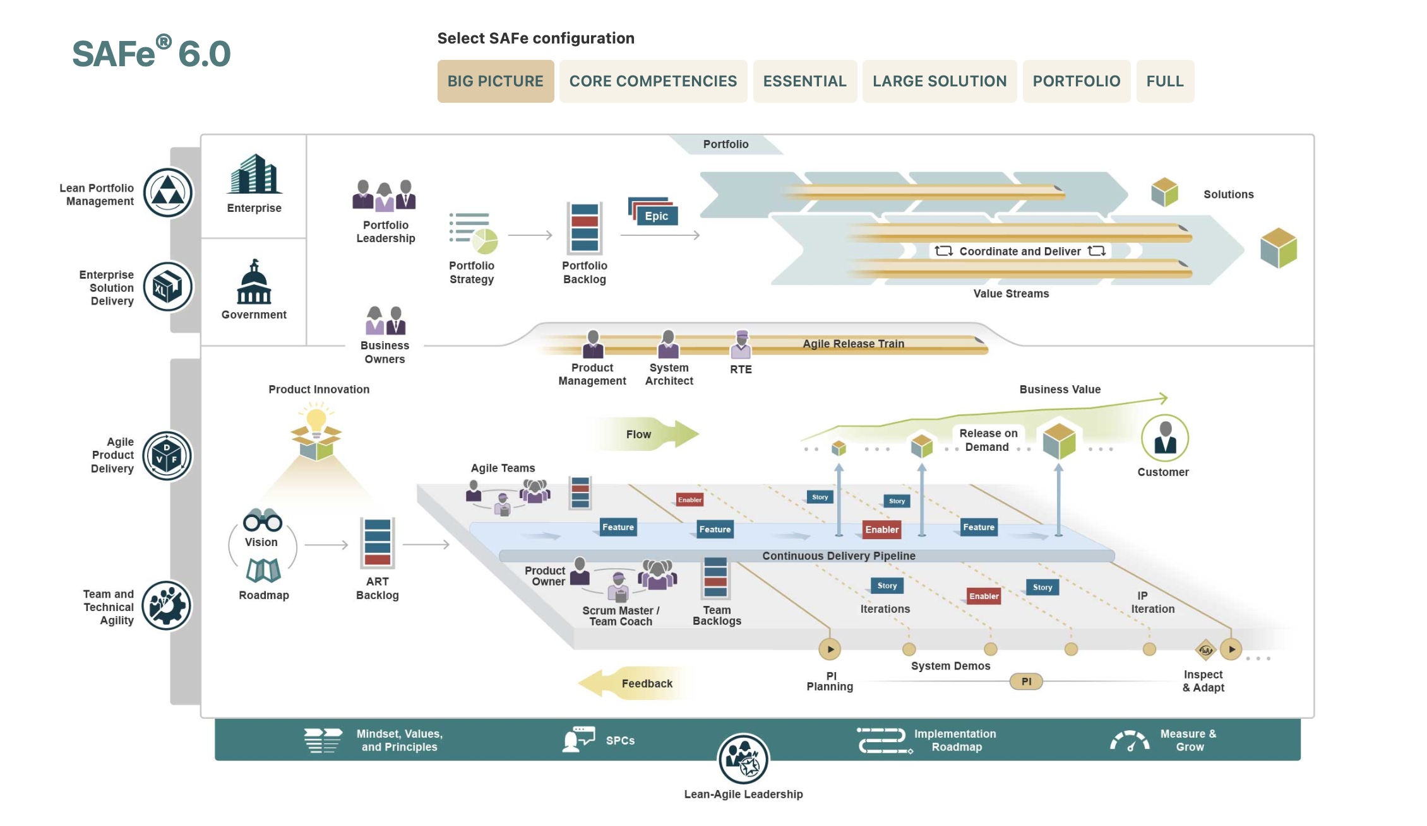
Figure 7. Scaled Agile Framework

Task 4. Discover Recent Trends in Agile Project Management using the latest State of Agile Report. Be prepared to present your findings in class.
KEY TAKEAWAYS

1. Agile emerged as a response to real-world problems in software development.
By the 1980s and 1990s, software projects became too complex for the traditional Waterfall approach. Teams struggled with long phases, late feedback, and frustrated clients who only saw the final product months later. Agile grew out of this crisis: it offered a more collaborative, flexible, and feedback-driven way of working. Influenced by Lean, Just-in-Time, Total Quality Management, and Kanban, Agile did not appear suddenly – it evolved from decades of practical experimentation and learning. The Agile Manifesto of 2001 simply crystallized these emerging practices into shared values and principles.

2. Agile vs. Waterfall is fundamentally about adaptability vs. predictability.
Waterfall is linear, sequential, and works well when requirements are stable, technology is known, and uncertainty is low. Agile, in contrast, compresses phases into short, repeatable cycles where teams deliver small increments of working product. With Agile, customers give feedback early and often. A key insight is that neither approach is “better” universally: Waterfall fits predictable projects; Agile fits dynamic, uncertain ones. In reality, many organizations blend both approaches to manage risk.

3. Real project decisions depend on context – not ideology.
The case studies observed demostrate how companies select methodologies based on business needs. A grocery chain chose Waterfall for installing self-checkout stations because requirements were clear, technology was mature, and the project was predictable. On the other hand, the same company chose Agile (Scrum) for developing an m-commerce app because the environment was volatile, requirements were uncertain, and rapid feedback was essential. That methodology should follow the problem – not the other way around.

4. Adopting Agile is not a technical switch – it is an organizational transformation.
Agile cannot flourish in a rigid environment. The transformation story of Penta Technologies shows that structural and cultural barriers must be addressed first. Organizations need to:
-remove silos,
-build trust and ownership,
-reduce unnecessary bureaucracy,
-rethink leadership roles, and
-focus on value instead of control.
Creating an Agile environment requires developing an Agile mindset across all levels, from executives to team members, and preparing people emotionally and structurally for change.

5. Agile brings significant benefits but also real challenges.
Benefits include faster delivery, earlier business value, stronger customer interaction, improved quality, transparency, and adaptability. Agile helps organizations respond to change rather than resist it.
However, challenges are equally real: shifting mindsets, handling long-term planning, ensuring knowledge sharing, avoiding scope creep, maintaining visibility, and aligning stakeholders. Agile is powerful but not effortless; it requires discipline, communication, and a willingness to continuously improve.

6. Agile roles redefine responsibility and leadership.
Agile teams are small, cross-functional, and self-organizing. Key roles include:
Team members with diverse skills who choose their own tasks and collaborate actively.
Product Owners who represent customers, manage the backlog, and set priorities.
Team Facilitators (Scrum Masters / Agile PMs) who practice servant leadership, removing obstacles rather than commanding work.
This shift from “control and direct” to “guide and support” is at the heart of Agile success.

7. Agile practices create rhythm, transparency, and continuous learning.
Agile teams rely on a set of recurring activities:
Iteration/Sprint Planning to select the highest-value work.
Daily Standups to synchronize and surface impediments.
Reviews/Demos to gather early feedback.
Retrospectives to reflect and improve.
Backlog Refinement to prepare future work.
These practices turn Agile into a disciplined learning cycle rather than a chaotic approach.

8. User stories and backlogs help teams stay customer-centered.
User stories capture not only what the customer wants but also why they want it. The backlog becomes a dynamic, prioritized list that evolves with new insights and feedback. Selecting stories based on value and estimating effort helps teams manage capacity and deliver meaningful increments each cycle. This way of thinking creates empathy with the stakeholder and clarity for the team.

9. Agile comes in many forms – from single-team methods to enterprise-scale frameworks.
Single-team Agile methods include Scrum, XP, Kanban, Scrumban, Crystal, FDD, DSDM, and AgileUP.
For large organizations, Agile must scale and frameworks like SAFe®, LeSS, Scrum of Scrums, Enterprise Scrum, and DA offer ways to coordinate dozens or hundreds of teams.
SAFe®, in particular, is the most widespread scaling framework globally and structures work at team, program, and portfolio levels to align the entire enterprise around value.

10. Ultimately, Agile is about value, learning, and adaptability, not rituals.
Across all sections of the lecture, one message is consistent: Agile is less about ceremonies and more about outcomes. The aim is to deliver value early, learn constantly, adapt to change, engage stakeholders, and empower teams. Organizations succeed with Agile when they treat it as a mindset and culture, not a checklist of practices.

TASKS
Be prepared to answer the following questions:
1. How did the historical challenges of software development in the 1980s–1990s lead to the creation of Agile methods, and which earlier industrial approaches influenced this shift?
2. In what fundamental ways do Agile and Waterfall differ in terms of planning, risk management, customer involvement, and handling uncertainty? Provide examples of when each approach is more appropriate.
3. Why do many organizations adopt a hybrid approach that blends elements of Agile and Waterfall? What risks and advantages does such a hybrid model introduce?
4. Based on the Penta Technologies case study, what organizational and cultural barriers can prevent successful Agile adoption, and why must they be addressed before shifting to Agile practices?
5. What is meant by an “Agile mindset,” and how does it differ from simply applying Agile practices or using Agile terminology?
6. How do cross-functional, self-organizing teams differ from traditional project teams in terms of responsibility, decision-making, and workflow?
7. Explain the distinct roles of Product Owner, Team Facilitator (Scrum Master / Agile PM), and team members in Agile teams. How do these roles contribute to customer-centered value delivery?
8. What is an increment in Agile, and why does delivering work in small increments help teams manage risk, incorporate feedback, and improve product quality?
9. How do key Agile practices (such as daily standups, sprint reviews, retrospectives, backlog refinement, and short planning horizons) support continuous learning and adaptability within teams?
10. Why are user stories an essential tool in Agile? How do they shape backlog prioritization and stakeholder communication?
11. What factors determine whether an organization should choose a single-team Agile method (e.g., Scrum, XP, Kanban) or a scaling framework (e.g., SAFe®, LeSS, Scrum of Scrums)?
12. How does SAFe® coordinate work across multiple Agile teams, and in what organizational situations is SAFe® particularly valuable?
13. Agile promises many benefits, such as faster delivery, better quality, and greater stakeholder engagement. What common challenges may undermine these benefits, especially in non-software contexts?
14. What is the role of servant leadership in Agile project management, and how does it contrast with traditional command-and-control leadership styles?
15. Why is transparency (in progress, priorities, impediments, and decisions) considered a core element of an effective Agile environment?

PROJECTS
1. Create the glossary based on the lecture (quiz check).
2. Creating a Mini Agile Manifesto. In groups (3-4 students), create your own Agile ‘micro-manifesto’ for the student environment: 4 values; 4-6 principles. Present it in the form of a poster.
3. Trend-Research: “Most Popular Agile Methods Today”. Examine the latest State of Agile Report and prepare a brief analytical report on which methods dominate, what new trends have emerged, and which industries are implementing Agile the fastest.
4. Mini-Research: “How Agile Is Used in Different Industries?” Select one company from any field (IT, fintech, education, logistics, media, social services) and investigate: whether the company uses Agile; which methods (Scrum, Kanban, SAFe, hybrid); and why this approach suits them. Present the results of your research in the form of a short presentation or poster.
5. Interview-Based Study: Understanding Agile Mindset. Conduct a short interview with one person who works in IT or project management and find out what ‘Agile mindset’ means to them; what Agile values are evident in their work; what difficulties arise. Present the results in the form of an interview report (or record a video).

