“Good marketing makes the company look smart. Great marketing makes the customer feel smart.” – Joe Chernov

“The aim of marketing is to know and understand the customer so well the product or service fits him and sells itself.” – Peter Drucker

“Marketing is no longer about the stuff that you make, but about the stories you tell.” – Seth Godin

“Your brand is a story unfolding across all customer touchpoints.” – Jonah Sachs

Lecture 6
Taking Products to Market

1. The framework of Product Launch and Product Marketing
2. How to create a go-to-market strategy

1. The framework of Product Launch and Product Marketing [aha]

How to plan a marketing launch
It is exciting to launch something new. You might be delivering product enhancements, unveiling a redesigned website, introducing a customer loyalty program, or implementing a new lead scoring system. Whatever it is that you are introducing, you will want to build a plan that makes it clear exactly what needs to be done and when. Your marketing launch plan captures how you will introduce a new offering, feature, or program to customers.
Of course, every marketing launch is unique. Your approach will depend on what you are launching and your company or organization. For example, the launch of a new product will look different for a consumer product than it will for a B2B software company. The scope of work for a launch will also vary based on company size. The activities required will be different for a smaller startup and an established company.

What is the purpose of a marketing launch?
It helps to first think about the purpose behind the launch itself. Any launch is usually an important part of your overall marketing plan – part of how you will meet your business objectives. So you want to build a goal-first plan that reflects how your marketing launch is connected to your company’s strategy and goals.
Launches are also great opportunities to engage with prospective customers and provide even more value to your existing users. Marketing launches are typically external-facing and may involve product changes, so the work is inherently cross-functional and will impact many teams in your organization.
The volume of work and resources to coordinate will depend on the complexity of what you are introducing. But there will always be a lot of activities to track and manage. That is why you need a clearly defined marketing launch plan to ensure the team stays in sync and delivers on time.

Common types of marketing launches
Marketing teams may launch new brands, products, service offerings, programs, campaigns, etc. Each one will require different promotional assets and activities, as well as internal communication and training.
The list below features some of the most common types of marketing launches:
- New brand
A brand launch may introduce a completely new brand or a new identity for an existing brand. Brand launches typically involve longer-term planning because you are defining and committing to a new business strategy, with new goals and values. This might include a new look and feel for your company – with new logos, brand colors, content tone, and sometimes even a new name.
Launching a new brand affects your internal team as well as your external audience, so it is important to create both an internal and external launch plan. Introduce the new brand to your company first to ensure the brand values and goals are clear and everyone is on the same page.
- Go-to-market
A go-to-market launch is the delivery of a new or updated experience. The experience itself could be a new product or feature or an enhancement to an existing product or service. It could also be when your company wants to introduce a product to a new audience or user base.
Launching a new mobile app is a good example of a go-to-market launch. Product and product marketing teams work closely on go-to-market launches like this to communicate the value of the new customer experience and gain competitive advantage.
- Marketing program
A program launch is a coordinated effort aimed at achieving a higher-level company goal from your overall marketing strategy. A program could include a number of campaigns or a series of smaller marketing activities. Many teams organize their program plans by customer segment or how they work internally – breaking items out by vertical or function.
A customer referral program or a webinar program are program launches, for example.
- Marketing campaign
A campaign launch is how a marketing team achieves the goals of a broader marketing program. It is used to complete a specific marketing goal, such as raising awareness of a new product, increasing interest in existing products, or capturing customer feedback.

Components of a marketing launch plan
Your plan will help you communicate deadlines and progress with teammates and stakeholders. You can also share any schedule changes as the work gets underway. Include all the details of the work you will do – including the “who,” “what,” and “when” for each task. Here are the key components to include:

Dates. Dates provide a timeline to work towards. Choose your time frame based on the duration of your marketing launch. Are you launching in quarters, months, weeks, or days? Determine the level of detail you want to include.

Tasks. Tasks represent the activities or pieces of work to be done. Common marketing launch activities include website updates, ads, announcement emails, and blog posts. You should denote the start date, end date, and duration of each task. Show who each task is assigned to and include a progress bar if possible.

Phases. Phases are a way to group tasks together. Typically phases are sequential, though there can be overlap. You can use phases to group related work, such as planning, design, tracking, and launch day activities.

Milestones. Milestones are key points in time on your schedule. You will want to include a milestone for the launch day you are working towards. You can also include markers for other significant dates, deadlines, and decisions.

Dependencies. Dependencies help you visualize which tasks must be completed before another can begin or end. Because of the cross-functional nature of marketing launches, you will want to show the interrelated work between teams to make it easy for them to coordinate.

Success metrics. Success metrics are the specific goals you define for your launch. Set numerical targets and connect your launch goals to your overall business goals to help align expectations from the start.

How to create a marketing launch plan
As you work on your marketing launch, it is important to keep track of every detail. Utilize visual plans like a Gantt chart to show dependencies between different launch activities and phases. This is a great way to organize date-driven work and show a full picture of all the activities that need to be completed for a successful launch.

Define success. Determine what you want to achieve in your launch. Set specific launch metrics and connect those to your broader marketing and company goals.

Set the direction. You can write a creative brief to set the direction for the launch. Include key information about your target audience, creative assets, and promotional channels.

Meet deadlines. Because your marketing launch relates to something new, you will likely have a pre-established launch date and your timeline will be fixed. You use the phases and milestones in the marketing launch plan to highlight exactly what needs to happen and when.

Build the plan. Identify all of the tasks and cross-functional dependencies to help everyone stay aligned leading up to the launch.

Track progress. Share the plan with your team members so they can complete their work, collaborate on activities, and provide status updates.

Many teams find a Gantt chart useful for visualizing and showing dependencies between different launch activities and phases.

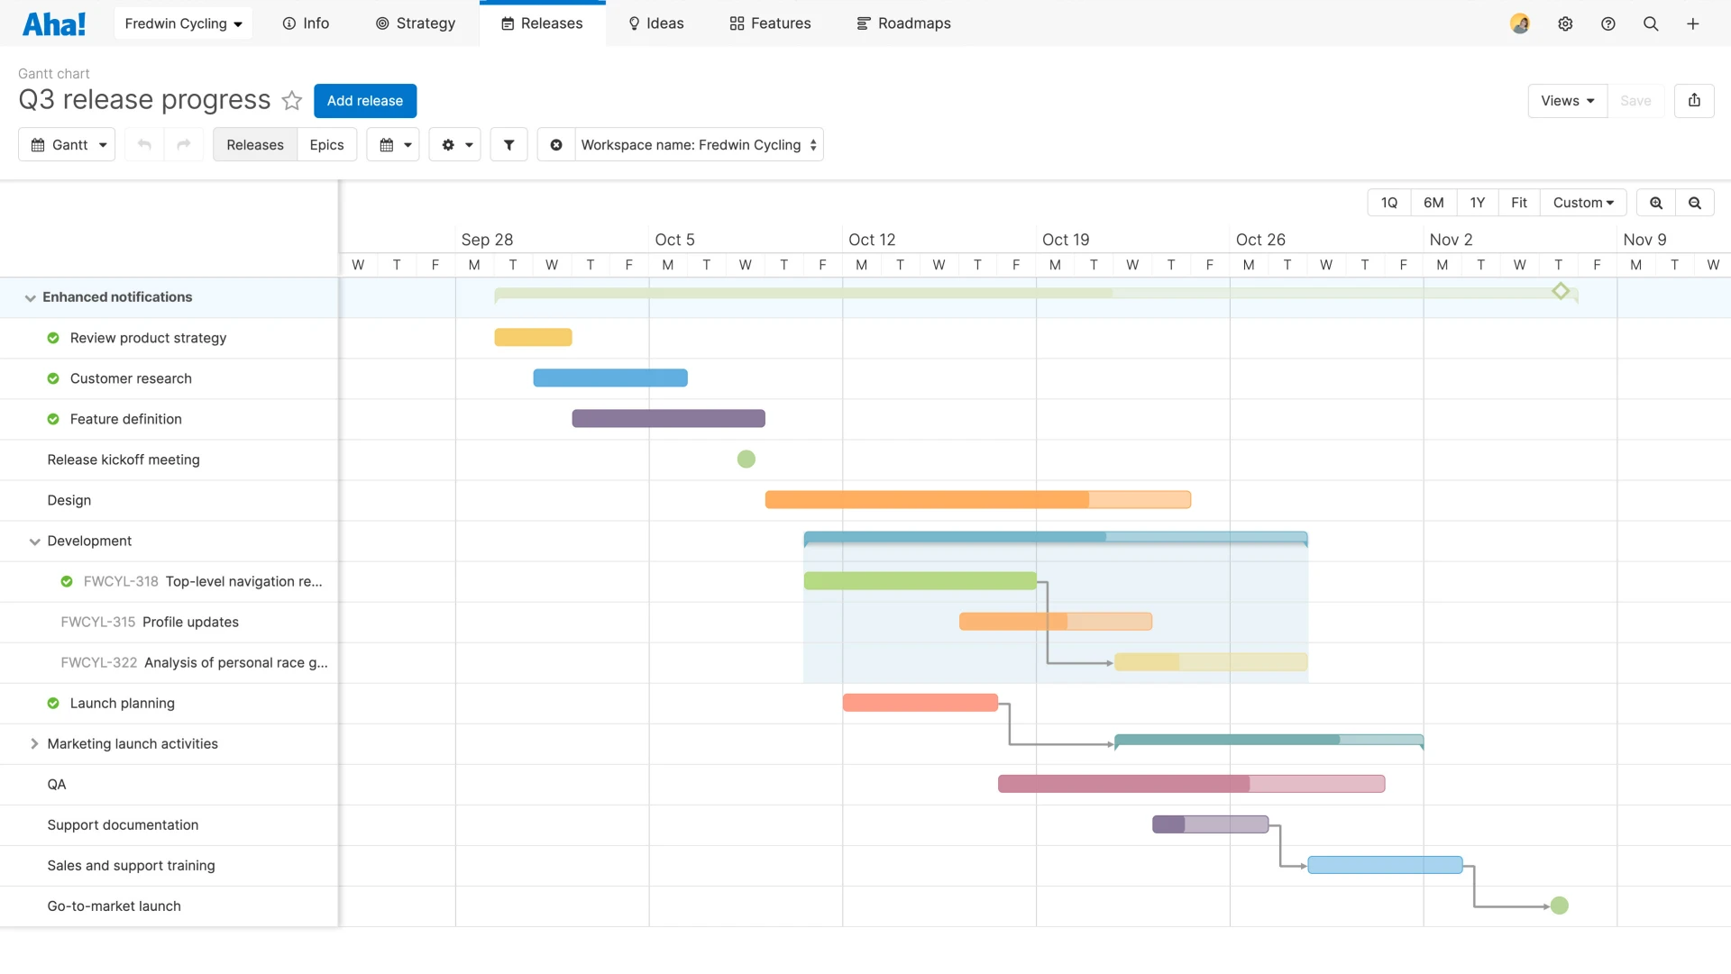
Task 1. Learn about Gantt chart and its derivatives. Be prepared to present your results in class (https://www.aha.io/roadmapping/guide/templates/gantt-charts)

2. How to create a go-to-market strategy [asana]

A go-to-market (GTM) strategy is a step-by-step plan for launching a new product or expanding into a new market. It helps you launch your product to the right audience, with the right messaging, at the right time.
Example. When the Swedish company Oatly expanded into the US, oat milk wasn’t top of mind for American consumers. But the brand had a trick up their sleeve – instead of investing in ads, they went straight to the coffee shops. Oatly teamed up with artisanal spots where customers tended to seek out dairy alternatives, and won patrons over with their product’s creamy and latte-friendly consistency. After its launch in the US, the company’s revenue grew ten-fold between 2017 and 2018, bringing a new oat-milk craze along with it.
Oatly went straight to their target audience at the exact moment customers were smelling the espresso and ready to buy.

What is a go-to-market strategy?
A go-to-market (GTM) strategy is a step-by-step plan for launching a new product or expanding an existing product into a new market.
It sets your initiative up for success by answering the following questions:
- What product are you selling, and what unique problem does it solve?
- Who is your ideal customer, and what pain points do they experience?
- Where will you sell your product? What markets do you want to pursue, and what does the demand and competition look like in those markets?
- How will you reach your target customers and create demand?
Launching a product is a big investment. And no matter how cutting-edge it is, a successful product launch is dictated by the strength of your marketing campaign and sales strategy. Creating a GTM strategy helps you ensure you’re taking everything into account and avoid costly mistakes – like launching your product to the wrong audience or in a market that’s already saturated with similar offerings.

When do you need a go-to-market (GTM) strategy?
Whenever you bring a product or service to market, you need a go-to-market strategy. This includes:
- Launching a new product in an existing market – for example, an established clothing brand launching a line of beauty products.
- Bringing an existing product to a new market – for example, a local grocery chain expanding into a different state.
- Testing a new product in a new market – for example, a tech startup launching their first app.
Even established companies need a go-to-market strategy when pioneering a new product or expanding into a new market. That’s because competition and market forces can quickly change. Even if you’ve had success with a similar product launch in the past, that same strategy might not work as well now.

Task 2. Watch the video about The Ansoff Matrix (the Product/Market Expansion Grid). Outline the main points. https://www.youtube.com/watch?v=axBKzmrjLT8&t=70s)

Go-to-market strategy vs. a marketing plan
A go-to-market strategy is specifically for launching a product or expanding to a new market. On the other hand, a marketing plan details how you’ll execute your overall marketing strategy. Instead of being launch specific, a marketing plan is a long-term approach to help you achieve your marketing objectives – like an annual roadmap or an overarching (comprehensive) digital marketing strategy. Your GTM strategy draws from your long-term marketing plan, but it’s tailored to a specific launch.
Marketing plan example: Sephora’s marketing plan leverages its loyalty program, which offers discounts and gifts to customers who spend a certain amount. This plan isn’t specific to a product launch; rather, it’s a long-term approach to building customer loyalty over time.
Go-to-market plan example: Microsoft executed a go-to-market strategy when launching its third-generation Surface tablet. Their strategy was specific to the tablet’s launch and addressed a particular market problem – that existing tablets didn’t have the functionality of a full-fledged computer.

Organize your go-to-market strategy with a project management platform
Every GTM strategy involves lots of moving pieces, whether you’re launching a new product or exploring new markets. The right project management tool can help you visualize your entire plan in one place, including the status, owners, and dependencies of each task. And as team members collaborate and execute your go-to-market strategy, you can see those updates in real-time.

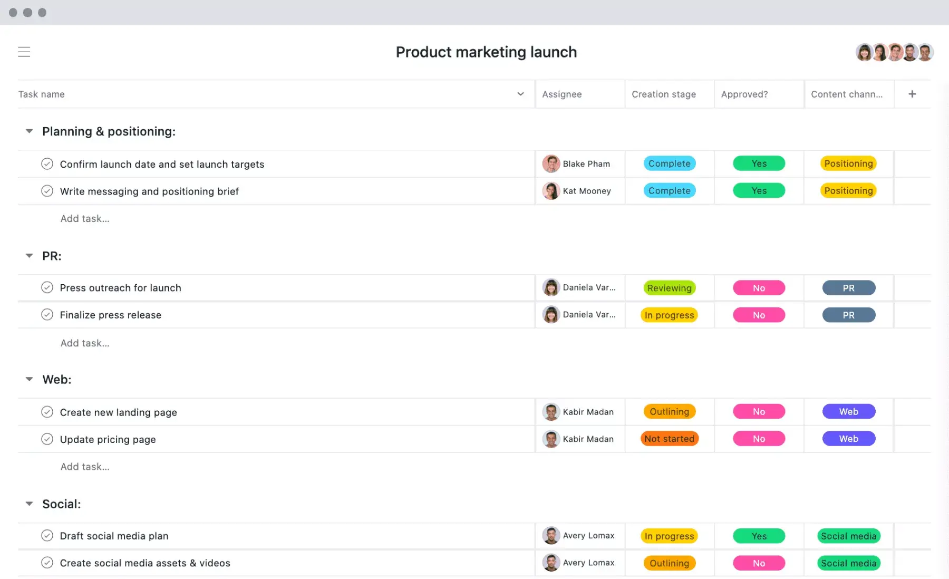
How to build a go-to-market strategy in 9 steps
So you’ve created an exciting new product or want to expand into a new market. You know you need a go-to-market strategy to make sure your initiative succeeds – but what exactly does that look like?

Step 1: Identify the problem
Every great product launch solves a specific problem. For example, Blackberry phones let business people answer emails on the go, Uber circumvents the cumbersome process of hailing or calling for a taxi, and Dawn detergent cuts through grease and makes washing dishes easier. Each of those products have a unique value proposition – a way they add value for customers by addressing their pain points. And most importantly, when those products launched, there was significant demand for solutions.
This concept is known as product-market fit – the degree to which a product satisfies a strong market demand. Understanding product-market fit is essential to gaining a competitive advantage and making sure you’re launching the right product to the right customers.

Step 2: Define the target audience
In order to have a successful GTM launch, you need to clearly understand your target audience. Start your market research by asking yourself the following questions:
- Who is experiencing the problem that your product solves?
- What are the specific frustrations your product can alleviate?
- How much is your audience willing to pay for a solution?
The two most common ways to define your target market are with an ideal customer profile (ICP) and buyer personas. These methods work together to narrow down your customer base and specify the types of people within your audience.

Ideal customer profile (ICP)
This approach defines your perfect customer – in other words, someone who experiences the frustrations your product solves. They’re aware of the problem, already looking for a solution, and are able to buy your product. To create an ideal customer profile, consider the following characteristics:
- Industry or demographic: If you’re selling to businesses, identify the specific industry you’re targeting – like financial, legal, or SaaS verticals. If you’re selling to individuals, define specific demographics your ideal customer falls within. For example, a child-care service may target families with kids between the ages of 1 and 5.
- Geography: Where do your ideal customers live? For example, a tour company that offers English-only experiences may target customers in the US and Europe.
- Size: This one is specific to B2B companies. Identify the size of the business you’re targeting – for example, you may market a new co-working space to funded startups with less than 20 employees.
- Budget: To shape your pricing strategy, consider how much your customers have to spend on your product. This will also influence the market’s perception of your product. For example, if your company sells luxury watches, you probably don’t want to go below a certain price point. Alternatively, a legal consulting firm may find it worthwhile to only target businesses who can spend at least $5,000 per month.
- Decision-making factors: What factors influence whether a customer decides to purchase your product? For example, do they rely on referrals from trusted friends or colleagues? Is there a primary decision-maker, like the CEO or sales manager of a company?
- Pain points: What specific frustrations does your ideal customer have? For example, a company selling a financial-planning app may target customers who lose time trying to track their budget with spreadsheets.
- Customer needs: Beyond pain points, understanding the needs of your customers is essential for an effective GTM strategy. For example, the technology company Apple emphasizes customer experience by analyzing customer needs and designing products accordingly.
- Preferred media: How does your ideal customer absorb information? For example, do they use social media, read print magazines, or browse the web with ease?

Buyer personas
Not all members of your target audience are the same – each person is a unique individual with their own problems, values, and goals. Creating buyer personas helps you differentiate between the different types of people within your target audience, so you can visualize who your customers are on a human level.
You should create multiple customer personas to fully understand your target audience. Here’s an example of one buyer persona for a tour company launching a new in-destination app:
Persona: Memory-maker
- Individuals between the ages of 25-35
- Travels alone or with a partner
- Willing to pay a higher price for premium experiences
- Values booking flexibility
- Wants to book high-demand experiences in advance, but also choose some activities after they’ve arrived at a destination
- Can use technology and apps with ease
Buyer personas may seem similar to an ideal customer profile, but they perform a different function. Personas help you visualize customer needs by breaking your ICP down into more specific segments – each representing a type of person with their own distinct problems, values, and goals.

Step 3: Research competition and demand
Now that you’ve identified your product’s value proposition and target audience, it’s time to do some market research. Before you invest in bringing your product to market, you want to make sure that there’s enough demand and not too much competition. To guide your marketing efforts, ask yourself the following questions:
- Who already offers a similar version of your product?
- What audiences and geographic regions do your competitors target?
- How does your product differ from the competition? What do you offer that others don’t?
- Is there demand for the product, or is the market oversaturated?
To design a comprehensive marketing campaign, you’ll need to conduct a competitive analysis. This method uses research to identify your direct and indirect competitors and uncover their strengths and weaknesses in relation to your own.

Step 4: Decide key messaging
The next step is to determine the key messages you’ll convey to potential customers. The best approach is to tailor individual messaging for each of your buyer personas, so you can address their unique values and frustrations.
To map your messaging to each buyer persona, create a value matrix. A value matrix breaks down each persona, their pain points, the value your product brings, and a key message that conveys how your product can solve their unique problem.
Let’s continue with the tour company example above. As a refresher, the company wants to launch a new in-destination app. One of their personas is a “memory-maker” – a customer who is willing to pay for premium experiences. Here’s what a value matrix might look like for this persona:
Pain points
- It’s hard to verify the quality of experiences when booking online.
- If they book an expensive tour in advance, they can’t get their money back if plans change.
Product value
- An app with customer pictures and reviews gives a feel for the quality of tours.
- A flexible booking policy allows them to cancel if plans change.
Key message
- Book quality experiences with peace of mind.
To complete your value matrix, continue this process for each buyer persona.

Step 5: Map the buyer’s journey
Now that you’ve identified your buyer personas and messaging, you can map the buyer’s journey – the path customers take from realizing their problem, considering your product as a solution, and deciding to purchase. Mapping your buyer’s journey is a key component of content marketing, because it helps you surface the right type of content to potential customers at the right time.
Most often, the customer journey is visualized as a funnel broken into three sections:
- Top of funnel: Customers know the problem they want to solve and research solutions. They may not be aware that your product exists yet. During this phase, you want to grab the customer's attention so they consider your product.
- Middle of funnel: Customers weigh your product against other available options. Your goal during this phase is to convince potential buyers that your product is the best option.
- Bottom of funnel: Customers decide whether to purchase your product. Your goal for this phase is to convince them to commit.

Task 3. Find the examples of mapping buyer’s journey for different products and services.

Step 6: Pick marketing channels
Marketing channels are the different types of content you use to create demand for your product and move potential customers down the marketing funnel. For example, social media, paid search ads, blogs, SEO content, and emails are different marketing channels. The marketing channels you choose depend on two things: your target audience, and where your potential customers are along their buyer’s journey.
- Align marketing channels with your ideal audience. You want to make sure the distribution channels you choose align with the way your target audience consumes content. For example, if your ideal customer uses YouTube but not Instagram or LinkedIn, you may want to focus on YouTube ads rather than paid social posts.
- Determine whether your ideal customer prefers outbound tactics like direct mail or inbound strategies such as social media. When deciding between inbound and outbound channels, consider whether you want to generate broad brand awareness or engage potential customers who have shown interest in what you have to offer. This approach ensures a more tailored and effective GTM strategy that aligns with the behavior and preferences of your target audience.
- Use different distribution channels for different phases of the customer journey. Depending on where customers are in the marketing funnel, different types of marketing content can help move them to the next phase. For example, search engine optimization (SEO) content can raise brand awareness among top-of-funnel customers. For those in the middle, case studies and webinars offer high-quality insights and build customer relationships. And at the bottom of the funnel, strategies like free trial options can help convince potential customers to commit.

Step 7: Create a sales plan
The goal of your GTM strategy is a successful product launch, so it’s essential to decide how you’ll sell to your target audience and turn prospective customers into buyers. That’s where your sales strategy comes in.
We’ve outlined the four most common sales strategies below. As needed, you can combine these strategies to fit your specific product and business model.
- Self-service model: Customers purchase your product on their own. This is a common sales process for e-commerce, in which customers can find and buy products online. While this option doesn’t require a dedicated sales team, you need to invest in marketing to drive traffic to your website.
- Inside sales model: Your sales team nurtures prospective customers to convince them to purchase your product. This is a good option for products with a medium price point that are a bit more complex, like design software for teams.
- Field sales model: Salespeople focus on closing big enterprise deals. This option requires more sales investment and a longer sales cycle, but there’s a big payoff. For example, you might use a field sales model to sell retail management software to large companies.
- Channel model: An external partner sells your product for you. While this option gives you less say in how you market your product, it’s the cheapest option and can work well if you partner with a company that sells similar products. For example, if you’re selling a new type of cereal, you could partner with a grocery chain.

Step 8: Set concrete goals
Every great go-to-market strategy starts with clear objectives and benchmarks. Goals give you specific targets to aim for and a clear timeline, and benchmarks (something that serves as a standard by which others may be measured or judged) allow you to measure progress. Without clearly defined goals, it’s hard to tell if your GTM strategy is working.
Here are a few different goal-setting frameworks you can use to set measurable objectives. Depending on your business needs, you can combine these strategies or use them on their own.
- SMART goals: This acronym helps you set goals that are specific, measurable, achievable, realistic, and time-bound. For example, you could set the following SMART goal when launching a new app: “In six months, generate 1M total app downloads and 50K new user accounts.”
- Key performance indicators (KPIs): KPIs are quantitative metrics that help you track progress toward business objectives. For example, you could track total purchases and ad click-throughs when executing a go-to-market strategy for your new product. Keep in mind that you can use the SMART goal framework when crafting KPIs – for example, “Within three months, generate 100K total conversions and 1M ad click-throughs.”
- Objectives and key results (OKRs): This strategy pairs the objectives you want to achieve with the key results you’ll use to measure progress. It follows this format: “I will [objective] as measured by [key result].” For example, “The marketing team will increase awareness of a new product, as measured by the following key results: Drive 1M web visitors to the product page, increase social media engagement by 50%, and generate 50K new customers through email signups.”

Step 9: Create clear processes
Creating a great go-to-market strategy is one thing, and executing it is another. That’s why creating clear processes is essential when bringing a product to market – because regardless of how well-crafted your strategy is, it only succeeds when you communicate and execute your strategy with your team. For example, you should consider the following when crafting your GTM strategy:
How you’ll share your strategy and collaborate with team members. Don’t let your strategy gather dust in a drawer – instead, house the plans and projects that comprise your strategy in one easily accessible place. A robust work management tool can help you accomplish this. That way, team members can work and collaborate in the same space where your GTM strategy lives.
How you’ll course-correct and track goals. In order for goals to be effective, they need to be connected to your day-to-day work. That means instead of setting and forgetting goals for your GTM strategy, make a plan to regularly check in and track your progress – for example, at the end of each week or month. Share these updates with project stakeholders in a centralized project management tool. That way, everyone is on the same page.
How to optimize the customer experience process. A smooth CX is critical to the success of your go-to-market strategy, which includes everything from onboarding to retention and customer service. Making your customers feel supported boosts loyalty and advocacy. Consider implementing structured onboarding programs, processes that nurture retention, and establishing helpful customer service. Tools that collect feedback and enable swift service adjustments can significantly improve these processes, making each customer's journey with your product a positive and memorable one.
How to effectively manage customer acquisition costs (CAC). Monitoring CAC is key for long-term growth. Optimize your marketing and sales funnel to reduce CAC and maximize marketing ROI. Incorporate data-driven strategies to fine-tune targeting, leverage cost-effective channels, and improve conversion rates. Regularly reviewing these costs in relation to customer lifetime value (CLV) can provide insights into the long-term viability and profitability of your customer acquisition strategies.
How you can standardize processes with go-to-market strategy templates. Every go-to-market strategy contains lots of components and moving pieces. But while it’s important to evaluate your strategy for each new product launch, that doesn’t mean you have to reinvent the wheel. To avoid duplicate work, create process documentation and go-to-market strategy templates to standardize your go-to-market process.

Go-to-market strategy benefits
In addition to supporting a successful product launch, there are a number of ways in which your company may profit from developing a solid GTM strategy.

- Faster market entry
A well-crafted go-to-market strategy streamlines your approach to entering new markets or launching products. By identifying the most effective distribution channels, target audience, and messaging from the get-go, businesses can significantly reduce the time it takes to go from concept to customers. Being first can often mean the difference between leading the market and playing catch-up.
GTM strategy example: Consider the launch of a groundbreaking health app that leverages AI to personalize workout plans. With a detailed go-to-market plan, the company identified fitness enthusiasts on social media as their primary audience and created affiliate partnerships with influencers for promotions. The strategy led to a rapid increase in user adoption within the first few months, showcasing how targeted efforts can result in faster market penetration.

- Enhanced customer understanding
A go-to-market strategy requires in-depth market research into customer needs, preferences, and behaviors. This process not only ensures that the product or service meets market demand but also deepens the company's understanding of its customer base. This customer insight is invaluable for tailoring marketing efforts, developing future products, and improving customer satisfaction over time.
GTM strategy example: Imagine a company launching a new eco-friendly home cleaning product. Through their go-to-market strategy research, they discovered their target customers frequented eco-conscious blogs and forums. By engaging with these communities and addressing their specific concerns, the company was able to build a loyal customer base that felt heard and understood, which led to strong word-of-mouth endorsements.

- Streamlined resource allocation
Crafting a go-to-market strategy forces businesses to think critically about how they allocate their resources, including time, money, and manpower. By focusing efforts on the most promising markets, channels, and customer segments, companies can achieve higher returns on investment and avoid wasteful spending.
GTM strategy example: A small software startup developed a project management tool tailored for remote teams. By concentrating their resources on online advertising targeting remote work platforms and collaboration forums, they were able to maximize their limited marketing budget, achieving a higher conversion rate than spreading their efforts across more generic channels.

- Competitive advantage
A thorough go-to-market strategy equips businesses with the knowledge to differentiate themselves from the competition. By clearly articulating the unique value proposition and tailoring the marketing mix to highlight these differences, companies can carve out a distinct space in the market. This not only attracts more customers but also builds a strong brand identity.
GTM strategy example: Take the case of a new beverage company entering a crowded market. Their GTM plan concentrated on their drink's distinctive flavor combination and health advantages, which differentiators did not provide. By targeting health-conscious consumers through niche health and wellness events and partnerships, the company was able to establish a dedicated following, distinguishing itself from the competition and securing a loyal customer base.

Task 4. Learn about Marketing messaging and present your findings in class. (https://www.aha.io/roadmapping/guide/marketing-templates/messaging-templates)

Task 5. Learn about Contemporary Ways To Effectively Market A Product Or Service. Be prepared to present your findings in class. (https://www.forbes.com/councils/forbesbusinessdevelopmentcouncil/2022/07/19/12-ways-to-effectively-market-a-product-or-service/)

- https://www.aha.io/roadmapping/guide/marketing-launches/how-to-plan-marketing-launch

- https://asana.com/resources/go-to-market-gtm-strategy

https://www.aha.io/roadmapping/guide/marketing-templates/messaging-templates

https://www.olivinemarketing.com/articles/the-12-stages-of-taking-a-new-product-to-market

https://2stallions.com/blog/6-steps-to-create-an-integrated-marketing-communications-strategy/

https://www.forbes.com/councils/forbesbusinessdevelopmentcouncil/2022/07/19/12-ways-to-effectively-market-a-product-or-service/ (останні тенденції)

