DEMO
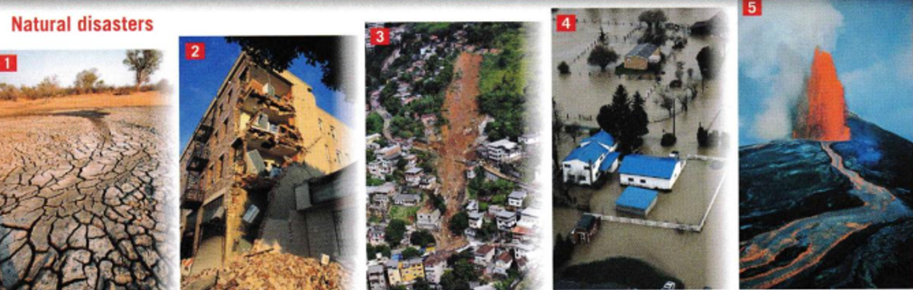
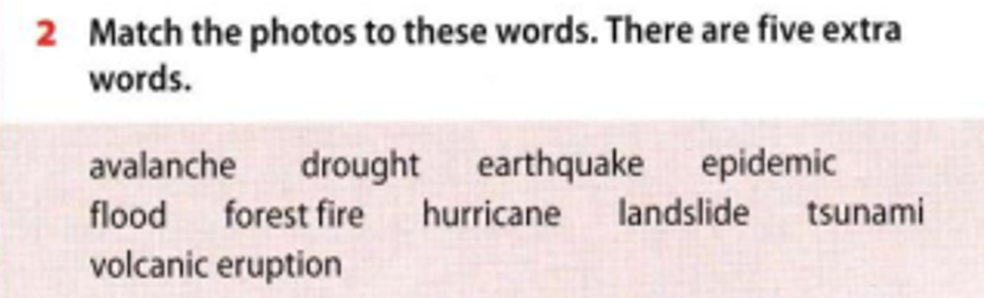

Drought

Task 2
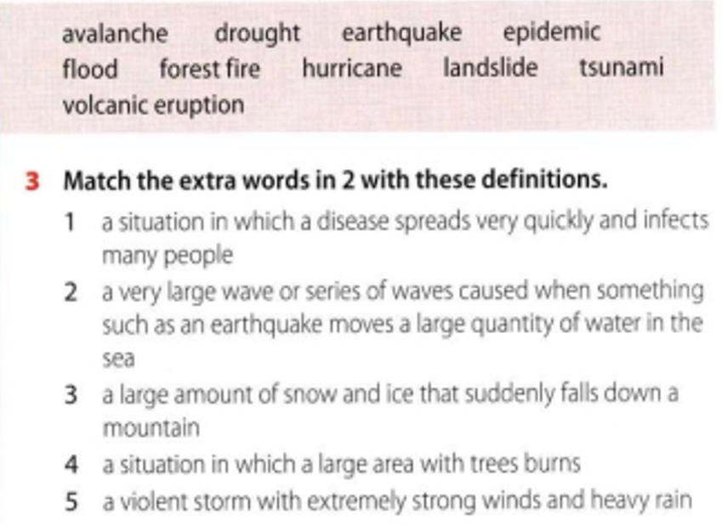

Epidemic

Task 3
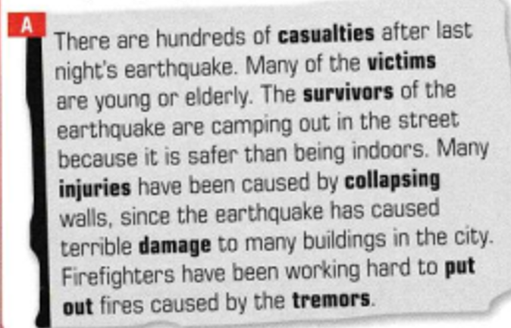
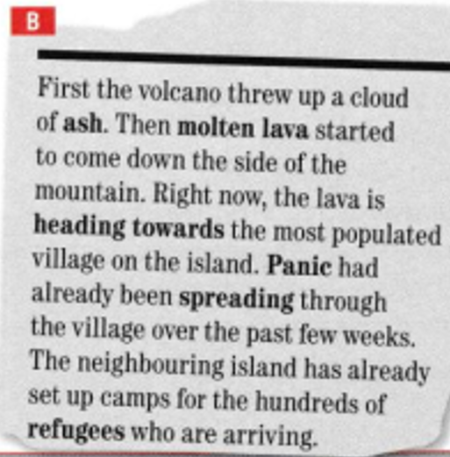
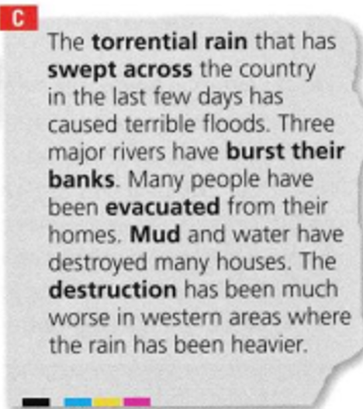

Task 4

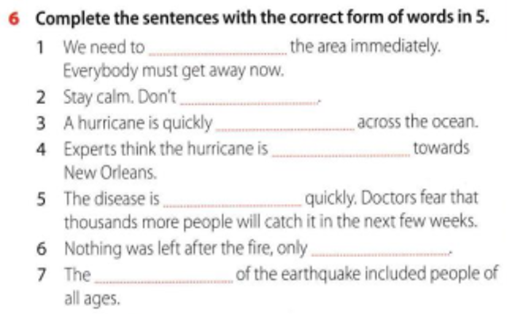

We need to evacuate the area immediately. Everybody must get away now.

Task 5
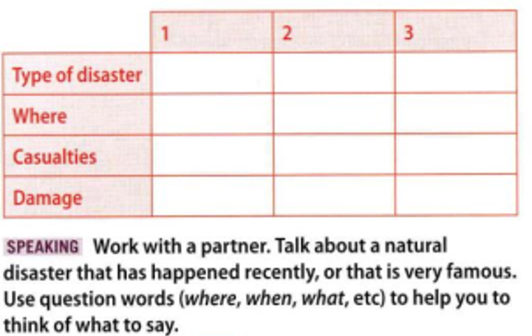

 | 1 | 2 | 3
Type of disaster | Earthquake | Hurricane | Flood
Where | Turkey (2023) | New Orleans (2005) | Pakistan (2022)
Casualties | 50,000+ people | 1,800+ people | 1,700+ people
Damage | Buildings destroyed | Homes and power lost | Crops and homes lost

