“We have to have a business model that can be a sustainable and acceptable one to both regulators and the other stakeholders, clients, and investors.” – Sergio Ermotti, a Swiss manager and investment banker

“I’m here to build something for the long-term. Anything else is a distraction.” – Mark Zuckerberg, Founder of Facebook

Lecture 4
Business Model Design

1. The Importance of Using Business Model Design
2. A robust business model for an organization: main points
3. Types of Business Models

1. The Importance of Using Business Model Design [thinkers360]
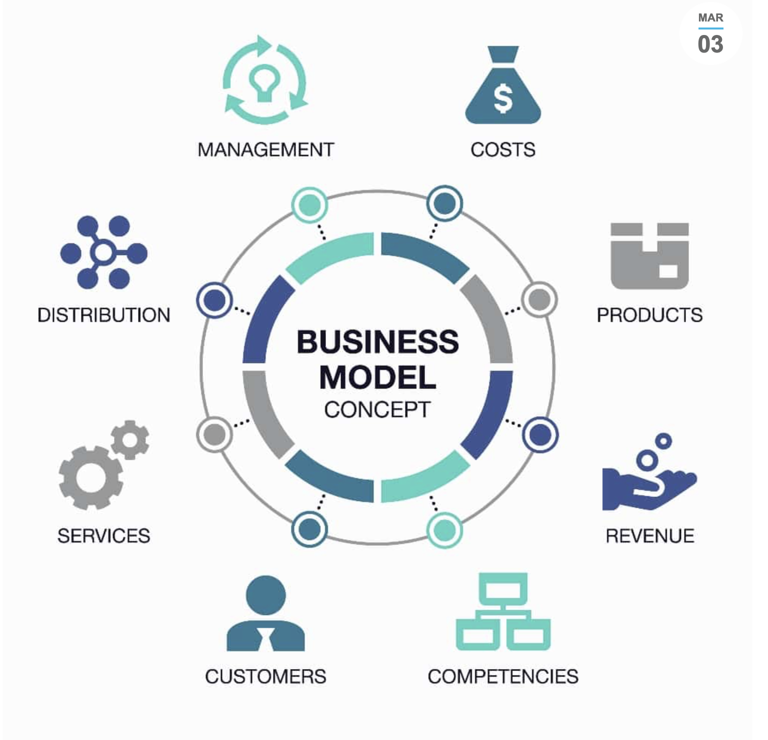
Business model design is a critical aspect of building a successful business. A business model defines the strategy and structure of a company and provides a framework for decision-making. It is an essential tool entrepreneurs, and managers use to create value, generate revenue, and manage costs. A well-designed business model helps companies to achieve their goals, attract investors, and stay competitive in a constantly changing market.
The term business model refers to a company's plan for making a profit. It identifies the products or services the business plans to sell, its identified target market, and any anticipated expenses. Business models are important for both new and established businesses. They help companies attract investment, recruit talent, and motivate management and staff. [investopedia]

Firstly, a business model is the foundation of a company’s strategy. It defines how a company creates and delivers value to its customers and how it captures that value in the form of revenue. A well-designed business model helps a company focus on its core strengths and identify the key activities to drive success. It also enables a company to differentiate itself from competitors and create a unique value proposition that resonates with customers.
For example, consider the business model of Amazon. Amazon’s business model is built on customer-centricity, low prices, and fast delivery. This strategy has enabled Amazon to dominate the e-commerce market and become one of the most valuable companies in the world. By focusing on these core strengths and creating a unique value proposition, Amazon has built a loyal customer base and attracted investors.

Secondly, a well-designed business model helps companies to generate revenue and manage costs. A business model defines a company’s revenue streams, including the pricing strategy, distribution channels, and customer segments. It also outlines a company’s cost structure, including the key resources, activities, and partners required to deliver the value proposition.
Managers can make informed decisions about pricing, marketing, and investments by understanding a company’s revenue streams and cost structure. For example, if a company’s cost structure is too high, it may need to adjust its pricing strategy or look for ways to optimize its operations. Alternatively, if a company’s revenue streams are not generating enough income, it may need to expand its customer base or explore new distribution channels.

Thirdly, a well-designed business model helps companies to stay competitive in a constantly changing market. Markets are dynamic, and companies must be agile and adaptable to stay ahead of the competition. A business model provides a framework for innovation and growth, enabling companies to experiment with new products, services, and business models.
For example, consider the business model of Netflix. Netflix started as a DVD rental service and has since evolved into a streaming platform that produces original content. By experimenting with different business models and revenue streams, Netflix has been able to stay ahead of the competition and maintain its position as a market leader.

Finally, a well-designed business model helps companies to attract investors and secure funding. Investors are interested in companies with a clear and compelling business model demonstrating the potential for growth and profitability. A business model provides a roadmap for success, and investors want to see evidence that a company has thought through its strategy and is focused on achieving its goals.
For example, consider the business model of Airbnb. Airbnb’s business model is built on the sharing economy, enabling it to disrupt the hospitality industry and generate significant revenue. Investors were attracted to Airbnb because of its innovative business model and the potential for growth in the sharing economy.

The importance of using business model design cannot be overstated. A well-designed business model provides a roadmap for success and helps companies generate revenue, manage costs, stay competitive, and attract investors. It is a critical tool that entrepreneurs and managers can use to create value and build successful businesses. By understanding the importance of business model design and investing time and resources into developing a robust business model, companies can achieve their goals, stay ahead of the competition, and create value for their customers and shareholders.

2. A robust business model for an organization: main points. [boardofinnovation]
Research has shown that business model innovation can create up to 25x greater competitive advantage compared to product and process innovation. However, only 17% of companies have invested in evaluating their business model design.
There are some important notes to design of business model.

1. Know your industry before diving deep
In the first stages of business model design, map your industry & most dominant business models. This will help you identify long-held beliefs that might be ready for disruption.
Also, know the numbers (data, statistics, analytics) behind your industry. You’ll understand exactly what you need to know about the market you’re going to operate in.
1.1. Identify the dominant business models & most important long-held beliefs that can be disrupted
1.2. Understand the numbers, KPIs & benchmarks behind your industry, market & business
1.3. Identify the most important trends & how they will change your industry
1.4. Identify the important things you don’t know about the industry, that you will need to ask during interviews with stakeholders

2. Model your business to understand it better
Ideas are great. But if they stay on post-its, they tend not to make it off the paper.
You will further develop your business by modeling and structuring the most important aspects of your company. This will help to further ideate on features of the business model as well as uncover critical assumptions to test.
2.1. Translate long-held beliefs to opportunities for disruption (opposite thinking for BMs)
2.2. Identify business models that you could operate (Business Model flowchart)
2.3. Ideate your business model features

3. Don't rely on the only business model, ideate at least five
Most teams run with the first business model they come up with. You can end up with 5 models that could work for your business.

4. Evaluate your business models
A lot of business models that are only ideated and modeled don’t make sense simply because they don’t add up (or have a very low chance of adding up in the future).
You need to challenge your own business model to see if it has a chance of surviving in the real world.
4.1. Build your business factory using growth metrics (AARRR) and identify your potentially biggest challenges under an operating business model that you can start testing right away
4.2. Estimate the cost of acquisition (COA) and lifetime value (LTV) of your customers. Learn how will this impact your business.
4.3. Build your scale model & understand your upcoming scaling challenges ahead of time that you can start testing immediately
4.4. Based on your model, what are the examples and unique features of well-designed business models, go-to-market strategies, scaling techniques and things you should keep in mind when moving forward

Task 1. Learn about Business Model flowchart. Be prepared to present your findings in class (https://www.lucidchart.com/pages/business-process-mapping, https://venngage.com/blog/types-of-flowcharts/)

Task 2. Learn about growth metrics (AARRR), cost of acquisition (COA) and lifetime value (LTV).

Task 3. Learn about How to Scale Your Business Model (https://growthidea.co.uk/blog/growth-vs-scaling-how-to-scale-your-business-model)

3. Types of Business Models [investinasia]

In the world of business, understanding the various types of business models is essential for entrepreneurs to make well-informed decisions for their ventures. A business model defines how a company creates, delivers, and captures value, playing a significant role in its profitability and sustainability. With a myriad of options available, entrepreneurs need to explore different types of business models to choose the one that aligns best with their business goals and market demands.

1. E-commerce Business Model
The e-commerce business model types operates entirely online, allowing companies to conduct commercial transactions without the need for physical stores. This model provides convenience to customers, who can shop from the comfort of their homes, and offers global reach to businesses. Examples of successful e-commerce platforms include Amazon and eBay.

2. Subscription-Based Business Model
The subscription-based business model entails customers being charged a regular fee in return for gaining access to products or services. This model fosters customer loyalty and generates consistent revenue streams. Companies like Netflix and Spotify have thrived with this approach, providing users with continuous value and a seamless experience.

3. Peer-to-Peer (P2P) Business Model
The P2P business model connects individuals directly to facilitate the exchange of goods or services. P2P platforms, such as Uber and Airbnb, have disrupted traditional industries by creating a sharing economy where people can offer and avail services from one another.

4. Freemium Business Model
The freemium business model types offers basic services for free to attract users and then entices them to upgrade to a premium version with additional features. This approach has been successfully employed by companies like Dropbox and LinkedIn, enabling them to acquire a large user base and convert them into paying customers.

5. Franchise Business Model
The franchise business model allows entrepreneurs to replicate a successful business’s brand and operations by licensing its rights. Well-known examples include McDonald’s and Starbucks, which have expanded their presence globally by partnering with franchisees.

6. Marketplace Business Model
Marketplace business models bring together multiple sellers and buyers on a single platform. These platforms, such as Etsy and Alibaba, act as intermediaries, facilitating transactions and creating a thriving ecosystem for sellers and customers alike.

7. Rental Business Model
The rental business model involves leasing products or services for a specific duration instead of selling them outright. Companies like Rent the Runway and Zipcar offer rental services, providing cost-effective solutions for consumers who don’t need a product permanently.

8. Direct Sales Business Model
The direct sales business model types involves selling products directly to customers without involving intermediaries. Companies like Avon and Tupperware use direct sales representatives to market their products directly to consumers, building strong personal connections.

9. Razor and Blade Business Model
The razor and blade business model relies on selling a primary product at a low cost and making profits from complementary or consumable products. A classic example of this strategy is selling printers at low prices and making revenue from the sale of ink cartridges.

A razor with its attached blade. With the razor and blades model, the razor would be inexpensive but the blades would come at a significant cost.

The legend about Gillette is that he realized that a disposable razor blade would not only be convenient, but also generate a continuous revenue stream. To foster that stream, he sold razors at an artificially low price to create a market for the blades. However, Gillette razors were expensive when they were first introduced, and the price only went down after his patents expired in the 1920s: it was his competitors who invented the razors-and-blades model.

10. Platform as a Service (PaaS) Business Model
The Platform as a Service (PaaS) business model provides a platform that allows developers to build, deploy, and manage applications without worrying about the underlying infrastructure. Companies like Google Cloud Platform and Microsoft Azure offer PaaS solutions, empowering developers and businesses alike.

11. Pay-as-You-Go Business Model
The pay-as-you-go business model charges customers based on their usage of products or services. Cloud-based services like AWS and Google Workspace have embraced this model, providing flexibility and cost-effectiveness to users who only pay for what they use.

12. B2B (Business-to-Business) Business Model
The B2B (Business-to-Business) business model focuses on providing products or services to other businesses rather than individual consumers. Companies like IBM and Cisco operate on this model, catering to the specific needs of other enterprises and organizations.

13. B2C (Business-to-Consumer) Business Model
The B2C (Business-to-Consumer) business model involves selling products or services directly to individual consumers. Companies like Apple and Nike excel in B2C strategies, using effective marketing and brand building to connect with their target audience.

14. Brick-and-Mortar Business Model
The brick-and-mortar business model refers to traditional physical stores that sell products directly to customers. Although facing competition from e-commerce, physical stores like Walmart and Target continue to play a significant role in the retail industry.

15. Hybrid Business Model
Hybrid business models combine elements of two or more business models to cater to a diverse customer base and create competitive advantages. Companies like Disney and Apple have successfully implemented hybrid models to diversify their revenue streams and expand their market presence.

Task 4. Pick up any model from the list and describe it in a detailed way. Use real-business-world examples.

In conclusion, exploring the types of business models is essential for entrepreneurs to make well-informed decisions for their ventures. Each model comes with its own set of advantages and challenges, and choosing the right one can greatly impact a company’s success. As the business landscape continues to evolve, staying adaptable and innovative in selecting and implementing business models will remain critical for sustained growth and prosperity.

https://www.thinkers360.com/tl/blog/members/the-importance-of-using-business-model-design
https://www.boardofinnovation.com/business-design/business-model-design/
https://www.investopedia.com/terms/b/businessmodel.asp
https://investinasia.id/blog/types-of-business-models/

