Тема 3. Framework for Project Management and Project Scope

Project Management Standards and Knowledge Areas. Overview of the Project Management Institute (PMI) and the PMBOK® Guide. Ten Knowledge Areas: Integration, Scope, Time/Schedule, Cost, Quality, Human Resources, Communication, Risk, Procurement, and Stakeholder Management
Project Integration and Scope Management. Planning Scope Management and Collecting Requirements. Defining Scope and Creating a Work Breakdown Structure (WBS).
Time and Schedule Management. Activity Definition and Sequencing. Critical Path Method (CPM): Network Diagram Construction, Critical Path Calculation, Float and Slack Analysis. Program Evaluation and Review Technique (PERT): Probabilistic Time Estimates and PERT Diagrams. Gantt Charts: Purpose, Typical Pitfalls, and Use in Modern Software.

1. Project Management Institute Overview. Project Management Knowledge Areas
2. Project Integration and Scope Management
3. Time and Schedule Management

1. Project Management Institute Overview. Project Management Knowledge Areas [full]

Many different professions contribute to the theory and practice of project management. Engineers and architects have been managing major projects since pre-history. Since approximately the 1960s, there have been efforts to professionalize the practice of project management as a specialization of its own. There are many active debates around this: Should project management be a profession in the same way as engineering, accounting, and medicine? These have professional associations that certify who is legally allowed to use the job title, and who can legally practice the profession. They also provide a level of assurance of quality and discipline members who behave inappropriately. Another ongoing debate is: How much industry knowledge is required of a seasoned project manager? How easily can a project manager from one industry, say, IT, transition to another industry such as hospitality?
There are two major organizations with worldwide impact on the practice of project management: the Project Management Institute (PMI), with world headquarters in the United States, and the International Project Management Association (IPMA), with world headquarters in Switzerland. Here we take an approach that is closer to the PMI approach.

Project Management Institute Overview
Five volunteers founded the Project Management Institute (PMI) in 1969. Their initial goal was to establish an organization where members could share their experiences in project management and discuss issues. Today, PMI is a non-profit project management professional association and the most widely recognized organization in terms of promoting project management best practices.
PMI was formed to serve the interests of the project management industry. The premise of PMI is that the tools and techniques of project management are common even among the widespread application of projects from the software to the construction industry.
PMI first began offering the Project Management Professional (PMP) certification exam in 1984. Although it took a while for people to take notice, now more than 590,000 individuals around the world hold the PMP designation.
To help keep project management terms and concepts clear and consistent, PMI introduced the book A Guide to the Project Management Body of Knowledge (PMBOK Guide) in 1987. It was updated it in 1996, 2000, 2004, 2009, 2013.
2017 – PMBOK Guide, Sixth Edition. The sixth edition added several topics and included agile practices for the first time.
2021 – PMBOK Guide, Seventh Edition. The seventh edition presents major structural changes, such as replacing the 10 knowledge areas with 12 principles and including agile practices more comprehensively.

So what is PMBOK?
PMBOK is the fundamental knowledge you need for managing a project, categorized into 10 knowledge areas of PMBOK:

1. Managing integration: Projects have all types of activities going on and there is a need to keep the “whole” thing moving collectively – integrating all of the dynamics that take place. Managing integration is about developing the project charter, scope statement, and plan to direct, manage, monitor, and control project change.
2. Managing scope: Projects need to have a defined parameter or scope, and this must be broken down and managed through a work breakdown structure (WBS). Managing scope is about planning, definition, WBS creation, verification, and control.
3. Managing time/schedule: Projects have a definite beginning and a definite ending date. Therefore, there is a need to manage the budgeted time according to a project schedule. Managing time/schedule is about definition, sequencing, resource and duration estimating, schedule development, and schedule control.
4. Managing costs: Projects consume resources, and therefore, there is a need to manage the investment with the realization of creating value (i.e., the benefits derived exceed the amount spent). Managing costs is about resource planning, cost estimating, budgeting, and control.
5. Managing quality: Projects involve specific deliverables or work products. These deliverables need to meet project objectives and performance standards. Managing quality is about quality planning, quality assurance, and quality control.
6. Managing human resources: Projects consist of teams and you need to manage project team(s) during the life cycle of the project. Finding the right people, managing their outputs, and keeping them on schedule is a big part of managing a project. Managing human resources is about human resources planning, hiring, and developing and managing a project team.
7. Managing communication: Projects invariably touch lots of people, not just the end users (customers) who benefit directly from the project outcomes. This can include project participants, managers, and external stakeholders who have an interest in the success of the project. Managing communication is about communications planning, information distribution, performance reporting, and stakeholder management.
8. Managing risk: Projects are discovery-driven and often reveal new customer needs or unexpected issues such as staff changes, shifting resources, or emerging technologies. Therefore, it is essential to identify potential risks early and manage them effectively. Managing risk is about risk planning and identification, risk analysis (qualitative and quantitative), risk response planning, risk monitoring, and control.
9. Managing procurement: Projects procure the services of outside vendors and contractors, including the purchase of equipment. There is a need to manage how vendors are selected and managed within the project lifecycle. Managing procurement is about acquisition and contracting plans, sellers’ responses and selections, contract administration, and contract closure.
10. Managing stakeholders: Every project impacts people and organizations and is impacted by people and organizations. Identifying these stakeholders early, and as they arise and change throughout the project, is a key success factor. Managing stakeholders is about identifying stakeholders, their interest level, and their potential to influence the project; and managing and controlling the relationships and communications between stakeholders and the project.

Introduction to the Project Management Knowledge Areas
As discussed above, projects are divided into components, and a project manager must be knowledgeable in each area. Each of these areas of knowledge will be explored in more depth.

Project Start-Up and Integration
The start-up of a project is similar to the start-up of a new organization. The project leader develops the project infrastructure used to design and execute the project. The project management team must develop alignment among the major stakeholders – those who have a share or interest – on the project during the early phases or definition phases of the project. The project manager will conduct one or more kickoff meetings or alignment sessions to bring the various parties of the project together and begin the project team building required to operate efficiently during the project.
During project start-up, the project management team refines the scope of work and develops a preliminary schedule and conceptual budget. The project team builds a plan for executing the project based on the project profile.
Flowcharts, diagrams, and responsibility matrices are tools to capture the work processes associated with executing the project plan.
This is typically an exciting time on a project where all things are possible. The project management team is working many hours developing the initial plan, staffing the project, and building relationships with the client. The project manager sets the tone of the project and sets expectations for each of the project team members. The project start-up phase on complex projects can be chaotic, and until plans are developed, the project manager becomes the source of information and direction. The project manager creates an environment that encourages team members to fully engage in the project and encourages innovative approaches to developing the project plan.

Project Scope
The project scope is a document that defines the parameters, factors that define a system and determine its behaviour, of the project, what work is done within the boundaries of the project, and the work that is outside the project boundaries. The scope of work (SOW) is typically a written document that defines what work will be accomplished by the end of the project – the deliverables of the project. The project scope defines what will be done, and the project execution plan defines how the work will be accomplished.
No template works for all projects. Some projects have a very detailed scope of work, and some have a short summary document.
The quality of the scope is measured by the ability of the project manager and project stakeholders to develop and maintain a common understanding of what products or services the project will deliver. The size and detail of the project scope is related to the complexity profile of the project. A more complex project often requires a more detailed and comprehensive scope document.
According to the PMI, the scope statement should include the following:
- Description of the scope
- Product acceptance criteria
- Project deliverables
- Project exclusions
- Project constraints
- Project assumptions
The scope document is the basis for agreement by all parties. A clear project scope document is also critical to managing change on a project. Since the project scope reflects what work will be accomplished on the project, any change in expectations that is not captured and documented creates the opportunity for confusion. One of the most common trends on projects is the incremental expansion in the project scope. This trend is labeled “scope creep.” Scope creep threatens the success of a project because the small increases in scope require additional resources that were not in the plan.
Events do occur that require the scope of the project to change. For example, changes in the marketplace may require change in a product design or the timing of the product delivery. Generally, the later in the project the change occurs, the greater the increase to the project costs. Establishing a change management system for the project that captures changes to the project scope and assures that these changes are authorized by the appropriate level of management in the client’s organization is the responsibility of the project manager. The project manager also analyzes the cost and schedule impact of these changes and adjusts the project plan to reflect the changes authorized by the client.

Project Schedule and Time Management
The development and management of a project schedule that will complete the project on time
The definition of project success often includes completing the project on time. The development and management of a project schedule that will complete the project on time is a primary responsibility of the project manager, and completing the project on time requires the development of a realistic plan and the effective management of the plan. On smaller projects, project managers may lead the development of the project plan and build a schedule to meet that plan.
To develop the project schedule, the project team does an analysis of the project scope, contract, and other information that helps the team define the project deliverables. Based on this information, the project team develops a milestone schedule. Milestones are checkpoints that identify when activities or groups of activities have been completed or when a new phase or activity is launched. The milestone schedule establishes key dates throughout the life of a project. For less complex projects, a milestone schedule may be sufficient for tracking the progress of the project. For more complex projects, a more detailed schedule is required.
To develop a more detailed schedule, the project team first develops a work breakdown structure (WBS) – a description of tasks arranged in layers of detail. Although the project scope is the primary document for developing the WBS, the WBS incorporates all project deliverables and reflects any documents or information that clarifies the project deliverables. From the WBS, a project plan is developed. The project plan lists the activities that are needed to accomplish the work identified in the WBS.
After the project team identifies the activities, the team sequences the activities according to the order in which the activities are to be accomplished. An outcome from the work process is the project logic diagram. The logic diagram represents the logical sequence of the activities needed to complete the project. The next step in the planning process is to develop an estimation of the time it will take to accomplish each activity or the activity duration. Some activities must be done sequentially, and some activities can be done concurrently. The planning process creates a project schedule by scheduling activities in a way that effectively and efficiently uses project resources and completes the project in the shortest time.
On larger projects, several paths are created that represent a sequence of activities from the beginning to the end of the project. The longest path to the completion of the project is the critical path. If the critical path takes less time than is allowed by the client to complete the project, the project has a positive total float or project slack. If the client’s project completion date precedes the calculated critical path end date, the project has a negative float. Understanding and managing activities on the critical path is an important project management skill.
To successfully manage a project, the project manager must also know how to accelerate a schedule to compensate for unanticipated events that delay critical activities. Compressing–crashing–the schedule is a term used to describe the techniques used to shorten the project schedule. During the life of the project, scheduling conflicts often occur, and the project manager is responsible for reducing these conflicts while maintaining project quality and meeting cost goals.

Project Costs
Project success is often defined by completing the work within budget, making cost management a critical skill for project managers. While clients expect efficiency, some projects face greater schedule pressures than cost concerns, for example, launching a new drug, releasing a revenue-generating product, or being first to market with a new technology. In such cases, deadlines can outweigh budget considerations.
Because early project stages lack detailed information, budgets are created at different levels of accuracy. A conceptual or “ballpark” estimate is based largely on expert judgment and past experience. As more data becomes available, teams can create rough order of magnitude (ROM) estimates using approximate measures such as square footage or production capacity. Once designs are complete, detailed estimates are possible, supported by specific information such as material types and quantities.
Project costs are then tracked against progress. The project manager ensures estimates are updated as better information emerges, monitors deviations between actual and planned costs, and investigates the causes of significant differences. Corrective actions are taken when necessary to keep project performance aligned with revised plans and objectives.

Project Quality
Project quality focuses on the end product or service deliverables that reflect the purpose of the project. The project manager is responsible for developing a project execution approach that provides for a clear understanding of the expected project deliverables and the quality specifications. The project manager of a housing construction project not only needs to understand which rooms in the house will be carpeted but also what grade of carpet is needed. A room with a high volume of traffic will need a high-grade carpet.
The project manager is responsible for developing a project quality plan that defines the quality expectations and ensures that the specifications and expectations are met. Developing a good understanding of the project deliverables through documenting specifications and expectations is critical to a good quality plan. The processes for ensuring that the specifications and expectations are met are integrated into the project execution plan. Just as the project budget and completion dates may change over the life of a project, the project specifications may also change. Changes in quality specifications are typically managed in the same process as cost or schedule changes.

Project Team: Human Resources and Communications
Staffing the project with the right skills, at the right place, and at the right time is an important responsibility of the project management team. The project usually has two types of team members: functional managers and process managers. The functional managers and team focus on the technology of the project. On a construction project, the functional managers would include the engineering manager and construction superintendents. On a training project, the functional manager would include the professional trainers; on an information technology project, the software development managers would be functional managers.
The project management team also includes project process managers. The project controls team would include process managers who have expertise in estimating, cost tracking, planning, and scheduling. The project manager needs functional and process expertise to plan and execute a successful project.
Because projects are temporary, the staffing plan for a project typically reflects both the long-term goals of skilled team members needed for the project and short-term commitment that reflects the nature of the project. Exact start and end dates for team members are often negotiated to best meet the needs of individuals and the project. The staffing plan is also determined by the different phases of the project. Team members needed in the early or conceptual phases of the project are often not needed during the later phases or project closeout phases. Team members needed during the implementation phase are often not needed during the conceptual or closeout phases. Each phase has staffing requirements, and the staffing of a complex project requires detailed planning to have the right skills, at the right place, at the right time.
Typically a core project management team is dedicated to the project from start-up to closeout. This core team would include members of the project management team: project manager, project controls, project procurement, and key members of the function management or experts in the technology of the project. It is important on all projects to have team members who can provide continuity through the project phases.
Project team members can be assigned to the project from a number of different sources. The organization that orders the project can assign talented managers and staff from functional units within the organization, contract with individuals or agencies to staff positions on the project, temporarily hire staff for the project, or use any combination of these staffing options. This staffing approach allows the project manager to create the project organizational culture. Some project cultures are more structured and detail oriented, and some are less structured with less formal roles and communication requirements. The type of culture the project manager creates depends greatly on the type of project.
Communications
Completing a complex project successfully requires teamwork, and teamwork requires good communication among team members. Communicating can be divided into two categories: synchronous and asynchronous. If all the parties to the communication are taking part in the exchange at the same time, the communication is synchronous (e.g. a telephone conference). When the participants are not interacting at the same time, the communication is asynchronous. Establishing effective communications requires a communications plan.

Project Risk
Risk is present in every project, and the role of the project management team is to recognize the types and levels of risks and create strategies to address them. Risks vary depending on the industry, project complexity, and phase, and the overall plan must also consider the attitudes of the project manager and stakeholders, as some may be more risk averse than others.
The first step in risk management is identifying potential risks, which may be obvious or hidden. Checklists developed from past industry experience, such as those used in construction, can guide discussion but never capture all possible risks. Once identified, risks are analyzed in terms of their likelihood and potential impact, resulting in a prioritized list for action.
Based on this analysis, the team creates a mitigation plan to reduce the chance of risks occurring or minimize their impact if they do. Contingency funds are often set aside for unexpected events, with more allocated to high-risk activities or as a general reserve. The plan is integrated into project execution and reviewed periodically to ensure risks remain under control throughout the project.

Project Procurement
Procurement on projects can vary greatly depending on project type and complexity. On smaller projects, procurement is often handled by the client’s organization. In such cases, the project team identifies required materials, equipment, and supplies, prepares specifications, and develops a delivery schedule. A liaison may assist the procurement department to ensure project-specific and time-critical needs are understood.
Larger, more complex projects usually dedicate personnel to procurement activities. Because projects are temporary, materials and equipment are procured either as part of the project’s final product (e.g., bricks for construction) or for execution purposes (e.g., a mortar mixer). At the project’s end, execution-related equipment is sold, returned, or otherwise disposed of.
Different procurement methods are used depending on project needs. Commodities such as concrete, office supplies, or lab equipment are often purchased from the lowest bidder. More specialized products require vendors who can meet technical specifications, schedules, and quality standards. Vendor performance becomes critical, and project managers assign resources to manage coordination and timelines.
A third approach involves developing partnerships with firms that contribute directly to project execution. Examples include design companies for major project components or research firms handling critical subparts. Such partners are integrated into the project plan, share responsibility for success, and align with the project’s goals. The project procurement plan identifies the most effective approach to ensure project objectives are achieved.

Project Stakeholder Management
People and organizations can have many different relationships to the project. Most commonly, these relationships can be grouped into those who will be impacted by the project and those who can impact the project.
A successful project manager will identify stakeholders early in the project. For each stakeholder, it is important to identify what they want or need and what influence or power they have over the project. Based on this information, the need to communicate with the stakeholder or stakeholder group can be identified, followed by the creation of a stakeholder management plan. A stakeholder register is used to identify and track the interactions between the project and each stakeholder. This register must be updated on a regular basis, as new stakeholders can arise at any time, and the needs and interest levels of a particular stakeholder may change through the course of the project.

Task 1. Outline the roles of a project manager at each stage considered above.

Task 2. Learn about Project Initiation. Outline the main points to be done at this stage in Project Management.
(https://asana.com/resources/project-initiation, https://www.notion.so/blog/project-initiation )

Task 3. Consider the following examples of business strategies and goals. Find out what the vision and mission are. Find more examples from other companies.
Organizations exist to fulfill a purpose. These purposes are analyzed through a process and ultimately expressed in an organization’s vision and mission statements. Vision statements are often very broad and they describe what the organizational leaders want the organization to accomplish. Mission statements are more specific: they describe how the organization is going to fulfill its vision. Recently, on many organizations’ websites, mission and vision statements have not been explained separately, but as one statement named “mission statement”. Organizations may also elaborate on their principles, values, culture, and goals to explicate their missions. Some examples of vision and mission statements are provided below:
[1] LinkedIn :
Vision: Create economic opportunity for every member of the global workforce.
Mission: The mission of LinkedIn is simple: connect the world’s professionals to make them more productive and successful.
[2] Facebook :
Mission: Give people the power to build community and bring the world closer together.
Culture: At Facebook, we are constantly iterating, solving problems, and working together to connect people all over the world. That’s why it’s important that our workforce reflects the diversity of the people we serve. Hiring people with different backgrounds and points of view helps us make better decisions, build better products and create better experiences for everyone.
[3] Ikea :
Vision: Our vision is to create a better everyday life for the many people – for customers, but also for our co-workers and the people who work at our suppliers.
Business idea: While our vision tells us why we exist, our business idea tells us what we want to achieve. And for everyone that has visited IKEA, our business idea is pretty obvious – “to offer a wide range of well-designed, functional home furnishing products at prices so low, that as many people as possible will be able to afford them.”
[4] Microsoft :
Mission: Our mission is to empower every person and every organization on the planet to achieve more.

Task 4. Learn about the SMART protocol in the development of the objectives of the project. Be prepared to present your findings in class.

2. Project Scope Management

Scope Planning
You always want to know exactly what work has to be done before you start it. You have a collection of team members, and you need to know exactly what they’re going to do to meet the project’s objectives. The scope planning process is the very first thing you do to manage your scope. Project scope planning is concerned with the definition of all the work needed to successfully meet the project objectives. The whole idea here is that when you start the project, you need to have a clear picture of all the work that needs to happen on your project, and as the project progresses, you need to keep that scope up to date and written down in the project’s scope management plan.

Defining the Scope
You already have a head start on refining the project’s objectives in quantifiable terms, but now you need to plan further and write down all the intermediate and final deliverables that you and your team will produce over the course of the project. Deliverables include everything that you and your team produce for the project (i.e., anything that your project will deliver). The deliverables for your project include all of the products or services that you and your team are performing for the client, customer, or sponsor. They include every intermediate document, plan, schedule, budget, blueprint, and anything else that will be made along the way, including all of the project management documents you put together. Project deliverables are tangible outcomes, measurable results, or specific items that must be produced to consider either the project or the project phase completed. Intermediate deliverables, like the objectives, must be specific and verifiable.
All deliverables must be described in a sufficient level of detail so that they can be differentiated from related deliverables.

For example:
A twin engine plane versus a single engine plane
A red marker versus a green marker
A daily report versus a weekly report
A departmental solution versus an enterprise solution

One of the project manager’s primary functions is to accurately document the deliverables of the project and then manage the project so that they are produced according to the agreed-on criteria. Deliverables are the output of each development phase, described in a quantifiable way.

Project Requirements
After all the deliverables are identified, the project manager needs to document all the requirements of the project. Requirements describe the characteristics of the final deliverable, whether it is a product or a service. They describe the required functionality that the final deliverable must have or specific conditions the final deliverable must meet in order to satisfy the objectives of the project.
A requirement is an objective that must be met. The project’s requirements, defined in the scope plan, describe what a project is supposed to accomplish and how the project is supposed to be created and implemented. Requirements answer the following questions regarding the as-is (current) and to-be (future) states of the business: who, what, where, when, how much, and how does a business process work?
Requirements may include attributes like dimensions, ease of use, colour, specific ingredients, and so on.
Requirements specify what the final project deliverable should look like and what it should do. Requirements must be measurable, testable, related to identified business needs or opportunities, and defined to a level of detail sufficient for system design. They can be divided into six basic categories: functional, non-functional, technical, business, user, and regulatory requirements.
(1) Functional Requirements. They describe the characteristics of the final deliverable in ordinary non-technical language. They should be understandable to the customers, and the customers should play a direct role in their development. Functional requirements are what you want the deliverable to do.
Vehicle Example. If you were buying vehicles for a business, your functional requirement might be: “The vehicles should be able to take up to a one ton load from a warehouse to a shop.”
Computer System Example. For a computer system you may define what the system is to do: “The system should store all details of a customer’s order.”
The important point to note is that what is wanted is specified and not how it will be delivered.
(2) Non-Functional Requirements. They specify criteria that can be used to judge the final product or service that your project delivers. They are restrictions or constraints to be placed on the deliverable and how to build it. Their purpose is to restrict the number of solutions that will meet a set of requirements. Using the vehicle example, the functional requirement is for a vehicle to take a load from a warehouse to a shop. Without any constraints, the solutions being offered might result in anything from a small to a large truck.
Non-functional requirements can be split into two types: performance and development.
To restrict the types of solutions, you might include these performance constraints:
- The purchased trucks should be American-made trucks due to government incentives.
- The load area must be covered.
- The load area must have a height of at least 10 feet.
Similarly, for the computer system example, you might specify values for the generic types of performance constraints:
- The response time for information is displayed on the screen for the user.
- The number of hours a system should be available.
One important point with these examples is that they restrict the number of solution options that are offered to you by the developer. In addition to the performance constraints, you may include some development constraints.
There are three general types of non-functional development constraints:
Time: When a deliverable should be delivered
Resource: How much money is available to develop the deliverable
Quality: Any standards that are used to develop the deliverable, development methods, etc.
(3) Technical Requirements. They emerge from the functional requirements to answer the questions: how will the problem be solved this time and will it be solved technologically and/or procedurally? They specify how the system needs to be designed and implemented to provide required functionality and fulfill required operational characteristics.
For example, in a software project, the functional requirements may include the development of a database system to provide access to financial data via a remote terminal. The relevant technical requirements define the required data elements, the language in which the database management system will be written (due to existing knowledge in-house), the hardware on which the system will run (due to existing infrastructure), telecommunication protocols that should be used, etc.
(4) Business Requirements. They are the needs of the sponsoring organization, always from a management perspective. Business requirements are statements of the business rationale for the project. They are usually expressed in broad outcomes, satisfying the business needs, rather than specific functions the system must perform. These requirements grow out of the vision for the product that, in turn, is driven by mission (or business) goals and objectives.
(5) User Requirements. User requirements describe what the users need to do with the system or product. The focus is on the user experience with the system under all scenarios. These requirements are the input for the next development phases: user-interface design and system test cases design.
(6) Regulatory requirements. They can be internal or external and are usually non-negotiable. They are the restrictions, licenses, and laws applicable to a product or business that are imposed by the government.

An Example of Requirements
Automated teller machines (ATMs) can be used to illustrate a wide range of requirements. What are some of the physical features of these machines, and what kinds of functions do they perform for the bank’s customers? Why did banks put these systems in place? What are the high-level business requirements?
The following represents one possible example of each type of requirement as they would be applied to a bank’s external ATM.
- ATM functional requirement: The system will enable the user to select whether or not to produce a hard-copy transaction receipt before completing a transaction.
- ATM non-functional requirement: All displays will be in white, 14-point Arial text on black back ground.
- ATM technical requirement: The ATM system will connect seamlessly to the existing customer’s database.
- ATM user requirement: The system will complete a standard withdrawal from a personal account, from log-in to cash, in less than two minutes.
- ATM business requirement: By providing superior service to our retail customers, Monumental Bank’s ATM network will allow us to increase associated service fee revenue by 10% annually on an ongoing basis.
- ATM regulatory requirement: All ATMs will connect to standard utility power sources within their civic jurisdiction, and be supplied with an uninterrupted power source approved by the company.

The effective specification of requirements is one of the most challenging undertakings project managers face.
Documenting requirements is much more than just the process of writing down the requirements as the user sees them; it should cover not only what decisions have been made, but why they have been made, as well. Understanding the reasoning that was used to arrive at a decision is critical in avoiding repetition. For example, the fact that a particular feature has been excluded, because it is simply not feasible, needs to be recorded. If it is not, then the project risks wasted work and repetition, when a stakeholder requests the feature be reinstated during development or testing.
Once the requirements are documented, have the stakeholders sign off on their requirements as a confirmation of what they desire.
While the project manager is responsible for making certain the requirements are documented, it does not mean that the project manager performs this task. The project manager involves all stakeholders in cooperation (business analysts, requirement analysts, business process owners, customers and other team members) to conduct the discussions, brain-storming, and interviews, and to document and sign off the requirements. The project manager is responsible only for enabling the process and facilitating it. If the project manager feels that the quality of the document is questionable, his or her duty is to stop the development process.
The project manager reviews the requirements, incorporates them into the project documentation library, and uses them as an input for the project plan.

Software Requirements Fundamentals
This section refers to requirements of “software” because it is concerned with problems to be addressed by software. A software requirement is a property (feature, quality) that must be exhibited by software developed or adapted to solve a particular problem. The problem may be to automate part of a task of someone who will use the software, to support the business processes of the organization that has commissioned the software, to correct shortcomings of existing software, to control a device, etc. The functioning of users, business processes, and devices is typically complex. Therefore, the requirements on particular software are typically a complex combination of requirements from different people at different levels of an organization and from the environment in which the software will operate.
An essential property of all software requirements is that they be verifiable. It may be difficult or costly to verify certain software requirements. For example, verification of the throughput requirement on a call centre may necessitate the development of simulation software. Both the software requirements and software quality personnel must ensure that the requirements can be verified within the available resource constraints.
Requirements have other attributes in addition to the behavioural properties that they express. Common examples include a priority rating to enable trade-offs in the face of flimited resources and a status value to enable project progress to be monitored. Typically, software requirements are uniquely identified so that they can be monitored over the entire software life cycle.

Measuring Requirements
As a practical matter, it is useful to have a clear understanding of the scope and volume of requirements for a particular software product. Such information helps evaluate the magnitude of changes in requirements, estimate the cost of development or maintenance, and serves as a basis for other measurements. To ensure these requirements are meaningful, they should be expressed in measurable terms.
For instance, system speed can be assessed by the number of processed transactions per second or by user response time. Size is often measured in kilobytes or by the number of RAM chips required. Ease of use may be evaluated through the time needed for user training or the amount of supporting documentation available. Reliability is reflected in indicators such as mean time to failure or the probability of system unavailability. Finally, portability can be measured by the percentage of environment-dependent commands or by the number of target systems on which the software can operate.

Scope Inputs
The project manager gathers initial project facts from the project charter. In addition, background information on the stakeholder’s workplace, existing business model and rules, etc. assist in creating the vision of the final product/service, and consequently, the project scope.

Techniques
Gathering requirements is part of scope definition, and it can be done using one or more of following techniques:
- Interviews
- Focus groups
- Facilitated groups such as JAD (joint application development)
- Group creativity techniques: brainstorming, nominal groups, delphi, mind map, affinity diagnostics
- Prototyping
- Observation
- Questions and surveys
- Group decision-making techniques: unanimity, majority, plurality, dictatorship

Requirements Traceability Matrix
The requirements traceability matrix is a table that links requirements to their origin and traces them throughout the project life cycle. The implementation of a requirements traceability matrix helps ensure that each requirement adds business value by linking it to the business and project objectives. It provides a means to track requirements throughout the project life cycle, helping to ensure that requirements approved in the requirements documentation are delivered at the end of the project. Finally, it provides a structure for managing changes to the product scope. This process includes, but is not limited to, tracking:
- Requirements to business needs, opportunities, goals, and objectives
- Requirements to project objectives
- Requirements to project scope/work breakdown structure deliverables
- Requirements to product design
- Requirements to product development
- Requirements to test strategy and test scenarios
- High-level requirements to more detailed requirements

Requirements Traceability Matrix (Sample)
Requirement ID | Requirement Description | Test Case ID | Design Module | Status
RQ-01 | User shall be able to log in with email | TC-01 | DM-Login | Passed
RQ-02 | System shall lock account after 3 fails | TC-02 | DM-Login | Pending
RQ-03 | User shall be able to reset password | TC-03 | DM-Password | In-Progress
RQ-04 | System shall display dashboard summary | TC-04 | DM-Dashboard | Passed
RQ-05 | Reports shall be exportable in PDF | TC-05 | DM-Reports | Not Tested

Work Breakdown Structure (WBS)
Now that we have the deliverables and requirements well defined, the process of breaking down the work of the project via a WBS begins. The WBS defines the scope of the project and breaks the work down into components that can be scheduled, estimated, and easily monitored and controlled. The idea behind the WBS is simple: you subdivide a complicated task into smaller tasks, until you reach a level that cannot be further subdivided. You stop breaking down the work when you reach a low enough level to perform an estimate of the desired accuracy. At that point, it is usually easier to estimate how long the small task will take and how much it will cost to perform than it would have been to estimate these factors at the higher levels.

WBS is a hierarchical decomposition of the project into phases, deliverables, and work packages. It is a tree structure, which shows a subdivision of effort required to achieve an objective (e.g., a program, project, and contract). In a project or contract, the WBS is developed by starting with the end objective and successively subdividing it into manageable components in terms of size, duration, and responsibility (e.g., systems, subsystems, components, tasks, subtasks, and work packages), which include all steps necessary to achieve the objective.
The WBS creation involves:
- Listing all the project outputs (deliverables and other direct results)
- Identifying all the activities required to deliver the outputs
- Subdividing these activities into subactivities and tasks
- Identifying the deliverable and milestone(s) of each task
- Identifying the time usage of all the resources (personnel and material) required to complete each task

Example of a WBS
If I want to clean a room, I might begin by picking up clothes, toys, and other things that have been dropped on the floor. I could use a vacuum cleaner to get dirt out of the carpet. I might take down the curtains and take them to the cleaners, and then dust the furniture. All of these tasks are subtasks performed to clean the room. As for vacuuming the room, I might have to get the vacuum cleaner out of the closet, connect the hose, empty the bag, and put the machine back in the closet. These are smaller tasks to be performed in accomplishing the subtask called vacuuming. Figure 9.3 shows how this might be portrayed in WBS format.
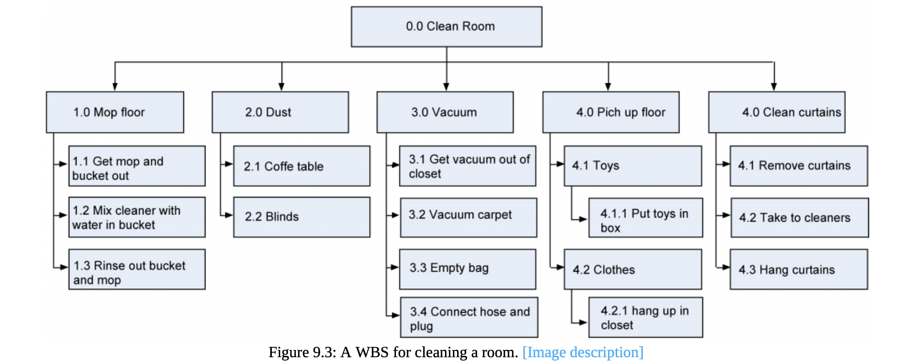
It is very important to note that we do not worry about the sequence in which the work is performed or any dependencies between the tasks when we do a WBS. That will be worked out when we develop the schedule. The main idea of creating a WBS is to capture all of the tasks, irrespective of their order. A WBS can be structured any way it makes sense to you and your project.

You’ll notice that each element at each level of the WBS is assigned a unique identifier. This unique identifier is typically a number, and it’s used to sum and track costs, schedules, and resources associated with WBS elements. These numbers are usually associated with the corporation’s chart of accounts, which is used to track costs by category. Collectively, these numeric identifiers are known as the code of accounts.
There are also many ways you can organize the WBS. For example, it can be organized by either deliverable or phase. The major deliverables of the project are used as the first level in the WBS. For example, if you are doing a multimedia project the deliverables might include producing a book, CD, and a DVD (Figure 9.5).
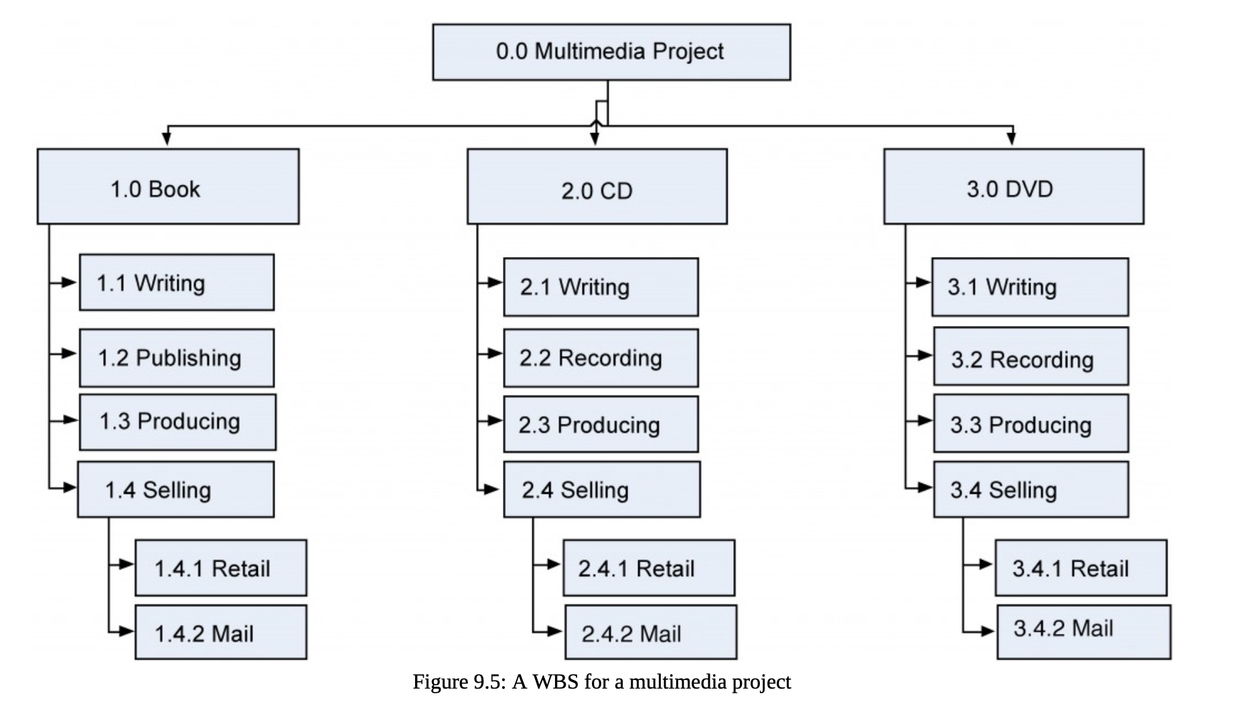
Many projects are structured or organized by project phases (Figure 9.6). Each phase would represent the first level of the WBS and their deliverables would be the next level and so on.
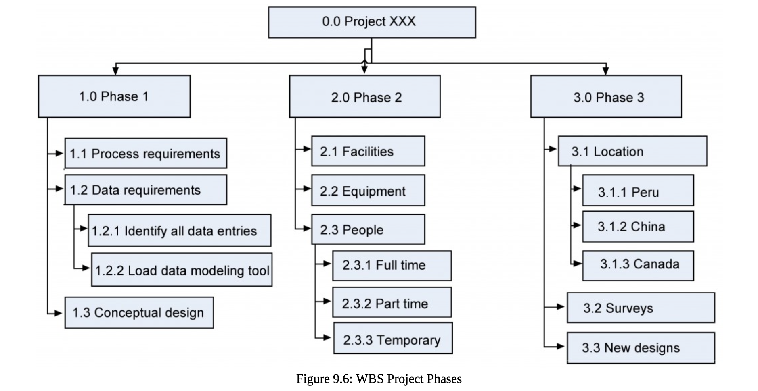
The project manager is free to determine the number of levels in the WBS based on the complexity of the project. You need to include enough levels to accurately estimate project time and costs but not so many levels that are difficult to distinguish between components. Regardless of the number of levels in a WBS, the lowest level is called a work package.
Work packages are the components that can be easily assigned to one person or a team of people, with clear accountability and responsibility for completing the assignment. The work-package level is where time estimates, cost estimates, and resource estimates are determined.
3. Time and Schedule Management
[Oguz]

Project planning is at the heart of the project life cycle and tells everyone involved where we are going and how we are going to get there. It involves creating a set of plans to help guide our team through the implementation and closure phases of the project. The project schedule management plan is one of the sub-plans of our overall project plan. It provides the guidelines to project managers on how to develop a project schedule by defining and sequencing project activities and milestones, and by estimating activity durations. It is the process of establishing the policies, procedures, and documentation for planning, developing, managing, executing, and controlling the project schedule.

In line with the project schedule management plan, we should start scheduling the whole project by defining activities based on the WBS (Work Breakdown Structure). The activity definition process is a further breakdown of the work package elements of the WBS. It documents the specific activities needed to fulfill the deliverables detailed in the WBS. These activities are not the deliverables themselves but the individual units of work that must be completed to fulfill the deliverables. Activity definition uses everything we already know about the project to divide the work into activities that can be estimated.
Detailed planning begins by identifying all the tasks to be completed. The project team begins by reviewing the scope of the project which is found in the project scope statement (predictive/waterfall projects) or the product backlog.

Estimating Activity Durations
After we define the lowest level of activities in an activity list, each activity is reviewed and evaluated to determine the duration (how long it will take to accomplish from beginning to end) and what resources (e.g., human resources, materials, facilities, and equipment) are needed. An estimate is an educated guess based on knowledge, experience, and inference – the process of deriving conclusions based on assumptions. The accuracy of the estimate is related to the quality of the knowledge and how that knowledge is applied. The person with the most knowledge may not be the most objective person to provide duration estimates. The person responsible for the work may also want to build in extra time. Therefore, multiple inputs into the duration estimate and a more detailed WBS help reduce bias – the making of decisions based on a prejudged perspective.
It is of high importance here to highlight how a milestone is different from an activity. A milestone is a significant point or event in a project. Milestones have zero duration because they represent a significant point or event. A milestone list identifies all project milestones and indicates whether the milestone is mandatory, such as those required by contract, or optional, such as those based on historical information.
The unit of time used to develop the activity duration is a function of the level of detail needed by the user of the schedule. The larger and more complex the project, the greater the need for detail, which usually translates into shorter durations for activities. However, it is common to use two types of units – one is days or weeks for activities, and hours to display the work hours.
There are five types of estimation methods:
1. Expert judgment: The project team consults domain and implementation subject matter experts who have technical knowledge and experience in the areas the project activities are related to.
2. Appropriation method (Analogous estimating): Actual durations from similar projects are reviewed, and the same proportions are applied to the current project.
3. Parametric estimating: In this estimation technique, we can use equations and algorithms to calculate the duration based on the resources we use and how many hours they need to work, or how many of them we need to use. This method is quantitative. We can multiply the quantity of work to be performed by the number of hours per unit of work. If we can estimate the amount of the work, we can divide it by the work that can be done in an hour.
For example, let’s assume that, in our m-commerce project, we estimated that software developers need to create 200 lines of code for a module. Based on the previous projects and the feedback we received from the subject matter experts, we have estimated that a developer can finish 40 lines in an hour. Therefore, a developer needs 5 hours to finish all 200 lines. We can also add a one-hour break and two-hour review for this task. Therefore, the total work hours amount to 8 hours which is translated to one day in our schedule.
Another example can be regarding the installation of cables in an infrastructure project. If workers can install 100 feet of cable per hour, the duration required to install 1,000 feet would be 10 hours (1,000 feet divided by 100 feet per hour). Parametric schedule estimates can be applied to a total project or segments of a project, in conjunction with other estimating methods.
4. Three-point estimates: Duration estimates are done based on three scenarios:
a. A realistic estimate (most likely to occur – m)
b. An optimistic estimate (best-case scenario – o)
c. A pessimistic estimate (worst-case scenario – p)
In the three-point estimation method, two distributions are possible – triangular and beta. In triangular distribution, all three duration estimates get the same weight. In a beta distribution, the realistic estimate gets four-sixths of the weight whereas the other two estimates have one-sixth of the weight.
5. WBS method (Bottom-up estimating). The Work Breakdown Structure (WBS) serves as the foundation for this approach.
In practice, each work package or activity at the lowest level of the WBS is analyzed individually, and its duration (or cost) is estimated based on available data, expert judgment, or historical information. Once all activity estimates are made, they are aggregated upward to form estimates for higher-level deliverables, phases, and finally the total project.
The main advantage of this method is that it usually produces more accurate and reliable estimates, since they are based on detailed tasks rather than broad assumptions. However, it can be time-consuming and resource-intensive, as it requires thorough analysis of each activity.

Creating an Activity Network Diagram
After we define the activities and estimate their duration, we are ready to create an activity network diagram which is a graphical representation of the logical relationship (i.e., dependencies) among the project activities. Duration estimation can also accompany the creation of an activity network. The process can be iterative, and the project team can move back and forth to refine the activities, durations, and their relationships with other activities.
Activities are carried out in order. Therefore, they have predecessors and successors. They have logical relationships or dependencies which show the sequence in which the activities are to be performed. There are four relationships between activities, which can be indicated as “Finish-to-Start” (FS), “Finish-to-Finish” (FF), “Start-to-Start” (SS), and “Start-to-Finish” (SF). The most common relationship is Finish-to-Start at which we start a successor activity once we finish the predecessor activity. A Start-to-Finish relationship is very rarely used.
Showing the activities in rectangles or circles, and their relationships (dependencies) as arrows is called a precedence diagramming method (PDM). This kind of diagram is also called an activity-on-node (AON) diagram (Figure 7.1). Another way to show how tasks relate is with the activity-on-arrow (AOA) diagram (Figure 7.1). AOA diagram is traditionally drawn using circles as the nodes, representing the beginning and ending points, and the arrows representing activities. AON is more commonly used and is supported by all project management programs.
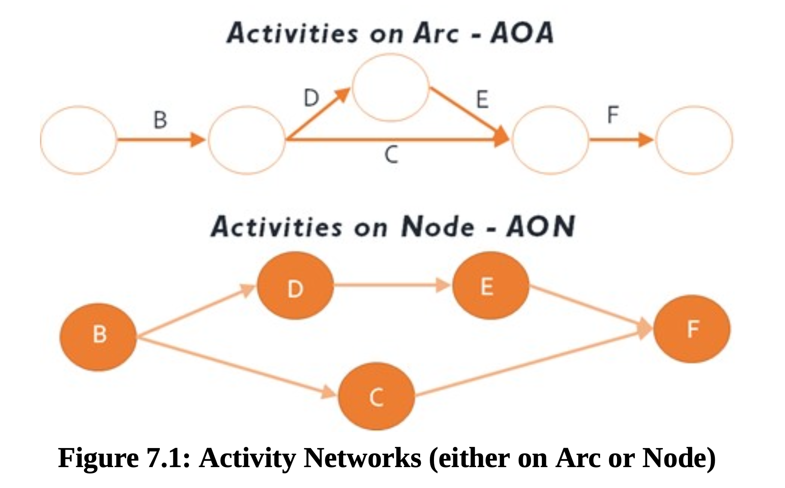
Logical Relationships / Dependencies
Table
Activity Dependencies in Project Management
Dependency Type | General Example | Software Development Example
Finish-to-Start (FS)  The successor activity cannot start until the predecessor activity finishes.  Most common dependency in projects. | You cannot start testing until programming is complete. | Coding a module must finish before unit testing of that module can start.
Finish-to-Finish (FF)  The successor activity cannot finish until the predecessor activity finishes | Documentation cannot finish until development is finished. | System integration and integration testing run in parallel, but testing cannot finish until integration is complete.
Start-to-Start (SS)  The successor activity cannot start until the predecessor activity starts. | As soon as development starts, test case preparation can also start. | When coding begins, QA engineers can start preparing test cases.
Start-to-Finish (SF)  The successor activity cannot finish until the predecessor activity starts.  Least common | The old support shift cannot finish until the new shift starts. | The old software version cannot be shut down until the new version is live in production.

Lag
A lag is the amount of time a successor activity can be delayed with respect to a predecessor activity. Consider that we should paint one room in our house. We need to apply plaster to walls first (predecessor). When the walls dry, we can paint them (successor). It is an FS relationship. However, we need to wait for two days for the walls to dry. This causes a two-day delay between two activities which is called a lag (Figure 7.3).
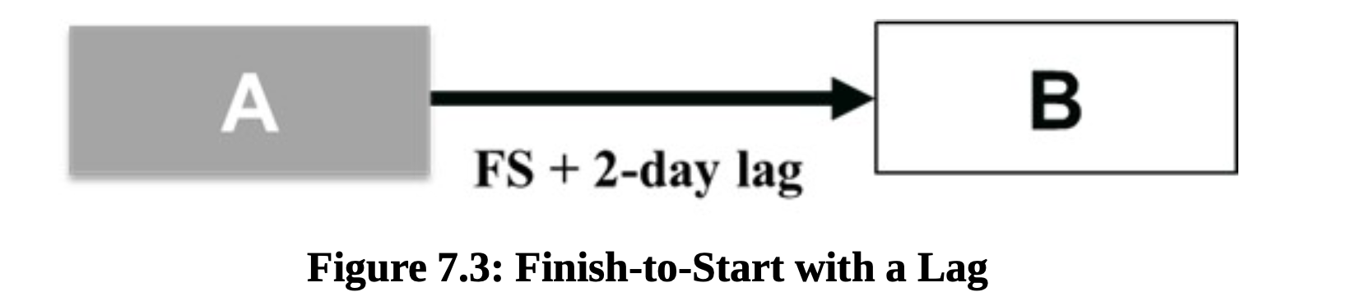
Lead
A lead is the opposite of a lag. A lead is the amount of time a successor activity can be advanced with respect to a predecessor activity. In Figure 7.4, Activity B (successor) can start three days before Activity A (predecessor) finishes. For example, in the project, we should elicit the requirements of stakeholders first. Then, we can start designing the product based on the requirements. If we have ten stakeholder groups, and five of them are key stakeholders, we can start the design before we finish all the elicitation.

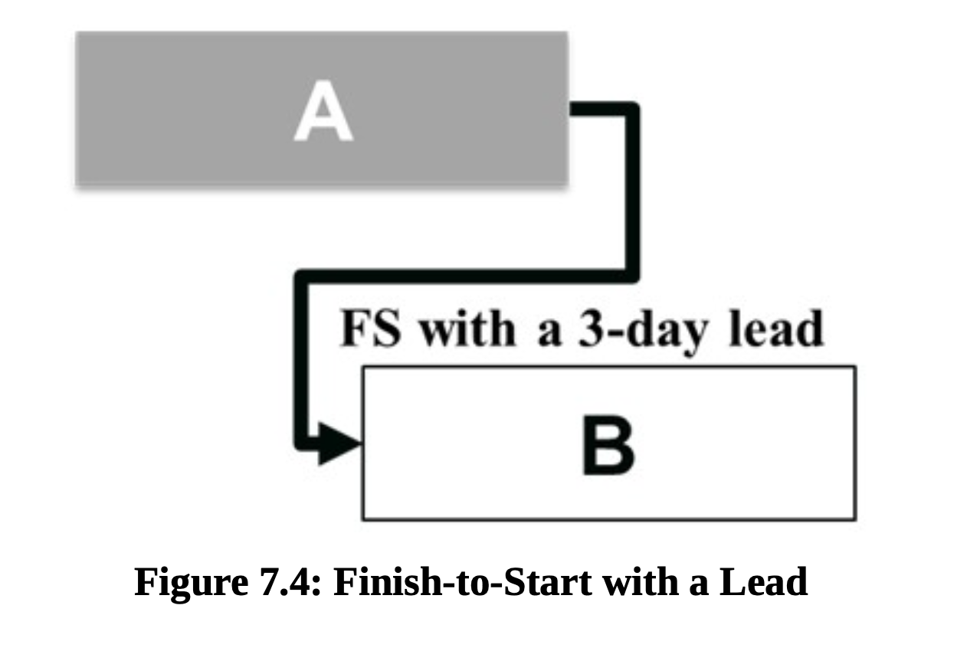

Task. Exercise to Create an Activity Network Diagram

Creating a Gantt Chart
A Gantt chart is a type of bar chart, developed by Henry Gantt, that illustrates a project schedule. Gantt charts are easy to read and are commonly used to display scheduled activities. These charts display the start and finish dates of project activities. Gantt charts also show the dependency relationships (i.e., precedence network) between activities.
Gantt charts show all the key stages of a project and their duration as a bar chart, with the time scale across the top. The key stages are placed on the bar chart in sequence, starting in the top left corner and ending in the bottom right corner. A Gantt chart can be drawn quickly and easily and is often the first tool a project manager uses to provide a rough estimate of the time that it will take to complete the key tasks. The detailed Gantt chart is usually constructed after all WBS activities are identified, an activity list is created, activity durations are estimated, and predecessors are determined.
Let’s look at the example of the Gantt Chart for a particular project (fig. ).

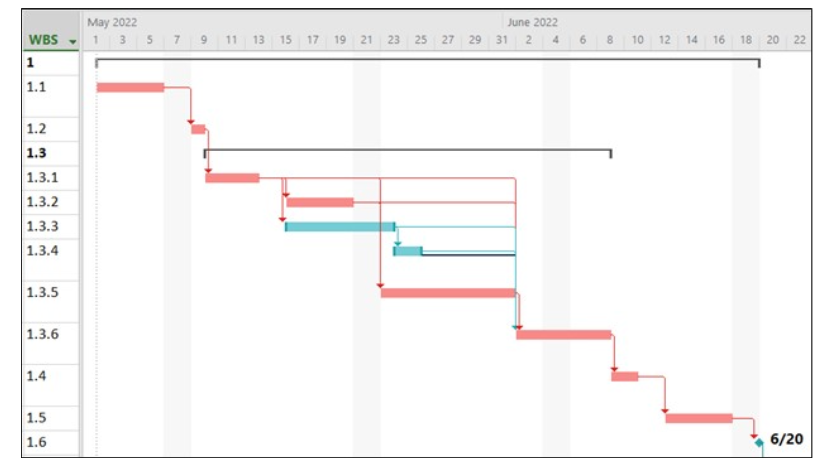
Figure. The example of the Gantt Chart

In the Gantt chart in Figure , red bars show the critical tasks whereas blue bars illustrate the non-critical tasks. Dependencies between all the activities are Finish-to-Start, which is the most common dependency and the default relationship in MS Project.

