Lecture 2. Introduction to Project Management.
Project Constraints: Time, Cost, Scope, Resources, Quality, and Risks. Project Success and Project Management Success. Project Management Expertise: Application Knowledge, Standards and Regulation; Understanding the Project Environment; Management Knowledge and Skills; Interpersonal Skills. Project Management Life Cycle and Process Groups.

1. Project Constraints. Project Management Success.

One of the most common term about Project Management is “triple constraint”, which traditionally consists of time, cost, and scope. The triple constraint is illustrated in the form of a triangle to visualize the project work and see the relationship between the scope/quality, schedule/time, and cost/resource (Figure 1). They are considered to be the main pillars of a project. They are also regarded as the main reason why we need a systematic project management approach. These primary constraints also compete with each other. Therefore, project managers should consider trade-offs among them.
The best projects have a perfectly balanced triangle. Maintaining this balance is difficult because projects are prone to change. For example, if scope increases, cost and time may increase disproportionately. Alternatively, if the amount of money you have for your project decreases, you may be able to do as much, but your time may increase.
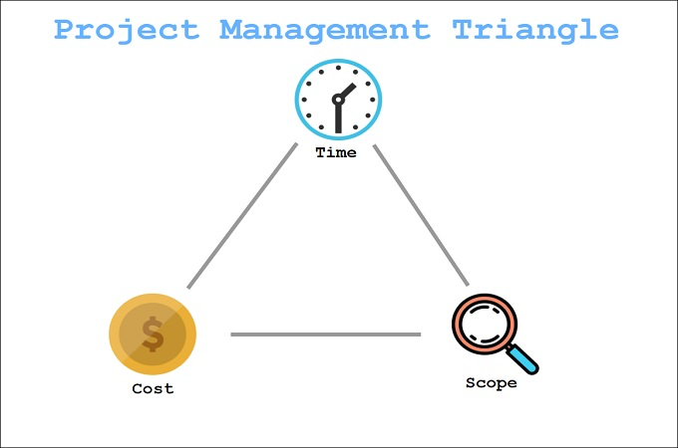

Figure 1. Project Management Triangle

Your project may have additional constraints that you must face, and as the project manager, you have to balance the needs of these constraints against the needs of the stakeholders and your project goals. For instance, if your sponsor wants to add functionality to the original scope, you will very likely need more money to finish the project, or if they cut the budget, you will have to reduce the quality of your scope, and if you don’t get the appropriate resources to work on your project tasks, you will have to extend your schedule because the resources you have take much longer to finish the work.
You get the idea; the constraints are all dependent on each other. Think of all of these constraints as the classic carnival game of Whack-a-mole (Figure 2). Each time you try to push one mole back in the hole, another one pops out. The best advice is to rely on your project team to keep these moles in place.

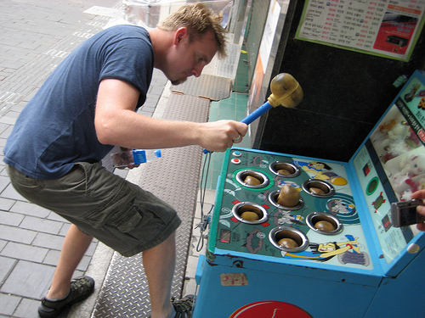

Figure 2. Whac-a-mole

The dynamic trade-offs between the project constraint values have been humorously and accurately described in Figure 3.

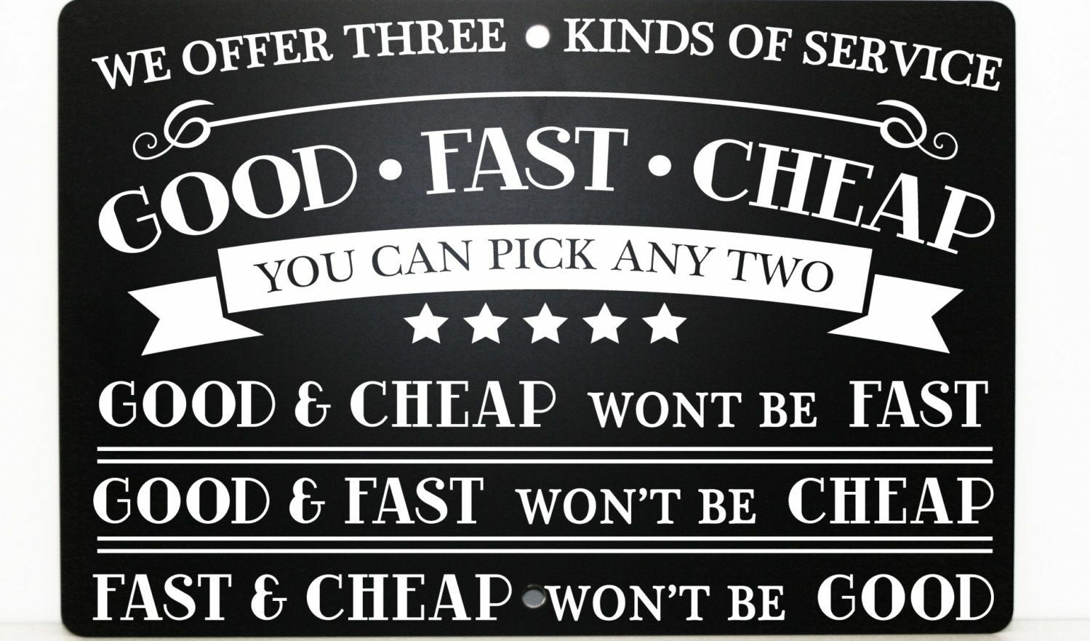
Figure 3. Good, Fast, Cheap: Choose two.

Task 1. Consider an example of a poor-quality project. Find more details (information) about this project. Analyse the mistakes made. Give own examples of poor-quality project from your experience or well-known projects.
Here is an example of a project that cut quality because the project costs were fixed. The P-36 oil platform was the largest footing production platform in the world capable of processing 180,000 barrels of oil per day and 5.2 million cubic metres of gas per day. Located in the Roncador Field, Campos Basin, Brazil, the P-36 was operated by Petrobras.
In March 2001, the P-36 was producing around 84,000 barrels of oil and 1.3 million cubic metres of gas per day when it became destabilized by two explosions and subsequently sank in 3,900 feet of water with 1,650 short tons of crude oil remaining on board, killing 11 people. The sinking is attributed to a complete failure in quality assurance, and pressure for increased production led to corners being cut on safety procedures. It is listed as one of the most expensive accidents with a price tag of $515,000,000.
The following quotes are from a Petrobras executive, citing the benefits of cutting quality assurance and inspection costs on the project.
“Petrobras has established new global benchmarks for the generation of exceptional shareholder wealth through an aggressive and innovative program of cost cutting on its P36 production facility.”
“Conventional constraints have been successfully challenged and replaced with new paradigms appropriate to the globalized corporate market place.”
“Elimination of these unnecessary straitjackets has empowered the project’s suppliers and contractors to propose highly economical solutions, with the win-win bonus of enhanced profitability margins for themselves.”
“The P36 platform shows the shape of things to come in the unregulated global market economy of the 21st century.” [Full, p. 22]

Besides triple constraints, the other three constraints which are also tightly linked to the triple constraints are resources, quality, and risks. Tightly aligned with and at the top of all these six constraints, the success of a project depends on the client and/or stakeholder satisfaction. Clients make their decisions to accept the final deliverables of a project by evaluating these constraints. Let's take a brief look at each of them.

Cost is the budget approved for the project including all necessary expenses needed to deliver the project. Within organizations, project managers have to balance between not running out of money and not underspending because many projects receive funds or grants that have contract clauses with a “use it or lose it” approach to project funds. Poorly executed budget plans can result in a last-minute rush to spend the allocated funds. For virtually all projects, cost is ultimately a limiting constraint; few projects can go over budget without eventually requiring a corrective action.

Scope is what the project is trying to achieve. It entails all the work involved in delivering the project outcomes and the processes used to produce them. It is the reason and the purpose of the project.

Quality is a combination of the standards and criteria to which the project’s products must be delivered for them to perform effectively. The product must perform to provide the functionality expected, solve the identified problem, and deliver the benefit and value expected. It must also meet other performance requirements, or service levels, such as availability, reliability, and maintainability, and have acceptable finish and polish. Quality on a project is controlled through quality assurance (QA), which is the process of evaluating overall project performance on a regular basis to provide confidence that the project will satisfy the relevant quality standards.

Risk is defined by potential external events that will have a negative impact on your project if they occur. Risk refers to the combination of the probability the event will occur and the impact on the project if the event occurs. If the combination of the probability of the occurrence and the impact on the project is too high, you should identify the potential event as a risk and put a proactive plan in place to manage the risk.

Resources are required to carry out the project tasks. They can be people, equipment, facilities, funding, or anything else capable of definition (usually other than labour) required for the completion of a project activity.

Time is defined as the time to complete the project. Time is often the most frequent project oversight in developing projects. This is reflected in missed deadlines and incomplete deliverables. Proper control of the schedule requires the careful identification of tasks to be performed and accurate estimations of their durations, the sequence in which they are going to be done, and how people and other resources are to be allocated. Any schedule should take into account vacations and holidays.

Cost is the budget approved for the project including all necessary expenses needed to deliver the project. Within organizations, project managers have to balance between not running out of money and not underspending because many projects receive funds or grants that have contract clauses with a “use it or lose it” approach to project funds. Poorly executed budget plans can result in a last-minute rush to spend the allocated funds. For virtually all projects, cost is ultimately a limiting constraint; few projects can go over budget without eventually requiring a corrective action.

Quality is a combination of the standards and criteria to which the project’s products must be delivered for them to perform effectively. The product must perform to provide the functionality expected, solve the identified problem, and deliver the benefit and value expected. It must also meet other performance requirements, or service levels, such as availability, reliability, and maintainability, and have acceptable finish and polish. Quality on a project is controlled through quality assurance (QA), which is the process of evaluating overall project performance on a regular basis to provide confidence that the project will satisfy the relevant quality standards.

Risk is defined by potential external events that will have a negative impact on your project if they occur. Risk refers to the combination of the probability the event will occur and the impact on the project if the event occurs. If the combination of the probability of the occurrence and the impact on the project is too high, you should identify the potential event as a risk and put a proactive plan in place to manage the risk.

Resources are required to carry out the project tasks. They can be people, equipment, facilities, funding, or anything else capable of definition (usually other than labour) required for the completion of a project activity.

Time is defined as the time to complete the project. Time is often the most frequent project oversight in developing projects. This is reflected in missed deadlines and incomplete deliverables. Proper control of the schedule requires the careful identification of tasks to be performed and accurate estimations of their durations, the sequence in which they are going to be done, and how people and other resources are to be allocated. Any schedule should take into account vacations and holidays.

Project success and Project Management success are generally evaluated as different concepts.
Project success deals with the impacts of a project’s final product or service on stakeholders. Projects aim to create a unique outcome.
Project management success focuses on the processes of a project including the successful accomplishment of the scope, within budget (cost), within time (schedule), and quality aspects.
The project can be successfully managed but do not meet the client and customer expectations. Projects are initiated by organizations to address business needs (problems or opportunities) and create tangible and intangible benefits by creating an outcome that organizations can benefit from. Realized value of the project can be measured by the project stakeholders. For instance, a particular e-commerce implementation can ignore human contact that could be a non-obvious reason for project falure. Most of the customers, especially Generation X and baby boomers, still wanted to maintain an interaction with employees to ask for the warranties, the quality of the items, or even have a short chat with the service providers.
It is evident that not all projects benefit from successful completion. Many factors influence the success of a project. PMI 2020 Pulse of the Profession reported that 11.4% of investment is wasted due to poor project performance. What makes it worse is that this percentage rises to 67% in the organizations that undervalue project management as a strategic competency for driving change. PMI’s same study reported that the factors responsible for the failure were lack of clearly defined and/or achievable milestones and objectives to measure progress (37%), poor communication (19%), lack of communication by senior management (18%), employee resistance (14%), and insufficient funding (9%).
Another report by the Standish Group, “CHAOS 2020: Beyond Infinity”, indicated that 31% of projects were successful while 50% were challenged and 19% failed. This report referred to three factors to improve project performance, that are good sponsor, good team, and good place.
Consequently, a project should be managed effectively by a project manager and the team. If not done so, projects may fail due to the factors listed below:
- Unrealistic and vague goals
- Uncontrolled expansion of the project scope (Scope creep)
- Absent or ineffective relations with the clients/customers and other stakeholders
- Cost overruns
- Schedule delays
- The insufficient amount and/or quality of resources
- Toxic organizational culture and politics (e.g., mistreatment, aggression, incivility, harassment)
- Organizational and/or team conflicts
- Poor communication with stakeholders
- Unsatisfied stakeholders
- Ineffective quality assurance and inspections, and/or
- Poor quality
[Oguz, p.18]

2. Project Management Expertise

To manage the competing project constraints and the project as a whole, there are some areas of expertise you should bring to the project team (Figure 4). They are knowledge of the application area and the standards and regulations in your industry, understanding of the project environment, general management knowledge and skills, and interpersonal skills. It should be noted that industry expertise is not in a certain field but the expertise to run the project. So while knowledge of the type of industry is important, you will have a project team supporting you in this endeavor. For example, if you are managing a project that is building an oil platform, you would not be expected to have a detailed understanding of the engineering since your team will have mechanical and civil engineers who will provide the appropriate expertise; however, it would definitely help if you understood this type of work.

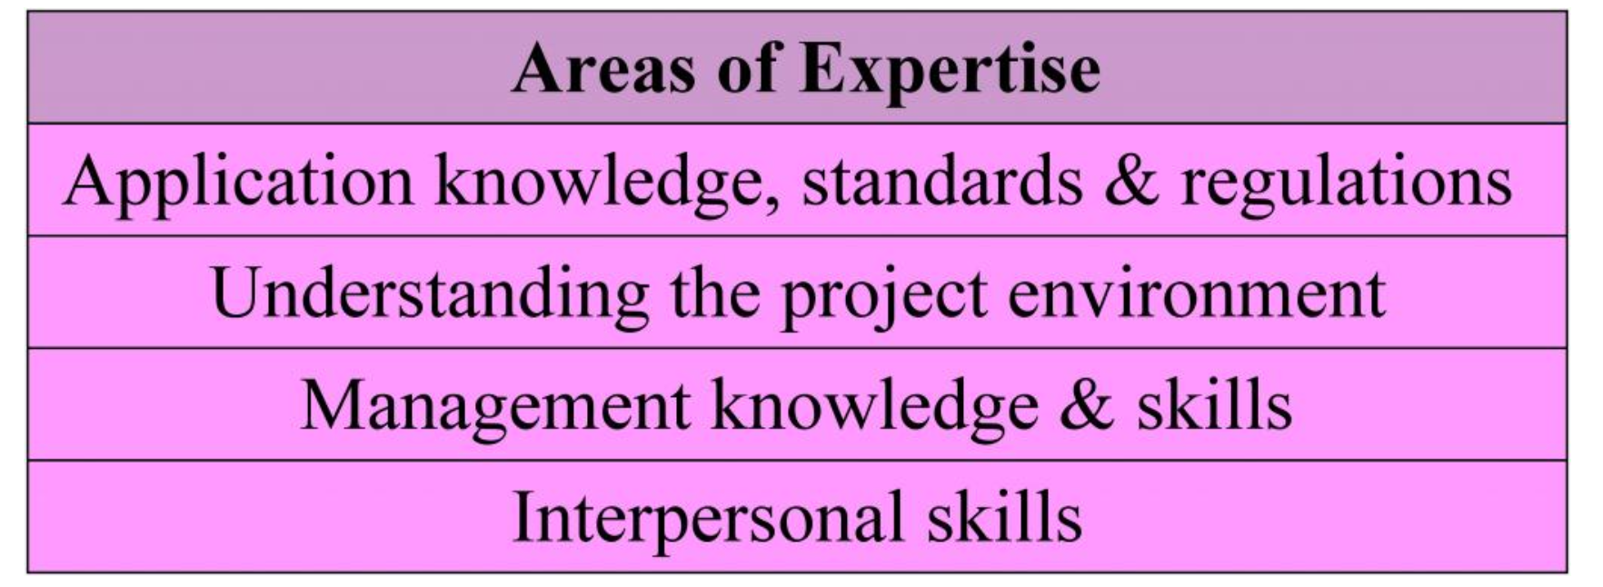
Figure 4. Areas of expertise that a project manager should bring to the project team.

Let’s take a look at each of these areas in more detail.
Application knowledge, standarts and regulations
By standards, we mean guidelines or preferred approaches that are not necessarily mandatory. In contrast, when referring to regulations we mean mandatory rules that must be followed, such as government-imposed requirements through laws. It goes without saying that you’re required to follow all applicable laws and rules regarding your industry, organization, or project. Every industry has standards and regulations. Knowing which ones affect your project before you begin work will not only help the project to unfold smoothly, but will also allow for effective risk analysis.
Some projects require specific skills in certain application areas. Application areas are made up of categories of projects that have common elements. They can be defined by industry group (pharmaceutical, financial, etc.), department (accounting, marketing, legal, etc.), technology (software development, engineering, etc), or management specialties (procurement, research and development, etc.). These application areas are usually concerned with disciplines, regulations, and the specific needs of the project, the customer, or the industry. For example, most government agencies have specific procurement rules that apply to their projects that wouldn’t be applicable in the construction industry. The pharmaceutical industry is interested in regulations set forth by government regulators, whereas the automotive industry has little or no concern for either of these types of regulations. You need to stay up-to-date regarding your industry so that you can apply your knowledge effectively. Today’s fast-paced advances can leave you behind fairly quickly if you don’t stay abreast of current trends.
Having some level of experience in the application area you’re working in will give you an advantage when it comes to project management. While you can call in experts who have the application area knowledge, it doesn’t hurt for you to understand the specific aspects of the application areas of your project.

Task 2. Choose any industry on your own and analyse standarts imposed in this field.

Understanding the Project Environment
There are many factors that need to be understood within your project environment (Figure 5). At one level, you need to think in terms of the cultural and social environments (i.e., people, demographics, and education). The international and political environment is where you need to understand about different countries’ cultural influences. Then we move to the physical environment; here we think about time zones. Think about different countries and how differently your project will be executed whether it is just in your country or if it involves an international project team that is distributed throughout the world in five different countries.
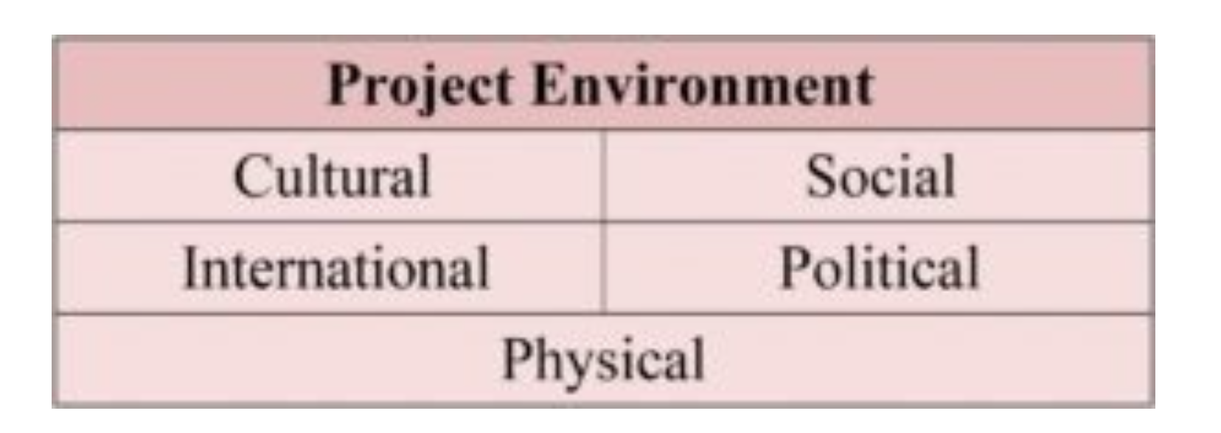
Figure 5. The important factors to consider within the project environment.

Of all the factors, the physical ones are the easiest to understand, and it is the cultural and international factors that are often misunderstood or ignored. How we deal with clients, customers, or project members from other countries can be critical to the success of the project. For example, the culture of the United States values accomplishments and individualism. Americans tend to be informal and call each other by first names, even if having just met. Europeans tend to be more formal, using surnames instead of first names in a business setting, even if they know each other well. In addition, their communication style is more formal than in the United States, and while they tend to value individualism, they also value history, hierarchy, and loyalty. The Japanese, on the other hand, tend to communicate indirectly and consider themselves part of a group, not as individuals. The Japanese value hard work and success, as most of us do.
How a product is received can be very dependent on the international cultural differences. For example, in the 1990s, when many large American and European telecommunications companies were cultivating new markets in Asia, their customer’s cultural differences often produced unexpected situations. Western companies planned their telephone systems to work the same way in Asia as they did in Europe and the United States. But the protocol of conversation was different. Call-waiting, a popular feature in the West, is considered impolite in some parts of Asia. This cultural blunder could have been avoided had the team captured the project environment requirements and involved the customer.
It is often the simplest things that can cause trouble since, unsurprisingly, in different countries, people do things differently. One of the most notorious examples of this is also one of the most simple: date formats. What day and month is 2/8/2009? Of course it depends where you come from; in North America it is February 8th while in Europe (and much of the rest of the world) it is 2nd August. Clearly, when schedules and deadlines are being defined it is important that everyone is clear on the format used.
The diversity of practices and cultures and its impact on products in general and on software in particular goes well beyond the date issue. You may be managing a project to create a new website for a company that sells products worldwide. There are language and presentation style issues to take into consideration; converting the site into different languages isn’t enough. It is obvious that you need to ensure the translation is correct; however, the presentation layer will have its own set of requirements for different cultures. The left side of a website may be the first focus of attention for a Canadian; the right side would be the initial focus for anyone from the Middle East, as both Arabic and Hebrew are written from right to left. Colors also have different meanings in different cultures. White, which is a sign of purity in North America (e.g., a bride’s wedding dress), and thus would be a favoured background colour in North America, signifies death in Japan (e.g., a burial shroud).
Project managers in multicultural projects must appreciate the culture dimensions and try to learn relevant customs, courtesies, and business protocols before taking responsibility for managing an international project. A project manager must take into consideration these various cultural influences and how they may affect the project’s completion, schedule, scope, and cost.

Task 3. Give examples of possible misunderstanding between different cultures due to differences in perception.

Task 4. Learn about two methods of Project Environment Analysis, i.e. PEST Analysis (and its possible derivatives), and Porter’s Five Forces. Be prepared to present your result in class.

Management Knowledge and Skills
As the project manager, you have to rely on your project management knowledge and your general management skills. Here, we are thinking of items like your ability to plan the project, execute it properly, and of course control it and bring it to a successful conclusion, along with your ability to guide the project team to achieve project objectives and balance project constraints.
There is more to Project Management than just getting the work done. Inherent in the process of Project Management are the general management skills that allow the project manager to complete the project with some level of efficiency and control. In some respects, managing a project is similar to running a business: there are risk and rewards, finance and accounting activities, human resource issues, time management, stress management, and a purpose for the project to exist. General management skills are needed in every project.

Interpersonal Skills
Last but not least you also have to bring the ability into the project to manage personal relationships and deal with personnel issues as they arise. Here were talking about your interpersonal skills.
Communication
Project managers spend 90% of their time communicating. Therefore they must be good communicators, promoting clear, unambiguous exchange of information. As a project manager, it is your job to keep a number of people well informed. It is essential that your project staff know what is expected of them: what they have to do, when they have to do it, and what budget and time constraints and quality specifications they are working toward. Project communication can be summed up as knowing “who needs what information and when” and making sure they (employees, project managers, customers) have it.
All projects require sound communication plans, but not all projects will have the same types of communication or the same methods for distributing the information. For example, will information be distributed via mail or email, is there a shared website, or are face-to-face meetings required? The communication management plan documents how the communication needs of the stakeholders will be met, including the types of information that will be communicated, who will communicate them, and who will receive them; the methods used to communicate; the timing and frequency of communication; the method for updating the plan as the project progresses, including the escalation process; and a glossary of common terms.
Influence
Project Management is about getting things done. Every organization is different in its policies, modes of operations, and underlying culture. There are political alliances, differing motivations, conflicting interests, and power struggles. A project manager must understand all of the unspoken influences at work within an organization.
Leadership
Leadership is the ability to motivate and inspire individuals to work toward expected results. Leaders inspire vision and unite people around common goals. A good project manager can motivate and inspire the project team to see the vision and value of the project. The project manager as a leader can inspire the project team to find a solution to overcome perceived obstacles to get the work done.
Motivation
Motivation helps people work more efficiently and produce better results. Motivation is a constant process that the project manager must guide to help the team move toward completion with passion and a profound reason to complete the work. Motivating the team is accomplished by using a variety of team-building techniques and exercises. Team building is simply getting a diverse group of people to work together in the most efficient and effective manner possible. This may involve management events as well as individual actions designed to improve team performance.
Recognition and rewards are an important part of team motivations. They are formal ways of recognizing and promoting desirable behaviour and are most effective when carried out by the management team and the project manager. Consider individual preferences and cultural differences when using rewards and recognition. Some people don’t like to be recognized in front of a group; others thrive on it.
Negotiation
Project managers must negotiate for the good of the project. In any project, the project manager, the project sponsor, and the project team will have to negotiate with stakeholders, vendors, and customers to reach a level of agreement acceptable to all parties involved in the negotiation process.
Problem Solving
Problem solving is the ability to understand the heart of a problem, look for a viable solution, and then make a decision to implement that solution. The starting point for problem solving is problem definition. Problem definition is the ability to understand the cause and effect of the problem; this centres on root-cause analysis. Root-cause analysis looks beyond the immediate symptoms to the cause of the symptoms, which then affords opportunities for solutions.
Solutions can be presented from vendors, the project team, the project manager, or various stakeholders. A viable solution focuses on more than just the problem; it looks at the cause and effect of the solution itself. In addition, a timely decision is needed or the window of opportunity may pass and then a new decision will be needed to address the problem. As in most cases, the worst thing you can do is nothing.
All of these interpersonal skills will be used in all areas of Project Management.

3. Project Management Life Cycle and Process Groups
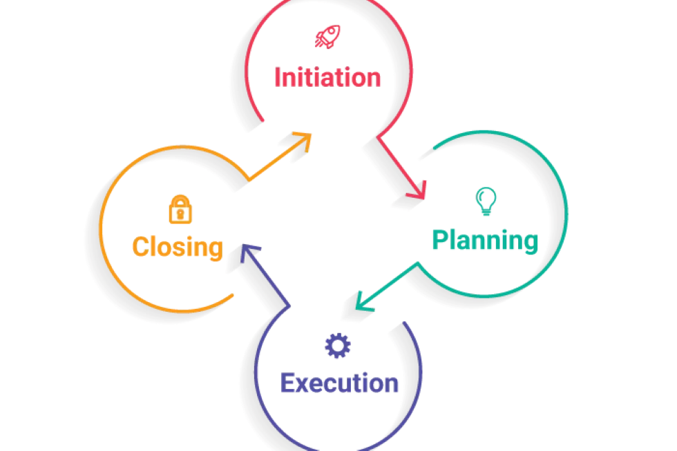
Figure 6. Main phases of Project Life Cycle

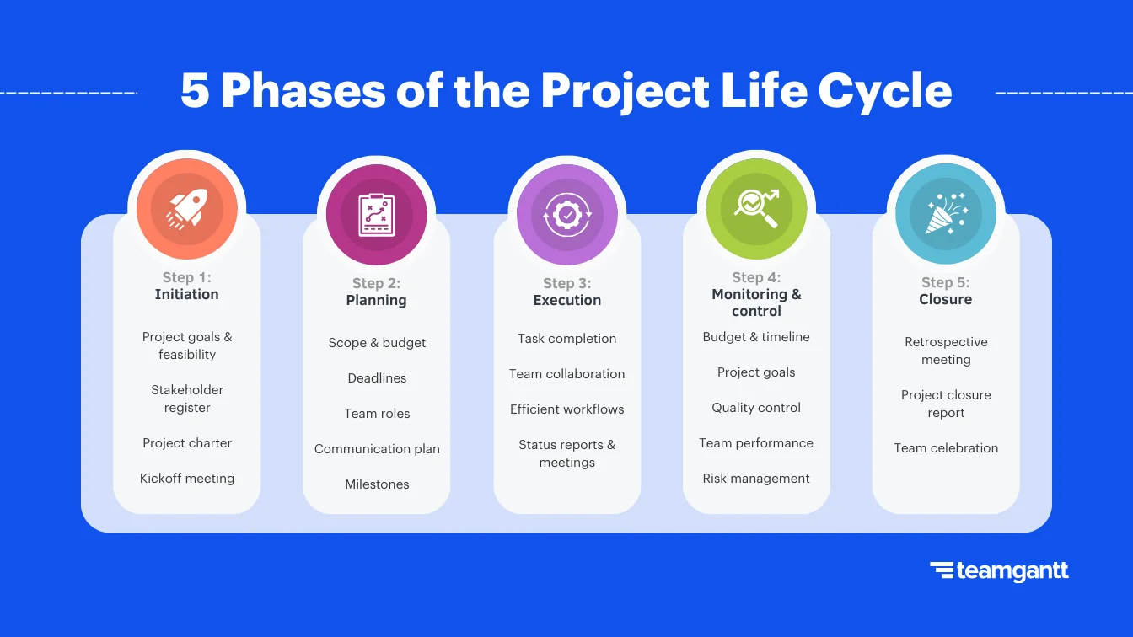
Figure 7. Project Management Life Cycle: a close look.

The project manager and project team have one shared goal: to carry out the work of the project for the purpose of meeting the project’s objectives. Every project has a beginning, a middle period during which activities move the project toward completion, and an ending (either successful or unsuccessful). A standard project typically has the following four major phases (each with its own agenda of tasks and issues): initiation, planning, implementation, and closure (fig. 6). Taken together, these phases represent the path a project takes from the beginning to its end and are generally referred to as the project “life cycle.”
Initiation Phase
During this phase, the project objective or need is identified; this can be a business problem or opportunity. An appropriate response to the need is documented in a business case with recommended solution options. A feasibility study is conducted to investigate whether each option addresses the project objective and a final recommended solution is determined. Issues of feasibility (“can we do the project?”) and justification (“should we do the project?”) are addressed.
Once the recommended solution is approved, a project is initiated to deliver the approved solution and a project manager is appointed. The major deliverables and the participating work groups are identified, and the project team begins to take shape. Approval is then sought by the project manager to move onto the detailed planning phase.

Planning Phase
The next phase, the planning phase, is where the project solution is further developed in as much detail as possible and the steps necessary to meet the project’s objective are planned. In this step, the team identifies all of the work to be done. The project’s tasks and resource requirements are identified, along with the strategy for producing them. This is also referred to as “scope management.” A project plan is created outlining the activities, tasks, dependencies, and timeframes. The project manager coordinates the preparation of a project budget by providing cost estimates for the labour, equipment, and materials costs. The budget is used to monitor and control cost expenditures during project implementation.
Once the project team has identified the work, prepared the schedule, and estimated the costs, the three fundamental components of the planning process are complete. This is an excellent time to identify and try to deal with anything that might pose a threat to the successful completion of the project. This is called risk management. In risk management, “high-threat” potential problems are identified along with the action that is to be taken on each high-threat potential problem, either to reduce the probability that the problem will occur or to reduce the impact on the project if it does occur. This is also a good time to identify all project stakeholders and establish a communication plan describing the information needed and the delivery method to be used to keep the stakeholders informed.
Finally, you will want to document a quality plan, providing quality targets, assurance, and control measures, along with an acceptance plan, listing the criteria to be met to gain customer acceptance. At this point, the project would have been planned in detail and is ready to be executed.

Implementation (Execution) Phase
During the third phase, the implementation phase, the project plan is put into motion and the work of the project is performed. It is important to maintain control and communicate as needed during implementation. Progress is continuously monitored and appropriate adjustments are made and recorded as variances from the original plan. In any project, a project manager spends most of the time in this step. During project implementation, people are carrying out the tasks, and progress information is being reported through regular team meetings. The project manager uses this information to maintain control over the direction of the project by comparing the progress reports with the project plan to measure the performance of the project activities and take corrective action as needed. The first course of action should always be to bring the project back on course (i.e., to return it to the original plan). If that cannot happen, the team should record variations from the original plan and record and publish modifications to the plan. Throughout this step, project sponsors and other key stakeholders should be kept informed of the project’s status according to the agreed-on frequency and format of communication. The plan should be updated and published on a regular basis.
Status reports should always emphasize the anticipated end point in terms of cost, schedule, and quality of deliverables. Each project deliverable produced should be reviewed for quality and measured against the acceptance criteria. Once all of the deliverables have been produced and the customer has accepted the final solution, the project is ready for closure.

Closing Phase
During the final closure, or completion phase, the emphasis is on releasing the final deliverables to the customer, handing over project documentation to the business, terminating supplier contracts, releasing project resources, and communicating the closure of the project to all stakeholders. The last remaining step is to conduct lessons-learned studies to examine what went well and what didn’t. Through this type of analysis, the wisdom of experience is transferred back to the project organization, which will help future project teams.

Task 5. Consider the example, outstand its phases and features of each stage.
Large Multinational Project
A U.S. construction company won a contract to design and build the first copper mine in northern Argentina. There was no existing infrastructure for either the mining industry or large construction projects in this part of South America. During the initiation phase of the project, the project manager focused on defining and finding a project leadership team with the knowledge, skills, and experience to manage a large complex project in a remote area of the globe. The project team set up three offices. One was in Chile, where large mining construction project infrastructure existed. The other two were in Argentina. One was in Buenos Aries to establish relationships and Argentinian expertise, and the second was in Catamarca—the largest town close to the mine site. With offices in place, the project start-up team began developing procedures for getting work done, acquiring the appropriate permits, and developing relationships with Chilean and Argentine partners.
During the planning phase, the project team developed an integrated project schedule that coordinated the activities of the design, procurement, and construction teams. The project controls team also developed a detailed budget that enabled the project team to track project expenditures against the expected expenses. The project design team built on the conceptual design and developed detailed drawings for use by the procurement team. The procurement team used the drawings to begin ordering equipment and materials for the construction team; develop labour projections; refine the construction schedule; and set up the construction site. Although planning is a never-ending process on a project, the planning phase focused on developing sufficient details to allow various parts of the project team to coordinate their work and allow the project management team to make priority decisions.
The implementation phase represents the work done to meet the requirements of the scope of work and fulfill the charter. During the implementation phase, the project team accomplished the work defined in the plan and made adjustments when the project factors changed. Equipment and materials were delivered to the work site, labour was hired and trained, a construction site was built, and all the construction activities, from the arrival of the first dozer to the installation of the final light switch, were accomplished.
The closeout phase included turning over the newly constructed plant to the operations team of the client. A punch list of a few remaining construction items was developed and those items completed. The office in Catamarca was closed, the office in Buenos Aries archived all the project documents, and the Chilean office was already working on the next project. The accounting books were reconciled and closed, final reports written and distributed, and the project manager started on a new project.

