“If you keep your eye on the profit, you’re going to skimp on the product. But if you focus on making really great products, then the profits will follow.”
Steve Jobs

Lecture 2.
Discovering and Assessing Product Opportunities

1. Discovering Product Opportunities.
2. Product Opportunities. Approaches to Assesment.
3. Ways to Conduct a Product Opportunity Assessment.

I. Discovering Product Opportunities.

Product opportunities are not always obvious. They emerge when consumer needs, pain points, and market trends intersect.
“Most of the ideas for successful new businesses come from a systematic search for opportunities.” (Peter F. Drucker, Innovation and Entrepreneurship, 1985)
In today’s digital economy, discovery is more challenging but also more rewarding:
Consumers interact with brands through multiple touchpoints (social media, websites, in-app notifications, physical stores).
At the present time, the customer journey is non-linear, and opportunities arise at every step.

Customer needs are the underlying desires, requirements, and motivations that influence a customer's decision to purchase a product or service, encompassing physical, psychological, and social factors. These needs can be categorized as functional (e.g., a car's fuel efficiency), emotional (e.g., feeling prestigious from a luxury watch), and social (e.g., choosing a restaurant popular with friends). Understanding and meeting these needs allows businesses to develop better products, implement effective marketing strategies, and provide superior customer service, fostering loyalty and profitability.

A customer experience pain point is any specific problem, frustration, or obstacle that a customer encounters while interacting with a product, service, or brand, leading to dissatisfaction, delays, or a loss of confidence. These issues can range from financial concerns and productivity issues to poor customer service, inefficient processes, or technical problems. Identifying and resolving these pain points is crucial for improving customer retention, enhancing loyalty, and driving business growth.

A customer touchpoint is any moment of contact or interaction between a customer and a business, occurring before, during, or after a purchase, such as a social media post, website visit, or customer service call. These touchpoints collectively shape the customer's perception of the brand and are crucial opportunities to build loyalty, improve satisfaction, and drive business growth by creating a positive overall customer experience.

Task 1. Learn about types or/and levels of pain points and touchpoints in customer experience. Why are they important in discovering product opportunities? Give some examples.

Customer Journey as a Basis for Discovery
From AIDA to 5A’s
AIDA (Attention → Interest → Desire → Action) – a classic linear model, effective in the era of mass communication.
“The AIDA model assumes that customers move through a cognitive process of attention and interest before forming a desire and taking action.” [Kotler et al., Marketing 4.0, 2017]
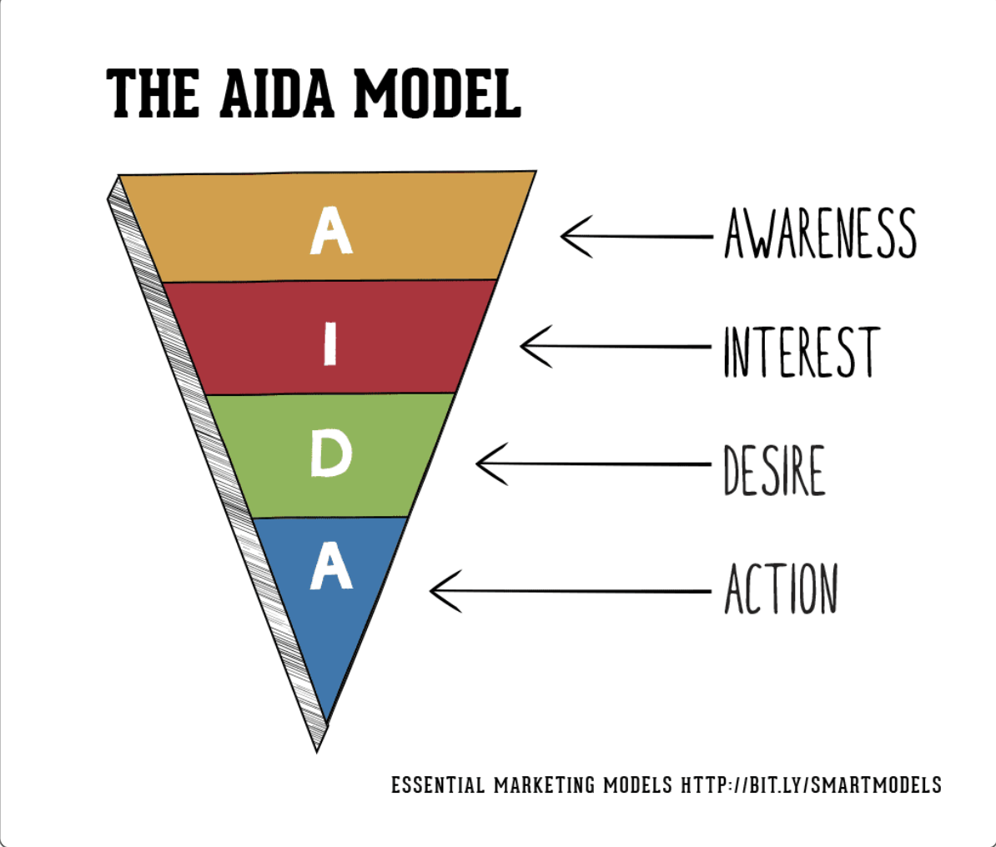
Figure 1. AIDA model.
Source: https://www.smartinsights.com/traffic-building-strategy/offer-and-message-development/aida-model/

What is the AIDA model? The AIDA Model identifies cognitive stages an individual goes through during the buying process for a product or service. It's a purchasing funnel where buyers go to and fro at each stage, to support them in making the final purchase.
It's no longer a relationship purely between the buyer and the company since social media has extended it to achieving the different goals of AIDA via information added by other customers via social networks and communities.

What does AIDA stand for?
Awareness: creating brand awareness or affiliation with your product or service.
Interest: generating interest in the benefits of your product or service, and sufficient interest to encourage the buyer to start to research further.
Desire: for your product or service through an 'emotional connection', showing your brand personality. Move the consumer from 'liking' it to 'wanting it'.
Action: CTA (call to action) - Move the buyer to interact with your company and taking the next step ie. downloading a brochure, making the phone call, joining your newsletter, or engaging in live chat, etc.
Retention: We all know that this is key to upsell, cross-sell, referrals, Advocacy and the list goes on.. as companies are also focussing on LTV.
The additional "R" is sometimes added by some Marketers to show the importance of ongoing relationship-building to give the AIDAR model. This is similar to the 'engage' aspect of our RACE funnel (you can discover more on the net).
An example of the AIDA model
Here is a case study from our Marketing Models Guide showing how an award-winning hairdressing company, Francesco Group used the model to launch their new salon.
1. Awareness: Ran a PR campaign four months prior to launch, promoting award, stylists, qualifications etc. and was reinforced through a DM (direct marketing) campaign to targeted customer groups.
2. Interest: Executed a direct mail campaign to offer a free consultation or hair cut and finish. They used research to support that this would work, as females are loyal if the offer is compelling.
3. Desire: Close to the opening of the new salon, they ran exclusive local launch events which was advertised through local press and social media. This created a local buzz for 'people wanting an invite' and excited to see the new salon.
4. Action: Clear CTAs were positioned on the Facebook site (call to reserve), the website (call to book) and local advertising (call in to receive discount or the offer).
The case study didn't highlight Retention, though there are many ways to increase loyalty around sign up to mailing lists or social platforms which offer news about offers and events, discounts on product ranges, discounts according to the frequency of visit, etc.
Structure your marketing plan around a funnel proven to boost performance. Join Smart Insights as a Free Member for instant access to our free digital marketing plan template to hone your skills and drive the results you need.

5A’s (Aware → Appeal → Ask → Act → Advocate) – developed by Philip Kotler and colleagues to reflect digital behaviors.
“The new 5A model reflects how customers move from awareness to advocacy in the digital era, influenced by communities, peers, and digital platforms.” [Kotler, Kartajaya & Setiawan, Marketing 4.0, 2017]
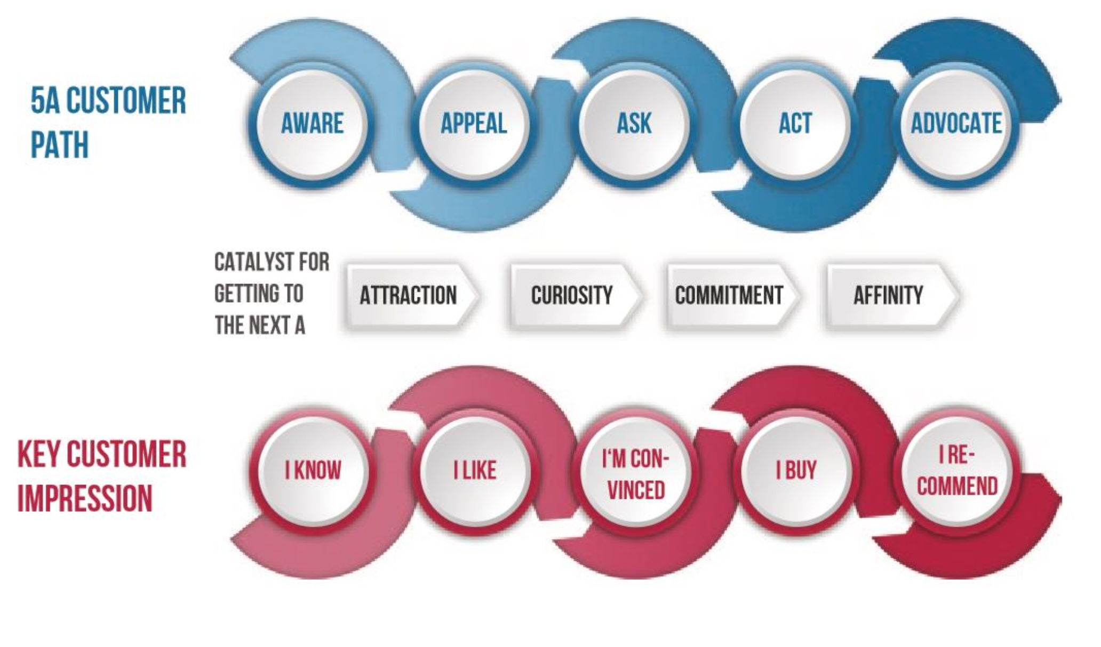
Figure 2. The 5A customer path in detail
Source: Kotler, P., Kartajaya, H., & Setiawan, I. (2017). Marketing 4.0: Moving from traditional to digital. Hoboken, NJ: Wiley.

Stages in detail:
AWARE. Customers are exposed to brands through experiences, ads, and recommendations. Typically, they might first notice the company through ads or social media posts and also from the referral by current or past customers. At this stage, the potential customers might not be ready to make a purchase yet but they are interested in your products or services.
APPEAL. At this stage, the potential customers understand the brand’s messages and company offers. The company might be on their list of potential vendors. So, customers might spend time looking at the website to read your solutions, promotion, testimonial, etc.
ASK. Prompted by their curiosity, customers research for more information, so they can compare to their other options they are considering. They might contact you via email, chat, or phone. At this stage, the customer is already interested in the specific product or service, so they make a contact to discuss the details. Potential customers might also use the third-party resources to evaluate the company and its services by reading the review or creating a poll in relevant groups to find more information and narrow down their choices.
ACT. Customers decide which brand to buy and use, and they make a purchase decision. Once they make their purchase, they become customers of the company.
ADVOCATE. This is the final stage that a customer becomes an advocate for your company. They might recommend your company to friends and family, share posts from your website or social media channels, and submit their testimonials or reviews for your product or service. Also, the customer might make additional purchases or upgrade their service.

Four Approaches to Customer Discovery [https://productschool.com/blog/user-experience/customer-discovery]
«Everyone should, in a product role, be spending a lot of time with customers. It's something you should measure and should be part of your success criteria for your team». Trisha Price, CPO at Pendo, on The Product Podcast
When it comes to how to do customer discovery, different teams often lean on specific product management frameworks or methods to guide the process. These methods provide structure. They help teams figure out who their customers are, what problems they’re trying to solve, and how their product fits into the picture.
The four primary approaches to customer discovery are Lean Startup, Design Thinking, Jobs-to-Be-Done (JTBD), and the Customer Development Model. Here’s how each ties into customer discovery and how different teams approach them.
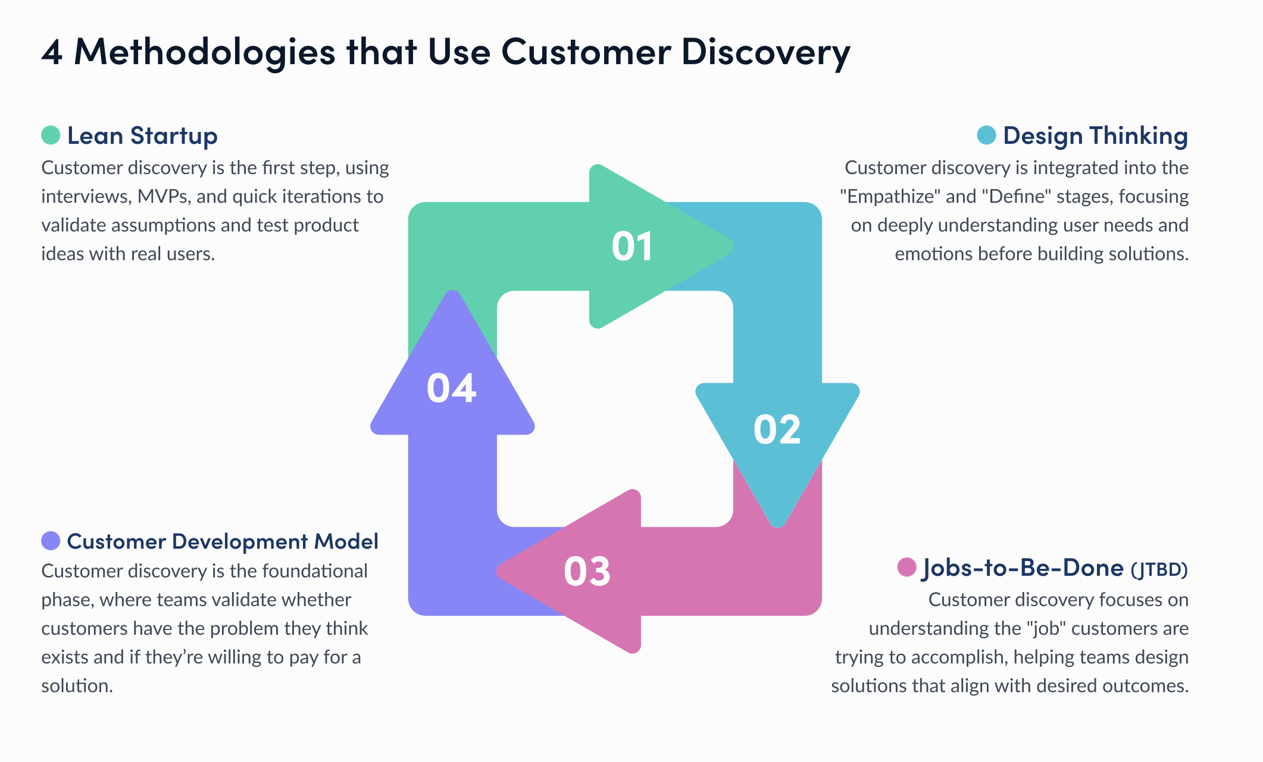
Figure 3. Approaches to Customer Discovery

1. Lean Startup: Learn Fast, Fail Fast
The Lean Startup method is built on the idea that instead of assuming and then building, you start with the MVP and get feedback as early as possible. This makes customer discovery the cornerstone of the approach.
Customer discovery is the first step in the Lean Startup approach. Before you even think about developing a product, you need to validate whether your idea solves a real customer problem.
Teams do this by conducting interviews, collecting ‘qual and quant’ data, running A/B tests, and building MVPs to test hypotheses. The focus is on quick iterations and constant product learning, so the discovery process doesn’t stop after the first round of feedback. It’s an ongoing cycle of learning, building, and testing.
Product teams using the Lean Startup approach are often flexible, nimble, and ready to pivot quickly. They thrive in environments where speed and adaptability are critical.
A team might start with a simple hypothesis – "Will users find value in this feature?" – and build a basic version of that feature to test with a small group of users. Based on user feedback, they iterate and refine, continuously discovering what customers need and want.

Task 2. Take a detailed look at such processes as conducting interviews with customers, collecting ‘qual and quant’ data, running A/B tests, and building MVPs. Give them a short characteristic and some examples.

2. Design Thinking: Empathy at the Core
Design Thinking is all about understanding the human side of the problem before jumping into solutions. This method, used by many product design and management teams, encourages a deep dive into users’ emotions, motivations, and pain points. It's often associated with creative, disruptive approaches to problem-solving.
Customer discovery fits into the first two stages of Design Thinking: Empathize and Define.
During the Empathize stage, teams conduct interviews, shadow users, and observe real-life interactions to gain a deep understanding of the customers' needs and pain points. Once they’ve gathered insights, they move to the Define stage, where they frame the problem in a clear, user-centered way.
The goal is not just to confirm assumptions but to uncover needs users might not even be aware of themselves. It’s about gaining empathy, understanding how users feel, and then defining the real problem to solve.
Design teams and product managers who embrace Design Thinking often spend a significant amount of time upfront talking to users. They conduct in-depth interviews, create empathy maps, and create user journeys or user flows. Unlike Lean Startup, where the focus is on quick iteration (not just customer discovery), Design Thinking digs deep into the customer experience. It makes sure the problem is fully understood before moving to solution development.
Design Thinking works especially well for teams building highly user-focused products, such as apps, software interfaces, or physical products where product experience is key.

3. Jobs-to-Be-Done (JTBD): Focus on Customer Outcomes
The Jobs-to-Be-Done (JTBD) framework takes a different angle on customer discovery by focusing on the outcome or "job" that the customer is trying to accomplish. The idea here is that customers “hire” products or services to complete specific tasks or solve particular problems.
In JTBD, the discovery process revolves around understanding the job a customer is trying to get done rather than focusing on features or product attributes. Teams conduct interviews not just to understand pain points but to explore the broader context in which the customer is trying to achieve something.
For example, instead of asking, “What do you like or dislike about this invoicing tool?” you might ask, “What are you trying to accomplish when you send out invoices?” This shifts the focus to the desired outcome, revealing deeper insights into the customer's true needs.
Teams using JTBD are focused on outcomes. They structure their interviews and discovery efforts around what users are trying to achieve rather than the product itself. This approach works well for teams building solutions in complex, high-stakes environments (like enterprise software or healthcare) where understanding the user’s larger context is critical.

Task 3. Take a detailed look at the Jobs-to-be-Done (JTBD) Framework by Clayton Christensen.

4. Customer Development Model: Find the Right Market
The Customer Development Model focuses on understanding customers before fully committing to product development. It’s all about systematically testing whether your idea has a viable market and the right customer base.
Customer discovery is literally the first phase of the Customer Development Model. This phase involves reaching out to potential customers to validate whether they actually have the problem you think they do and whether they would pay for a solution.
It’s a methodical approach that involves gathering direct customer feedback through interviews and early-stage testing. The idea is that you focus on customer needs, pain points, and buying behaviors. Customer discovery feeds directly into the next stage of the model, which is customer validation, where you confirm that customers are willing to pay for the solution.
Teams following the Customer Development Model take a disciplined approach to discovery. Startups, in particular, use this model to avoid burning through time and resources before proving there’s a market. They’ll often begin with a barebones MVP, test it with potential users, and gather as much feedback as possible. If the feedback aligns with their hypothesis, they move forward. If not, they pivot.
The model is especially helpful in industries where customer needs are uncertain or where market validation is crucial before scaling up.

II. Product Opportunities. Approaches and Assesment

A product opportunity is any perceived or actual need that a newly developed, altered, or reimagined good or service can serve while remaining commercially viable and profitable. Opportunities for products or services come in various shapes and types.
A product creates a new market, undercuts competitors, reshapes the industry or provides a differentiator. For example, it can be a broader or narrower selection, different pricing, special packaging, or a unique user experience. Some products close opportunities, while, others finish adjacencies or serve as alternatives.
How to Find New Product Opportunities? Businesses and entrepreneurs find product opportunities using or combining various techniques like trial, organized analysis, unstructured brainwaves, gut feelings, and more. The hypothesis-driven approach and background research are crucial for a product opportunity at the beginning of the discovery process. With their help, product managers maximize their time, providing a basic understanding and framing the discovery.
The Role of Product Managers in Product Opportunity Assessment. Product managers should verify a product opportunity, its priority, and its relevance to the company's goals. It’s also vital to prioritize product opportunities. This way, product managers create a hierarchy of the most critical ones and ensure that tackling a specific problem aligns with the company's product development strategy. Thus, the assumptions of product managers and other product team members significantly impact opportunity assessment. [artcai]
Assessing ideas and opportunities is the practice of collecting, discussing, analyzing, and deciding on proposed new products, features, or other potential growth ideas by weighing them against standard criteria. It involves thoroughly assessing elements like market opportunity, customer value, technical feasibility and constraints, strategic alignment, and long term business impact to judge an idea against organizational objectives and measures of projected success. The evaluation process filters concepts to pursue or table based on expected viability and value.
Product management and operations involve overseeing the development, production, and delivery of products to the market. This includes everything from the initial concept and design, through to manufacturing and distribution. Assessing ideas and opportunities is a key part of this process, helping to ensure that the right products are developed and delivered to the market. [launchnotes]

1 approach (Marty Cagan)
A product opportunity statement is a simple template invented by Marty Cagan and is meant to help people concentrate on the ‘right’ opportunities. How do you know which opportunities to focus on and which ones to discard? How do you prioritise between ‘great sounding product idea A’ and ‘great sounding product idea B’? What are the grounds on which you base such a – typically difficult – decision? Marty Cagan’s product opportunity assessment helps us work through these thorny questions in a very systematic and structured manner:
1. What problem will it solve, exactly? (value proposition)
2. For whom do we solve that problem? (target market)
3. How big is the opportunity? (market size)
4. What alternatives are out there? (competitive landscape)
5. Why are we best suited to pursue this? (our differentiator)
6. Why now? (market window)
7. How will we get this product to market? (go-to-market strategy)
8. How will we measure success and make money from this product? (metrics and revenue strategy)
9. What factors are critical to success? (solution requirements)
10. Given the above, what’s the recommendation? (go or no-go)
By Marty Cagan – Taken from: http://svpg.com/assessing-product-opportunities/

The Cagan's framework can be deployed in the step-by-step process.
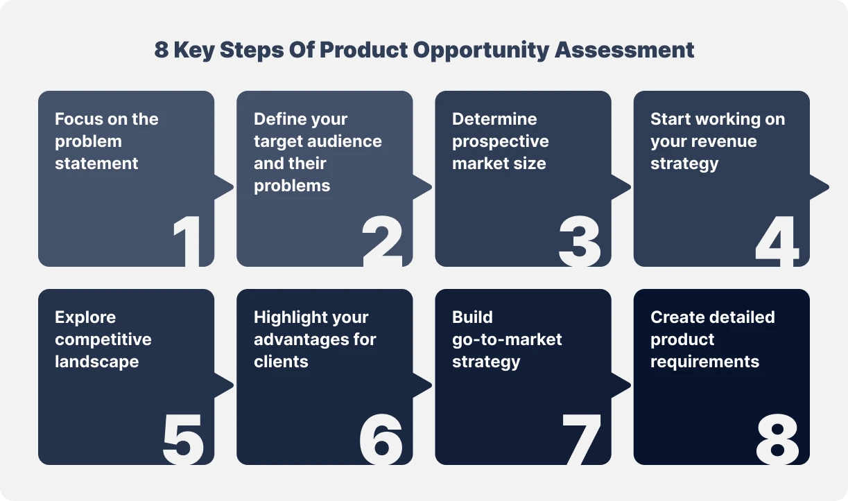
1. Problem Statement
When assessing an opportunity, focus on the problem rather than the proposed solution. Note that it’s often challenging to solely discuss a pain point and avoid discussing how to solve it. But in this case, you should evaluate the opportunity itself to decide whether it's worth solving eventually. It’s also vital to speak to potential clients to determine your solution’s value proposition.
Identify what problems your product solves for potential users and customers. What demands, objectives, or tasks will your solution address? List possible improvements, features, and innovations that are valuable for your target audience.
2. Target Audience
The following assessment phase aims to identify who struggles with the problem discovered in the first stage. Once you respond to these first two inquiries, you have the basis for a strong problem statement: the target user has problems with particular tasks.
Think about the types of users facing the problems your product solves. Next, search for variations in user objectives that impact how they adopt the product. Finally, divide target customers into multiple categories depending on the distinctions that matter. Note that it’s better to avoid marketing your product to "everyone."
3. Market Size
When you know the users’ issue, determine how many people face. It will give you an idea of your prospective market’s size, serving as an early warning system for the business opportunity you’re pursuing.
4. Revenue Strategy
The following subject makes you consider how you will evaluate your performance if you use the opportunity. Avoid rushing new product development and launching new solutions too soon. First, you should reach a consensus on how they will benefit your company. Thus, you will prevent your product portfolio from becoming bloated and unmanageable.
Also, identify the business KPIs showing you if the solution is successful. It’s vital as people purchasing and using your product trigger changes in these core metrics.
Think of your company's consequences if you fail to develop the solution. What could your company gain or save if you do? You will learn how much your company should invest in developing the product by answering this question. (lost opportunities)
5. Competitors
To survive, you should learn what your target customers do to address the problem and what solutions your direct competitors provide. These indications will guide your business to creating a custom solution that is more beneficial than the other existing options.
6. Our Advantages
It's time to look within at this point of the assessment. You should identify why your business is best suited to take advantage of this opportunity. In a nutshell, answer the question, "Why you?" The client's problem should be something you are aware of and qualified to handle. You must provide a compelling solution that lies within your company’s competence.
7. Strategy
All your development, quality assurance, and deployment efforts won’t pay off without an efficient go-to-market strategy. So as you evaluate how to bring your new product to customers, give this subject a significant thought. Most importantly, determine whether the channels are already set up or you’re diving into unexplored territory.
The market window is the ideal moment for the launch. That’s when a product is sufficiently different from the competitors from a strategic positioning standpoint. Decide what user behavior you can track to see if they try, adopt, use, and value your solution.
Finally, here’s your conclusion. Senior management should know the findings of the product opportunity assessment. Then, the company decides whether or not to pursue a product to address this opportunity. Thus, you will understand what you will gain and what it takes to succeed if you decide to move forward.
8. Product Requirements
In this step, sit down with your technical staff members and ask them to list all the dependencies and factors that impact your development plans. You need this information to make a decision. Thanks to a direct conversation with engineers, you will assess the opportunity objectively from a technical point of view.

Task 4. Consider the process of Cagan's product opportunity assesment using an example. (https://insideproduct.co/internal-product-opportunity-assessment/, https://www.linkedin.com/pulse/product-opportunity-assessment-using-marty-cagans-framework-hegde-fekjc)

Task 5. (Optional). Watch the video «The Root Causes of Product Failure by Marty Cagan at Mind the Product San Francisco» and outline the main ideas presented in the video. (https://www.youtube.com/watch?v=9dccd8lihpQ)

2 approach (Traditional Product Strategy) [e-book]
Product Strategy
Before you start building a product, you’ll need to have a solid plan - a product strategy. It is the foundation of the entire product lifecycle. It should answer 3 main questions:
1. What are you building?
2. Why are you building it?
3. How are you building it?
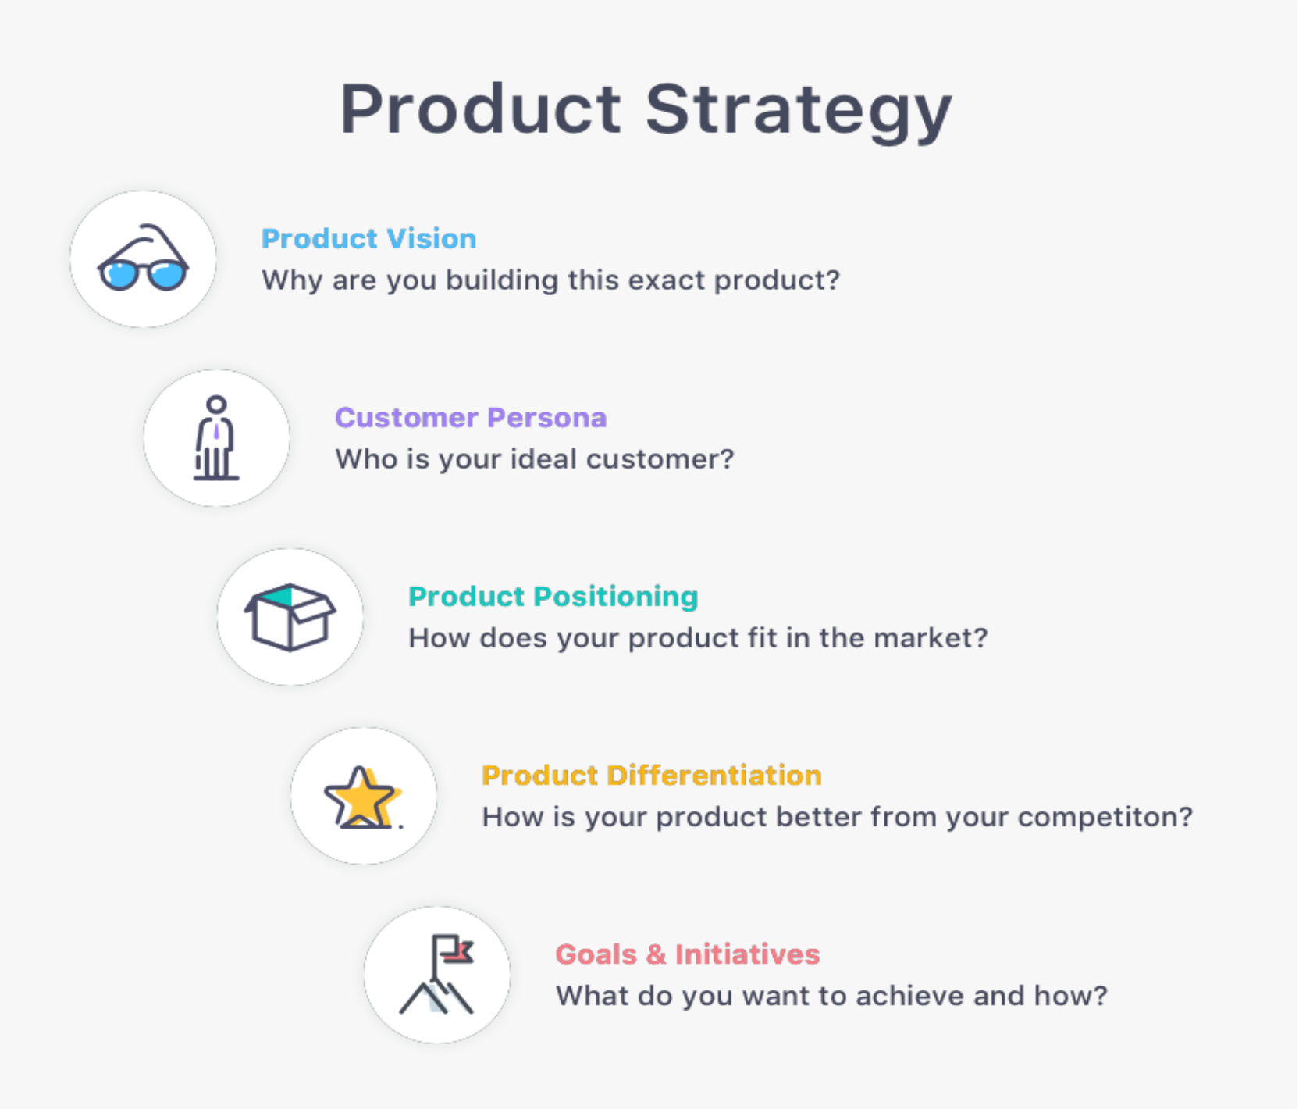
Aside from being a plan for building the product, product strategy should provide direction to the product manager and the whole team and set out the steps necessary to turn the product into success.
As such, it involves all aspects of product creation:
● Development
● Marketing
● Sales
● Support

A great product strategy should define the following:
Product Vision. Product vision should determine the ‘why ’behind your product. Why are you building this exact product and why should people care about it? It should capture the essence of what you want to accomplish with your product, and how it will improve the lives of the people using it.
Target Market/Customer Persona. Next, it’s time to answer the question ‘who’. Who is going to be using your product?
For this, you’ll need to determine the target market - the segment of people who will be most likely to use your product, and you’ll need to define your customer persona - your ideal customer, together with their goals, challenges, buying motivation, and objectives.
This will be crucial to decide how your product will look, how you will communicate with your audience, where you will reach them, etc.
Product Positioning. It means defining how your product fits into the marketplace. Rather than changing the product itself, product positioning focuses on the messaging, the way you’re going to present your product to the world, and how your audience will perceive it.
However, the most important thing about positioning is to be realistic - positioning is not about how you describe your product, it’s ultimately how your users perceive it.
Product Differentiation. Product differentiation should answer the following questions:
- How does your product differ from other similar products on the market?
- What are its unique values that would motivate your customers to choose your product over another one?
To be able to do proper product differentiation, you’ll need to perform a thorough competitive analysis. This way, you can get to know your competition and discover how to outshine them.
Goals and Initiatives. Lastly, product strategy includes product goals and initiatives. The goals should be clearly defined, measurable, and time-bound to help you and your team understand what you want to achieve with the product.
After setting your goals, it’s time to define initiatives, which are high-level efforts necessary to achieve the goals you’ve set.
Product strategy will be your guide throughout the whole product creation process and essential for both inbound and outbound product management. That’s why strategy is important for the whole team and should be visible to the stakeholders.

1. How To Define a Product Vision To Guide Your Team
Your product vision should capture the essence of what you want your product to accomplish. In one or two sentences, you should be able to explain where your product is headed and what its ultimate long-term goal is.
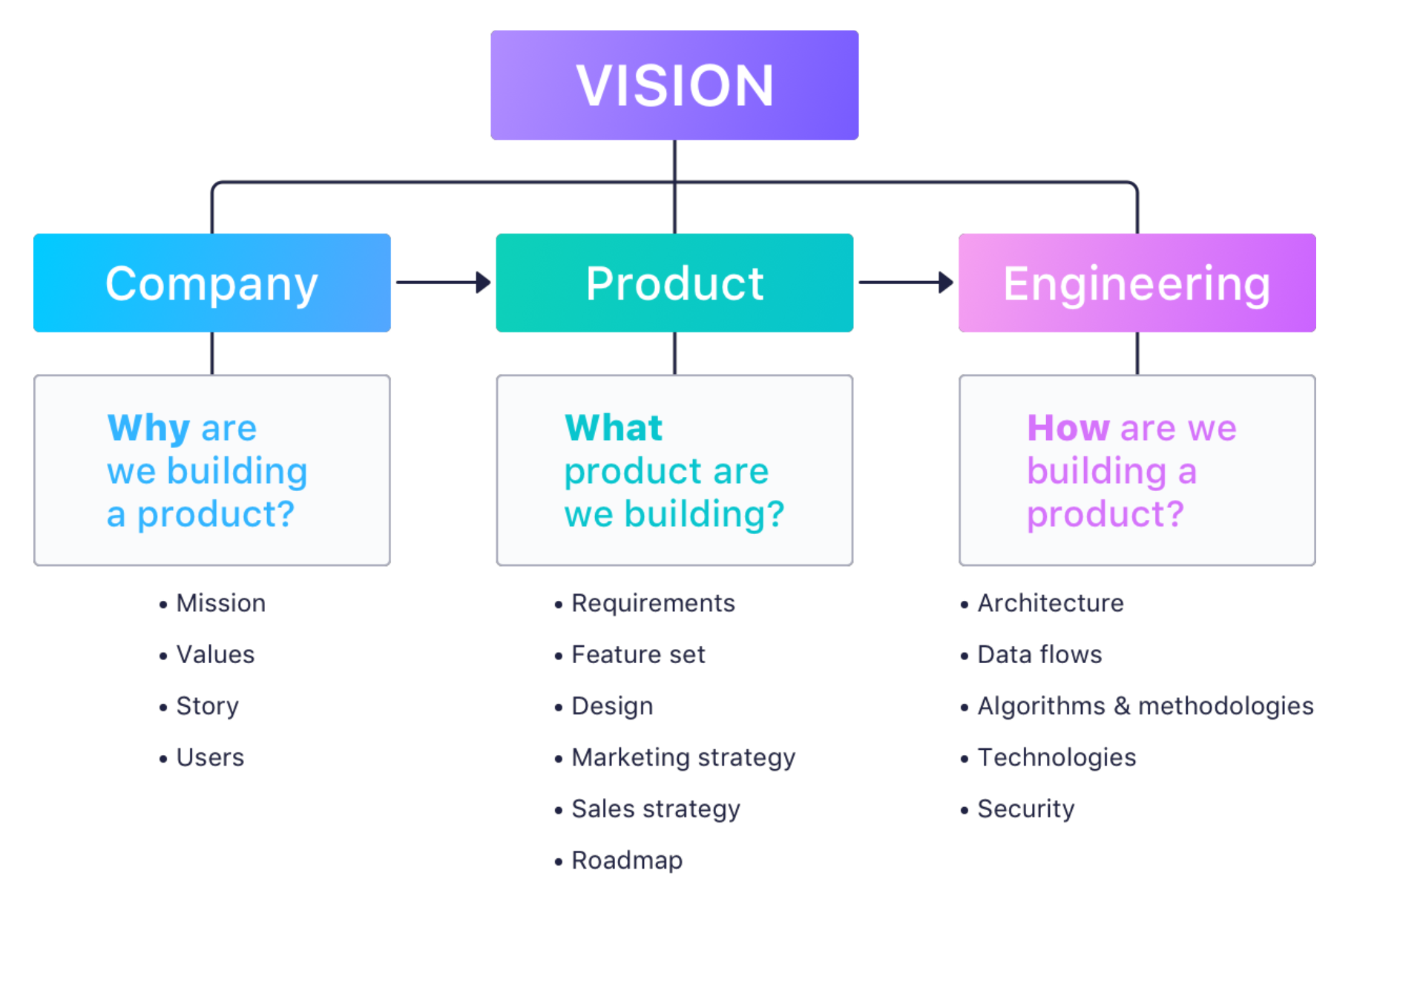
In other words, you’ll need to determine the “why” behind your product, the reason for its existence on the market. You need to ask yourself “why am I creating this exact product?”
Once you define your product vision, it will be like a compass for your whole team, guiding every aspect of the product creation process.
Creating a Product Vision Statement
When creating a product vision statement, you need to keep your end user in mind. What do you want your product to achieve for your users? As cheesy as it sounds – how are you planning to make the world a better place with your product? Having this in mind, the product vision needs to also capture the essence of your audience – their challenges, problems, and goals – and the way your product is ultimately going to make their lives better. Creating a product vision board will help you arrive at your vision statement.
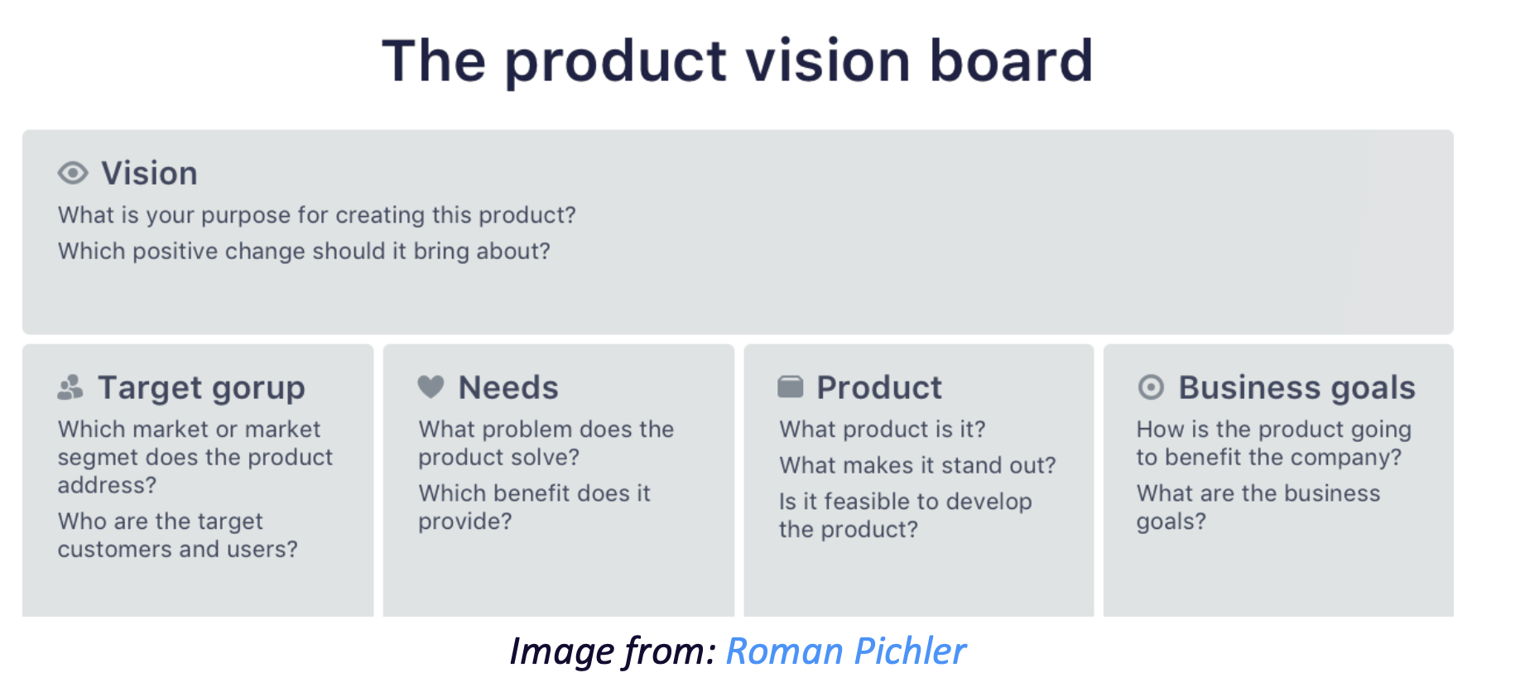
When it comes to the product management process, a product vision is a guiding light that will help you set up your whole product strategy.
The product vision should help you:
● Create a better product roadmap
● Give your team directions along the way
● Align your whole team while working toward the same goal.
Even though all stakeholders should participate in developing the product vision statement, the product manager should have the final say and polish the final version.
Product Vision Examples
Here are some examples of the product vision statements from the world’s most successful companies:
Microsoft: A computer on every desk and in every home.
Google: To provide access to the world’s information with one click.
Amazon: To be Earth’ s most customer-centric company, where customers can find and discover anything they might want to buy online.
Samsung: Inspire the world. Create the future.
Instagram: To capture and share the world’ s moments.

Task 6. Find out the Product Vision Examples from companies, brands, startups, etc.

2. How to Define Your Target Market and Customer Persona
Once you’ve created the product vision, you’ll need to determine who you’re creating this product for.
For this, you’ll have to define your target market and then go a step further to define your customer persona(s). So what is the difference between the two?
Defining Your Target Market
Defining your target market will give you the segment of people you’re targeting, according to their age, location, education, industry, interests, gender, and similar demographic information. Of course, you don’t have to note down all these details, only those that are relevant to your product.
Although narrowing down your audience may sound counterintuitive at first, it’s a crucial step. The fact of the matter is that you can’t sell to everyone, and if your marketing scope is too wide, you’ll only be wasting your resources.
Marketing to everyone is like shooting darts in the dark – you will probably run out of darts before you even hit the dartboard once.
Keep in mind that the target market and the target audience are two separate things. The target market are people who will be using your product, and the target audience are people you’re selling the product to.
Here’s an example: you’re making software that helps children learn to read. Your target market are children aged 5-8. But, since kids of that age rarely have money (or the desire) to invest in software, your target audience are their parents, grandparents, etc.
So, when making the product, you keep your target market in mind, but when selling the product, you sell it to the target audience. In most cases, these two are the same group of people or they greatly overlap, but sometimes they are completely different.

Creating Your Customer Persona
A customer persona (also known as a buyer persona) is the representation of your ideal customer based on market analysis and data collected from existing customers.
Aside from demographics, a customer persona should give you information about your ideal customers such as their typical buying behavior, their lifestyle, needs, problems and challenges, goals, and motivations.
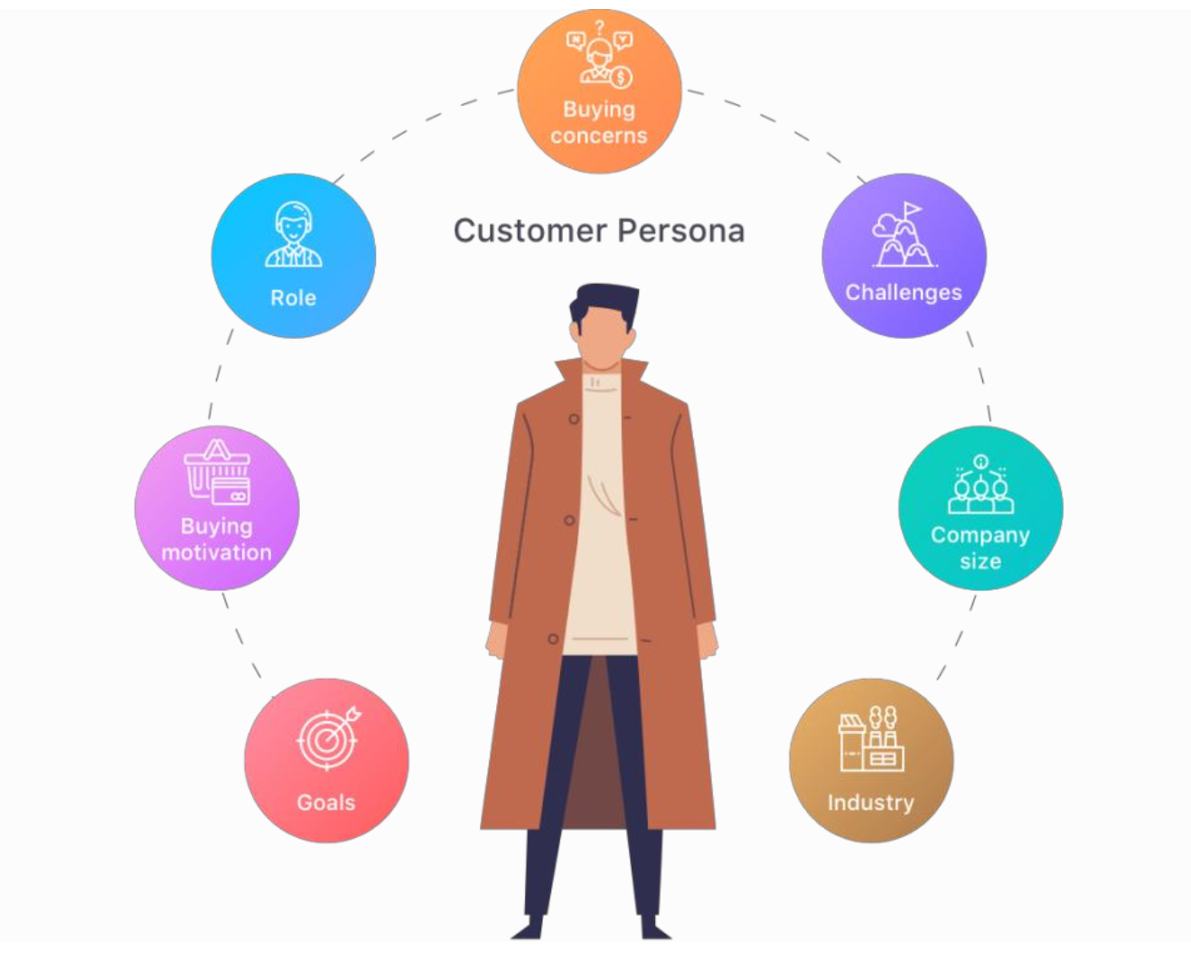

Once you define your customer persona (or personas), it will help you further develop your strategy when it comes to the product itself but also marketing and sales. You’ll be able to know where to find your ideal customers, how to speak their language, create the features they need, deliver the content they’re interested in, and even predict their common objections.

3. Product Positioning - How Your Product Fits in the Market
The next step in your product strategy is product positioning. It means defining where your product fits in the marketplace. So rather than changing the product itself, positioning represents the messaging – how you want your audience to perceive your product.
To be able to position your product, you will need to determine your target market first. Only after you have defined your target market, you’ll be able to figure out what kind of message you want to send to them, and the best channels for sending it.
Once you know the group of people you’re creating the product for and once you have your customer persona(s), you’ll be able to translate their core values and needs into the product benefits that will sound most appealing to them. And you’ll be able to create a message that resonates with them.
However, there is one important detail you need to keep in mind. No matter how you position your product, you need to make sure to deliver on the promise. Because at the end of the day, positioning is not what you say about your product, it’s how your audience perceives it.
If you have several audience segments, you will also need to adjust your messaging, since different audience segments may see different benefits from your product.
Aside from that, you’ll need to adjust your messaging depending on the channel you’re using. For example, your style will have to be completely different when sending an email, writing a Facebook post, or creating a banner.

Creating Your Product Positioning Statement
Ultimately, your positioning statement should define your target audience, the unique features that set your product apart from the competition, and the benefits that the users will have from it. According to the famous organizational theorist and management consultant, Geoffrey Moore, a product positioning statement formula should look something like this:
For (target customer) who (has a specific problem or a need), our product is a (product category) that (provides this key benefit/solves this problem/fulfills this need). Unlike (primary competitive alternative), our product (provides this unique value).
Don't forget that product positioning is all about crafting a compelling message that resonates with your target audience. Once you do that, it will serve as the foundation for your product management strategy.

Product Differentiation - What's Your Competitive Edge
Although often defined as a marketing process, product differentiation is much more than that. It is related to every aspect of the product and every part of your team.
Unless you have an incredibly unique idea for a product that nobody has thought of before, chances are you’re going to enter a competitive market with lots of similar products already available. Product differentiation should answer the following question – what does your product offer that other similar products on the market don’t? What is the unique value of your product that makes it stand out from the competition?
This kind of differentiation can be focused on any aspect of your product. Maybe you’re planning to offer a better, more beautiful design. Maybe you’re going to develop unique features that your competitors don’t have. Or, you’re simply planning to offer a lower price and better customer support.
All these aspects are an opportunity for product differentiation, and ultimately product differentiation should motivate the customer to choose your product over another one.

Task 7. Give some examples of product differentiation. Choose the products on your own.

Competitive Analysis
To be able to differentiate your product from the competition, you first need to know who your competitors are and what they have to offer. This is called competitive analysis.
First of all, you’ll need to create a list of your ten biggest competitors. After you compile that list, it’s time for a thorough analysis. You’ll need to define all relevant factors in your niche such as:
● Feature segments
● Design
● Company size
● Prices
● Website traffic
● Number of users
● Customer support
● Other
One of the most important things to analyze is the feature segments. Feature segments are groups of features that are commonly found in your niche. Defining them will help you create initiatives and build your product roadmap.
To define the feature segments in your niche, you’ll need to do the following steps:
1. Find and note down all your major competitors
2. List all the features these tools have
3. Group those features into segments

4. How To Set Smart, Measurable Product Goals
Product goals are the highest-level objectives regarding the product – the big, bold ideas for your product and business in the future. These goals should be the crucial achievements that need to happen to turn your vision into reality.
By always keeping product goals in front of you and your team, you will make it much easier to focus on what needs to be done and when.
Although product goals are abstract, they should derive from KPIs. In other words, they should be measurable and achievable within a certain timeframe.

How To Set SMART Goals
Setting goals might turn out more challenging than you expect. The SMART methodology provides one of the best guidelines for coming up with the right goals and for defining them the right way.
Here’s what the acronym SMART stands for:
S = specific, significant, stretching
M = measurable, meaningful, motivational
A = agreed upon, attainable, achievable, acceptable, action-oriented
R = realistic, relevant, reasonable, rewarding, results-oriented
T = time-based, time-bound, timely, tangible, trackable
Aside from creating SMART goals, you’ll need to ensure they are aligned with your overall product strategy and business strategy.

Here are a few examples of high-level product goals that will help you drive your product forward:
● Become #1 work and data management platform by 2025
● Become a $1 billion company by January 2024
● Develop an exceptionally secure and trustworthy application by 2023
● Reach 1 million users by Q1 2025

How To Set Actionable Product Initiatives
Once you set your product goals, initiatives will be the actual steps you’ll need to take if you want to reach those goals. Even so, product initiatives don’t have to be tied to a specific goal as long as they’re aligned with your overall product strategy and vision.
The timeframe necessary to complete an initiative can vary from a few months to even a few years. For example, one initiative can be to improve the conversion rate by 3% which can take a few months to accomplish. If your initiative is to reach 100,000 signups, this will take much longer to complete.
The important thing is to set a timeframe and stick to it so you can track your progress, measure the results, and improve your strategy over time.
Here are some examples of product initiatives:
● Get 10,000 new users by November 2024
● Increase free trial engagement by 5%
● Get into the top 10 tools for project management
● Build 3 collaboration features
● Improve onboarding by 50%
It’s easy to see why initiatives are such an important part of your product strategy, but they have more than a single purpose.
Firstly, they will help you figure out what needs to be done inside and outside the product in order to reach the desired goals. Once you lay the initiatives out in the roadmap, you’ll be able to share and track them with the team so everyone can be in the loop.
And finally, you’ll be able to analyze the effort and impact of your initiatives, so you can tweak your product strategy accordingly and allocate resources in an optimal way.

3 approach Product Opportunity Canvas [artkai]
The canvas is a one-page opportunity assessment template for evaluating new product ideas. It’s inspired by the Business model canvas developed by Swiss business theorist, author, speaker, consultant, and entrepreneur Alex Osterwalder.
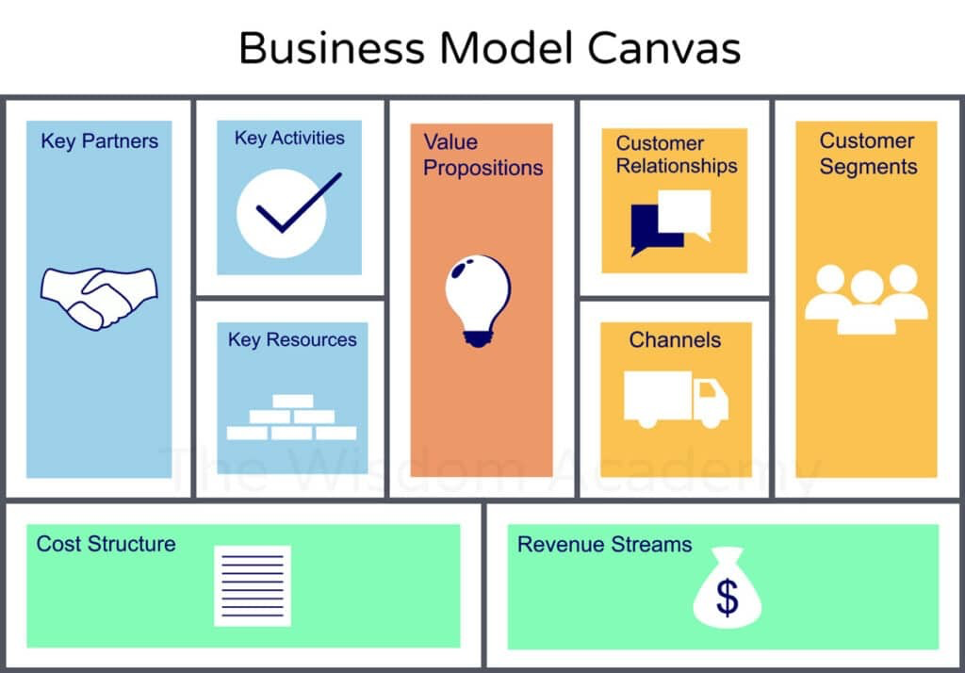
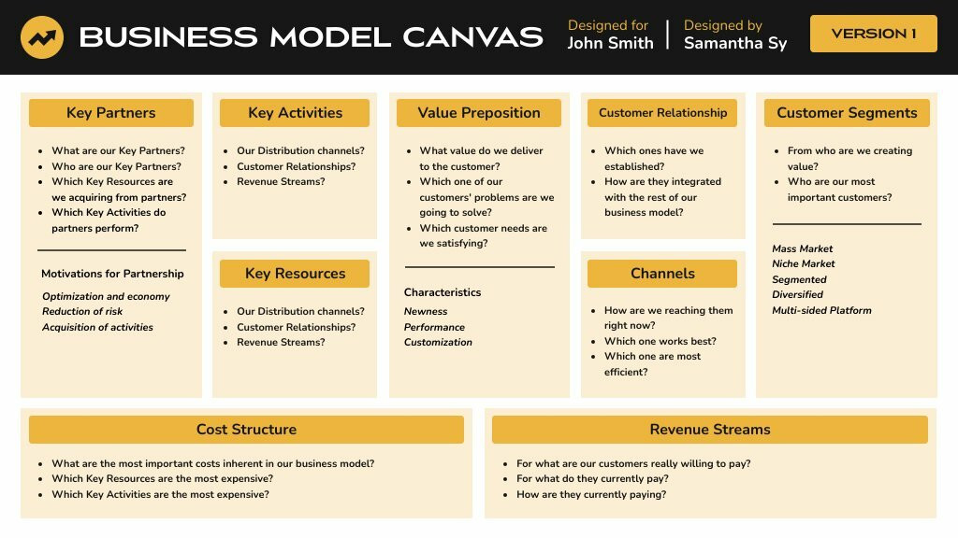
The Product. Emphasize your product’s advantages. Make sure your product description highlights all unique features and services that make it stand out from the competition. Keep your description focused on the customers.
Positioning. Specify the desired role of the product on the market and in potential customers’ minds. The product position should show how unique its UTP (unique trade/selling proposition) is, how it differs from competitors, and how it can address the customers’ pain points.
Core features and functions. Provide a brief list of your product functionalities and how they make your product distinct from others on the market.
Customer benefits. Define tangible and intangible characteristics your customers will recognize, buy, or use.
Customer segments. Divide your consumer base into groups based on each category’s shared traits.
Channels. List your communication, distribution, and sales to describe how your business reaches your customer segments and interacts with them to deliver your value proposition.
Cost structure. Describe the most significant expenses to establish your innovation and value proposition creation strategy.
Revenue streams. List the potential ways a company can benefit from selling the product.
Critical success factors. Provide the elements the company needs to achieve its objectives. Also, determine the differences between the keys and various roles of the key result area.
Key performance indicators (KPIs). Create a list of goals and achievements in your sector. Financial KPIs include the current ratio (liquidity and cash availability), revenues, less specific expenses, and net profit (or the bottom line, gross profit margin).
The product opportunity canvas aims to gather and clarify these sections to the best of your knowledge. With its help, you will obtain a perspective through critical analysis and synthesis. But note that you shouldn’t aim to make your idea look good. Instead, it should be a sincere effort to determine the viability and outcome, whether you like it or not.

Task 8. Learn about Lean Canvas Intro – Uber example. Be prepared to present your results in class. (https://www.youtube.com/watch?v=pvIN9STpzCQ)

Task 9. Familiarize yourselves with other examples of Canva model in different businesses. (https://railsware.com/blog/5-lean-canvas-examples/)

III. Ways to Conduct a Product Opportunity Assessment

Depending on how much money you should invest in developing the suggested solution, the assessment should be as thorough as possible. It’s better to go through the sequence of assessment approaches until you feel confident in the chosen promising opportunities. Generally speaking, the more thorough the technique, the bigger the opportunity. Here are the three major approaches to business opportunity assessment.

- Scoring ( for characteristics of an existing product);
- Opportunity Assessment (for extensive features and small products);
- Prototype or MVP (for full-size products). [artkai]

Scoring

The quickest assessment method is to rate the suggestion using a weighted scoring formula in an accessible spreadsheet. You can easily compare your ideas using this technique. This approach is often sufficient when rating improvements to current products.

The list of methods [zeda.io]
RICE scoring model – This framework has four components: Reach, Impact, Confidence and Effort. You measure each feature on a scale of 1-10 and then use a formula to determine which one you should focus on first.
ICE scoring model – This framework is similar to the previous one, but it focuses most on identifying high-impact tasks that you can do with relatively low effort.
Kano prioritization model – This framework classifies initiatives into different categories based on how they'll affect your customers (from delighting them to neutral and even negative impact).

Task 10. Learn about the framework of RICE, ICE scoring models, and Kano prioritization model. Be prepeared to present your findings in class. (https://zeda.io/blog/rice-scoring-prioritisation-model, https://zeda.io/blog/ice-scoring-prioritisation-model, https://zeda.io/blog/kano-prioritization)

Impact mapping – Impact maps are a great way to visualize multi-level diagrams to help you understand the bigger picture.
Impact/Effort matrix – This framework is great for boosting efficiency when you want to maximize the positive impact of your efforts.
Value/Effort – This is the best framework for identifying high-value, low-effort business opportunities.

Task 11. Learn about Impact mapping, Impact/Effort matrix, and Value/Effort framework. Be prepeared to present your findings in class.

Opportunity Assessment

Ideas that propose significant features or a new product require a more detailed opportunity assessment. According to Marty Cagan, the ten questions should evaluate a product's possibility. Now, let’s review these fundamental questions in detail.
Besides answering the ten fundamental questions, it’s a good idea to complete a lean canvas to evaluate the opportunity. Here are the two critical components to mention:
Solution. The Lean Product Canvas briefly describes the solution itself. This way, it keeps everyone on the same page and provides more detail on the product requirements.
Unique value proposition. It’s worth clarifying why a particular idea has a unique value proposition that makes it competitive.
Sometimes, a quick sketch of the answer helps communicate the assessed product idea. For example, a visual representation of the product idea in wireframes and a list of essential workflows can provide the agreement. It’s especially crucial when you share the assessment with your team.

Prototyping / MVP

The lean startup movement encourages early market testing of a potential product idea. This way, you can learn from the results and adjust your product based on the insights discovered. It’s the next step to commercialization for product ideas that address unmet customers’ needs in new markets.
You can’t genuinely answer some questions (such as how much you should invest and whether a product workflow corresponds with actual business processes) until a prospective client assesses a prototype. The minimum viable product (MVP) is an excellent way to get those answers as early as possible.

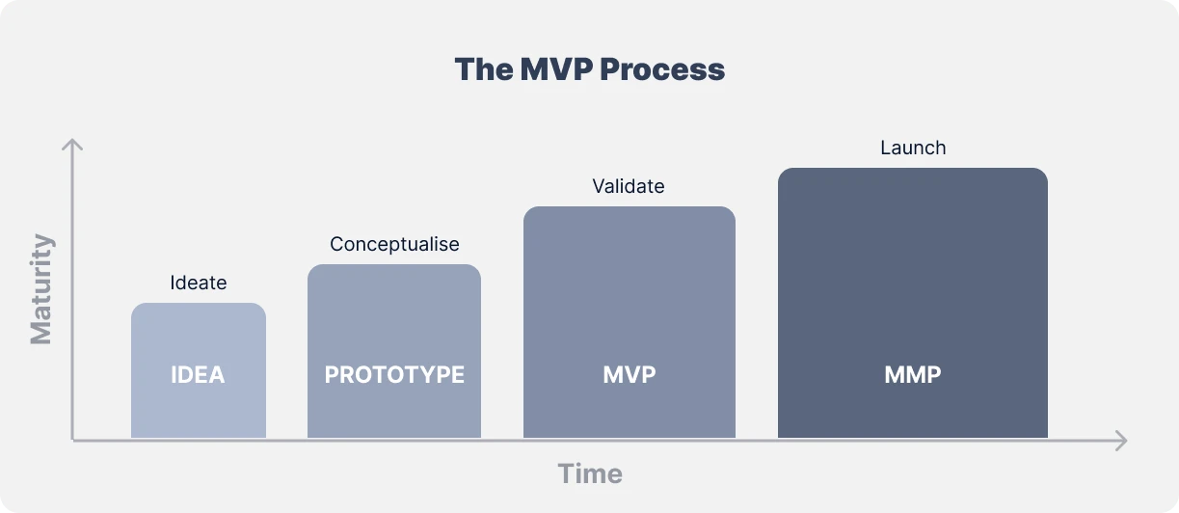
A startup can demonstrate that a specific market issue doesn't present a viable opportunity via the opportunity assessment. It could be the case for several different reasons, including the following ones:
Too narrow market
Not enough room for profit
No alignment between the opportunity and the company’s business strategy
In such cases, it might not be wise to build an MVP. Instead, you may need to pivot and change the idea before moving further. Alternatively, suppose your findings show that the opportunity is feasible. Then, you can keep testing it using an MVP.

