This person is a needle in a haystack. An almost impossible combination of structured thinker and visionary leader.
Tony Fadell, Build: An Unorthodox Guide to Making Things Worth Making. Harper Business, 2022.

Lecture 1.
Product Management. Overview

1. What is Product Management?
2. The role of Product Manager.
3. Product Life Cycle.

Огляд IT компаній на ринку України

1. What is Product Management?

History

The idea of product management (PM) first appeared in the early 30s with a memo written by the president of Procter & Gamble, Neil H. McElroy, where he introduced the idea of a product manager – a “brand man” completely responsible for a brand and instrumental to its growth.
Decades later, in the 1980s, modern PM started to take shape with the explosive growth of the software market. Since then, PM has been closely connected to and typically found in companies creating software. [Book]

PM is pretty well known today – particularly in the tech industry. However, before it became widespread, there were some "product people" (brand managers, executives, and engineering leads) driving product growth and innovation:
Early 1900s: The concept of PM emerged as companies started producing goods at a larger, more ambitious scale thanks to technological advancements such as the assembly line. However, PM work was not formally introduced until 1931, when Procter & Gamble employee Neil H. McElroy drafted a memo to executive leadership. Although he was simply trying to justify hiring more people, his work influenced how we think about brand and product management.
1950s-1960s: During the post-World War II economic boom, businesses started focusing on marketing and selling their products to a more extensive consumer base. PM evolved to include market research, product development, and strategic planning to meet customer demand.
1970s-1980s: The rise in technology and globalization motivated companies to adopt more structured product development approaches. This included introducing project management as a standalone function and closer collaboration with cross-functional teams such as engineering, sales, and marketing.
1990s and beyond: Then, the internet changed everything. It revolutionized product development, marketing, and sales. PM expanded to include digital products and services, emphasizing user experience (UX) and continuous improvement.
Fast-forward to the present day, and PM now extends beyond product development and marketing to include the overall strategic direction of a company's portfolio. To thrive, products cannot be good (or even great). They must be lovable and fit into the bigger picture of what your company wants to achieve. [Aha!]

PM work is dynamic and rewarding – it continues to grow in popularity. From 2023-2024, for example, just over 16% of MBA students at MIT's Sloan School of Management accepted jobs in PM – making this the third-largest job category for its graduates. Hiring site Glassdoor also ranked PM as the 10th best job in the United States in 2022. [Aha!]

Definitions

The main activities of Product Management: Market Research (understanding customer needs, industry trends, and competitive landscapes), Product Strategy (defining the product vision, mission, and goals), Product Planning (creating product roadmaps, prioritizing features, and setting release schedules), Product Development (collaborating with cross-functional teams (e.g., engineering, design, marketing) to bring the product to market), Product Launch (executing go-to-market strategies, etc.), and Monitoring product performance.

Product management is the practice of planning, developing, marketing, and continuous improvement of a company’s product or products. [Book]

Product management is an organizational function that guides every step of a product’s lifecycle – from development to positioning and pricing – by focusing on the product and its customers first and foremost. To build the best possible product, product managers advocate for customers within the organization and make sure the voice of the market is heard and heeded.
Thanks to this focus on the customer, product teams routinely ship better-designed and higher-performing products. In tech, where products are quickly uprooted by newer and better solutions, there is more need than ever for an intimate (deep) understanding of customers and the ability to create tailored solutions for them. That’s where product management comes in. [Atlassian]

Product management is the practice of strategically driving the development, market launch, and continual support and improvement of a company’s products. [The Ultimate Guide to Product Management]

Product management is defined as a role within a product development team that focuses on successfully executing the product lifecycle. [What Is Product Management? A Beginner’s Guide]

Product Management is the function responsible for defining desirable, viable, feasible, and sustainable solutions that meet customer needs and supporting development across the product life cycle. [Scaled Agile, Inc.]

Product management is the process of bringing products and services to market that customers need. Its core function is to align the organization around what must be completed to ensure a successful delivery – growing the business as a result. [Aha!]

Product management is a process that focuses on bringing a new product to market or enhancing an existing one. It starts with an idea that a customer will interact with and ends with evaluating the product’s success. Product management unites business, product development, marketing, and sales. Studies show that effective product management can increase profit by 34.2 percent.
What do you need to create a product? First, an idea of how it will look in the end. Then follows a process of product creation that takes a lot of time, effort, a team of professionals, and a team leader. To transform any idea into a profitable product, a company has to go through several stages to set a vision, define a strategy, develop a product, and sell it to the right people. [altexsoft]

Task 1. Сompare the given definitions according to the following scheme: the main concept and the corresponding specific features. Based on the analysis, find the commonalities and differences in all the definitions.

[Book] The main objective of product management is the development of a new product. Its ultimate goal is making sure you’re building the right product and building the product right.

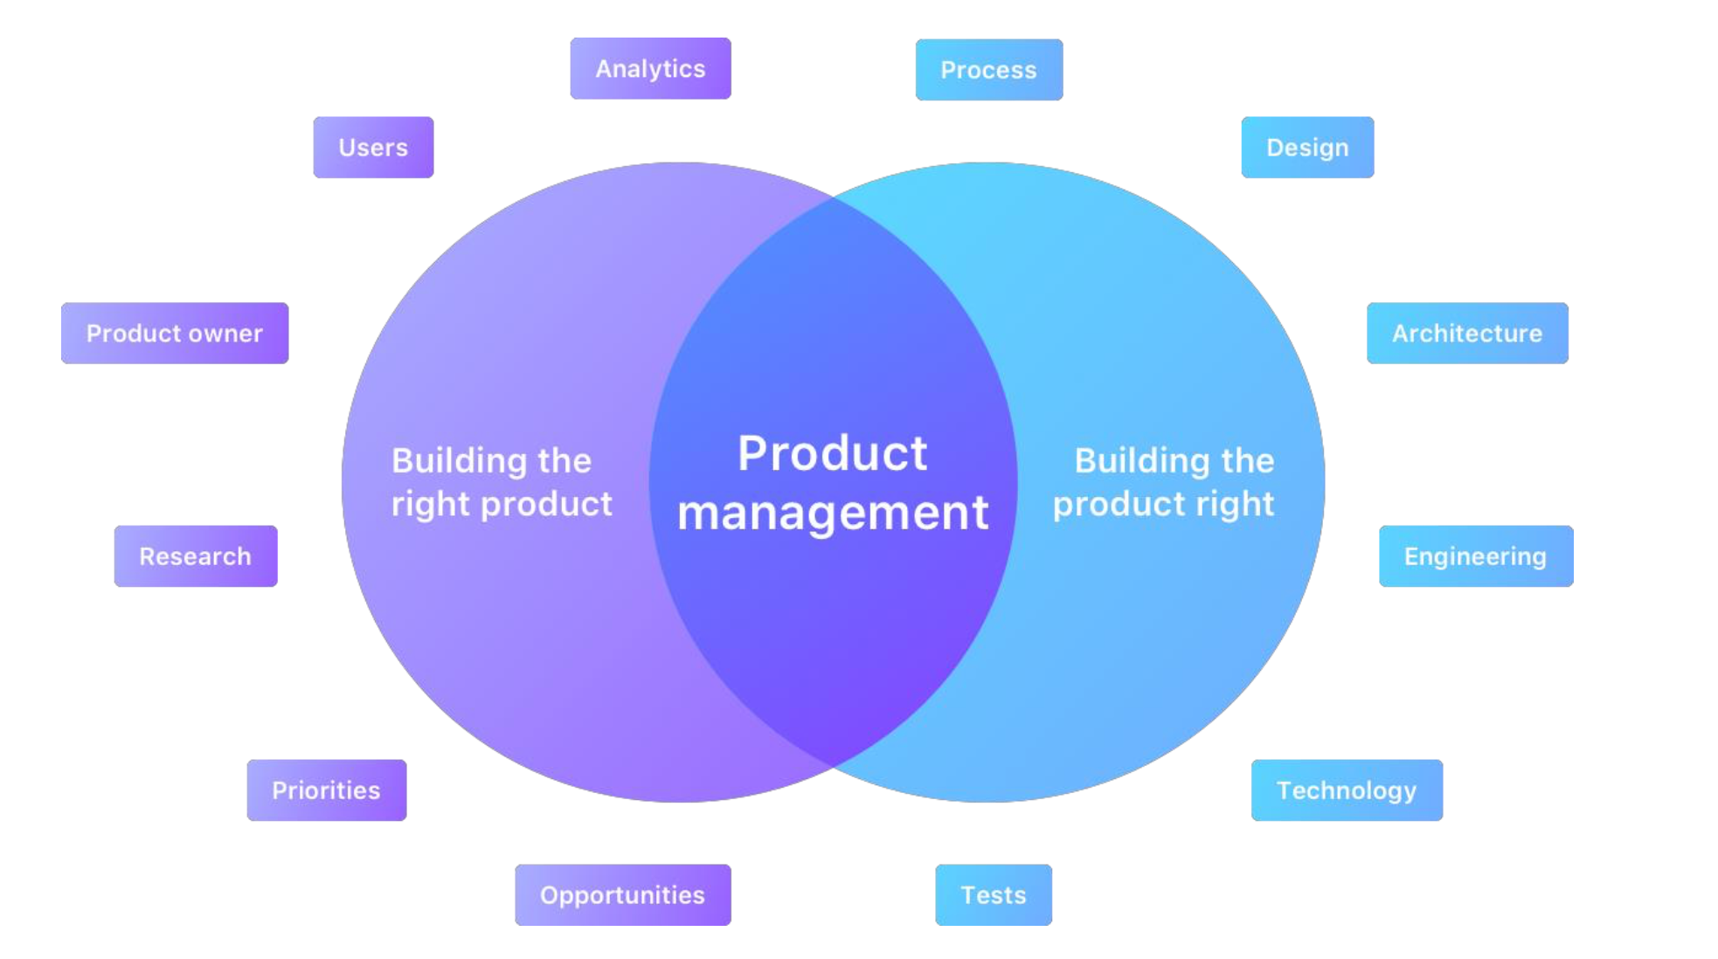
Most notably, PM means linking the development team on the one side with marketing, sales, and customer success teams on the other side, while ensuring the process is aligned with the business vision.
PM should translate business objectives into engineering requirements and explain product functionalities and limitations to commercial teams responsible for marketing, sales, and customer communication.

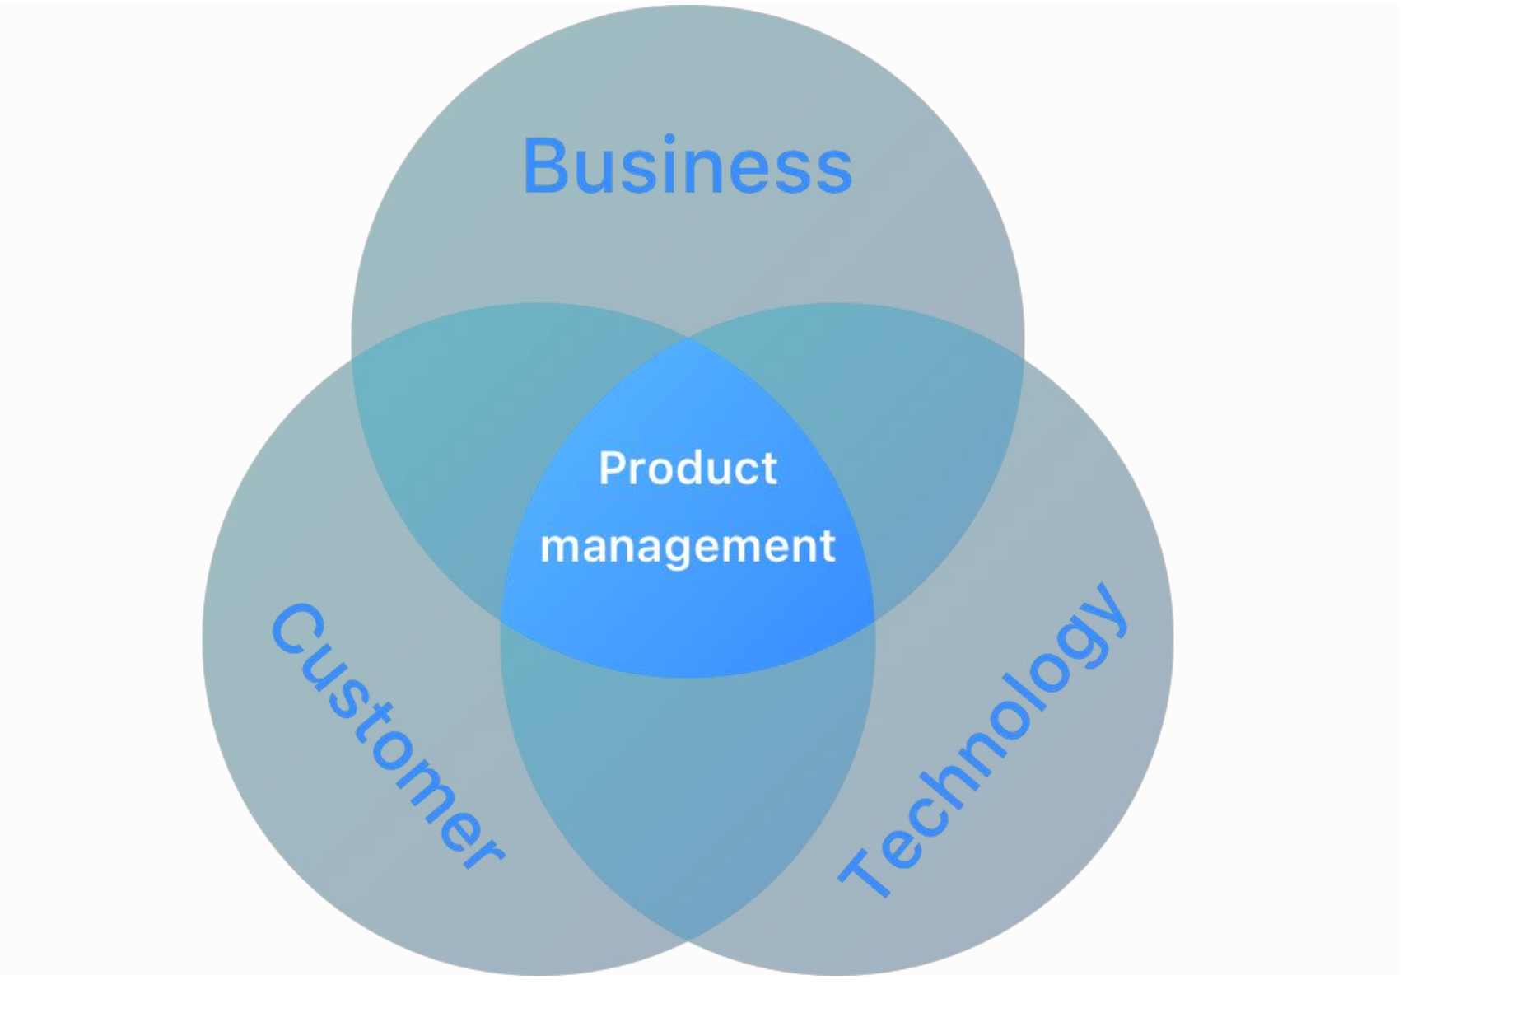

Inbound Vs. Outbound Product Management

Since PM is such a large concept, organizations usually split responsibilities across departments. That’s why we can differentiate between inbound and outbound PM.
Inbound PM involves market research, industry trends, and competitive analysis as well as the overall strategy and product roadmap.

Inbound PM responsibilities include:
● Customer research and insights
● Business care analysis
● Positioning
● Product roadmapping (It's a plan of action that aligns the organization around short and long-term goals for the product or project, and how they will be achieved.
● Market requirements and prioritization)
● Whole product definition
● Differentiation and desirability
● Features/cost/schedule trade-offs
● Developing product requirements with engineering and UX (User Expirience Design)
● Competitive analysis (product and market position)
● Beta programs (a phase in software development where a pre-release version is made available to a select group of users called beta testers)

Outbound PM focuses on product marketing – branding, messaging, positioning, product launches, PR, advertising, etc.
Outbound PM responsibilities include:
● Launch and marketing plans
● Features and benefits
● Messaging by market and role
● Training
● Sales tools
● Product launch
● Marketing program
● Success stories
● Market analysis
● Competitive analysis (price, promotion, and place)

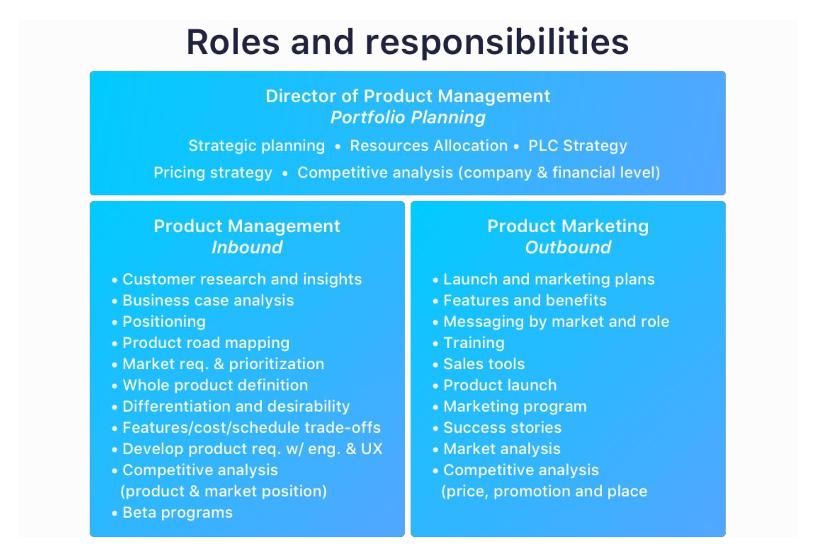
2. The role of Product Manager.

[Book] The concept of PM includes many different roles such as chief product officer, director of product management, product manager, product owner, and product marketing manager, to name just a few.
It’s important to keep in mind that product management and project management are two different roles.

Task 2. Define the differencies between (a) a product manager and a product owner (https://www.atlassian.com/agile/product-management/product-manager); (b) a product manager and a project manager (https://www.aha.io/roadmapping/guide/product-management, https://www.altexsoft.com/blog/product-management-main-stages-and-product-manager-role/)

There can be one person or a whole team in charge of PM. The number of people involved will largely depend on the size of the company. In some cases (for example, in growing startups) one person takes on several different roles – acting as a CEO, product manager, and product marketing manager.

Product Manager’s Roles And Responsibilities
A product team without a product manager is like an orchestra without a conductor. Even a group of geniuses would be completely uncoordinated and sound discordant without a conductor to guide and synchronize them.
Much like a conductor, a product manager is supposed to lead a cross-functional product team and coordinate product creation from strategy to execution. A product manager needs to be the leader who will ensure that everyone on the team is working toward the same goal.
To be able to handle such a complex and versatile role, a great product manager should be knowledgeable in several areas, most notably technology, business, and user experience.

What Does a Product Manager Do?

[altexsoft] Identifying opportunities. The first thing a product manager does is look for the opportunity to develop a new successful product or improve an existing one by adding necessary features. The expert must be aware of current trends and have a deep understanding of the market. This person is also responsible for the outcome of a product launch.

Developing product vision and strategy. A product manager defines the long-term mission of a project and builds a clear, realistic plan of how to reach the desired result. Feedback Loop’s survey demonstrated that the key activity of most product managers (84 percent) is setting a product strategy. It’s closely followed by crafting a clear roadmap and overseeing its completion.
When the strategy is ready, the product manager communicates it to the product team and the stakeholders.

Team and stakeholder management. A product manager makes sure that all members of a team work in harmony to achieve the main goal. One of the most important functions of this person is to clearly communicate the requirements to the development team and organize the development process in the most efficient way. On the other hand, the product manager negotiates with stakeholders and balances their demands and expectations.
Stakeholders greatly influence product development because they can cut the budget or change the timeline. They can suggest implementing product features they find necessary, which, in reality, can be completely useless to end customers. The product manager's task is to ensure a common understanding of the vision.

Marketing activities. Marketing is one of the main factors contributing to product success, so product managers collaborate with product marketing managers. That involves market research, observing current industry trends, collecting and analyzing customer feedback, defining pricing, and developing a marketing strategy.

Constant product improvement. While at first glance it seems a product manager only performs administrative tasks, that is not true. They are constantly working on improving the existing product, testing it, analyzing data, and managing defects. Eventually, a product manager makes the final decision on what the end product should be like.

A product manager is responsible for setting a strategic plan for product creation and making sure that the plan is executed. In other words, a product manager is in charge of the following: (product manager's deliverables)
● Conducting market research, competitor analysis, and customer research.
● Setting a product vision and strategy that states the unique value of the product.
● Creating a product roadmap with a clearly defined action plan, defining the responsibilities and the timeline
● Coordinating among design, engineering, and marketing teams
● Owning the Daily Scrum and Sprint Planning meetings, ensuring that all developers understand the user stories and are clear on what needs to be built
● Defining and analyzing product metrics and analytics

Three main responsibilities:
1. Set the strategy and long-term vision
2. Share this strategy with all the stakeholders
3. Oversee the execution of the strategy

Inside A Product Manager’s Mind
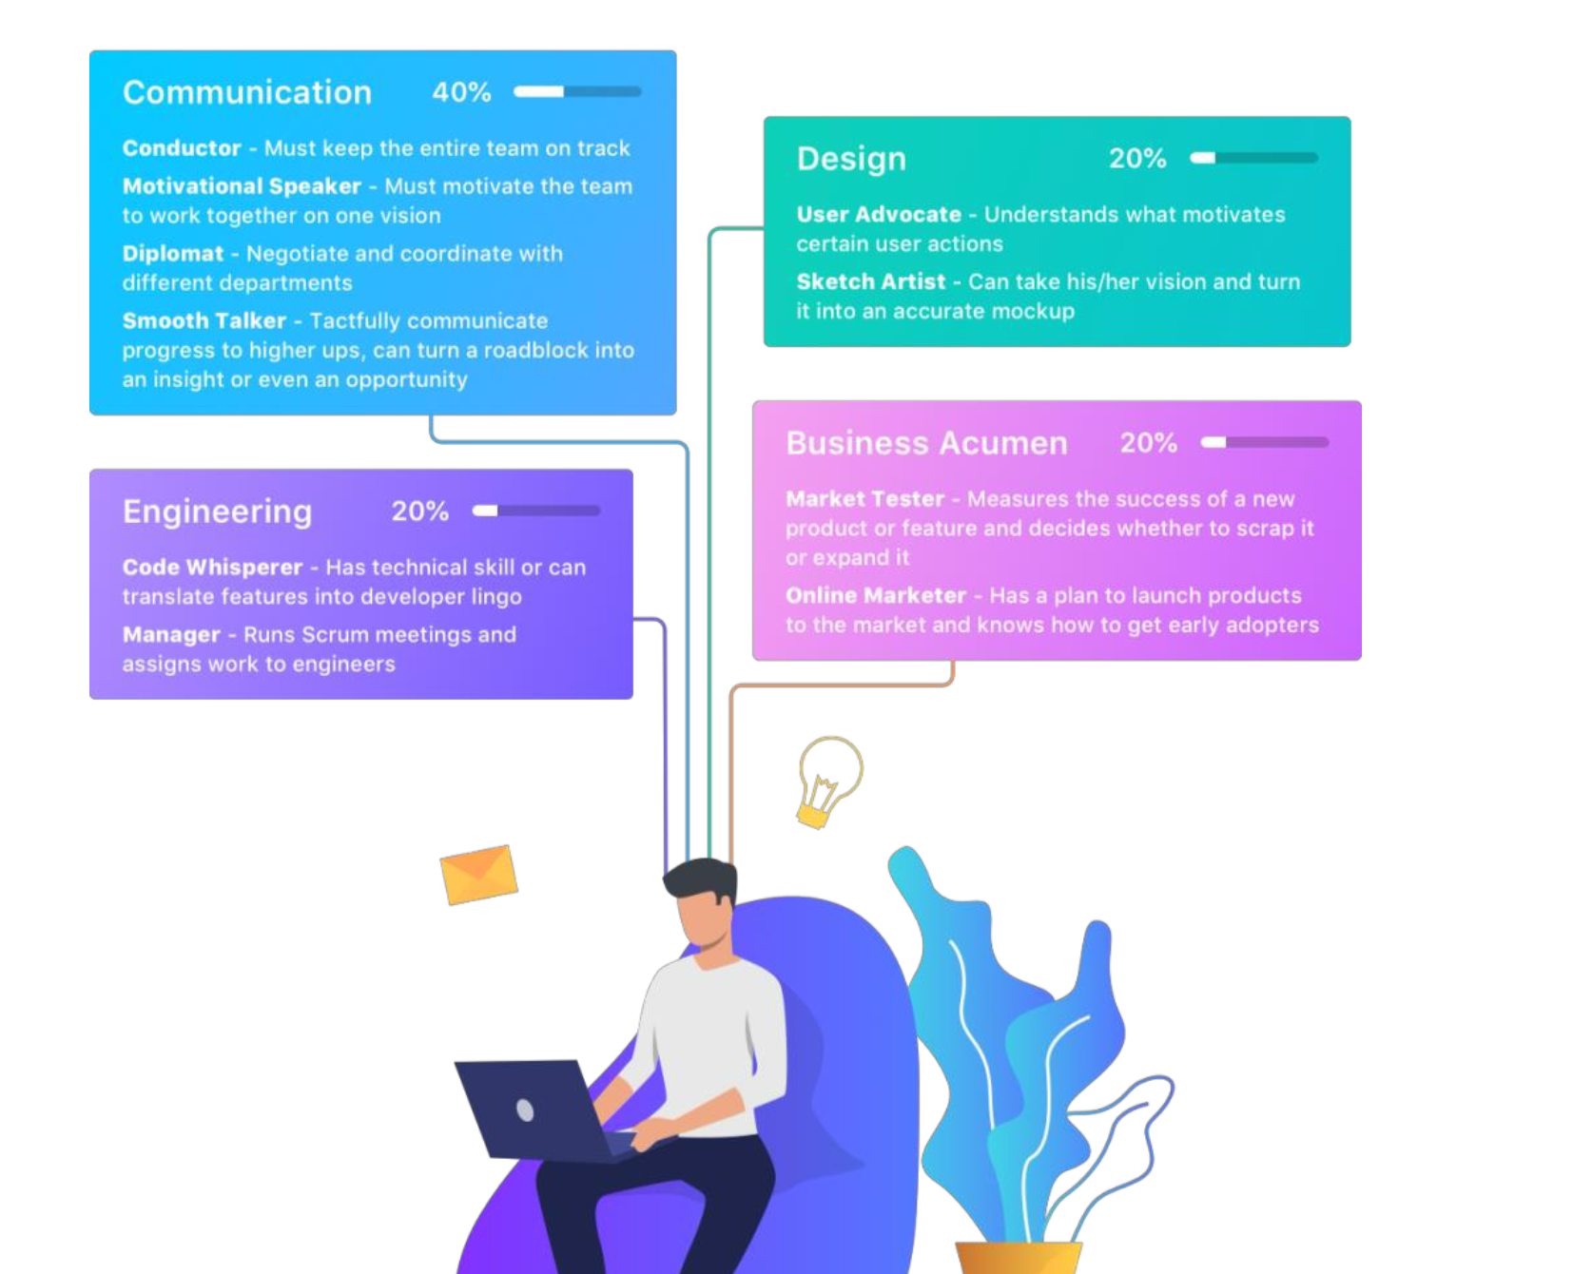
A great product manager should be the go-to person for all questions related to the product and the linking element of the whole team. That’s why they need to be as transparent as possible in the prioritizing process.
Although the product manager will have the final say, it’s important to keep all stakeholders in the loop when it comes to making decisions.
Having all the data necessary in one place – or one tool – will make it much easier for product managers to explain why they are prioritizing certain features over others and why they sometimes have to say no.

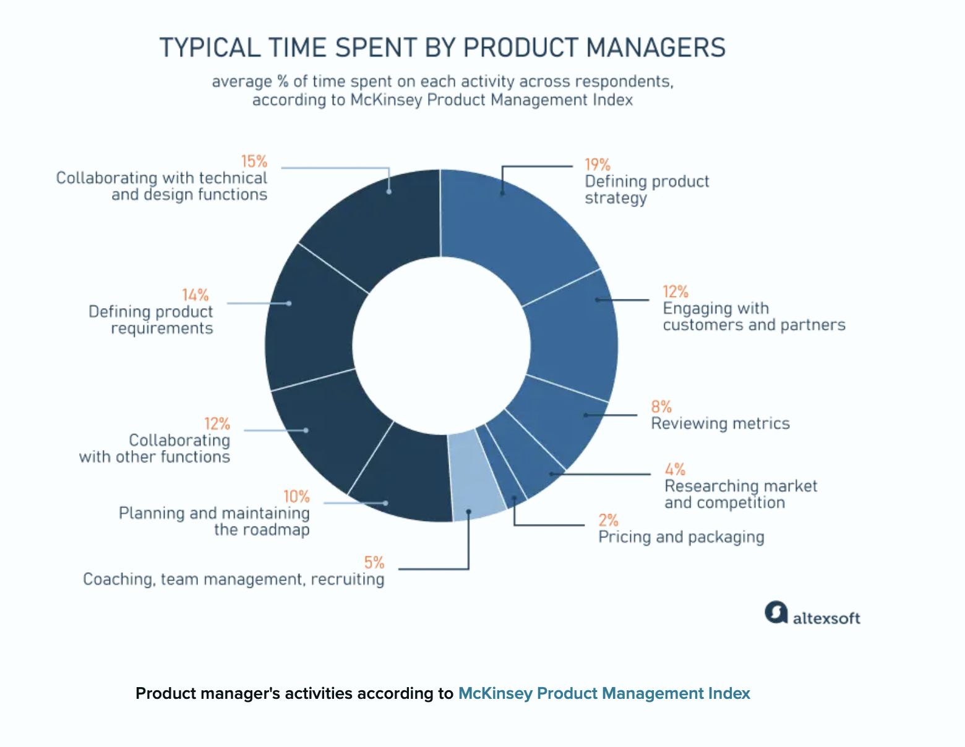
Tasks in PM cascade from strategic to tactical. The whole process involves:
(1) vision development, (2) market research, (3) strategy development,
(4) execution, (5) marketing and sales, and (6) metrics tracking.

Task 3. Watch the video and take notes on the main points.
https://www.youtube.com/watch?v=7j4WGVAsf4Y
What examples of successful software products were mentioned in the video?
What examples of successful software products do you know? Which one is your favorite?
Could you give any examples of software product in translation?

Task 4. Find and give a brief discription of the most common software for product manager's work (https://www.altexsoft.com/blog/product-management-main-stages-and-product-manager-role/).

3. Product Life Cycle.

[altexsoft]
What does it take to create a product which doesn’t go out of demand for years? The case of Airbnb shows that the hospitality idea, three air mattresses, and some boxes of cereal would be just enough to kick-start the exponential growth. How so?
If you’re deep into business and deal with PM, you are well aware that every product has its own lifecycle. After the development stage itself, which always comes with great efforts for a programming team and a thoughtful product manager, every product starts its life in its own market environment.
Regardless of your business model, your product will begin with its introduction and end with its decline, passing through all rises and falls of the market presence.
We’ll define the basic features of each lifecycle stage relying on common product lifecycle representation first introduced by a US economist Raymond Vernon in 1966. As an example, we’ll use Airbnb – one of today’s most successful hospitality networks – product lifecycle stages.

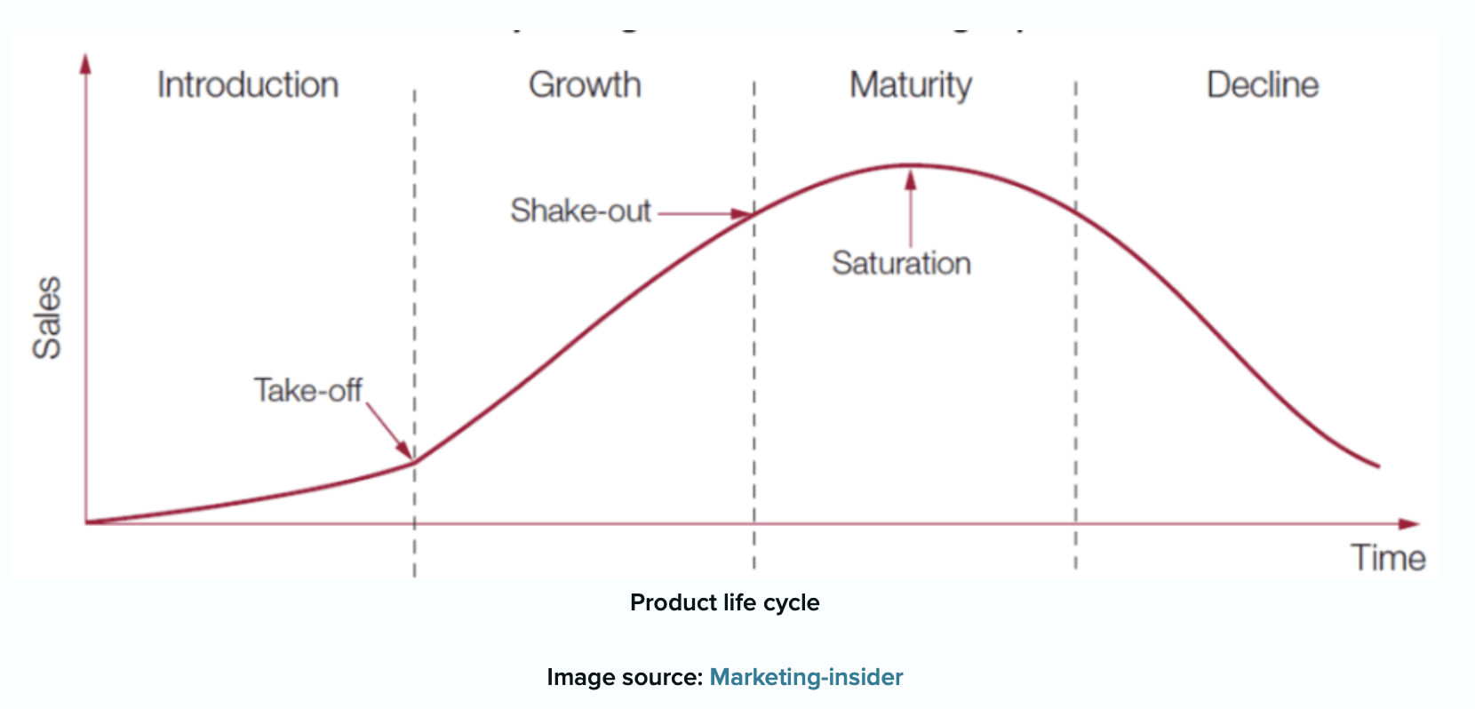

Stage 0: Development

A software product’s market entrance is usually preceded by the development stage. The most comprehensive and fundamental steps are covered by The Project Management Body of Knowledge, adopted and supervised by The Project Management Institute. They include ideation or conceptualization, designing the product roadmap, prototyping, developing, testing, and implementing, as seen on the image below.

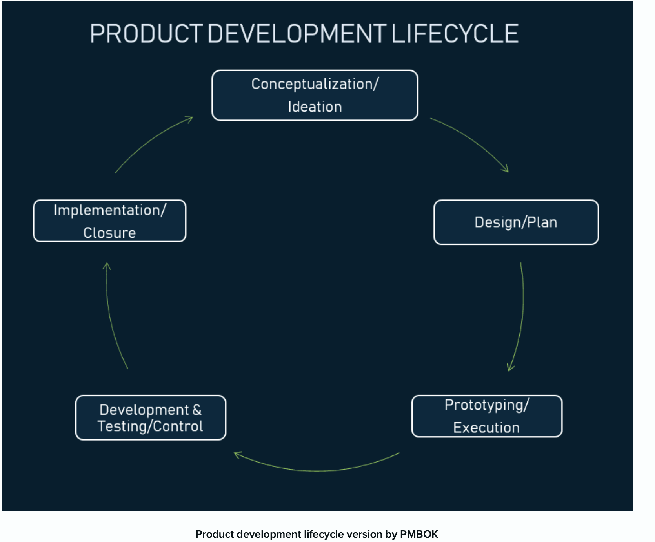
Refer to Airbnb. Let’s briefly return to late 2007. Brian Chesky and Joe Gebbia, the two roommates who couldn’t afford to pay for their loft, decided to profit from the space they had. All they could offer was three airbeds, some food, and a homey (homely) environment. Initially, they simply wanted to close the gap between the short-term accommodation supply and the demand for it.

Chesky and Gebbia had no more than an assumption that people would pay for sleeping on an air mattress in an occupied apartment. So, the first version of Airbnb included a simple website with pictures, targeted at attendees of that year’s tech conference. As they found three people each willing to pay $80 per night, the assumption became a viable business model. You may also believe that your product will succeed, but only tests and validation can prove that it’s not a waste of time and money. Basically, there are two ways to quickly transform an idea into something tangible and test it for survivability and possible means to accomplish it.

Proof of Concept (PoC). This is a demonstration of a small part of the software usually created as a presentation. You introduce a proof of concept within your company before defining broad technical details or specific characteristics. Usually, this approach is taken before development to make sure that your particular technical ideas will work. Although PoC is not aimed at future customers, you can use it at the initial stage to win more funding.

Minimum Viable Product. Statistics show that 42 % of startups fail because they don’t resolve the product-market fit. It happens mostly because startups invest no or too few resources into preliminary market research. Building a minimum viable product (MVP) helps avoid this problem by testing the product and tweaking (tailoring, setting) it iteratively. An MVP represents the earliest and simplest model of your product with basic functionality, enough for the product to work and sufficient to assess its value within its market segment. Additionally, building of the MVP helps you jump-start profits thanks to early adopters.

Upon recognizing the product virtue (advantage) and gaining initial funding, you go back to development, fix some issues, and complete it with additional functionality.
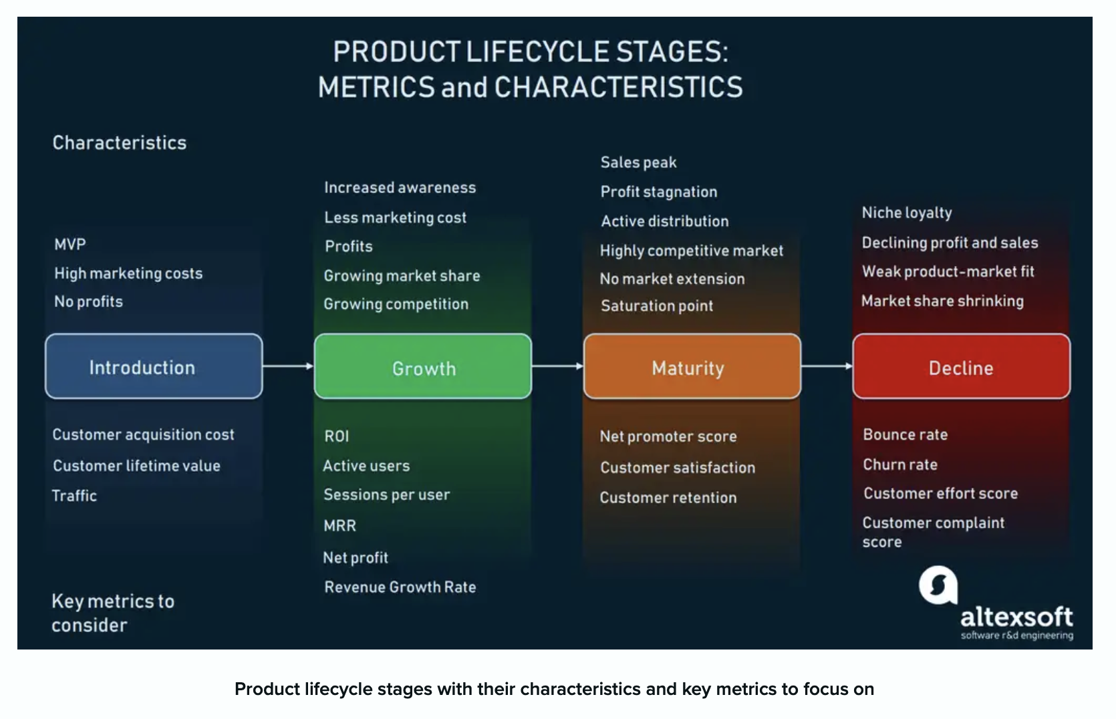
Stage 1: Introduction - Promote and engage with early adopters

At the introductory stage, a product has no market share. Here, above development efforts, you focus all your resources on market research, testing, and primary marketing activities.

In August 2008, the website AirBedAndBreakfast.com launched. To successfully attract its first customers, the company targeted that November's Industrial Design Conference attendees. In the winter of 2009, the founders obtained a $20,000 investments from Y Combinator. In November 2010, Airbnb sought venture funding and got $7.2 million.

Features - What characterizes the Introduction stage

Introducing your product to the market is difficult. If you do things right, most likely, you’ll be tasked with finding that perfect market fit, researching, reiterating, and trying to understand what your customers really want, and if they even exist. The wrong approach is relying on gut feeling, expecting that your market's somewhere. In either case, expect two main attributes in this stormy time:

High costs. Here you will bear the expenses of awareness- and marketing-related activities. Raising the brand’s recognition and visibility during the introduction usually takes a lot of effort.

No profit. Don’t expect profits at the entry level. Until your target user is aware of your product and agrees to the price, you won’t recoup your investments. While you distribute your product via selected channels and push all your efforts into gaining market, all your resources will go into customer acquisition.

Stage 2: Growth - Improve and Broaden

When the number of early adopters starts growing, and more and more customers show acceptance of your product, you’ve moved into a growth phase. Here, your focus must shift to product improvement, market challenges, and handling the competition.

Winter 2011. Airbnb declares its millionth booking since August 2008. Later, Ashton Kutcher announces his large investment in the company and establishment as a strategic brand advisor. Then comes the international expansion, starting with the German Accoleo acquisition in May 2011. Continuous user growth and a series of acquisitions of multiple travel platforms led Airbnb to 5 million and then to 10 million bookings in 2012. With each passing year, the company empowered its network and expanded its influence all over the world.

Features - How to recognize that your product is growing

Increased awareness. Since your product started attracting more customers, you don’t have to put all your efforts into awareness-raising activities. At this step, you’re achieving the word-of-mouth stage.

Reduced share of marketing costs. At this growth stage, there’s no need to invest all your resources into awareness, attraction, and engagement, as you did before. Here, you no longer distribute your product via paid channels. Your owned channels, like your website, blog, YouTube, or Facebook page should work fine.

Increase in profits. When you’re witnessing a surge in demand for your product, the monetization of your business begins. Your expenses don’t consume all your revenue anymore, and your income is rapidly growing.

Growing market share. As more customers show acceptance of your product, your market share starts increasing. This is partially caused by your revenue, and partially by growing demand and impact on the market.

Increasing competition. While your customers are more knowledgeable about your product, your market rivals are getting more aware, too. In these circumstances, the competition becomes stronger and more visible.

Stage 3: Maturity - Discover, differentiate, track

When you’ve won a solid market position, reached the maximum possible pool of customers, and your product provides stable returns, you’re in the maturity stage. Here, your product becomes widely accessible.

2015 may be considered the beginning of the Airbnb’s maturity stage. By this time, the company redesigned its logo, launched new apps, and enhanced user experience. Then, the company engaged in a series of arrangements with authorities in San Francisco and other cities that would legalize the Airbnb services and settle the tax issues. In late 2014, the company started providing $1 million in insurance to both parties in its rental transactions. Another series of funding, partnerships, and platform expansions strengthened its maturity and market position, which continues to this date.

Features - How to spot the Maturity

Sales peak. At the maturity stage, your sales volumes start reaching their highest point. Your product attracts fewer customers, whose interest is not as keen. Consequently, there's no sales growth, and stagnation ensues. For instance, since 2015 Airbnb usage frequency has been flat and started declining in 2018.

Profit stagnation. Once sales volume stops increasing, revenue doesn’t grow as well. Bus as the product has /been long on the market by this time and has obtained permanence, the income is rather stable.

Active distribution via different funnels. In the maturity phase, your product is already available to the public at large. For customer retention, your product is applied in every possible direction. To manage a fading interest and keep the sales level, your company includes sidewalk sales, surveying campaigns, and other promotional activities for customers reengagement.

More competitive market. When your product reaches maturity, the industry it belongs to and the market itself becomes highly competitive. Why? Mostly because as your product matured, rivals were moving in, introducing innovative approaches with their disruptive products.

No market extension. As you reach the maturity stage, your product no longer occupies new market segments. You defend the market share you already have as your product experiences heightened competition. This may only relate to your existing market segment, your region, age group, or a set of value propositions. For instance, Airbnb reached saturation in the vacation rentals market but can still venture to move into tours and attractions or flight booking.

Saturation point. By this time, your product has existed in the market long enough. If you don’t update or innovate, the product reaches its saturation point - it becomes top-heavy in the market and customers get used to it, which is demonstrated by decreasing interest.

Stage 4: Decline - Cut costs and market, pivot, or leave it

When the product has reached the saturation point, the overall demand is sinking, causing a drastic drop in sales and forcing profit collapse. At this stage, the product is less and less relevant to market requirements, and then customer interest focuses on other innovating products.

We can’t delimit the period when the Airbnb will go into decline. On the background of occasional scandals and lawsuits due to vandalism and inappropriate travelers behavior, the company seems to be maintaining its strength and popularity over a long period. It seems that Airbnb still sits at the maturity stage. We can simply predict that over time, customer expectations for hospitality solutions will change and more relevant and innovative startups will overshadow Airbnb.

Features - How to detect product decline

The loyal market niche is still ready to pay. Despite rapidly declining interest from the entire market and customers themselves, there’s still a firm but small market segment staying enthusiastic about your product. In large part, these are the customers who help you achieve the minimal required rate of return. But by choosing the wrong approach, they are likely to leave your product in favor of something more disruptive.

Sales and profit are declining. Since there are no more mass trade flows that your product experiences, sales volume is rapidly dropping. As there is no sustainable funding stream, your profits are running on empty. The minimum sales level keeps your product viability from collapsing into losses.

Weak product-market fit. By this time, your product has been on the market for several years. So, it’s most likely outdated. As almost any market itself is vulnerable and open to changes, for now, your product doesn’t meet massive needs and doesn’t fill the gap between users and the market. When no longer required, any product can suffer displacement from the market sooner or later.

The market share is shrinking. The market newcomers are expanding their businesses and rapidly gaining share. Accordingly, your market share is decreasing, suffering attacks from your innovative rivals. Although you still have your loyal customers, it won’t be enough to keep minimal profits without losses, along with the market presence as a whole.

Task 5. Consider the Product Life Cycle based on the real-world examples. Be prepared to present your findings to the group.

Task 6. On your own, create a dictionary covering PM and essential economic terms using contemporary digital tools.

REFERENCES
Atlassian https://www.atlassian.com/agile/product-management

The Ultimate Guide to Product Management https://www.productplan.com/learn/what-is-product-management/

What Is Product Management? A Beginner’s Guide
https://theproductmanager.com/topics/what-is-product-management/

Product Management: Main Stages and Product Manager Role
https://www.altexsoft.com/blog/product-management-main-stages-and-product-manager-role/

Product Life Cycle: How to Prolong Your Product Market Presence
https://www.altexsoft.com/blog/product-life-cycle-how-to-extend-your-product-market-presence/

Product Management
https://scaledagileframework.com/product-management/

Navigating product management: Essential skills, responsibilities, and tools
https://www.aha.io/roadmapping/guide/product-management

