“Too often, we jump to the first solution that comes to mind. Our brains are remarkably good at closing the loop – when we hear about a problem, we jump to solve it. But if we want to find good solutions, we need to take the time to make sure that our solutions are tailored to our customers’ specific needs.” Teresa Torres, product discovery coach

The purpose of product discovery: “...to quickly separate the good ideas from the bad. The output of discovery is a validated product backlog.” Marty Cagan

Lecture 3.
Discovery & Requirements Definition

1. What the discovery phase is.
2. Benefits of software product discovery.
3. Product discovery steps.
4. Product discovery deliverables.

1. What the discovery phase is.
[Hryvnyak] You have a product idea. Great!
What’s next? Here are 2 choices:
You first launch the idea, then test it. OR You first test the idea, then launch it.
The second option sounds obviously better. Unfortunately, businesses often do vice versa, since the product idea may sound very exciting and winning. “No need to wait, launch first!”
However, nothing can ensure 100% success. There are always chances that the product won’t be accepted by the market, meaning that you’ve wasted money and time.
Here, product discovery comes to save the day. It can significantly boost your chances of producing a successful product.

Task 1. Watch the video and define the main points in the process of product discovery. https://youtu.be/6GArA74eYk0

[euristiq]
Product discovery is one of the most important initial phases that happen before the project starts. During this stage, the product team explores the market, identifies problems requiring solving, and investigates possible solutions. Without rigorous discovery, a team risks developing a useless product, disappointing the clients, losing money or time, and missing opportunities. Unfortunately, many companies underestimate the significance of the discovery, preferring to spend resources on the delivery process. While mastering their development routine by implementing SCRUM or Kanban methodologies, they pay little attention to improving the research procedure.

What is the discovery phase of an IT project?
The Discovery Phase fills the gap between the raw concept of a product and actual product delivery. Its purpose is to identify the key properties of a future IT solution, define technical requirements, and estimate the development costs.
The idea of the Discovery Phase comes from the Dual-Track Development concept, also known as Dual-Track SCRUM or Dual-Track Agile, where the delivery of a product is separated from the product discovery. Product delivery implies the activities we make to provide the client with a product, for example, manufacturing, quality assurance, product distribution, etc. A counterpart to product delivery is product discovery. What is great about such distinction is that it helps us to recognize the discovery as a valuable stage of product management and motivates stakeholders and the development team to answer such questions as:
What are our business goals?
How will we define success?
How much time and money are we willing to spend?

History of the product discovery
Although market research has been conducted for a long time, only during the early 2000s did the discovery phase receive recognition as a stage requiring a special attitude. The increase of interest in product discovery is connected with the rise of an Agile movement and the development of Design thinking. By valuing customer collaboration over contract negotiation and individuals over tools, the Agile manifesto encouraged companies to be more client-oriented. Design thinking, in its turn, emphasized the importance of deep research of true consumers’ thoughts, needs, and feelings. Both Agile and Design thinking recognize clients’ feedback as a precious resource for product improvement. Quick prototyping and regular testing are the instruments to learn end-users opinions about the quality of the product.

Task 1. Learn about Agile manifesto and Design Thinking methodology. Be prepared to present your results in class. (https://agilemanifesto.org/iso/en/manifesto.html, https://www.interaction-design.org/literature/article/5-stages-in-the-design-thinking-process?srsltid=AfmBOooyn3U-ei87wAdnW-DlwrVVsNP5e2RIyg5tmcplZEkAPliBL06r, https://online.hbs.edu/blog/post/what-is-design-thinking )

Why is discovery important?
The history of software development is full of examples of failed products that appeared to be undemanded on the market. Do you remember Google+? Or Windows 8? You definitely don’t want to repeat their fate! It is frustrating for the team to work on a project that occurred to be unwanted and investors who lost their money.
Why do such scenarios even happen? The truth is, we don’t really know our customers, what they want and what they need. And to have a correct evaluation of the product’s success, stakeholders should define first if the product idea is viable and that is defined during the Discovery stage.

When to conduct a discovery?
Although discovery is usually conducted at the very beginning of product development, it is not too late to run it in the middle of a process. The environment might change; hence the requirements and the expected outcomes also vary. In addition, a SCRUM project management framework proposes to plan an agile discovery phase at the end of each sprint. It is done to review if the initial product goals were achieved and guarantee that all of the actual end-users needs are satisfied.

2. Benefits of software product discovery

Below are the outcomes of the product discovery phase that can make a huge difference in your product performance in the market.
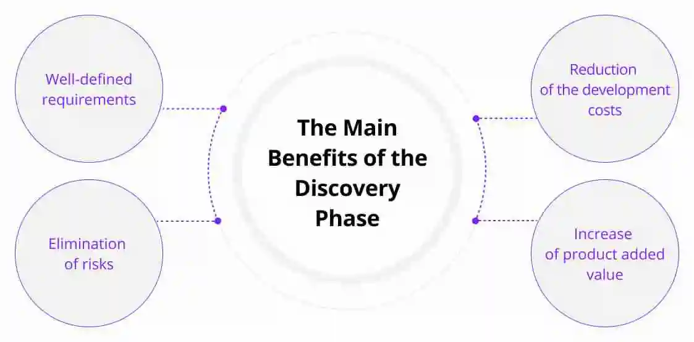

- Well-defined requirements. Wrong decisions on features can waste not only money but also time. Such false turns can be avoided with the help of product research and proper planning. The earlier you define technical requirements, the more accelerated your development process will be.
- Elimination of risks. The product discovery phase puts a strong emphasis on predicting future risks. Such outcomes of product discovery like time and cost estimates of the development process along with a technical vision of the product, mitigate major risks that can come up during the development stage.
- Reduction of the development costs. The exact time and cost estimate that the Discovery phase offers will help decrease the risks of a changed development course halfway into the project. During the technical examination of your idea, you can prioritize the most important features or cut off bad ideas, which will save you time and money.
- Increase of product added value. A product’s ability to satisfy clients’ needs is the main factor that forms a product’s value. Knowing what your consumers really need makes it much easier to design an attractive value proposition from the start.

Who is involved in the discovery phase?
To conduct a good digital product discovery, it is important to listen to as many opinions as possible and benefit from everyone’s experience. Different stakeholders hold different perspectives on the product requirements and outcomes. The best way of conveying information is a face-to-face conversation. The list of potential stakeholders includes:
Potential consumers. They are the most important people for any company. It is the end-users for whom you design the product. It is their problems you are trying to solve and their needs you are trying to satisfy. Immerse into their world, study the context, talk to focus groups, and run the surveys. Thus, you will identify the main pain points and will provide the best solution.
Development team members. These are the people who will probably carry out the development of your solution and should be involved during the Discovery stage:
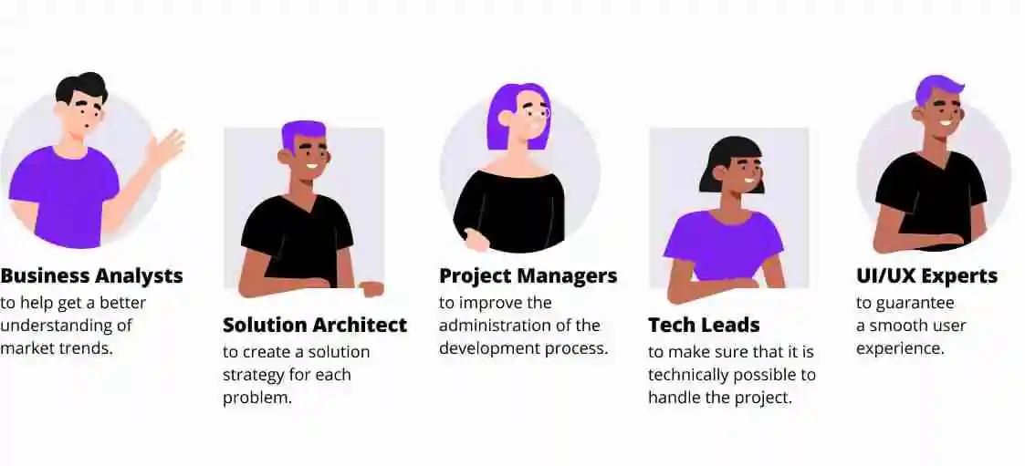
- Business analysts – to help get a better understanding of market trends.
- Solution architect – to create a solution strategy for each problem.
- Project managers – to improve the administration of the development process.
- Tech leads – to make sure that it is technically possible to handle the project.
- UI/UX experts – to guarantee a smooth user experience.

Investors. Any product requires external resources to be developed: finance, time, human experts, etc. The best policy to gain the support of investors is to be transparent. Share as much information as you can. Be honest about the deadlines, required supplies, and the expected outcomes.

3. Product discovery steps
The steps of the product discovery might be called or divided differently by different managers, but the overall framework is the same. This makes the method of product discovery worth internalizing, as it might appear in each of your projects.
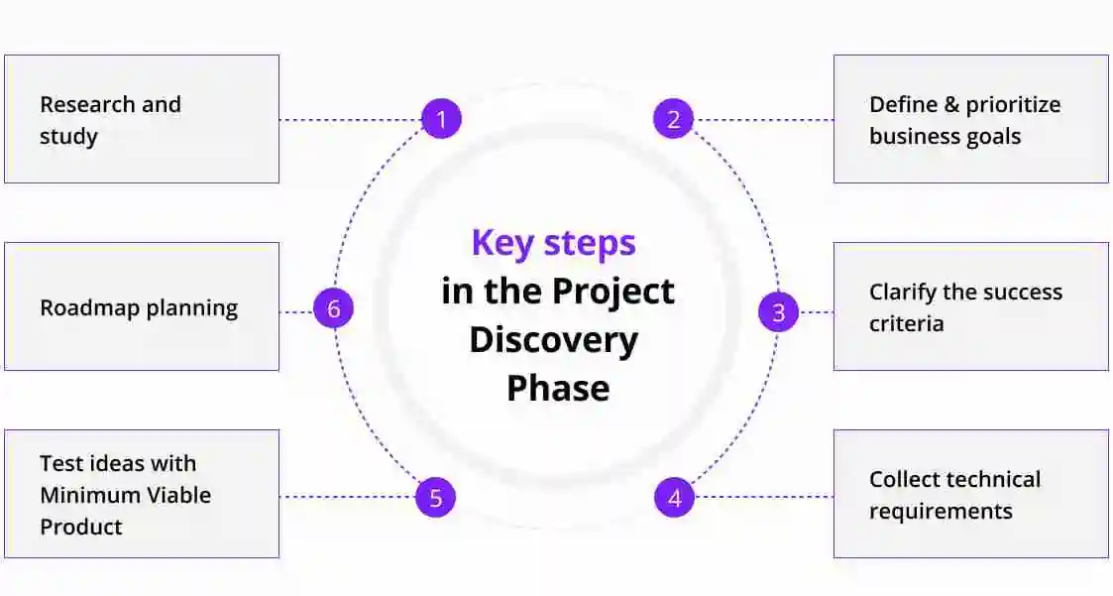
- Research and study. When starting a new project, your first aim is to immerse yourself in the world of your clients. Absorb as much information about your clients as possible so that you can clearly identify the main pain points.
- Define and prioritize business goals. As soon as you collect enough data about your clients, hypotheses will emerge. Document the ideas, then refine them and make a choice. Getting it right is crucial.
- Clarify the success criteria. At this stage, it is important to identify key quality attributes of a product or service that will signify a successful result for the stakeholders and end-users.
- Collect technical requirements. Now, that you know what the main problems of your clients are, it’s time to solve them. Define what features the product should have and technical experts will provide you with the technical requirements.
- Test ideas with Minimum Viable Product (MVP). Before starting a full-scale development process, test your concept to validate the idea. The MVP should take little time, consume minimal resources, and still give you information about the product’s success.
- Roadmap planning. Plan the solution implementation, generate the final deliverables, and estimate cost, time frame, team structure, and collaboration process design.

Tools to run a problem research
During the last two decades, product managers have been actively thinking about improving the product discovery process. Some of the thoughts were expressed in such books as Change by Design (Tim Brown, 2009), Jobs to Be Done: A Roadmap for Customer-Centered Innovation (Wunker, Stephen ; Wattman, Jessica ; Farber, David, 2016), and The Lean Startup (Eric Ries, 2011). As a result, several effective product discovery tools appeared.

Here are some tools from the leaders of the design industry.
Empathy Map
XPLANE company developed an empathy map that can be used as an instrument to help teams develop a deep, shared understanding of problems and empathy for other people. A goal of an exercise is to gain a better understanding of clients’ purchasing decisions or experience consuming a product or service. A rough empathy map can be made in 20 minutes. How do you create an empathy map? Here’s a scheme designed by the team of XPLANE.
Customers Personas
A customer persona represents real, living, and breathing characters who will use your product. Based on the hard data and rigorous research, it visualizes the key traits of your potential clients. To see what are the typical sections of customer persona profiles, have a look at the template provided by Xtensio.
Customer’s Journey Map
A route customers take to satisfy their needs can be visualized with the help of the customer’s journey map. It is an infographic that depicts all of the interactions with touchpoints customers take to meet their goals. By measuring customers’ excitement at different stages, the map helps identify the main pain points of consumer experience and cure them. How to create a customer’s journey map? Here are some recommendations prepared by UX research and consulting Nielsen Norman Group.

Task 2. Give summaries of the books mentioned above.

Task 3. Learn about the tools mentioned above. Be prepared to present your results in class.

4. Product discovery deliverables
A well-done discovery phase comes to the state where everything is lined up in a viable product concept. A shared, highly documented understanding of project goals and values is developed, and everyone in the team knows what and why should be done.

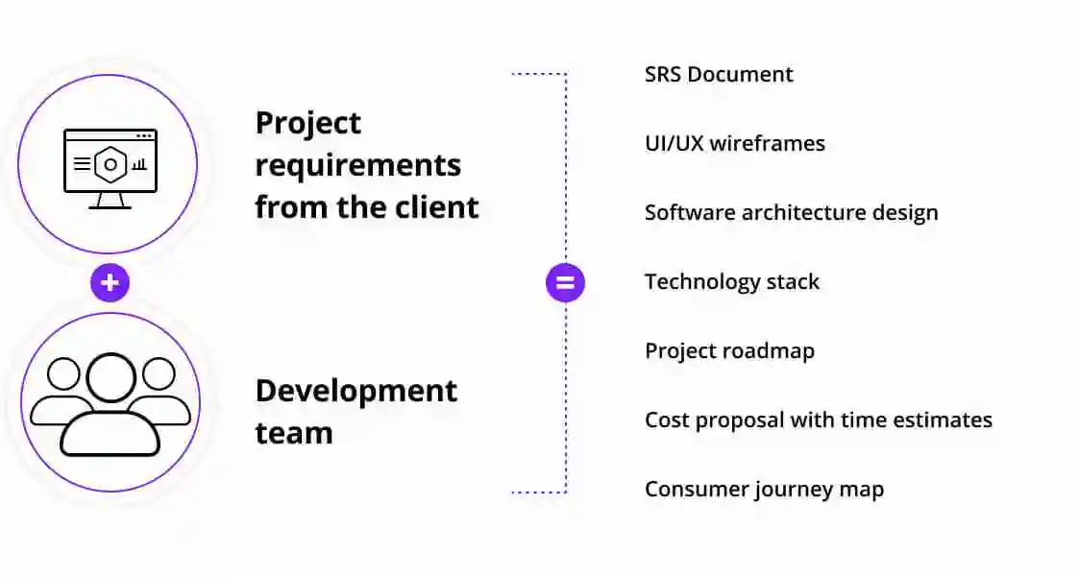
The final deliverables of the Discovery service establish clear steps in the software application development. Here are the typical outcomes of Discovery service:

- Software Requirements Specification (SRS) Document. This document describes how the software is expected to perform and is a documentation of expectations that prevent misunderstandings between development team members.
- UI/UX wireframes. A two-dimensional representation of an interface emphasizes space allocation and prioritization of content, intended behaviors, and functionalities available.
- Software architecture design. A high-level outline of a product designed to represent its infrastructure, features, and hierarchy.
- Technology stack. A brief description of the programming languages and frameworks you are going to use.
- Project roadmap. A timeline overview with milestones of the product’s objectives and dependencies.
- Cost proposal with time estimates. An estimation of the resources required to finish the project.
- Consumer journey map. It is a visual representation of all interactions the clients have with the product, a user flow diagram that shows how the customers go from one app page to another.

Having a good understanding of the people you design for is essential if you want to build a commercially successful product. Without it, you risk missing the market and losing money.

Task 4. Take a close look at some typical outcomes of Discovery service, such as (1) Software Requirements Specification (SRS) Document, (2) UI/UX wireframes, (3) Consumer journey map. Give a general overview and provide an example.
Reference
Hryvnyak Bozhena. What Is Product Discovery? An Ultimate Guide. https://ralabs.org/blog/what-is-product-discovery-ultimate-guide/
Lyadyk Lyubomyr. Product Discovery Process: What It Is and Why You Should Care. https://euristiq.com/product-discovery-process-what-it-is-and-why-you-should-care/

https://www.atlassian.com/agile/product-management/discovery

https://www.haveignition.com/what-is-product-management/the-product-management-dictionary-product-discovery

https://www.aha.io/roadmapping/guide/what-is-product-discovery

Tools and techniques https://medium.com/@rahul.sikder3/product-discovery-a-guide-for-product-manager-c284fe1c1ae3

https://www.productboard.com/blog/step-by-step-framework-for-better-product-discovery/?

