ANNEX 2

CURRICULUM VITAE

 |  | Curriculum Vitae |  |  |  |  |  |  |  |  |  |  | Olha Shomko
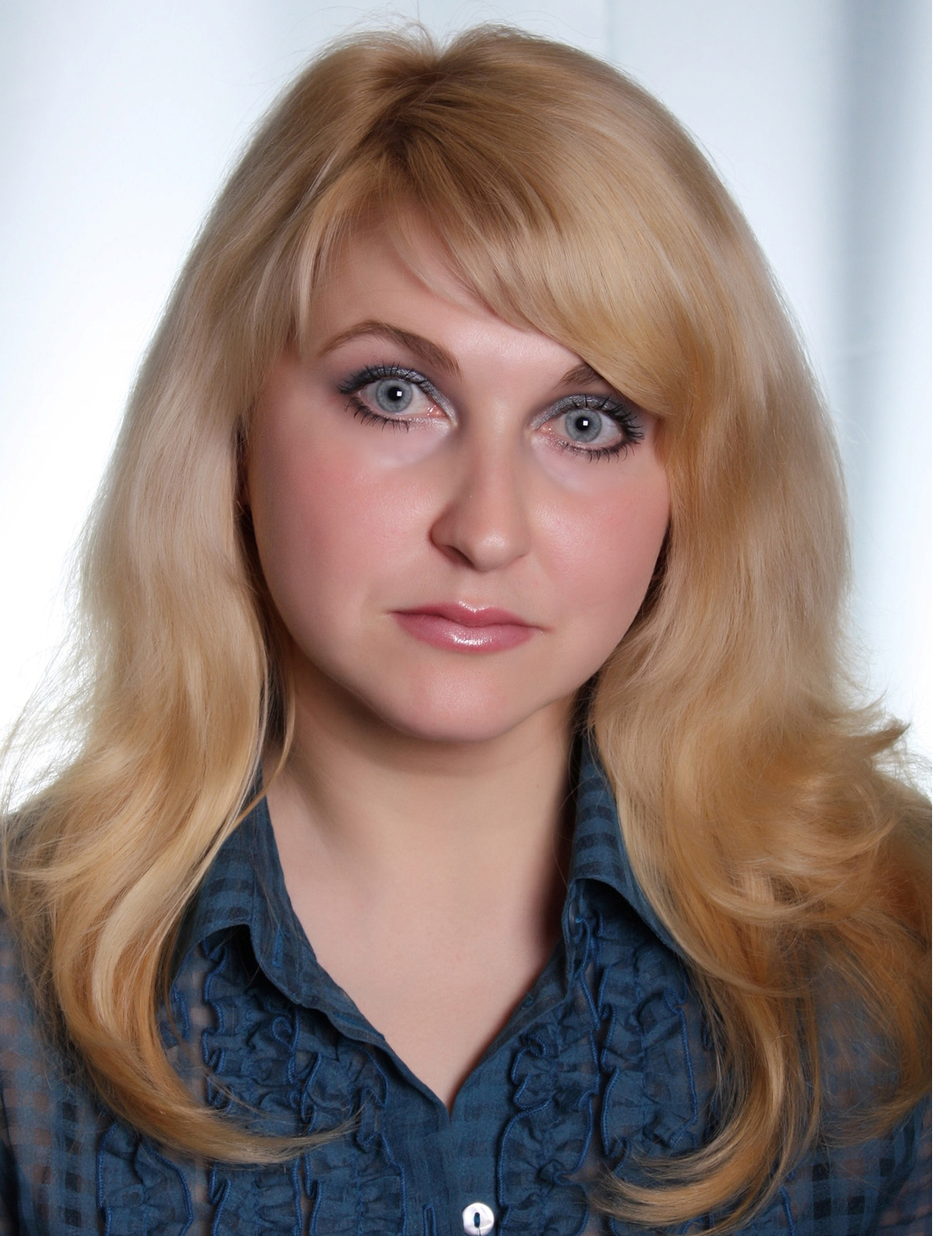
Personal information
First name(s) / Surname(s) |  | Nonik Liudmyla
Address(es) |  | 10025, Ukraine, Zhytomyr  Shkilny lane, 13, fl. 59
Telephone(s) |  | Mobile: 0038 068 38 62 702  Work: 0038 0412 22 49 13
E-mail |  | kgt_nlyu@ztu.edu.ua
Nationality |  | Ukrainian
Date of birth |  | 01.03.1983
Gender |  | Female
Education and training
Dates |  | 2021 – present
Name and type of organization  providing education and training |  | Zhytomyr Politechnic State University  Faculty of Mining, Environmental Management and Construction, Department of Ecology and Environmental Technologies  10005 Ukraine, Zhytomyr, Chudnivska str., 103
Occupation or position held |  | Postgraduate student
Title of qualification awarded
Principal subjects |  | Ecology
Title of Ph.D. thesis |  | Research of socio-ecological indicators and development of strategies for sustainable development of waste management in the region
Dates |  | 2017 – 2018
Name and type of organization  providing education and training |  | Zhytomyr State Technological University  Faculty of Mining and Ecology, Department of Mineral Resources Development named after prof. Bakka M.T.  10005 Ukraine, Zhytomyr, Cherniakovsky str., 103
Level in national or international classification |  | Master
Title of qualification awarded |  | Master of Mining
Dates |  | 2004-2005
Name and type of organization  providing education and training |  | Zhytomyr Ivan Franko State University  Faculty of History, Department of History of Ukraine  10008, Ukraine, Zhytomyr, Velyka Berdychivska Str. 40
Level in national or international classification |  | Master
Title of qualification awarded |  | Master of History
Work experience
Name and address of employer |  | Zhytomyr Politechnic State University  Faculty of Mining, Environmental Management and Construction, Department of Ecology and Environmental Technologies
Dates |  | 2000-present
Occupation or position held |  | Assistant of the Department of Ecology and Environmental Technologies
Main activities and responsibilities |  | Organization of diploma practice of students;  Participation in work of State Exam Commission;  Secretary of the Faculty Academic Council.  As an assistant professor, I teach practical and laboratory classes in the following disciplines:  - General ecology  - Meteorology and climatology  - Ecology of urban systems  - Normalisation of anthropogenic load on the environment  - Biological assessment of water quality
Personal skills and competences |  | Sociability:  - has experience in communicating and advising;  - has a professional attitude to colleagues;  - has experience in resolving conflict situations.  Time management:  - has ability to manage time correctly for improving efficiency.  Hardworking:  - has experience working with large amounts of information.  Volunteering:  - has experience in finding ways to help migrants during the war in Ukraine.
Mother tongue(s) |  | Ukrainian, Russian
Other language(s)
Self-assessment |  |  | Understanding |  |  |  |  | Speaking |  |  |  |  |  | Writing
European level (*) |  |  | Listening |  | Reading |  |  | Spoken interaction |  | Spoken production
English |  |  | B2 | Independent User | B2 | Independent User |  | B2 | Independent User | B2 |  | Independent User |  | B2 | Independent User
 |  | (*) Common European Framework of Reference for Languages
Computer skills and competences |  | Independent user of Microsoft Office, HTML, CorelDRAW, AutoCAD, EOL+, Kompas.
Scientific interests |  | sustainable development strategy, waste, urban ecology, functioning of urban ecosystems, ensuring the quality of the urban environment.
I, THE UNDERSIGNED, Nonik Liudmyla
aware that false declarations are punishable by law and that this Administration will carry out random checks on the accuracy of the declarations made by candidates
DECLARE UNDER MY OWN RESPONSIBILITY
THAT THE CONTENT OF THE ATTACHED “CURRICULUM VITAE” IS TRUE
Date Signature

