Картки «З’єднані конструкції »
1 | 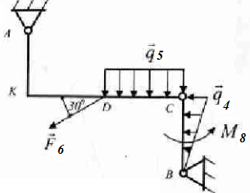  AK=DK=CD=BC=2,4 м;  $${\vec{X}}_{C}-?; {\vec{Z}}_{C}-?;{\vec{X}}_{A}-?; {\vec{Z}}_{A}-?;{\vec{X}}_{B}-?; {\vec{Z}}_{B}-?$$ | 2 | 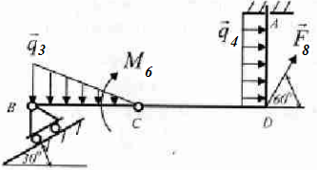  $$BC=2,1 m;CD=2,9 m;AD=2,0 m$$  $${\vec{X}}_{C}-?; {\vec{Z}}_{C}-?;{\vec{X}}_{A}-?; {\vec{Z}}_{A}-?;{\vec{R}}_{B}-?; M_{A}-?$$
3 | 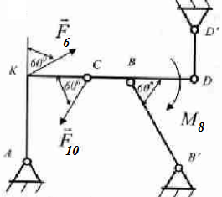  $$AK=3,0m;CK=1,0m;BC=1,0m;BD=2,0 m$$  $${\vec{R}}_{D}-?; {\vec{X}}_{A}-?; {\vec{Z}}_{A}-?;{\vec{R}}_{B}-?;$$ | 4 | 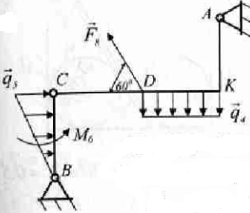  AK=DK=CD=BC= 2,4 м;  $${\vec{X}}_{C}-?; {\vec{Z}}_{C}-?;{\vec{X}}_{A}-?; {\vec{Z}}_{A}-?;{\vec{X}}_{B}-?; {\vec{Z}}_{B}-?$$
5 | 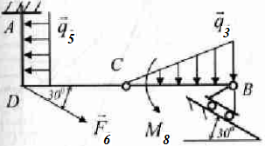  BC=CD= 3,0 м; AD=2 м.  $${\vec{X}}_{C}-?; {\vec{Z}}_{C}-?;{\vec{X}}_{A}-?; {\vec{Z}}_{A}-?;{\vec{M}}_{A}-?; {\vec{R}}_{B}-?$$ | 6 | 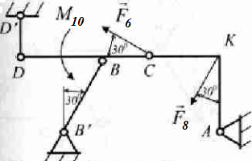  $$AK=2,0m;CK=1,5m;BC=1,0m;BD=2,0 m$$  $${\vec{R}}_{B}-?; {\vec{R}}_{D}-?;{\vec{X}}_{A}-?; {\vec{Z}}_{A}-?;$$
7 | 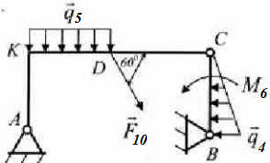  $$AK=KD=DC=BC=3,0 m$$  $${\vec{X}}_{C}-?; {\vec{Z}}_{C}-?;{\vec{X}}_{A}-?; {\vec{Z}}_{A}-?;{\vec{X}}_{B}-?; {\vec{Z}}_{B}-?$$ | 8 | 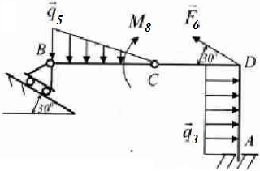$BC=3,3 m; DC=AD=3,0 m$  $${\vec{X}}_{C}-?; {\vec{Z}}_{C}-?;{\vec{X}}_{A}-?; {\vec{Z}}_{A}-?;{\vec{M}}_{A}-?; {\vec{R}}_{B}-?$$
9 | 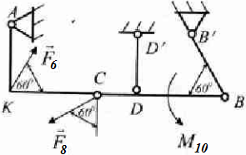  $$AK=2,0 m; KC=2,5 m; DC=1,0 m; BD=2,0 m$$  $${\vec{R}}_{B}-?; {\vec{R}}_{D}-?;{\vec{X}}_{A}-?; {\vec{Z}}_{A}-?$$ | 10 | 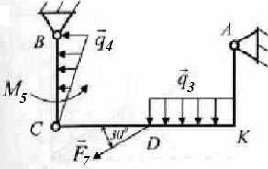  $$AK=KD=DC=BC=2,1 m$$  $${\vec{X}}_{C}-?; {\vec{Z}}_{C}-?;{\vec{X}}_{A}-?; {\vec{Z}}_{A}-?;{\vec{X}}_{B}-?; {\vec{Z}}_{B}-?$$
11 | 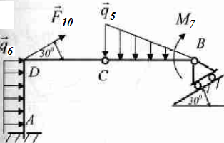  $$AD=DC=BC=3,0 m$$  $${\vec{X}}_{C}-?; {\vec{Z}}_{C}-?;{\vec{X}}_{A}-?; {\vec{Z}}_{A}-?;{\vec{M}}_{A}-?; {\vec{R}}_{B}-?$$ | 12 | 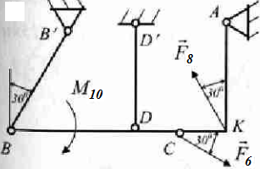$AK=3,0 m; KC=1,0 m; DC=1,0 m; BD=3,0 m$  $${\vec{R}}_{B}-?; {\vec{R}}_{D}-?;{\vec{X}}_{A}-?; {\vec{Z}}_{A}-?$$
13 | 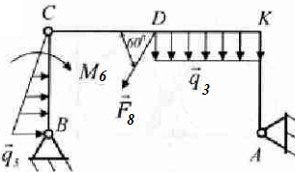  $$AK=KD=DC=BC=2,7 m$$  $${\vec{X}}_{C}-?; {\vec{Z}}_{C}-?;{\vec{X}}_{A}-?; {\vec{Z}}_{A}-?;{\vec{X}}_{B}-?; {\vec{Z}}_{B}-?$$ | 14 | 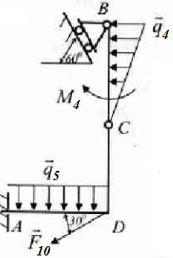  $$AD=DC=BC=2,1 m$$  $${\vec{X}}_{C}-?; {\vec{Z}}_{C}-?;{\vec{X}}_{A}-?; {\vec{Z}}_{A}-?;{\vec{M}}_{A}-?; {\vec{R}}_{B}-?$$
15 | 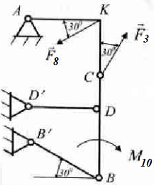  $$AK=2,0 m; KC=1,5 m; DC=1,0 m; BD=2,0 m$$  $${\vec{R}}_{B}-?; {\vec{R}}_{D}-?;{\vec{X}}_{A}-?; {\vec{Z}}_{A}-?$$ | 16 | 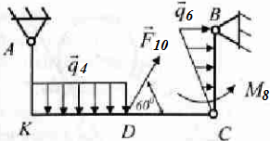  $$AK=KD=DC=BC=3,0 m$$  $${\vec{X}}_{C}-?; {\vec{Z}}_{C}-?;{\vec{X}}_{A}-?; {\vec{Z}}_{A}-?;{\vec{X}}_{B}-?; {\vec{Z}}_{B}-?$$
17 | 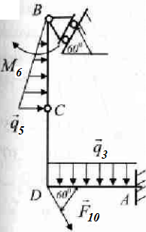  $$AD=DC=BC=2,1 m$$  $${\vec{X}}_{C}-?; {\vec{Z}}_{C}-?;{\vec{X}}_{A}-?; {\vec{Z}}_{A}-?;{\vec{M}}_{A}-?; {\vec{R}}_{B}-?$$ | 18 | 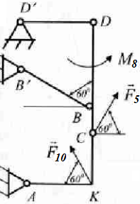  $$AK=2,5 m; KC=2,0 m; DC=1,5 m; BD=3,0 m$$  $${\vec{R}}_{B}-?; {\vec{R}}_{D}-?;{\vec{X}}_{A}-?; {\vec{Z}}_{A}-?$$
19 | 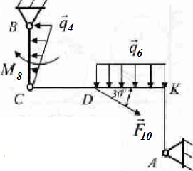  $$AK=2,0 m; KD=DC=BC=3,0 m$$  $${\vec{X}}_{C}-?; {\vec{Z}}_{C}-?;{\vec{X}}_{A}-?; {\vec{Z}}_{A}-?;{\vec{X}}_{B}-?; {\vec{Z}}_{B}-?$$ | 20 | 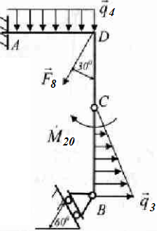  $$AD=DC=BC=2,0 m$$  $${\vec{X}}_{C}-?; {\vec{Z}}_{C}-?;{\vec{X}}_{A}-?; {\vec{Z}}_{A}-?;{\vec{M}}_{A}-?; {\vec{R}}_{B}-?$$
21 | 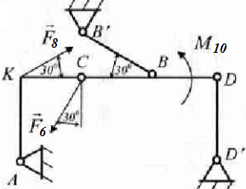  $$AK=3,0 m; KC=2,0 m; DC=2,0 m; BD=2,0 m$$  $${\vec{R}}_{B}-?; {\vec{R}}_{D}-?;{\vec{X}}_{A}-?; {\vec{Z}}_{A}-?$$ | 22

