Topic: Family. Relationships and Dating
Ex. 1,2,3,4 (in a written form)
Ex. 1,2,3,4,5,6 (write down the translation of all unfamiliar words and word combinations) + make up 5 sentences using new vocabulary units
Homework Ex. 7 ( write down a story about love of famous couple using new vocabulary)
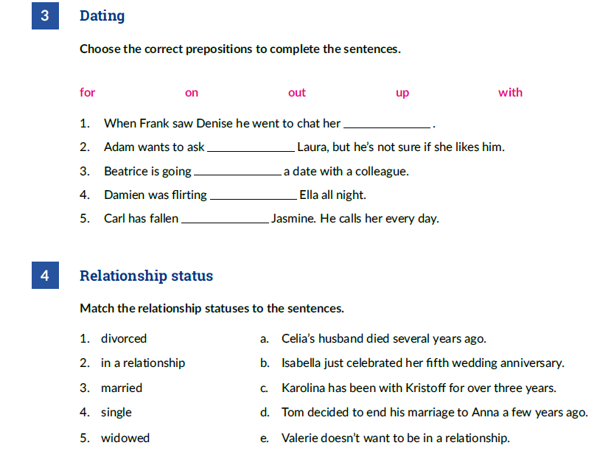

Resources:
https://www.linguahouse.com/esl-lesson-plans/general-english/relationships-and-dating
https://www.linguahouse.com/esl-lesson-plans/general-english/family

