ЗБІЖНА СИСТЕМА СИЛ (КАРТКА №1)
1  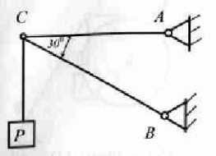  $$P=1000 H; {\vec{R}}_{AC}-?; {\vec{R}}_{BC}-?$$ | 2  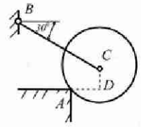  $$P=1000 H;CD=30 см;R=50 см;$$  $${\vec{R}}_{A}-?; {\vec{R}}_{BC}-?.$$
3  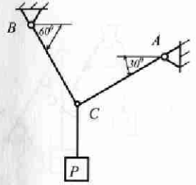  $$P=1000 H; {\vec{R}}_{AC}-?; {\vec{R}}_{BC}-?$$ | 4  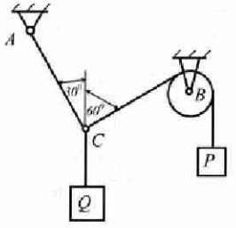  $$P=1000 H; {\vec{R}}_{AC}-?; Q-?$$
5  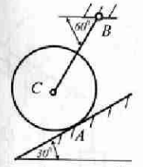  $$P=1000 H; {\vec{R}}_{A}-?; {\vec{R}}_{BC}-?$$ | 6  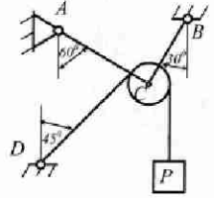  $$P=1000 H; {\vec{R}}_{AC}-?; {\vec{R}}_{BC}-?$$
7  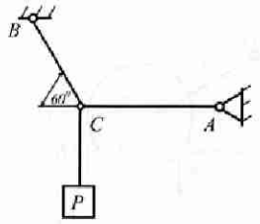  $$P=1200 H; {\vec{R}}_{AC}-?; {\vec{R}}_{BC}-?$$ | 8  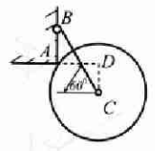  $$P=1200 H;CD=30 см;AD=40 см;$$  $${\vec{R}}_{A}-?; {\vec{R}}_{BC}-?.$$
9  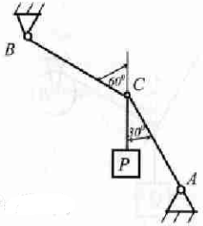  $$P=1200 H; {\vec{R}}_{AC}-?; {\vec{R}}_{BC}-?$$ | 10  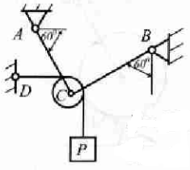  $$P=1200 H; {\vec{R}}_{AC}-?; {\vec{R}}_{BC}-?$$
11  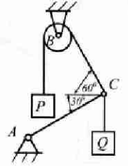  $$P=1200 H; {\vec{R}}_{AC}-?; Q-?$$ | 12  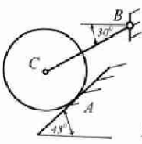  $$P=1200 H; {\vec{R}}_{A}-?; {\vec{R}}_{BC}-?$$
13  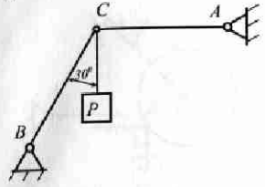  $$P=800 H; {\vec{R}}_{AC}-?; {\vec{R}}_{BC}-?$$ | 14  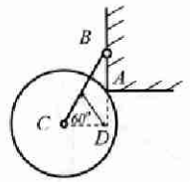  $$P=1000 H;CD=24 см;R=30 см;$$  $${\vec{R}}_{A}-?; {\vec{R}}_{BC}-?.$$
15  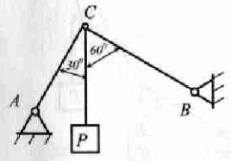  $$P=800 H; {\vec{R}}_{AC}-?; {\vec{R}}_{BC}-?$$ | 16  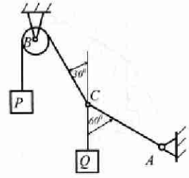  $$P=800 H; {\vec{R}}_{AC}-?; Q-?$$
17  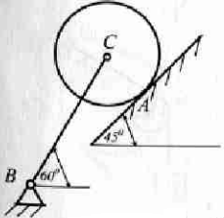  $$P=800 H; {\vec{R}}_{A}-?; {\vec{R}}_{BC}-?$$ | 18  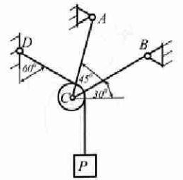  $$P=800 H; {\vec{R}}_{AC}-?; {\vec{R}}_{BC}-?$$
19  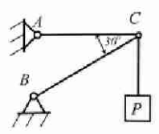  $$P=600 H; {\vec{R}}_{AC}-?; {\vec{R}}_{BC}-?$$ | 20  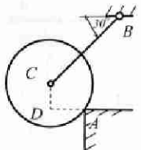  $$P=1000 H;CD=18 см;DA=24 см;$$  $${\vec{R}}_{A}-?; {\vec{R}}_{BC}-?.$$
21  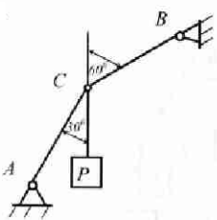  $$P=600 H; {\vec{R}}_{AC}-?; {\vec{R}}_{BC}-?$$ | 22  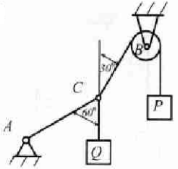  $$P=600 H; {\vec{R}}_{AC}-?; Q-?$$
23  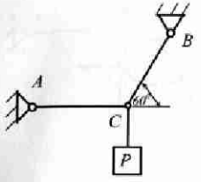  $$P=1500 H; {\vec{R}}_{AC}-?; {\vec{R}}_{BC}-?$$ | 24  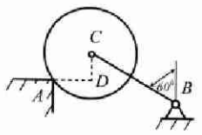  $$P=1500 H;CD=21 см;R=35 см;$$  $${\vec{R}}_{A}-?; {\vec{R}}_{BC}-?.$$
25  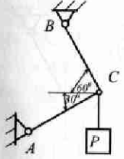  $$P=1500 H; {\vec{R}}_{AC}-?; {\vec{R}}_{BC}-?$$ | 26  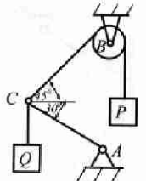  $$P=1500 H; {\vec{R}}_{AC}-?; Q-?$$
27  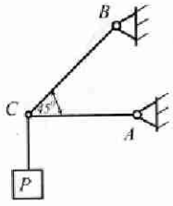  $$P=2000 H; {\vec{R}}_{AC}-?; {\vec{R}}_{BC}-?$$ | 28  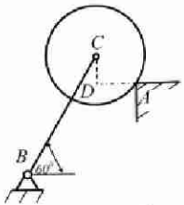  $$P=2000 H;AD=18 см;CD=24 см;$$  $${\vec{R}}_{A}-?; {\vec{R}}_{BC}-?.$$
29  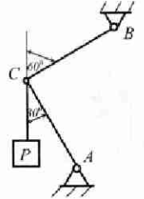  $$P=2000 H; {\vec{R}}_{AC}-?; {\vec{R}}_{BC}-?$$ | 30  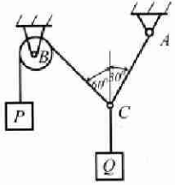  $$P=2000 H; {\vec{R}}_{AC}-?; Q-?$$

