ШАНОВНІ СТУДЕНТИ!!! ЗВЕРНІТЬ, БУДЬ-ЛАСКА УВАГУ: ВСІ ЗАВДАННЯ ВИКОНУЄМО В ЗОШИТІ(надсилаємо фото виконаного д.з.) АБО В ЕЛЕКТРОННОМУ ВИГЛЯДІ(в форматі Word doc.)
Завдання здаємо ДО або у день терміну! 1 студент – 1 повідомлення на пошту з усіма файлами.
kateryna_only_bondarenko@ukr.net
ДЯКУЮ!
Формуємо усі відповіді відповідно нашої теми: «GADGETS»

ADVERTISING


HOARDING (US)
BILLBOARD (UK)

Discuss the questions in pairs; take notes so that you are able to summarize your ideas:

How many adverts do you see every day?
Do you remember at least one advert from yesterday? Give details.
Where do you find ads? (Think of all possible places and media.)
What kind of adverts attracts you the most?
Do you think ads should be banned from some places or kind of media?
What do you think about billboards alongside the roads?

Surrounded by advertising


Do you enjoy watching adverts on TV or the internet, seeing them in papers or listening to them on the radio?
How do you react to advertisements on television and radio?
Do you switch TV channel or radio station when ads are on?
What else do you do while the adverts are on?
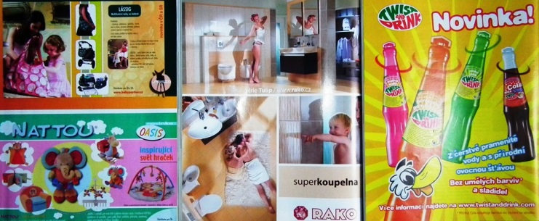


Discuss with your partner. Get ready to share with the whole class:

What makes an advertisement memorable? (What kind of special affects?)
Think of a TV advertisement that has impressed you in some way? Describe it.
Who was it aimed at? And how did they make the product appealing?
Can you think of an advert that actually made you go to the shop and buy the advertised product?

Are you easily influenced by advertising on TV?
Who in your family is influenced by advertising the most?
Which age groups do you think are influenced the most?
Should adverts be banned on TV channels for kids?

- Do you recognize these slogans? What brand do they represent? What is their typical product?

“Keep Walking”
“Life's Good”
“Just do It”
"I'm lovin' it!"
“Connecting People”
“Simply clever”

Can you think of some other slogans that got stuck in your mind?

Make your own advert:
Think of your favourite product or service and prepare an advertisement. Think about the effects, the target group and try to make your product or service the number one on the current market.

You can work alone, in pairs or groups of three.
You can act the whole advert or you can prepare posters and just be the voice of your advert.

